Sound Travels

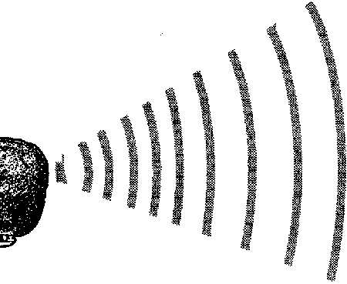
Key Concepts
1. Toothed whales use sonar to determine location of objects underwater and for food gathering, communication and navigation.
2. Humans have developed sonar to determine ocean depths and determine the location of objects underwater.

Background
Sonar, or SOund Navigation And Ranging, was first proposed as a means of detecting icebergs at sea in the hopes of avoiding disasters such as befell the Titanic. The idea was simple: a pulse of sound would be sent out which would bounce off of the iceberg and be reflected back to the source. The reflected waves would alert the operator to the presence and location of the iceberg. Although the idea was simple, the technology was not. The threat of submarine warfare in World War I helped spur the development of the first successful sonar systems. Even so, it was not until after World War II that sonar and echo sounders became widely available to ocean scientists for mapping and studying the ocean floor.

Since the speed of sound in water was known, the depth of the ocean could be determined by measuring the time it took a sound wave generated on a boat to travel to the bottom and return to the boat. By multiplying the speed and time together and dividing by two, the ocean depth could be calculated. (Division by two eliminates the return trip back up to the boat, thus giving the one-way distance).

While we thought we were pretty clever, it turns out that dolphins and whales (and bats as well) have been using sonar for millions of years to determine their distances from objects. Toothed whales generate sound waves from a special organ in their foreheads called the melon. The sound waves bounce off objects and return to the whale where they are received by the lower jaw bone and transmitted to the inner ear. The whale’s brain interprets the signals with astounding accuracy and perception. In experiments with captive dolphins, the animals were able to use their echolocation to differentiate between spheres of the same size made of different materials.

Scientists believe that toothed whales use echolocation to find prey, communicate, and navigate. Some species of toothed whales like sperm whales and pilot whales are said to be able to use their sonar to stun or disorient prey, making them easier to catch. Humans can hear the low frequency sounds under water and can feel some of the higher frequencies. A diver with surgically implanted screws in her knee has reported feeling the knee tingle when diving near juvenile spotted dolphins. The dolphins were emitting sound too high for the human ear, but the vibration could be felt in the metallic implants in her knee. Some individuals have felt stunning blasts at times. Flip Nicklin, a National Geographic photographer, related a story about photographing narwhals. Two males were competing for females, and apparently Flip got too close. One of the males turned, faced him, and gave a blast of high frequency sonar that pushed Flip backwards in the water. Similar occurrences have been reported by rescuers of a stranded baby sperm whale.

While we have learned a lot about echolocation and navigation in whales, there is still much to be discovered. For example, the exact mechanism of the sound wave generation has not yet been precisely determined. We also know that while toothed whales definitely use sonar, we are unclear about how baleen whales navigate and communicate.

Additional background information is found in the preceding activities, “Hear-Sighted” and “Echolocation”.

Materials
For each group of 3 students:

• meter sticks or rulers, 3

• marble

• stop watch or clock with second hand

• books

• tape

Teaching Hints
In “Sound Travels”, students attempt to determine unknown distances using the principles behind sonar. This activity may be used to supplement, or in lieu of, the preceding activity, “Echolocation”.

Rates may be difficult for some students to comprehend. Start with analogies like speed limit 55 mph (what is mph? how fast can race cars go? how fast can humans run?, etc.). Work through the math with your students. Remind them that they use math in their everyday lives. You may choose to integrate this activity with your math instruction and to emphasize the use of metrics. The Guinness Book of World Records is helpful regarding human and animal speed records.

Be aware that students need to be consistent in starting the timer as soon as the marble reaches the bottom of the incline. Have students practice the release and timing before recording “real” data. Be sure students do not change the angle of their ramp during the data collection. They need to complete three trials and then calculate the average.

Note that the distances and angles suggested are not critical. Vary the distances to suit your tables but realize that the shorter the distances the more difficult the timing becomes. Also note that the speed of the marble is affected by the table surface. If the marble rolls very fast, it will be difficult for students to time the passage. If the marble rolls too slowly, it may not cover the entire distance. You can vary the speed of the marble by increasing or decreasing the angle and by increasing or decreasing the point of release.

Key Words
echolocation - determination of the location of objects by using echoes (returning sound waves)

frequency - the number of sound waves per second or other unit of time

intensity - magnitude, as of energy or a force per unit area

sonar - (acronym for SOund Navigation And Ranging); the use of sound waves to detect and determine the location, size, and relative motion of underwater objects

speed - in this case, rate of motion (i.e., distance traveled divided by time to travel the distance)

Extensions
1. Have students experiment with the height of the ramp to see how it affects the speed.

2. Have students measure a precise distance, calculate the time it should take for their marble to traverse the distance, and then actually measure the time. (Provide students with this relationship: time = distance/speed.)

3. Have students convert their data to km/hr. or miles/hr.

4. Demonstrate how the diver (Flip) was pushed backwards in the water by a “blast” of high frequency sound from the narwhal. Have two students hold a stretched out slinky and generate wave pulses by shaking the slinky at one end. Have them create high frequency waves by more rapid shaking. Ask: Is it harder to hang onto the high frequency slinky or the low frequency slinky? Which kind of waves have more energy? What? No slinky? This demonstration can be done (albeit a bit less dramatically) with a jump rope.

Answer Key
1.a. The marble is like the sound wave made by toothed whales.

b. The book is like the object being “seen” by the whale.

2. Answers will vary depending upon experimental results.

3. Determining an average tends to minimize the effects of variability yielding a more reliable answer.

4.a. Answers will vary depending upon experimental results.

b. Sources of error for any differences observed include: timing, release, surface, etc.

5.a. Toothed whales may possibly make mistakes navigating.

b. Stranding or getting lost are possible consequences of such mistakes.

6. Noise pollution, boat traffic, and nets or other objects suspended in the water could affect a whale’s use of sonar.

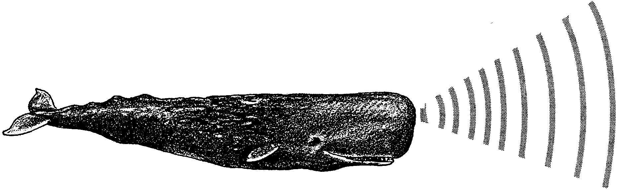
Sound Travels

Whales travel in the totally dark ocean depths. How do they avoid running into things? We know that toothed whales use echolocation (sonar) to find their way. The idea is simple. A sound wave is sent out. The sound hits something and is reflected back to the whale.

Toothed whales make the sound waves from a special organ in their foreheads. The organ is called the melon. The sound waves that return to the whale are sensed by the lower jaw bone. The jaw bone sends a signal to the inner ear. The whale’s brain makes sense out of the signals.

Toothed whales can change the number and strength of their sound waves. This helps them to find their way, to stun their prey and to “talk” to each other. The sonar of dolphins even lets them “see” pregnant females, both dolphin and human.

In this activity you will use the principles behind sonar to determine distances to objects.

Materials
• meter sticks or rulers, 3
• marble
• stop watch or clock with second hand
• books
• tape

Procedure:

Part 1

1. Tape 2 rulers together so they form a “V”. This will be your marble ramp.

2. Set your ramp up at an angle against a stack of books. The end on the books should be about 10 cm above the table. Gently tape the ramp down so it does not move.

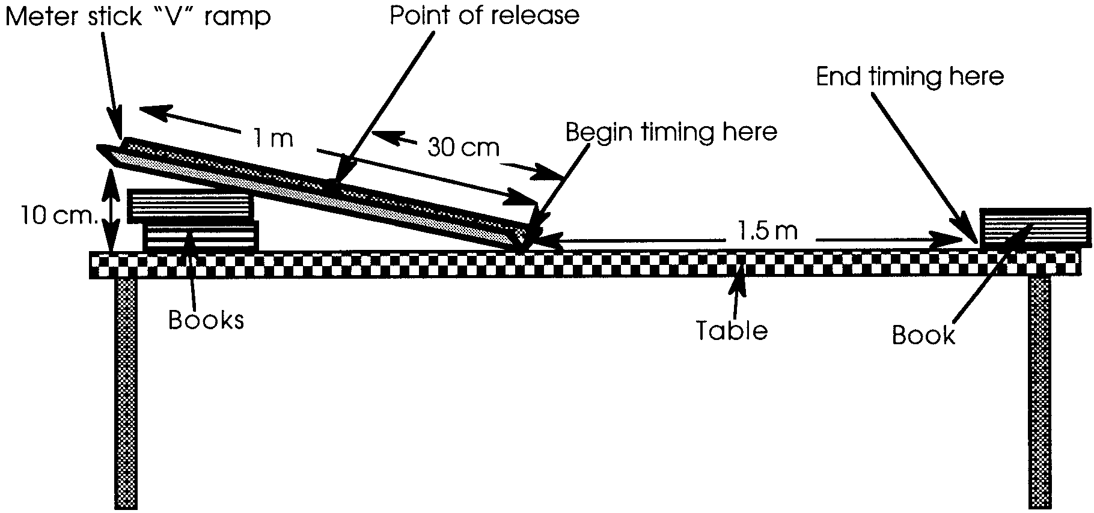
3. Mark off 1.5 meters from the bottom of your ramp. Place a book at 1.5 meters. Your set up should look something like this:

4. Practice rolling your marble down the ramp. Try to let go of the marble the same way each time.

5. Now practice timing. Here’s how:

a. Release your marble.

b. When the marble reaches the BOTTOM of the ramp, start the stop watch.

c. Stop timing when the marble hits the book.

Practice at least four times. Now you are ready to gather data to record.

6. Find Data Table 1. Release and time your marble. Record this time under “Trial 1” in Data Table 1.

7. Repeat two more times. Record the times in Data Table 1.

8. Find the speed for each trial. This is easy because

Speed = Distance
Time

9. What is your average speed? This is easy, too. Just add your three speeds together and divide by 3:

Average Speed = Speed 1 + Speed 2 + Speed 3
3

Record the average speed in Data Table 1.
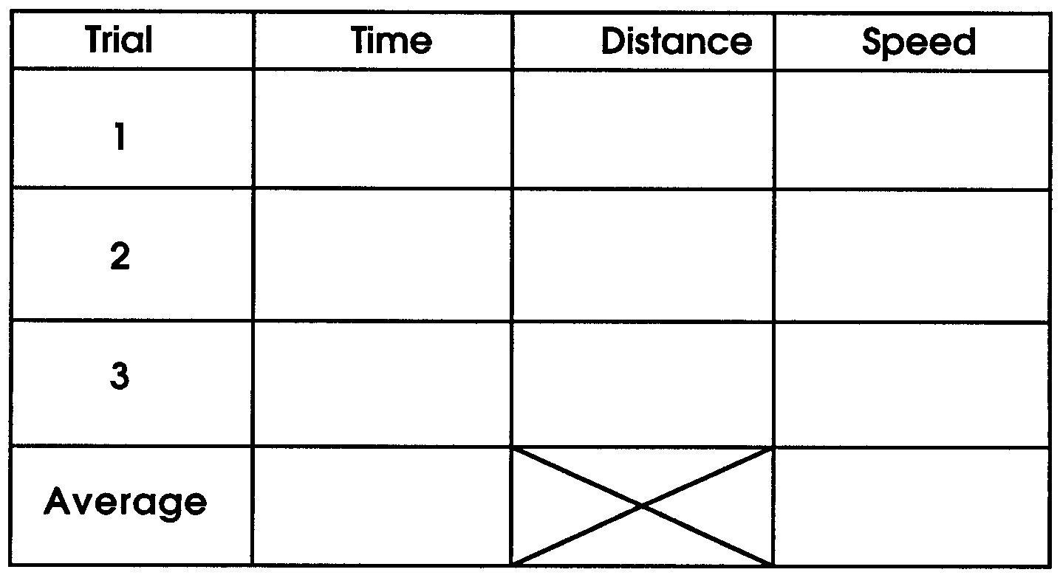

Table 1

Part 2

1. Pick any spot along the path of the marble. Place the book in this new location.

2. Find Data Table 2. Release and time your marble to the new location. Record this time under “Trial 1” in Data Table 2.

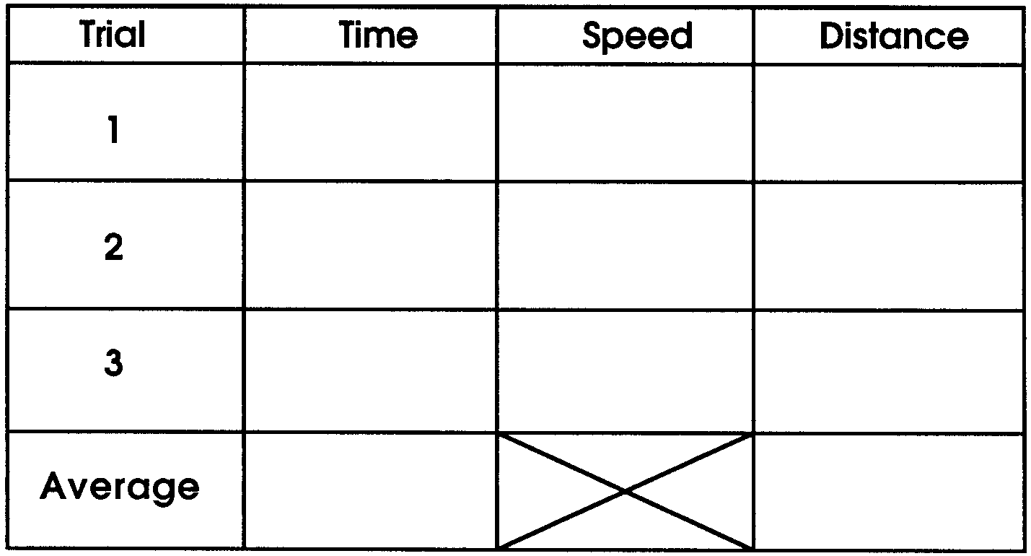
3. Repeat two more times. Record the times in Data Table 2.

Table 2

4. Calculate the new distance. This is pretty easy, too. Here’s how:

a. From Table 1 you know the average speed your marble travels. Write the average speed here .

b. From Table 2 you know how long it takes to travel the new distance. Write the time for Trial 1 here .

c. Calculate the new distance using this formula:

Distance = Speed x Time

5. Repeat step 4 for Trial 2 and Trial 3. Record the distances in Data Table 2.

6. Find the average distance. (Remember? Add the three distances and divide by 3. See step 9 for help.) Record the average distance in Table 2.

7. How well did you do? Check by measuring the actual distance with a meter stick.

8. Change the location of the book and repeat steps 1-7. Record your results in Table 3.

Table 3

Analysis and Interpretation

1. Your set up is a model of echolocation. It tries to represent how a whale uses sound to “see.”

a. What part of this set up is like the sound wave made by toothed whales?

b. What part of this setup is like the object being “seen” by the whale?

2. In Part 1, how close were your speed readings?

3. Why is it helpful to find the average?

4. a. In Part 2, how close were your calculated distances to the actual measured ones?

b. What might have caused any differences?

5. a. Do you think toothed whales ever make mistakes navigating?

b. What could happen if they do?

6. What factors could affect a whale’s use of sonar?

