Weave a Fish
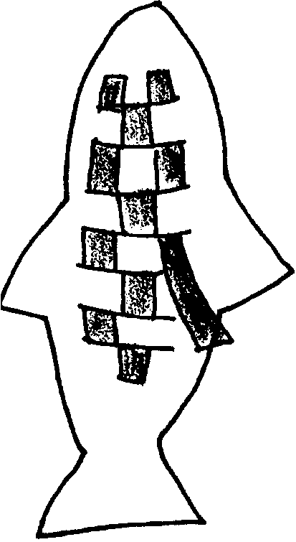
Lesson by Patty Enright, Stillwater, MN

Key Concepts
1. Fish have body parts that serve specific functions.
2. Fish have body parts and behaviors or adaptations that help them survive in their habitat.
3. The body parts and behaviors of a fish provide clues to the habitat of the fish.

Background

Fish exhibit a great diversity of shapes, sizes, and colors. The unique combination of these features displayed by each species of fish reflect a successful strategy for dealing with the ofttimes harsh marine environment. Examples of successful strategies and additional background material are found in the preceding lessons, “Fish Forms” and “Sculpting Sculpins”.

Materials

For each student:

• pieces of 12"x18" construction paper

• wrapping paper (optional)

• scissors

• glue

• pencil

Teaching Hints

In “Weave a Fish”, students create woven fish as a way of reinforcing fish anatomy and the relationship between form and function in fish.

Procedure

1. Discuss and review fish anatomy, especially how form relates to function.

2. Have students draw the shape (outline) of a large fish on the construction paper and cut it out.
3. Outline the following steps as you demonstrate the weaving process:

a. Fold the fish in half, and cut straight, wavy, or zigzag lines in the middle of the body, about 1/2" apart.
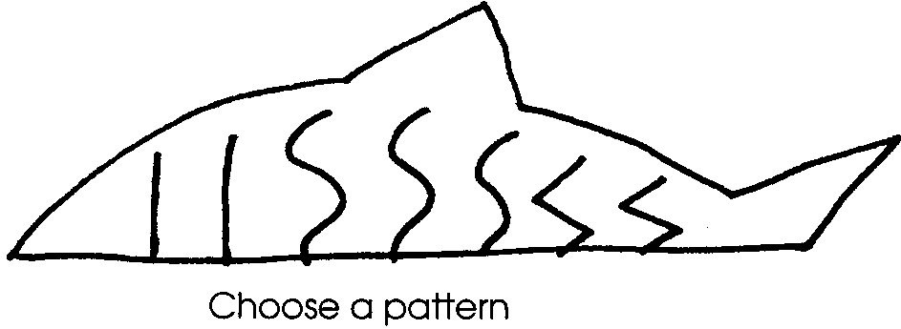
b. Cut several 1/2"-1" strips from different colored construction paper or wrapping paper. Make certain the strips are long and wide enough to weave through the slits in the fish’s body.
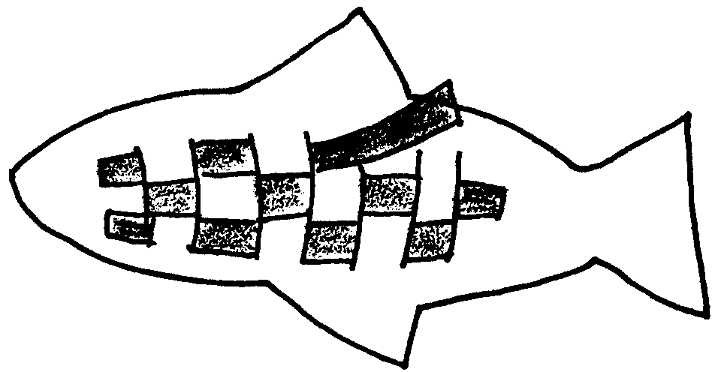

c. After each strip is woven through, trim and glue down the ends.

d. Add details with paper, sequins, buttons, etc.

e. Fringe the fins, if you like.

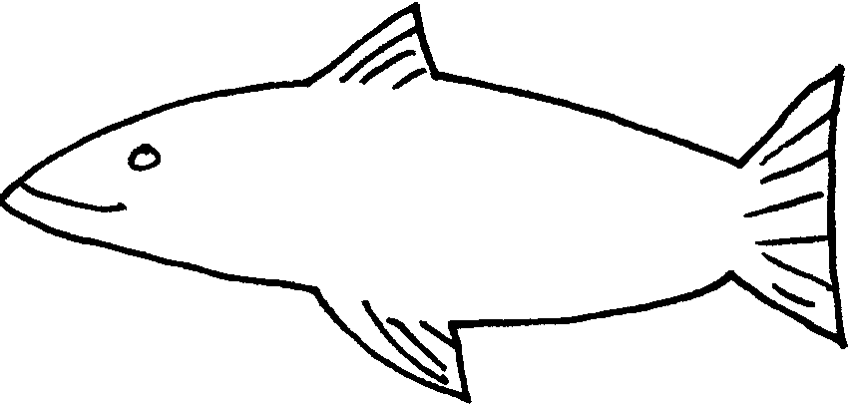

4. Hang the fish to display or create a mobile with several, smaller, woven fish.

