Sculpting Sculpins

Lesson by Sue Brimhall, Seattle, WA
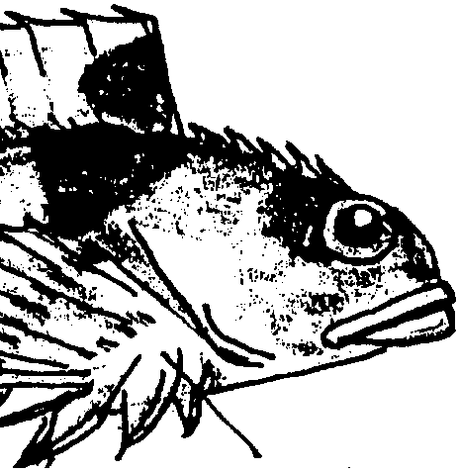

Key Concepts
1. Sculpins are bottom-dwelling fish, often found in coastal tidepools.
2. All fish have structural adaptations which help them survive.

Background

Sculpins are benthic fish, meaning they live on or near the bottom. Their bodies are poorly streamlined reflecting the fact that they are not long-distance swimmers. Instead, sculpins spend most of their time resting on their enlarged pectoral fins. They dart for short distances as they escape enemies or briskly search out food. Although many of these species will swim some distance from their tidepool when the tide is in, they always return to their “home” pool.

In a tidepool, a sculpin is very difficult to spot indeed! The mottled patterns of reds, greens, grays and browns are changeable, taking on a similar appearance to the background in which the fish sits. Enlarged and heavily spined fins also help hide their location by breaking up their outline. In addition, the spined fins give them protection from enemies.

Sculpins have large heads with bright eyes perched on top. The position of the eyes gives them the widest possible view of their tidepool surroundings. These little fish cruise the tidepools, looking among rocks and algae for their prey, small crustaceans (crabs, barnacles, shrimps) and other invertebrates. While most tidepool sculpins only grow to be about 8 cm long, their relatives in the deeper rocky habitats can grow to 3 feet.

Living in the intertidal zone means sculpins must adapt to a wide range of environmental changes. Water temperatures can change drastically as the summer sun beats down and heats their small tidepool for several hours each day. Their tidepools can also vary greatly in salinity due to rainfall or evaporation.

Materials

For each student or pair of students:

• metal coat hangers

• additional stiff, but malleable, pieces of wire (easier to bend than coat hanger wire)

• masking tape - lots

• newspapers - lots

• pliers

• flour - lots

• water

• sand paper

• acrylic or tempera paint and brushes

• glitter

• shellac or clear sealer and brushes

• “Sculpting Sculpins” student activity sheets

Teaching Hints

In “Sculpting Sculpins”, students research information about sculpins and other fish, and then create model fish using wire and papier-mâché.

Provide access to library resources to enable students to do their fish reports. Encourage students to include copious color sketches from different angles. Since the report provides the background information necessary for constructing the model fish, the more preparation and research students do, the better the end product.

Once construction begins, have the students make their fish as realistic as possible. Life size fish are great, but be aware - the larger the fish, the longer the time needed for construction. Allow time blocks of 60 minutes and encourage students to work carefully and take their time. A few helpful suggestions for each stage of the project follow:

Constructing the Frame for the Fish
This is the most crucial stage of construction. Have students include all fins and the tail now, using sufficient tape to hold them firmly in place.

Papier-mâché
Students really enjoy this messy stage since their fish will start to look realistic. Allow an hour for each work session each day, with time between days used for drying. Small groups can work on papier-mâché while the rest of the class is engaged in other tasks.
Left over papier-mâché mix can be refrigerated and used the next day. If left out, it ferments and starts to rise!

Tissue paper can also be used to cover the fish bodies. Paint liquid starch on the form and then put tissue paper on top. Smooth with more starch.

Painting
This last step is important so encourage students to take their time. (By this time, students usually have taken such ownership and pride in their work that they become surprisingly meticulous.) Acrylic paint works best, but can be expensive. Tempera is an acceptable, less costly, alternative.

When it comes to drawing the eyes and mouth, encourage students to practice on paper and then draw on their fish with pencil. Finally, they may use a paint brush, markers or oil pastels to add the details.

Tempera painted fish benefit from a layer of shellac or clear sealer for protection and to keep the paint from cracking and falling off. Shellacking or sealing can be messy. Spray shellacs or sealers are available and make the job easier. Look for those brands which are environmentally-safe. Because of the fumes and clean-up, you may elect to do the shellacking or sealing yourself, or to recruit parent volunteers to help.

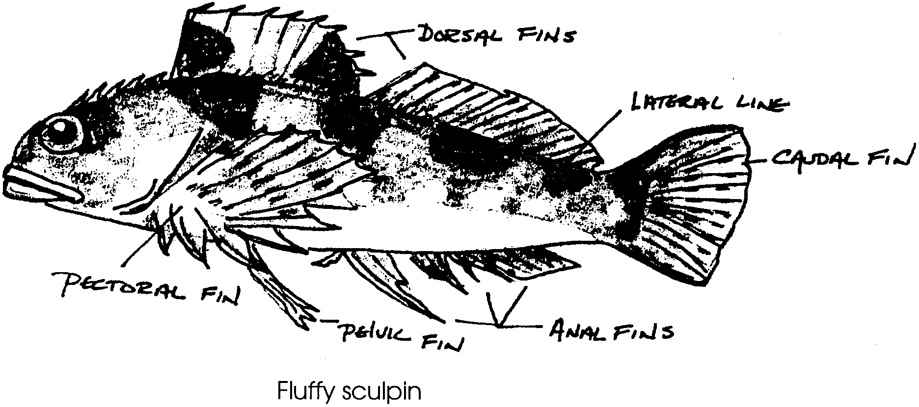
Sculpting Sculpins

Become An Expert

1. Research and find a particular sculpin or other fish you would like to study and sculpt.

2. Take notes about your fish. Include information about the fish’s:
a. length
b. habitat
c. range (northern-most point found to southern-most point)
d. diet and strategy for food collection
e. unique features or behaviors
f. is it normally found schooling with other fish or alone?

3. Draw your fish.

a. sketch a side view

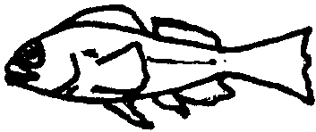

b. sketch a view looking at the front


c. sketch a life sized drawing of your fish

Remember: The more accurate and detailed your information, the better your sculpture will be. Become a real expert on your fish!


Construction of the Fish Frame

1. Form the outside shape (outline) of the fish with metal coat hangers. Straighten the hangers and cut the hooks off before beginning. Tape the hangers together. Be generous with the tape.

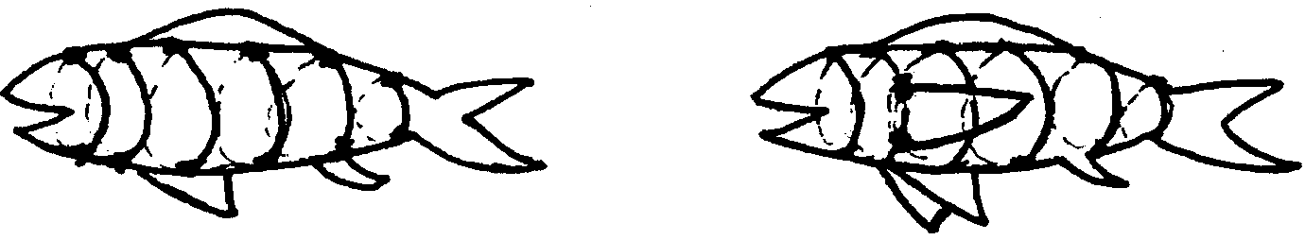
2. Add ribs to the fish, using stiff wire. Tape ribs to frame. The fish should have wider ribs in the middle and thinner ribs near the tail and head.

3. Add the appropriate fins for your fish. Tape the fins securely to the frame. Make sure they are in the correct position. The fins should not move.


4. Stuff newspapers between the ribs.

5. Tape the newspapers to the frame so they are secure.
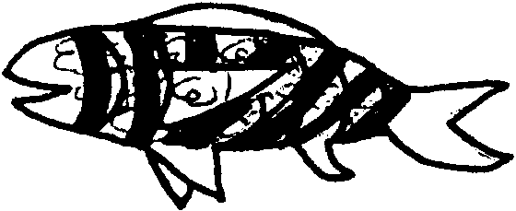

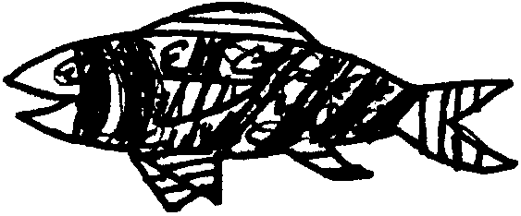
6. Carefully, cover the fins with tape.


Papier-Mache

1. Cut or rip lots of strips of newspaper.


2. Mix flour and warm water in the mixer until it is the consistency of pancake batter.

3. Dip strips of newspaper into the batter. Squeeze off the excess batter.


4. Cover the fish with papier-mâché strips. Crisscross the strips for added strength.

5. Cover the fish with a thin, smooth coat of batter before putting it aside to dry.

6. Let the fish dry.

7. Add additional layers of papier-mâché. Make certain the fish is dry before adding another layer. An additional 2-3 layers will make the fish strong and sturdy.

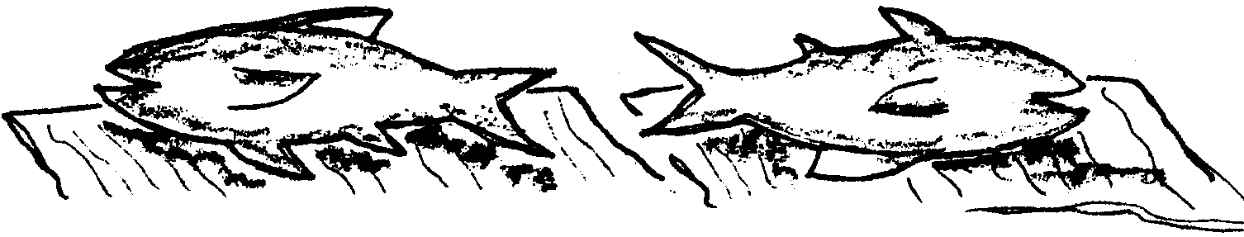
8. After all the papier-mâché layers have been added, allow the fish to dry completely. This can take several days. Turn the fish so that all parts receive air to dry.

Painting

1. Once the fish is completely dry, lightly sand any rough spots.

2. Mix the paints to get the right colors for your fish. Make sure you mix enough for all the areas needing that color.

3. Paint the fish. Allow drying time between the application of different colors.

4. When the fish is painted, add details. Use a pencil to sketch the details, then use a felt pen or oil pastels.

5. Shellac the fish and then sprinkle glitter on for scales. Do only one side of the fish at a time.

