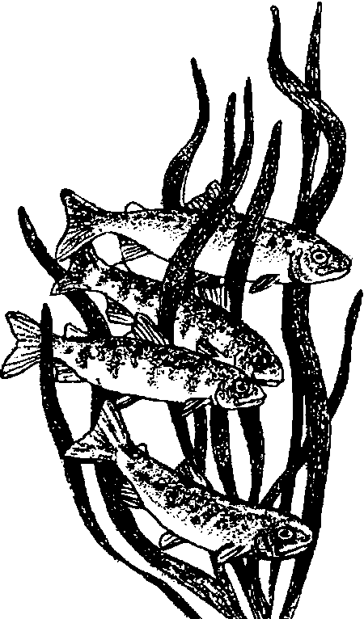
Camouflaging Fish Cookies

Key Concepts
1. Fish have body parts that serve specific functions.
2. Fish have body parts and behaviors that help them survive in their habitat.
3. The body parts and behaviors of a fish provide clues to the habitat of the fish.

Background

In fish, as well as in all animals, form follows function. As a result, a great deal can be learned about how a fish functions by looking at its form: the shape and number of fins, body shape, coloration, etc. This topic is more fully explored in the background for the preceding activity, “Fish Forms”.

Materials

For the class:

• pictures of camouflaged fish in a variety of habitats

• brightly colored wrapping paper or cloth to represent the sea floor

• frosting to “camouflage” the cookies (NOTE: Frosting colors must match the cloth or wrapping paper. Don’t forget you can use white frosting and food coloring to mix the colors you need.)

• stir sticks or other frosting spreaders

• assorted colored sugars or other cookie sprinkles

For each student:

• one fish cookie (sugar cookies work well)

Teaching Hints

In "Camouflaging Fish Cookies", students continue to study form and function in fish as they use frosting and other edible decorations to "camouflage" fish-shaped cookies on a sea floor of brightly colored wrapping paper or cloth.
Preparation

l. Make or buy unfrosted cookies. In case you don't have a favorite one of your own, here's a spicy sugar cookie recipe that is easy enough for even young bakers to manage.

Spicy Sugar Cookies

makes about 2 dozen, 2" cookies

Ingredients:
1 1/2 cups flour
1 teaspoon baking powder
1 tablespoon cinnamon (or cloves, nutmeg, or allspice - alone or in combination)
1/2 cup sugar
6 tablespoons butter
1 small egg
1/4 cup corn syrup

1. Preheat oven to 325 °F.

2. Sift the flour, baking powder, and cinnamon into a mixing bowl.

3. Add the sugar and stir mixture together.

4. Add butter and cut it up, blending everything together until the mixture looks like bread crumbs.

5. Break the egg into a cup and beat it with a fork. Add the corn syrup and mix until smooth.

6. Make a hollow in the flour and pour in the egg mixture. Mix together well to make a ball of dough.

7. Put the dough into a plastic bag and place in the refrigerator for 30 minutes.

8. Roll out the dough on flat surface, sprinkled with flour, until the dough is about 1/4 inch thick.

9. Use cookie cutters or a knife to cut the dough into fish shapes.

10. Place the cookies on a baking pan and bake on a high rack in the oven for 15 to 20 minutes, or until golden brown.

11. Remove from the oven and use a spatula to place them on a wire rack to cool. The cookies will harden as they cool.

2. Decorate a few to show the students examples of camouflaging.

Procedure

1. Use pictures or photographs of fish camouflaged in the kelp forest (or a different habitat). Focus the discussion on observations of body characteristics that help camouflage the fish.

2. Explain to the students that the wrapping paper or cloth will represent different (and imaginary) habitats in the sea. Challenge students to decorate their fish cookie so it is camouflaged.

3. When students have completed their camouflaging, have them put their fish on the wrapping paper or cloth habitats. Ask questions like:
Which fish are most difficult to see? Why?
Which fish would be easier prey than others? Why?

You may wish to play the predator and eat the cookie fish that’s easiest to see; but, if you do, be sure to have extra cookies on hand for the prey student!

4. Students will no doubt enjoy consuming their fish.

Key Word

camouflage - body coloration or parts that allow an animal to conceal itself in its habitat

Extensions

1. Have students do “A Black and White Camouflage Activity” (original idea from Sandy Stewart). Here's how. Spread out the classified section of a newspaper to make a large “pond.” Tape it to the floor. Have each student draw and cut out 5-10 fish from other newspaper (any section). Instruct students to use a black crayon to:

• color in the eye on one of their fish,
• outline the edge of another fish, and
• draw stripes on a third fish.

Gather the students around the “pond” to scatter their fish. Then have them take five steps to the right and close their eyes. Give a signal for them to open their eyes and have them pick up the first fish they see. Repeat 4 or 5 times. Discuss the results.
Which fish were caught and which were not?
Which fish were best camouflaged? Why?

2. Play “The Thicket Game” from Elementary Project Wild.

