Gyotaku - Japanese Fish Printing

Key Concepts
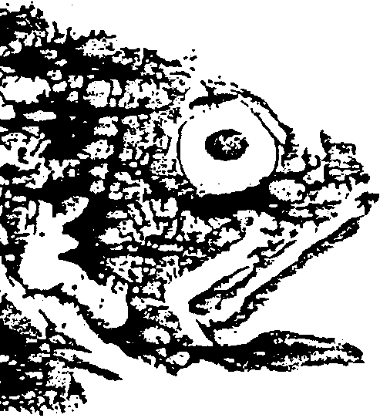
1. Fish have physical features that indicate how they have adapted to their environment.
2. The function of a fish’s body part is related to its form or shape.
3. Much can be learned about the life history of an animal by observing its physical features.
4. Gyotaku is the Japanese art of fish printing used by ichthyologists to study fish.

Background

Fish printing provides a hands-on opportunity to learn about fish anatomy through a tactile, creative experience. To help guarantee good printing results, a basic understanding of fish anatomy is useful. Conversely, fish printing provides an excellent opportunity to share information with your students about form and function in fish. A short lesson on fish anatomy follows:

Fish Anatomy

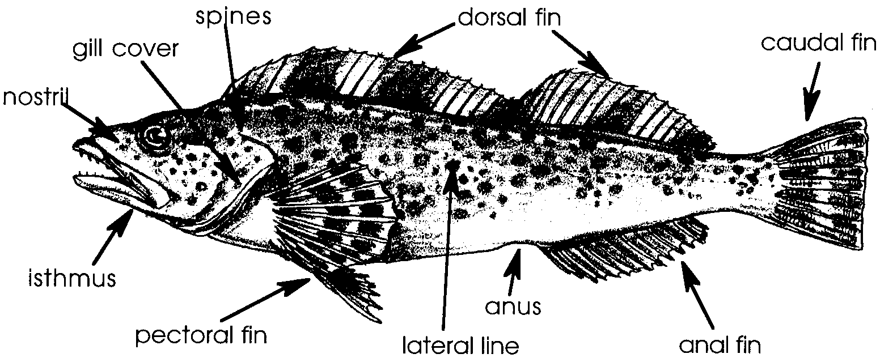

1. Fins: Most fish have at least one dorsal fin, a caudal fin, an anal fin, a pair of pelvic fins, and a pair of pectoral fins. Often the first dorsal fin will have hard, sharp spines, while the other fins will have soft, flexible fin rays. The fin spines and rays are connected by a thin, fleshy material that readily collects excess mucus (and ink, during fish printing). For clear fish prints, the fleshy material should be carefully wiped off before and between prints. Some fish (trout and salmon) have a small fleshy adipose fin located between the dorsal and caudal fins.
2. Scales: Fish scales vary in structure. Some kinds of scales make clearer prints than others. Fish such as perch and rock fish have hard, rough scales which turn out well in prints; these fish are easiest to work with. Sharks have sandpaper-like scales that are really modified teeth; they are difficult to print and require an extra thick coating of ink. Trout, salmon, and smelt have delicate “deciduous” scales that are difficult to print. Sometimes removing all scales and printing the “scale pocket”, the depression in which the scale lies, is best for these species.

3. Lateral line: Most fish have at least one lateral line. The lateral line is a series of small, pit-like organs used by the fish to sense turbulence and pressure changes. If printed carefully, the lateral line will be very striking in the prints.

4. Spines: Many fish have spines around the head. Care is required to avoid being injured by the spines, as they can easily poke through the paper. If properly printed, most of the fish’s spines will reproduce beautifully.

5. Mucus: Fish secrete mucus from their bodies to protect themselves from parasites and disease and to help them “slip” through the water easily. The mucus tends to make a fish print dark in color and less clear. For this reason, it is important to remove as much mucus as possible by washing the fish thoroughly. Mucus tends to collect on the fins, near the anus, gill cover, isthmus, and nostrils, and under the pectoral fins.

6. Body form: Fish bodies vary greatly in shape. Body shape reveals clues to a fish’s lifestyle. For example, a flat flounder lies on the ocean bottom, waiting for its prey; while a round, bullet-shaped tuna swims efficiently to capture its prey. Usually, the flatter the fish, the easier it is to print.

Additional background information may be found in the preceding, complementary, activity, “Fish Forms”.

Materials

For each group of 4-6 students:

• a very fresh fish

• newspaper to cover work surfaces

• waxed paper

• 3 or 4 ounces of plastic modeling clay

• approximately 10 straight pins

• water-base ink or paint (about 1 ounce per color)

• jars or containers for mixing ink and paints

• tap water for mixing ink and paints

• stiff 1/2" brush, ink brayer, or small (1"x1") square of sponge

• small artist’s brush (optional for eyes, signatures)

• paper towels, sponges or rags for cleaning

• soap and water

• field guides or keys for identification

For each student:

• 3 sheets of rice paper, newsprint, or other moisture tolerant paper

• T-shirt or cotton cloth if you use fabric paint

Teaching Hints

In “Gyotaku - Japanese Fish Printing”, students expand their knowledge of fish anatomy as they use a traditional technique for recording information about fish. This activity can be done in small groups with each group having a fish to identify, study, and print. Alternatively, it can also be completed as a station or center activity in which one adult monitors a small group at the printing station while other students work on more self-directed activities from this unit.

In selecting fish to print, choose whole fresh fish with the head left on. Supermarkets are a good source for whole fish. Select fish that have bright red gills, clear eyes, and a fresh smell. Fish which have been cut up the middle and have had the organs removed work fine, but make sure that such fish have not been cut anywhere else on the body. Fish with rough scales, spiny rays, and a pronounced lateral line make the best and most dramatic prints. Rock fish and bottom fish are good ones to use. Smooth skinned fish like salmon and true cod do not print as well. Flounders print well, but they are more delicate and do not hold up to excessive handling. Try to find fish that represent different habitats and adaptations. Specialty seafood markets often offer exotic sea life. You may also wish to try making prints from squid, herring, and shrimp; an octopus arm is exciting to print.

One fresh, firm rock fish can be used to make 15 to 20 prints or more. Two of these fish would suffice for this activity but students benefit from having several fish of different varieties, one for each small group. Fish can be frozen before printing and refrozen afterwards for use again.

Although Gyotaku prints are traditionally made on rice paper or silk, good prints may be made on newsprint, tissue paper, cloth or any absorbent surface. Paper with some degree of flexibility works best since it fits the contours of the fish. You may prefer to start with inexpensive newsprint. Experiment with different papers and applications to achieve different effects.

Traditionally, fish printing is done with Sumi ink which consists of ground carbon particles in a base similar to that of library paste. The advantage of using Sumi ink is that the ink is non-toxic and, hence, you can eat the fish after printing without concern. Sumi ink is available at most art stores. For beginning fish printers, thick water-based inks are easiest to use. Water-based linoleum block printing ink is an excellent ink. Tempera paints work well and are readily available. Black is the traditional color for fish printing. While it is a good color to work with, young people also enjoy using a variety of bright colors. If you buy primary colors you or your students can mix colors and shades, adding a valuable experience to the activity. Dilute the paint with water so that it brushes onto the fish easily.

Non-toxic fabric paints, such as Artex acrylics, can be used to make lasting prints on T-shirts and other cotton materials. For permanence, the paint needs to penetrate the fabric, but if too much is used it will “bleed” and the print will not be crisp. Choose acrylic fabric paints that are permanent after a 48-hour drying period and do not need to be heat-set.

Ink may be applied with a brayer, roller, brush or sponge. Ink brayers, or rollers, leave no trace of brush strokes. Paint brushes also work well, and small pieces of sponge allow one to dab the paint on in a speckled, naturalistic manner. Spread the ink or paint onto the fish from the head toward the tail. This helps keep the scales lined up and together. It also prevents paint from getting under the scales. For crisper outlines, clay may be used to hold fins away from the body or table surface and straight pins may be used to spread the fins. Be careful to position clay and pins so that they do not receive ink during application, otherwise they will show in the final print. The eye is usually left unpainted during printing so that it will stand out by contrast when printed. Later, a small brush can be used to fill it in or dot it, if students wish. Encourage students to think of themselves as artists and to sign their fish print art.

Since this can be a somewhat messy activity, be sure to cover desk tops with newspaper and provide paper towels for hands. After painting the fish, a piece of waxed paper slipped under the tail is helpful in preventing the paint from getting onto the tabletop. Small pieces of waxed paper are also handy for covering paint smears on the table that might otherwise print with the fish.

A good source of further information on Japanese fish printing is Leaflet 2548 “Gyotaku - Japanese Fish Printing” from California Sea Grant. The publication is available free of charge from: Extension Marine Resources Specialist, University of California, Davis, California. Art stores are another source of flyers about Gyotaku print making.

Key Words

biologists - scientists who study living things

characteristics - distinguishing features or attributes

form - shape

gills - the breathing organs of many aquatic animals

gyotaku - (g-yo-tah-koo) Japanese fish printing

ichthyologist - a scientist who studies fish

life history - the changes in an organism from birth to death

observation - the act of noting a phenomenon, often with instruments, and recording it for scientific or other purposes

physical features - observable characteristics

prints - lines left by pressing an object onto paper

water-base ink - ink that can be mixed with water

Extensions

1. Have the groups measure the length of the fish they printed. Ask them to predict the average length of the fish print-images made from their fish. Have them check their predictions by measuring and determining the average length of the prints. Discuss results and the uses of averaging. Ask students why the results may have differed from their predictions. Use the data to discuss why fish prints are not always an accurate re-creation of the actual specimen. Have them list some of the precautions scientists must take when they use fish prints to study fish.

Answer Key

Answers will vary depending upon the fish species used. This exercise is included to increase students’ observation and inference skills.

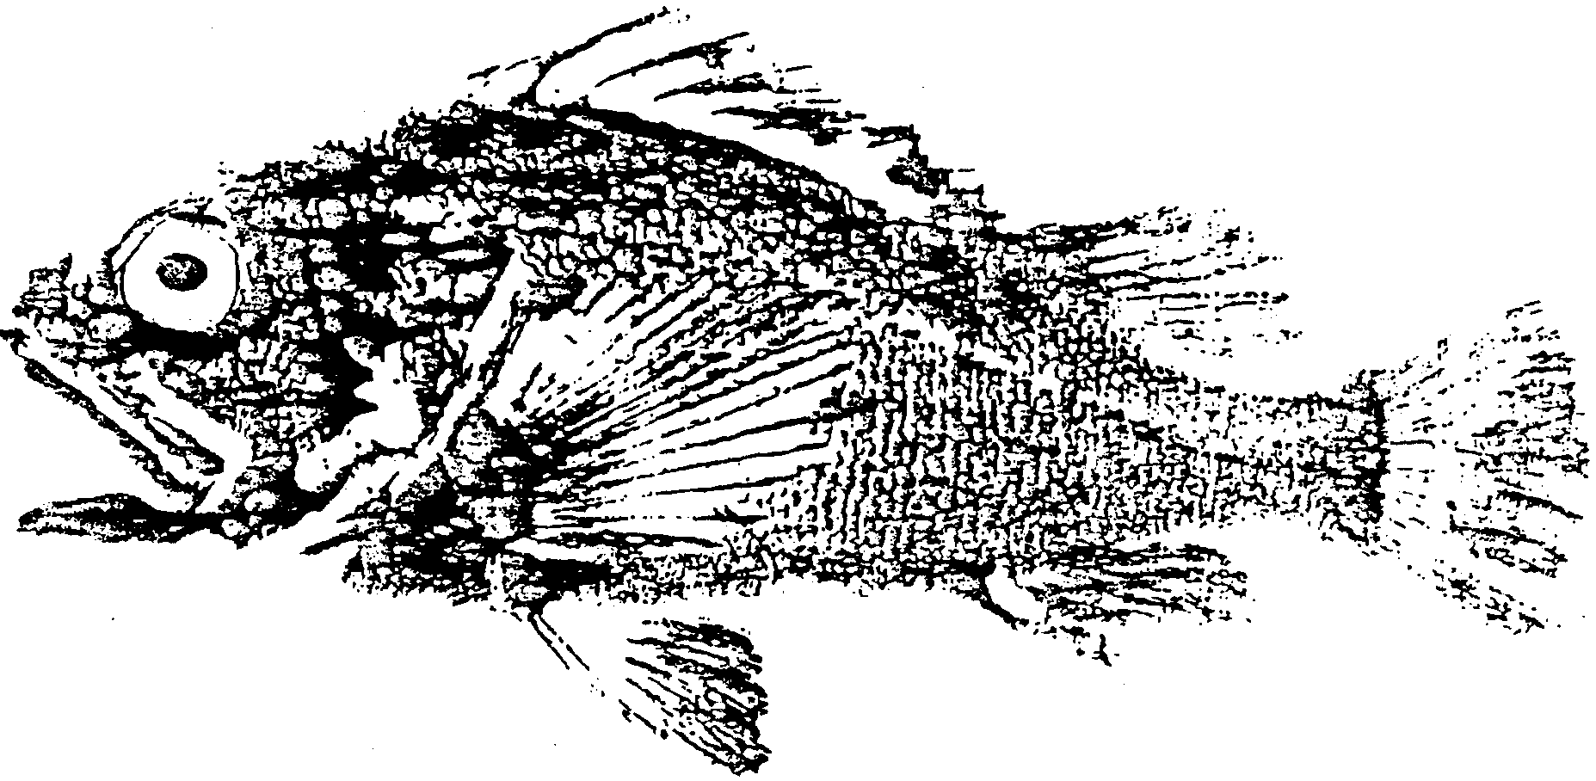
Gyotaku - Japanese Fish Printing

For over a 100 years, Japanese have made prints from fish. The prints look exactly like the fish. They are works of art. The prints are used to record a sports fisher’s catch.

The fish prints also help scientists get information about the fish. The study of life is called biology. The study of fish biology is called ichthyology. Ichthyologists are scientists who study fish. Ichthyologists at the University of Washington have used fish prints to identify and to study different kinds (species) of fish.

The art of Gyotaku (pronounced, g-yo-tah-koo) is a good way to gain an understanding of the beauty of marine animals. You can also use this technique for making prints of shells, rocks, flowers and other items.

Studying Your Fish

Before you make your print, learn about your fish by observing and studying it. Look it over and gently examine it. Use a book about fish to find out more. The following questions will help you learn about your fish.

Physical Features of the Fish

You may write or make a drawing to answer the questions below.

1. What is the shape of your fish’s body?

2. How do you think this body shape could help your fish to move and to protect itself?

3. Are there any spines on your fish? If so, describe them.

4. Are the scales rough or smooth? What shape are they?

5. How many fins are there and where are they located?

6. What is the shape of its mouth?

7. How do you think this shape helps the fish catch and eat its food?

8. Where are the eyes located? Are they on the top, same or opposite sides of the head, or low on the head?

9. What color is your fish?

10. How do you think the color could help your fish?

11. What do you think your fish eats and why do you think this?

12. What do you think eats your fish and why do you think this?

Identification

Use field guides or keys to identify your fish.

13. What kind of fish is your fish? Can you name it?

Habitat

14. Where do you think your fish lives? (Please circle your answer.)
bottom of the sea
mid water
surface
sand
rocky place
in algae beds (kelp, eelgrass, or other)

15. What clues about your fish causes you choose this habitat?

16. Draw a picture of your fish’s habitat.

CHALLENGE: Think about what you have found out about this fish. Use what you know to write or draw the life history of this fish. A life history tells a lot about a fish. It tells where the eggs are laid and how they develop. It tells where the young fish spend their time and where the adult fish spend their time. It also tells when the fish spawn (reproduce) and how long it usually lives. Include the life history in your Pagoo Field Guide. (What? You don't know everything? Then, use books and magazines to help.)

Making a Gyotaku Fish Print

Now that you know something about your fish, here’s how to make a Gyotaku print.
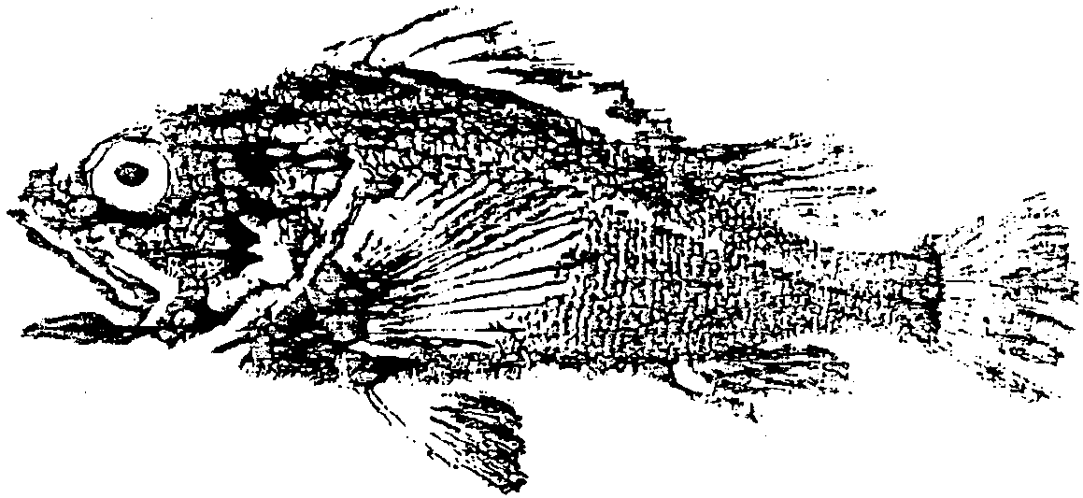
Here’s what you’ll need to make your own fish prints:
• a very fresh fish
• newspaper
• plastic modeling clay
• straight pins
• water-base ink or paint
• a stiff 1/2" brush or ink roller
• rice paper, newsprint, or other paper, or cloth
• soap and water
• paper towels, sponges or rags for cleaning

1. Use soap and water to clean the outside of the fish as completely as possible. The cleaner the fish, the better the print. Be very gentle so you don’t break spines or loosen scales. Rinse and dry the fish well. Gently pat it with a paper towel. Avoid rubbing it.

2. Place the fish on a table covered with newspapers. Spread the fins out over some clay. Use pins to hold the fins in this position. Continue to dry the fish.

3. Brush on a thin, even coat of ink. Important: Brush in one direction from head to tail. Leave the eye unpainted for now. Later, you can paint it in on the paper if you like. Carefully blot up any excess ink that forms “pools” on the fish. Wipe up any ink that smears on the table. You can cover big smears with pieces of waxed paper so they won’t print onto your paper. Reuse the waxed paper when making other prints.
4. Carefully lay a piece of newsprint or rice paper over the top of the entire fish.

5. Use your fingers to gently press the paper over the surface of the fish. Be careful not to move the paper. Moving paper results in double prints.

6. Carefully remove the paper. Start at the head and peel it backwards towards the tail. Soon you will see your fish print on the paper!

7. Use a small brush to sign your print. Paint the eye if you like. Hang up the print to dry.

8. Wash off the fish. If you are using non-toxic ink, prepare your fish for dinner!

