Fish Forms
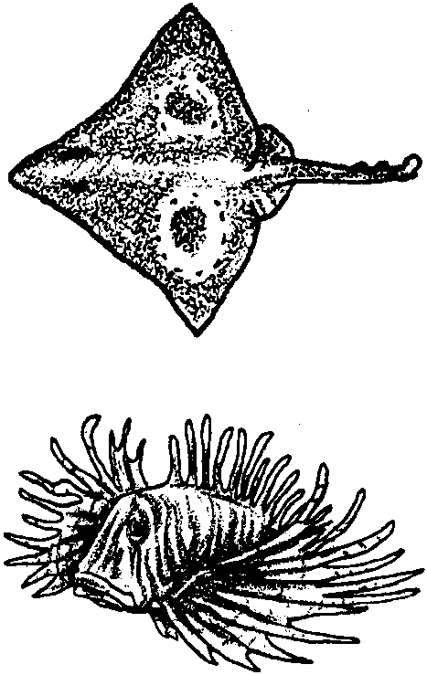

Key Concepts
1. Fish have body parts that serve specific functions.
2. Fish have behaviors or adaptations that help them survive in their habitat.
3. By examining the body parts and behaviors of a fish, one can obtain clues regarding its habitat.

Background

Great diversity is represented in the approximately 20,000 different kinds of fish observed by scientists. From the 50-foot long, ocean-dwelling whale shark to the tiny freshwater gobies that are approximately 1/2 inches long as adults, fish show an amazing variety of adaptations for enduring the many challenges of the water world.

An adaptation is an alteration or adjustment, often hereditary, by which a species or individual improves its condition in relationship to its environment. In other words, adaptations are those structures or behaviors which help plants or animals survive to reproduce. Behavioral adaptations are those specific behaviors that organisms carry out that help them survive; birds building nests, wolves marking their territory are examples of behavioral adaptations. Physical adaptations are body structures or parts that help an organism survive; large eyes, protective coloration, sharp claws are examples of physical adaptations. Fish show an abundance of behavioral and physical adaptations. In the oceans, these adaptations let fish live successfully in a wide variety of habitats from the surface to depths of over six miles!

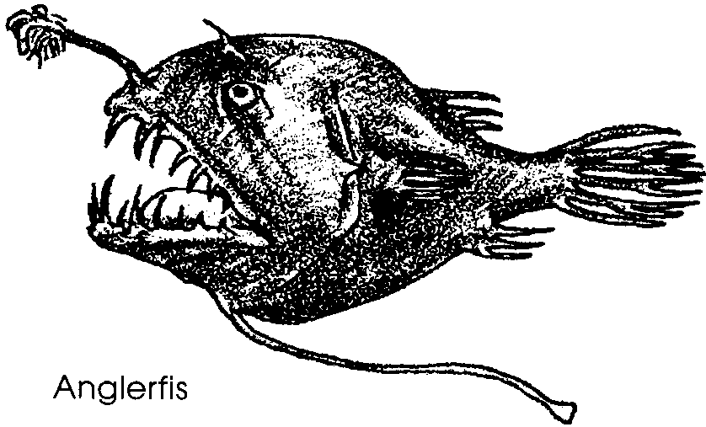
Anglerfish, dwellers of the darkest depths of the ocean, show many examples of behavioral and physical adaptations. On the head of the deep-sea anglerfish is a long, flexible rod with a glowing tip. The anglerfish dangles this glowing lure in front of its mouth. The lure attracts small fish. As they approach the lure, the anglerfish opens its wide mouth. A curious small fish swims closer and closer following the glowing “bait” until the fish disappears into the anglerfish’s toothy mouth. Consider this scene from the standpoint of adaptation. The long, flexible rod, the glowing tip, the wide mouth, and the many teeth are physical adaptations. Dangling the lure, opening the mouth in wait, and snapping the mouth shut on the curious fish are behavioral adaptations. Both types of adaptations are important in assuring the survival of the anglerfish.
Be aware, that the distinctions between behavioral adaptations and physical adaptations are somewhat arbitrary and that these categories and distinctions are made for our convenience - what we call them doesn’t make a bit of difference to the anglerfish! In fact, even though the deep-sea anglerfish depends on the lighted, physical lure to attract its prey, the anglerfish does not make the light itself. The lure is home to a colony of light producing bacteria which find protection and shelter in trade for their light. Is the glowing tip, then, a behavioral adaptation rather than a physical adaptation? Or is it some of each? The point here is that while it is helpful to our understanding to think about adaptations as physical and behavioral, sometimes the distinctions between the two types blur.

Materials

For each student or pair of students:

• “Fish Forms” student reading

• fish pictures (from magazines, etc.)

Teaching Hints

In “Fish Forms”, students identify fish adaptations as body structures and behaviors that help a fish survive in its habitat. By observing a fish’s body shape and structures, they then infer where the fish lives, as well as how the fish eats and how it behaves.

Preparation

1. Locate large, detailed pictures of fish (magazines such as National Geographic or Natural History are a good source). Cut out the pictures and, if possible, laminate them for ease of use. For the entire class to work on this activity simultaneously, you will need at least one picture per student.

Procedure

1. Explain to students that they will be learning how to “read a fish”. Ask students to give you names of different marine fish with which they are familiar. Write the names on the board. From the list choose two distinctive fish and,

Ask: “How do these fish differ from each other?” (If necessary, ask leading questions about body shape, mouth shape and location, and fin numbers and shapes.)

Say, “The differences you have just pointed out can tell us something about where each of these fish live and how each makes its living in the sea. Here is an activity that will help you learn how to “read a fish” to answer these and other questions.”

2. Distribute the “Fish Forms” student reading and have students work individually or in pairs on steps 1 to 3. After you distribute the reading,

Say: “When you get to step 4, please come to me for a picture of a mystery fish.”

3. As necessary, distribute the fish pictures to individuals or pairs of students. Rotate the pictures so that each student or pair has the chance to “read” five different fish.

4. When all have finished step 4, have each student or pair hold up the last fish picture sleuthed and outline the clues and the conclusion drawn regarding where the fish lives.

5. Have students complete steps 5 and 6. Plan to display their creative fish names, poems and pictures. If some students choose to create a song or rap, give them the opportunity to share their creation with the class.

Key Words

adaptation - an alteration or adjustment (body part, behavior, etc.), often hereditary, by which a species or individual improves its condition in relationship to its environment thereby improving its chances for survival

camouflage - body coloration or parts that allow an animal to conceal itself in its habitat

fins - parts of a fish that help it move forward or change direction

gills - the breathing organs of many water animals

lateral line - a line of pits on the side of a fish that allow it to sense water movement

predator - an animal that hunts and eats other animals

scales - small plates that cover a fish’s body

schooling - swimming or feeding in a large group

Answer Key

1. Answers will vary but will likely be similar to the following:
herring - fast moving (torpedo shaped)
skate - bottom feeder (horizontal disk)
sturgeon poacher - bottom dwelling (flat-bellied)

2. Answers will vary but will likely be similar to the following:
sturgeon poacher - feeds on bottom (sucker)
gulper - surrounds prey

tuna - feeds on prey above and below it (jaws are about same size; this question requires students to put together information from “long upper jaw” and “long lower jaw”)

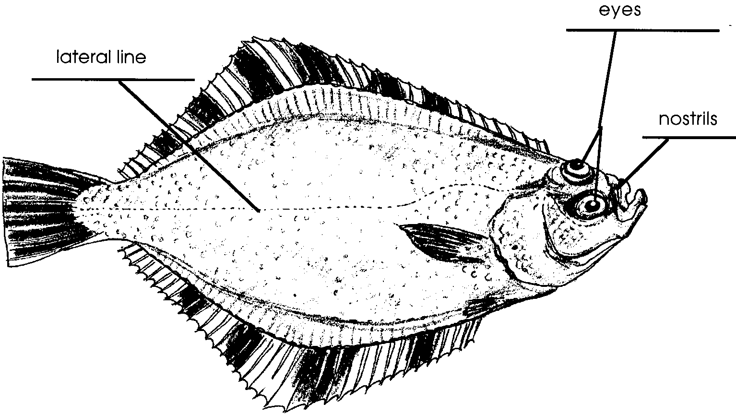
3. a. A correctly labeled flounder follows:

b. The eyes face upward.

c. Answers will vary. Most students will think that the flounder is a bottom dweller because of its shape and the location of its mouth. Since the question calls for an opinion, accept any well-thought out response.

4. Answers will vary depending upon the fish selected.

5. Answers will vary. The preceding lesson, “Creating Picture Words and Poems”, provides additional examples.

6. Poems, drawings, pictures, raps, etc. will vary depending upon ability, experience and resources available.
Extensions

1. As a class, read Fishes by Brian Wildsmith. Aesthetically very pleasing, this book provides students with a chance to apply what they have learned about reading a fish to the several different kinds of fish pictured.

Fish Forms
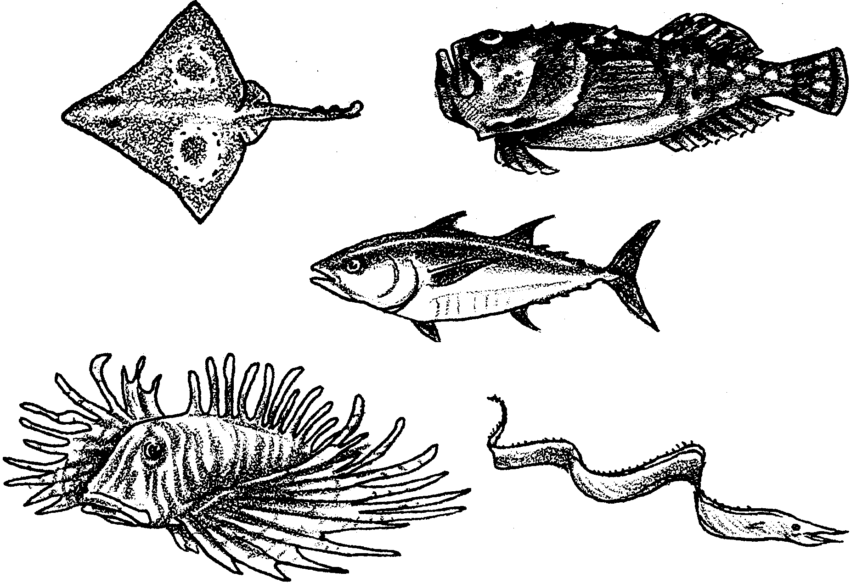
You may not be able to judge a book by its cover. But you can “read” something about a fish. How? Begin by looking at its body shape and behaviors.

Think about sardines.

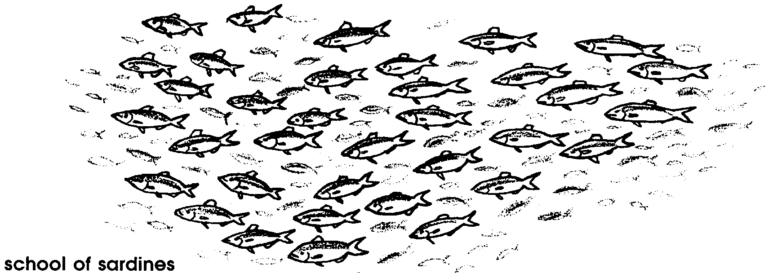
Schools of sardines are sleek, streamlined swimmers. They appear as silvery flashes in the midwater habitat. Forked tails give them speed and power. Their evenly placed fins keep them stable and help them move. They are constantly on the move, feeding on plankton.

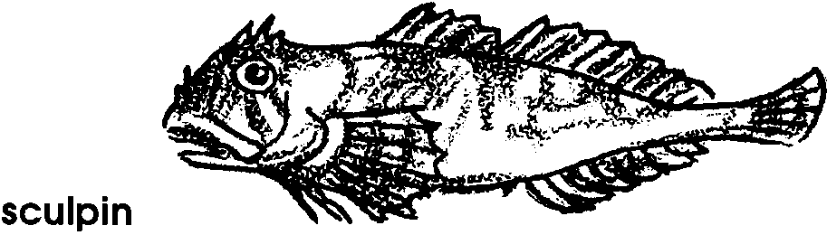
Think about lie-in-wait predators, like the sculpins.

Sculpins “read” differently than sardines. Their body colors and patterns match their rocky hiding places. Sculpins often wait motionless on the bottom. From there, they launch surprise attacks on crabs and fishes. Their large mouths that open upwards help them to snap up their food.

What should we look for when we “read” a fish?

Body Shape

A fish’s body shape provides clues about its habits and habitat.

Shape Habit/Habitat Example
torpedo fast moving sardine
flat-bellied bottom feeder catfish
vertical disk maneuvers in tight places bluegill
horizontal disk bottom dweller flounder
hump-backed stable in fast moving water salmon

1. Try “reading” these fish:

SHAPE WHAT IT SAYS ABOUT THE FISH
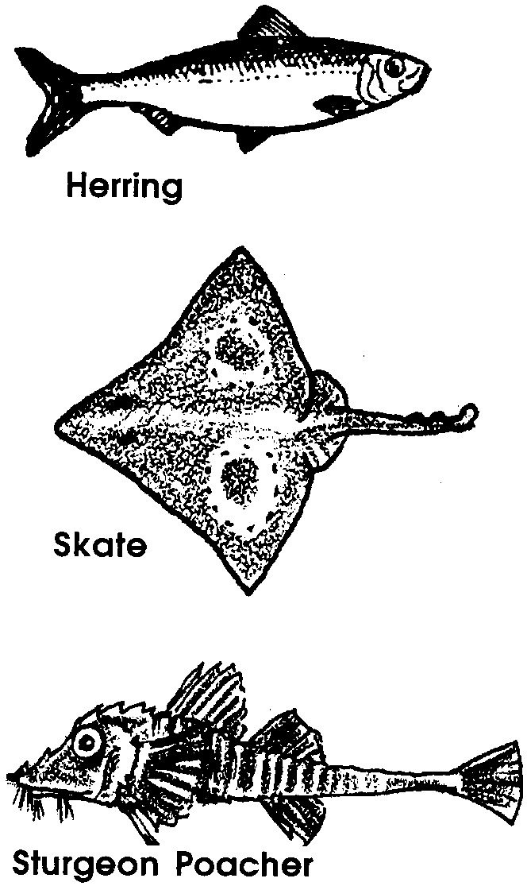

Fins

Fins help a fish to move and steer. Muscles move the fins up and down or back and forth. Most fish have the following types of fins:
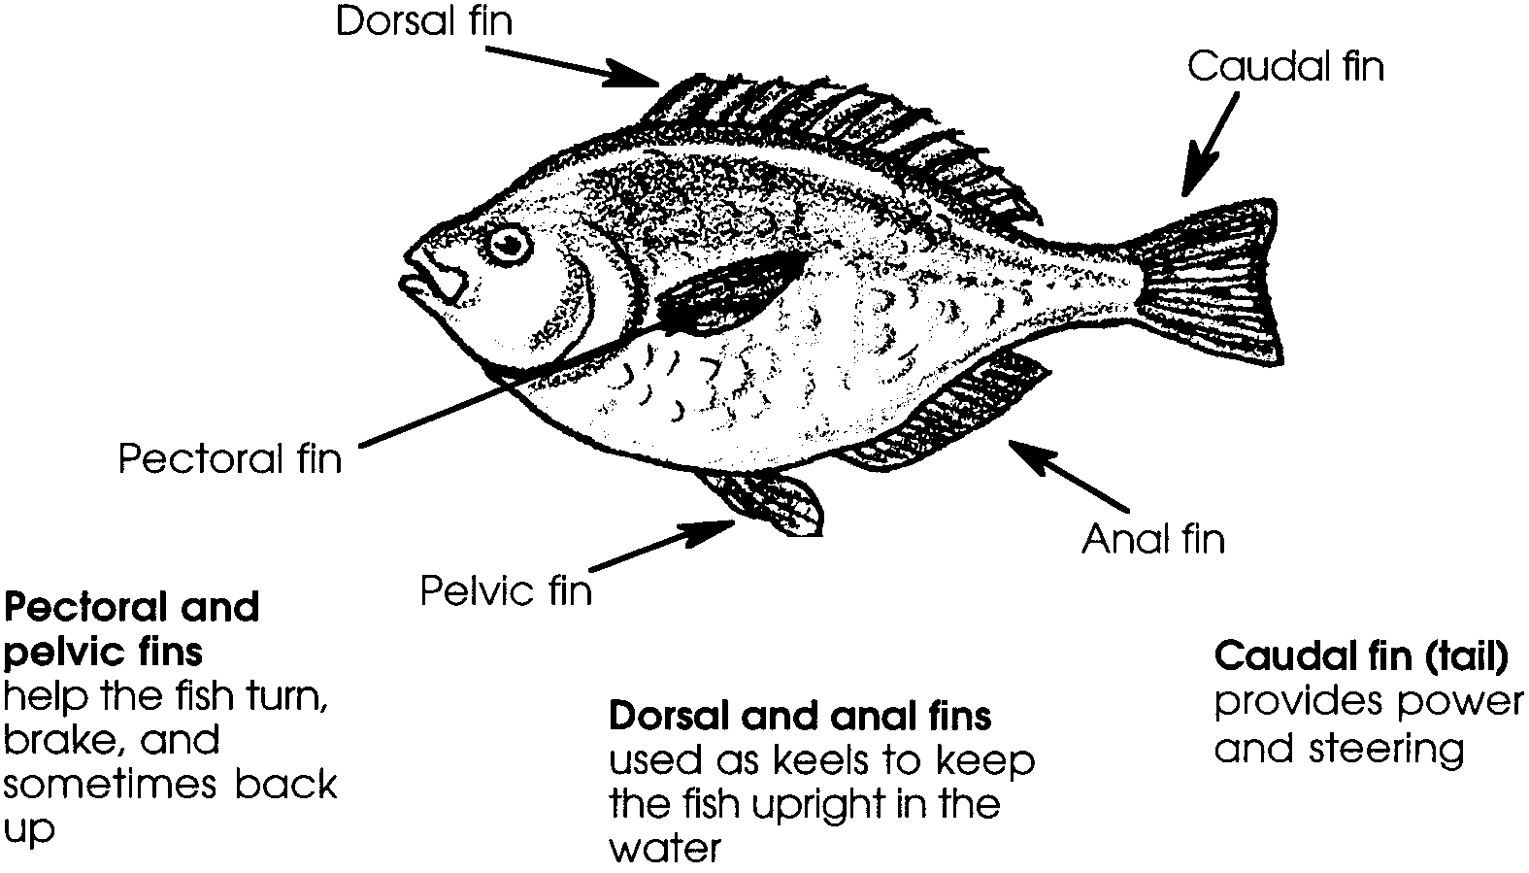
Not all fish have the same number of each kind of fin. For instance, a fish might have one, two, or no dorsal fins. The shape and size of the fins can tell us about how the fish moves.

Gills and gill flaps

Fish use gills to take oxygen from the water. Gill flaps or covers protect the delicate gills.

Mouth

The shape of a fish’s mouth provides clues as to what it eats. Sometimes it can also tell us how it eats.

mouth type feeding method
sucker feeds on very small plants & animals
long upper jaw feeds on prey below it
long lower jaw feeds on prey above it
duckbill jaws grasps prey
extremely large jaws surrounds prey

Some fish have sharp teeth. These help the fish to catch and hold their prey. Others have brush-like teeth. These are useful to scrap algae off rocks. Still others lack teeth completely. These fish swallow their food whole.

2. Try your skills at “reading” these fish mouths:

MOUTH WHAT IT SAYS ABOUT HOW THE FISH EATS

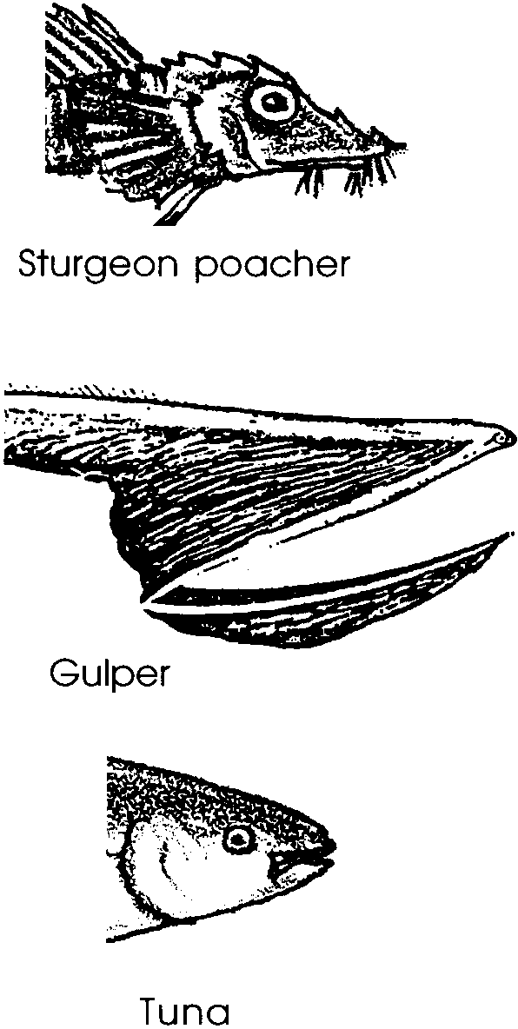

Scales

Many fish have scales. The scales are made from fingernail-like material. They protect fish skin from cuts and disease. Some scales are very small. Others are large and plate-like.
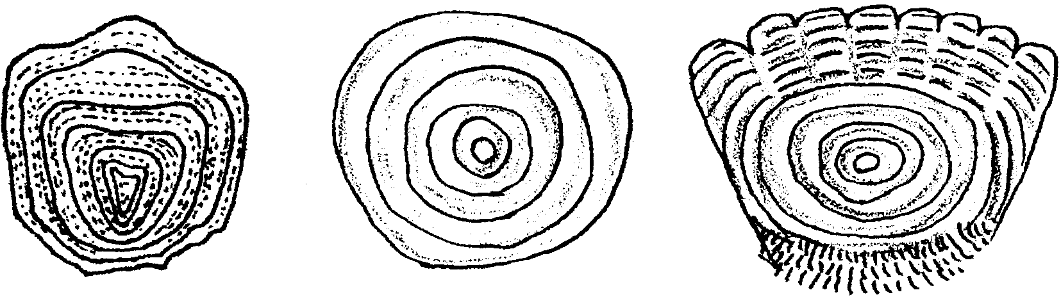
Sensory organs

How do fish see, smell, and hear? Fish eyes vary greatly in size and color. Cat sharks live in the deep sea. Their large eyes face upward to catch the faint light from the surface. Some cave fish lack eyes altogether. Fish have nostrils used to smell chemicals in the water. They do not have external ears. Below their skin, however, they have ear bones. These small bones pick up sounds.
Fish also have a lateral line. This is a line of small pits in the skin on the side of the fish’s body. These pits sense the movement of the water. They tell the fish whether there are other fish near it.

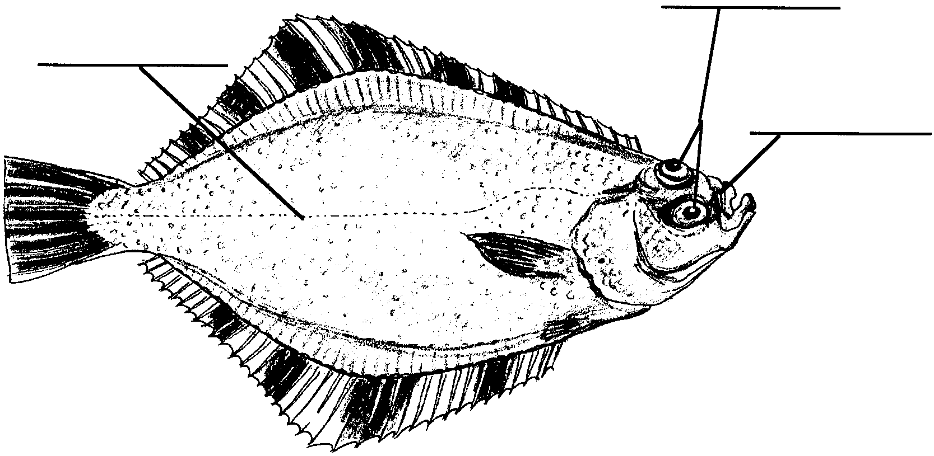

3. Look at the picture of the flounder.

a. Label the eyes, nostrils, and lateral line.

b. Which way do the eyes face?

c. Where do you think this fish lives? Why do you think so?

Protection

How do fish protect themselves from predators? Some fish do things. What kind of behaviors protect fish? Swimming together, called schooling, seems to help. Perhaps, the predator thinks the school is a larger fish. Or maybe it is harder for a predator to catch one fish out of a group. Other fish have things which protect them. Some fish are the same color as the place they live. This is called camouflage. A camouflaged fish may be almost invisible to predators. Other fish have spines or poison for protection.

Challenges

Now you know a little bit about “reading” fish.

4. Select at least five different fish. Make a list of the names. Look at each fish. List “clues” you can see about how the fish lives. Then, write down your best guess of where the fish lives.

Name Clues This fish lives . . .

a.

b.

c.

d.

e.

5. Choose one of the fish you selected in step 4. Write its name in a way that gives clues about how the fish lives or looks. Here's an example:
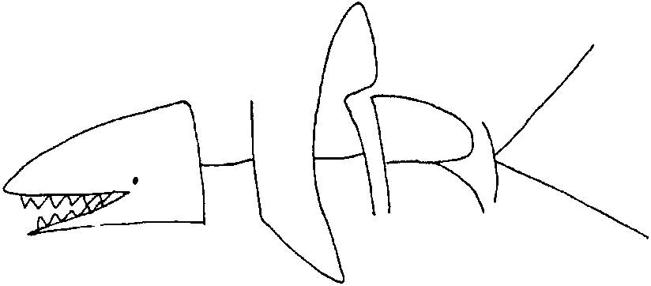

6. Write a poem, draw a picture, or create a rap. Show what you have learned about the basic body parts of a fish. Be sure to include how the parts relate to what they do.

