In, Out, Up With Traveling Towers*

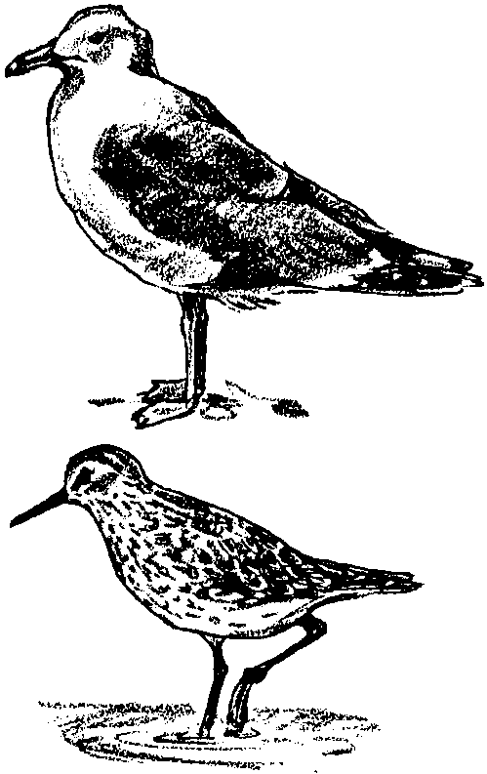

Key Concepts
1. Shorebirds such as curlews, sandpipers, and gulls often feed on hermit crabs and other sea creatures as they search for food at low tide.
2. Gulls can eat clams by grabbing them with their beak and dropping them on a hard surface so they break open, providing a tasty

Teaching Hints

Read chapter 9 of Pagoo with students. Add information and drawings of sea birds to the Pagoo Field Guides.

Chapter Summary

Pagoo and friends are swallowed by a Big Head Sculpin, a predator in the tide pool. The sculpin is not feeling well and heaves out Traveling Towers. Pagoo learns a valuable lesson . . . Beware of such creatures! Low tide strands Pagoo on shore with curlews, sandpipers, and gulls that are raiding the beach for edible tidbits. A gull grabs Pagoo and friends and flies away.

Key Words

curlew - a migratory shorebird distinguished by long legs and a long slender down-curved bill

gull - any of numerous long-winged, web-footed aquatic birds

sandpiper - any of numerous small shorebirds distinguished from the related plovers chiefly by the longer and soft-tipped bill

sculpin - any member of a numerous family of spiny, large-headed, broad-mouthed, usually scaleless, fishes

