Snail Tracker*

Lesson adapted by Sue Brimhall, Seattle, WA

Key Concepts
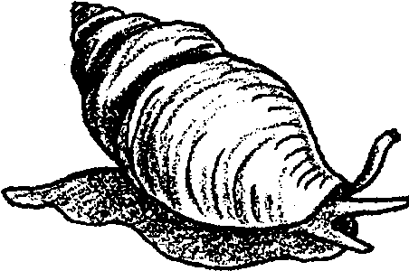
1. Snails have unique structural and behavioral adaptations which help them survive in their habitat.
2. Observations and experimentation lead to hypotheses about snail behavior.

Background

Scientists who describe and classify organisms place snails in a group they call “class Gastropoda”. They place all kinds of snails including abalone, moon snails, periwinkles, whelks, cowries, and turban snails in the group. These scientists, called taxonomists, place a lot of other animals in the group as well, including mussels, clams, oysters, nautilus, and the shell-less nudibranchs, squid, and octopus. All of these animals have some things in common. Each has eyes and feelers on a distinct head, and a muscular “foot” on the under surface of its body which it uses to glide about. Most also have a spiral or cone-shaped shell.

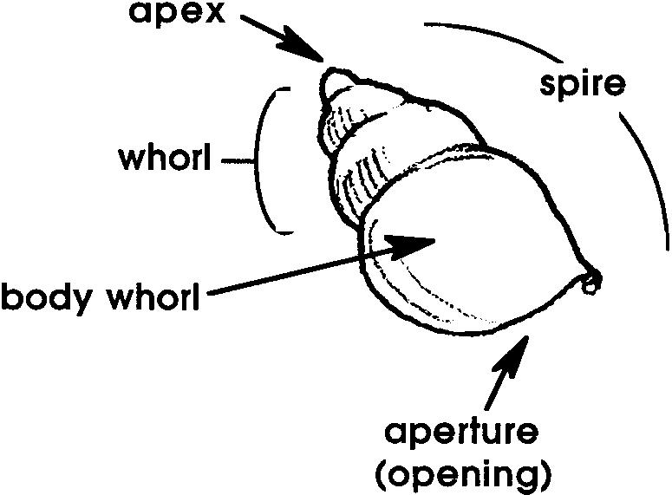
Most snail shells are built in a series of spirals with the apex (highest point) being the beginning of the shell. Each consecutive layer is laid down in whorls. All the whorls together make up the spire with the last whorl being the largest, called the body whorl. The aperture is the opening of the shell where the body is housed.

Snail bodies consist of a muscular foot with which the animal transports itself by creeping along the rocky or sandy ocean bottom. Most snails have an operculum, or “trapdoor”, which is carried by their broad foot and is used to shut the snail snugly inside the shell. Most snails also have two tentacles used as sense organs. Their eyes are light-sensitive and can detect movement. Near the tentacles and the eyes is a siphon used for bringing water into the gills so the snail can extract the oxygen molecules.

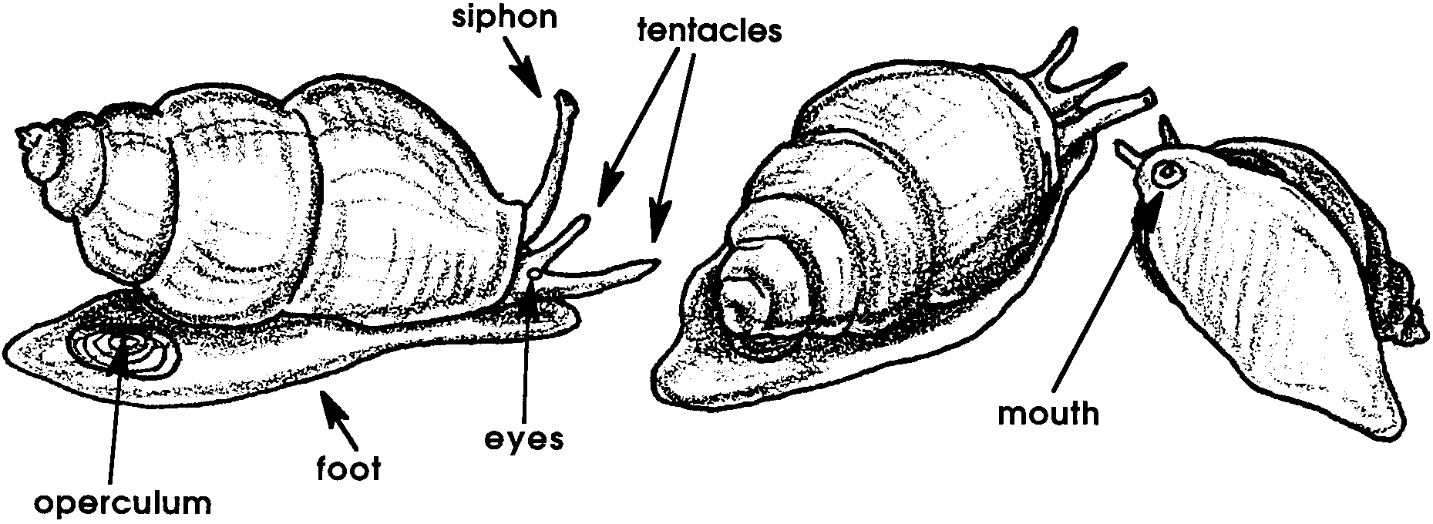

A snail’s mouth contains a long, tough, toothed, ribbon-like structure, the radula. Using it like a file, the radula helps the snail to rasp its food. Some snails excrete a chemical that aids in softening the shells of their prey. A snail in this group uses its radula as a drill to open a hole through the shell. The hole provides the snail with all the access it needs to eat the animal inside shell.

Materials

For the class:

• water for the living snails (fresh or salt)

• flashlights (several, to be shared by teams)

• rulers

• string

For each team of two or more students:

• “Snail Tracker” activity sheets

• clear jars or plastic containers

• live snail in the appropriate water (fresh or salt)

• magnifiers

• grease pen or marker

• dark paper

Teaching Hints

In “Snail Tracker”, students observe living snails and plot their movements over several days. If possible, start this activity on a Monday.

Obtaining Live Snails (fresh and saltwater)

Local ponds and tropical fish aquariums are usually good sources for fresh water snails. Additionally, pet stores often have an over-abundance that they may be willing to give away or sell cheaply.

If you live near the coast, you may be able to obtain a permit to collect snails. Call your state’s Department of Fisheries to check on collecting regulations and permits required. Tiny periwinkle snails can be found in the upper limits of the intertidal. Other, larger snails can be found lower in the intertidal, often on or under rocks. Please turn all rocks back to their original position.

Keeping Snails Alive

It is important to remember that you must replicate the natural environment of the snails to keep them alive and well. For example, periwinkles are rarely completely submerged in saltwater. They need access to saltwater, but they also need a dry place to crawl out onto. Other snails do well totally submerged in saltwater.

Observing Snails

Snail behavior can be unpredictable; be aware of this variable when doing this activity with your students.

Ideally, each small group should be set up with its own mini-aquarium for observations and measurements. Each group should circle the snail’s initial location daily, date the circle and plot the movement on their graphs.

Key Words

aperture - the opening of a snail’s shell

apex - the beginning or very top of a snail’s shell

operculum - a horny plate that closes the opening of the shell of a snail when the animal is retracted

radula - a file-like tongue possessed by some snails and used to break up food and scrape algae off of rocks

snail - a univalve with a hard, often coiled, shell into which the animal can withdraw (at least partially) and a muscular foot on which it slowly glides about

univalve - a mollusk with one shell; a member of the class Gastropoda

Extensions

1. Students may be interested in researching unusual snails, endangered snails, or snails of different habitats.

2. Snails show a great variety of shapes. Some are tall and thin, others flat and low. Some have thick shells, while others are paper-thin. If possible, make a collection of as many different snail shells as are available in students’ home collections, the school library, etc. Help students observe the variations and speculate on each snail’s habitat. Encourage students to get more information about snails and about the problems associated with shell collecting.

Answer Key

Snail Tracker - What Do You Think?

1. - 3. Answers will vary.

4. Students should add up the distances moved each day for a week, then to calculate the distance moved in a month multiply that distance by 4. To calculate the distance travelled in a year, multiply the distance for a week times 52.

5. Answers will vary.

6. It is not likely the snails will move in a straight line.

7. Some reasons the snails move may be: to avoid light, to get food, to avoid heat, etc.

8. - 10. Answers will vary.

Snail Tracker Super Experimenter

1. The snail will probably move away from the light.

2. The snail will probably move less when the container is covered with dark paper.

3. - 5. Answers will vary according to the variable used.

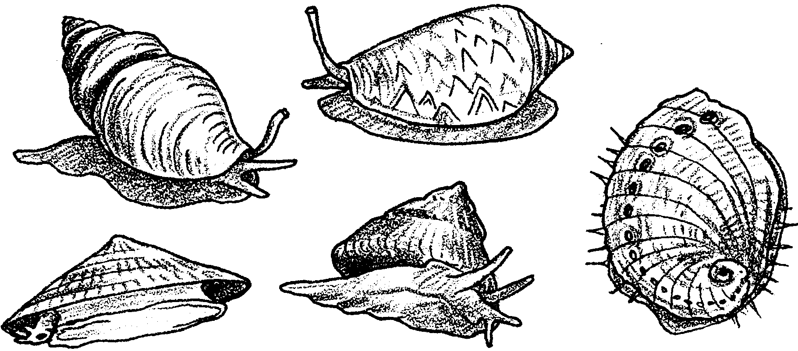
Snail Tracker

Snails are interesting animals. They live all over the world, in all kinds of habitats. The snails you will use in this activity live in water.
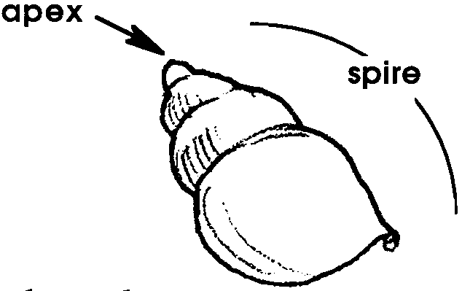
A snail’s body is housed inside of hard shell. Most snail shells are built in a series of spirals. The shell grows as the snail adds new layers. The highest point or apex is the oldest part of the shell.

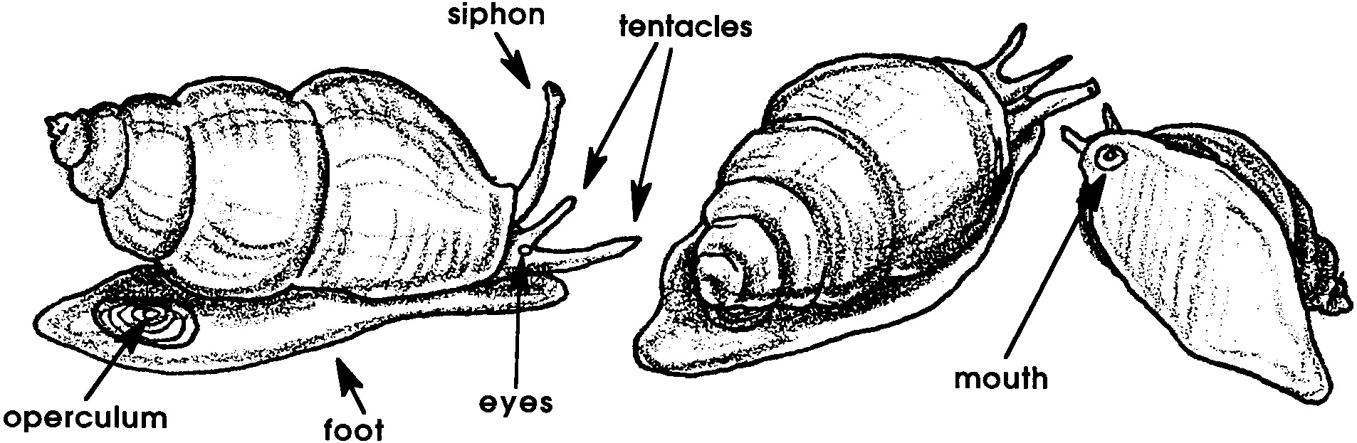
A snail can pull itself into its shell and close the opening with a flap. The flap, called an operculum, shuts the snail snugly inside the shell. Most snails have two tentacles which help the snail sense its environment. They also have two eyes, one near the base of each tentacle. While a snail’s vision is not great, their eyes can see light and dark and can detect movement.

Snails move on a muscular foot. They glide across their watery habitat with a slow but steady pace. People have wondered, “Why do snails go where they go? Is there a pattern to their movement? Do they ever return to the same spot?” If you are a good observer you may be able to answer these questions.

The Challenge

Observe living snails and find out where your snails go, if they ever return to the same spot, and if there is a pattern to their movement.

Here’s what to do:

1. Collect a live snail in a clear jar partly full of water. (Be sure the water in the jar is the kind of water in which the snail is used to living - fresh or salt). Take a close look at your snail. Use a magnifier to get an even closer look. Try to find these parts: tentacles, foot, apex, operculum, and eyes.

2. Make a drawing of your snail. Try drawing more than one view. Label as many parts as you can.

3. Use a marking pen to circle the snail’s location. Write today’s date next to the circle. Write the time right now .

4. Each day, for the next five days, circle your snail’s location in the container with the marking pen. Record the date by the circle. Be sure to make your mark at the same time each day.

5. Measure the distance between the most recent two circles each day. Record the distance on your data sheet.

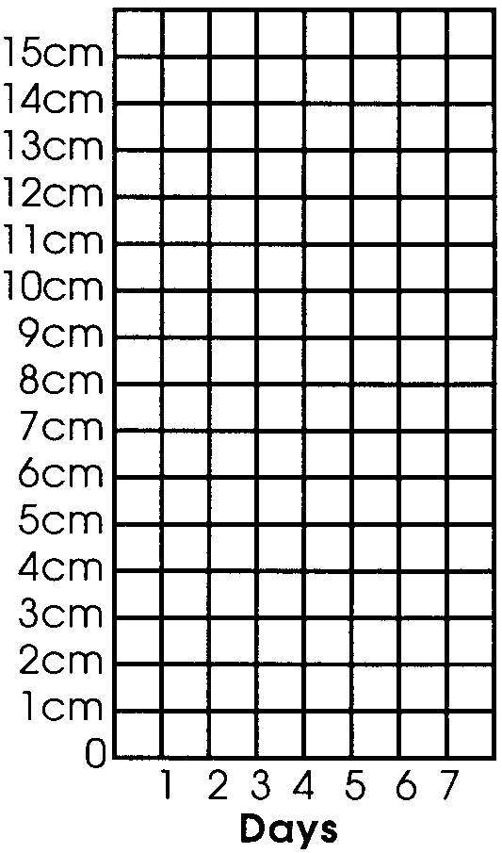
(Hint: Measuring might be difficult if your jar is curved. Here’s a trick. Use a piece of string. Stretch the string between the two circles. Make a mark on the string at each circle. Lay the string on a table and measure the distance between the marks with a ruler.)

4. Plot these daily measurements on a graph like the one on the right.

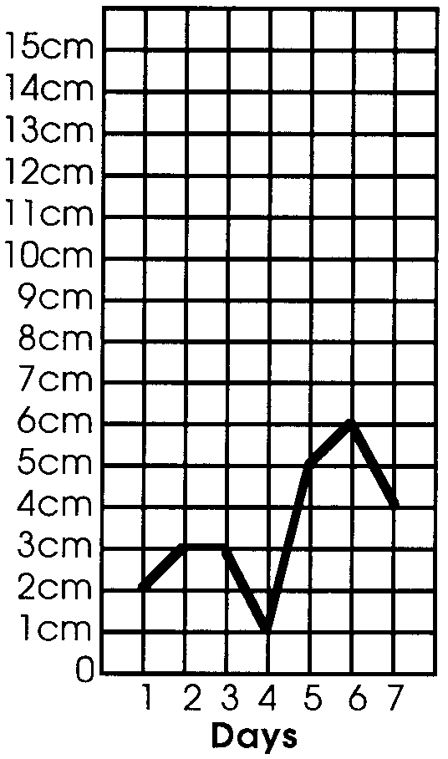
5. Connect the dots on the graph with straight lines.

6. Your snail tracker graph should look something like this:

What Do You Think?

After a week of observations answer the following questions. If something happened to your snail, use the completed graph above.

1. How long was the longest day’s journey?

2. How short was the shortest day’s trip?

3. What is the total distance traveled by your snail?

4. At this rate, how far could your snail travel in a month?

In a year?

5. Could your snail have moved further than it did?

Why do you think so?

6. Does the snail always move in straight lines?

7. Why do you think the snail moves?

8. Do you have any evidence to prove it is moving for the reason you gave?

What is the evidence?

9. Which part of the container does your snail prefer? (top, bottom, one side, etc.)

10. Calculate your snail’s speed by:

a. timing the snail’s movement for 15 seconds.

b. measuring in centimeters how far it went in those 15 seconds.

c. multiplying the distance by 4 to get speed in centimeters per minute [cpm]

How fast does your snail travel in a minute? cpm.

Try this at different times of the day to see if your snail is faster at one time or another.

Snail Tracker Super Experimenter

The Challenges

1. Try shining a light on your snail. What does it do? Be patient. Give it time to respond.

2. Try covering your jar with dark paper. Decide on a length of time to leave the paper on. How long?

Before covering your jar, circle the snail’s location and mark the time.

What does your snail do?

Does the snail move less or more than with regular light?

3. Repeat the original Snail Tracker experiment, circling the location of the snail everyday and recording the data. This time add ONE variable. For example, you might: darken the jar, add light to the jar, create motion in the jar, cool the jar, heat the jar, or add oxygen.

Aside from your one variable, be sure to do everything else just as before.

What variable did you add to the Snail Tracker experiment?

Show the results on a graph like the one below.
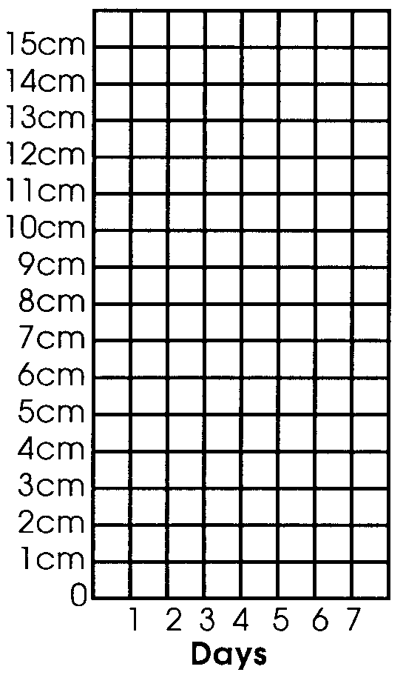

4. a. How did your snail react to this new experiment?

b. How is it different from the way it reacted in the first experiment?

5. What conclusions can you make about the snail’s behavior?

