Around Snail Cousins' Rock*
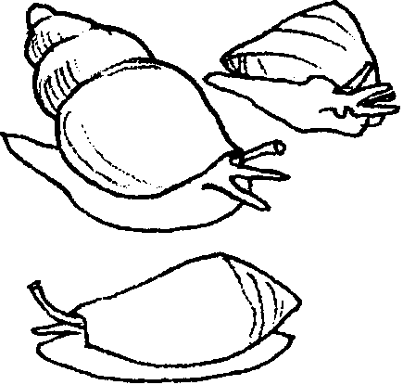

Key Concept
1. Univalves, mollusks with a single shell, are numerous and diverse in the intertidal zone.

Teaching Hints

Read chapter 8 of Pagoo with students. For their Pagoo Field Guides, have them write a short “eco-mystery”, a who-dunit of the marine world. Example: “The Case of the Disappearing Traveling Towers”.

Chapter Summary

Pagoo meets some univalves: an abalone and limpets. He also sees a nudibranch (sea slug) and sea hare, which are shell-less relatives of the snails. He observes each snail scraping algae with its radula, a sharp-edged tongue. Pagoo notices the shapes of snail shells, and Instinct tells him to search for one that is empty. Suddenly, Traveling Towers is swallowed.

Key Words

abalone - a large snail with a very powerful suction foot used to move and anchor itself; valued for food and for its single flattened shell lined with beautiful mother-of-pearl

limpet - a univalve with a large, flat muscular foot that slowly glides over rocks at high tide looking for food and returns “home” to its own scar at low tide.

nudibranch - a sea slug; a soft bodied, slug-like snail

operculum - a horny plate that closes the opening of the shell of a snail when the animal is retracted

radula - a file-like tongue possessed by some snails and used to break up food and scrape algae off of rocks

sea hare - a very large snail without a shell

snail - a univalve with a hard, often coiled, shell into which the animal can withdraw (at least partially) and a muscular foot on which it slowly glides about

univalve - a mollusk with one shell; a member of the class Gastropoda

