Creating Picture Words and Poems

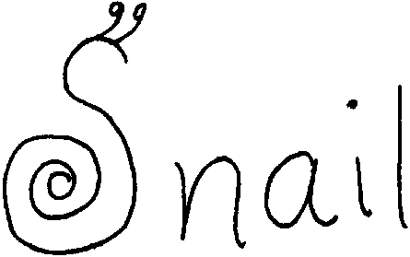
Key Concept
1. Words can be printed in such a way as to show their meaning.

Background

From “being a figurehead” to “being crabby”, the marine environment and maritime culture have produced a rich and varied vocabulary. This vocabulary, as well as marine related concepts, can be expanded and reinforced through art activities.

Materials

For the class:

• assorted art materials

• overhead of student examples

Teaching Hints

In “Creating Picture Words and Poems”, students use water and marine-related words to create pictures. As you discuss the procedure for creation of the marine picture words and poems, display the examples provided on the overhead transparency master.

Picture Words

1. Challenge students to think of water and marine-related words that can be written as a picture in whole or part. List these words for reference.

2. Display the overhead of examples to prompt students’ ideas. Discuss specifics on how the words show meaning. Select one of the suggested words from the brainstorm list and, as a class, create a picture word for demonstration.

3. Have students create their own marine picture words and display them in a creative way.

Picture Poems

1. Brainstorm a list of marine animals and plants and have each student or group choose an organism. You may elect to do this activity focusing on just one group of animals, such as crustaceans, or a particular habitat, including living and non-living components of the habitat, etc.
2. Begin by lightly drawing a large outline of the organism on unlined paper.

3. Write a poem about the organism. It can be rhyming, free verse, Haiku, cinquain, etc.

4. Write the poem around the shape of the sketched creature.

5. Mount and display.

