Room and Board, Travel Included*

Key Concepts
1. Seastars push their stomach into mussels and other prey to digest the meat.
2. Seastars secrete a special solution to tenderize their prey.
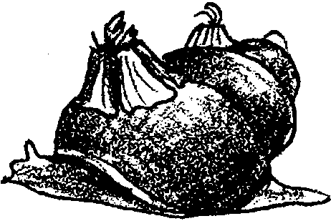
3. Many tide pool creatures live on each other - a barnacle may be on a snail shell containing a hermit crab.
4. The tide pool comes alive during flood tide (high tide).

Teaching Hints

Read chapter 7 of Pagoo with students, making additions to the Pagoo Field Guide as desired.

Chapter Summary

Even though Pagoo’s rear end has grown curved for coiling into a snail shell, he chooses a barnacle shell for his first home. While Pagoo sleeps, a seastar selects its prey and secretes a tenderizing liquid and absorbs its meal externally through its stomach. As Pagoo’s home begins to move, he discovers his barnacle home is attached to a snail, called “The Traveling Towers”.

