Barnacle Beats

Lesson by Sue Brimhall, Seattle, WA

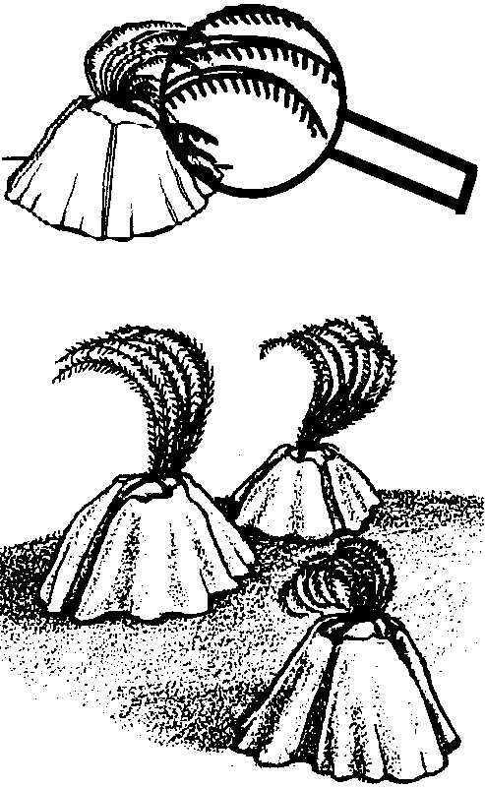
Key Concepts
1. Close observation brings a greater understanding of an animal and an appreciation of its habitat.
2. Barnacles use their feathery legs to collect plankton and oxygen from the water.
3. When the temperature of the saltwater surrounding barnacles is increased, they usually begin to beat their feathery legs faster.
4. Observations and experimentation lead to hypotheses about barnacle behavior.

Background

There are 800 known species of barnacles, all living in marine environments! Barnacles are crustaceans and are related to crabs, shrimp and lobsters. However, they are the only crustacean that is non-mobile. Because of their lack of mobility, barnacles need to attach themselves to areas providing a clean flow of water with lots of plankton and oxygen. During their larval stage, they attach themselves to rocks, pilings and shellfish, especially those found in swift currents. Barnacles can also attach themselves to boats and whales!

Barnacles are hermaphroditic, meaning both male and female sex organs are located in each barnacle body. However, they do need to “mate” with another barnacle. Each individual has a penis that is two times as long as its legs. This guarantees that at breeding season the barnacles will be able to avoid in-breeding. Each barnacle, after fertilization, broods its own eggs. Each individual can produce from 1,000 - 30,000 eggs! Breeding is spontaneous, usually triggered by changes in water temperature. When one barnacle begins, the whole clump follows suit. After the eggs have “hatched”, the nauplius form of barnacle larva joins the plankton fleet. The cyprid larva stage comes next. At this stage, the larva locates a place of attachment. The cyprid larva drifts to the bottom and creeps around on its antennae looking for a suitable home. Once a spot has been chosen it attaches its head with a glue like substance and begins to metamorphose into an adult.

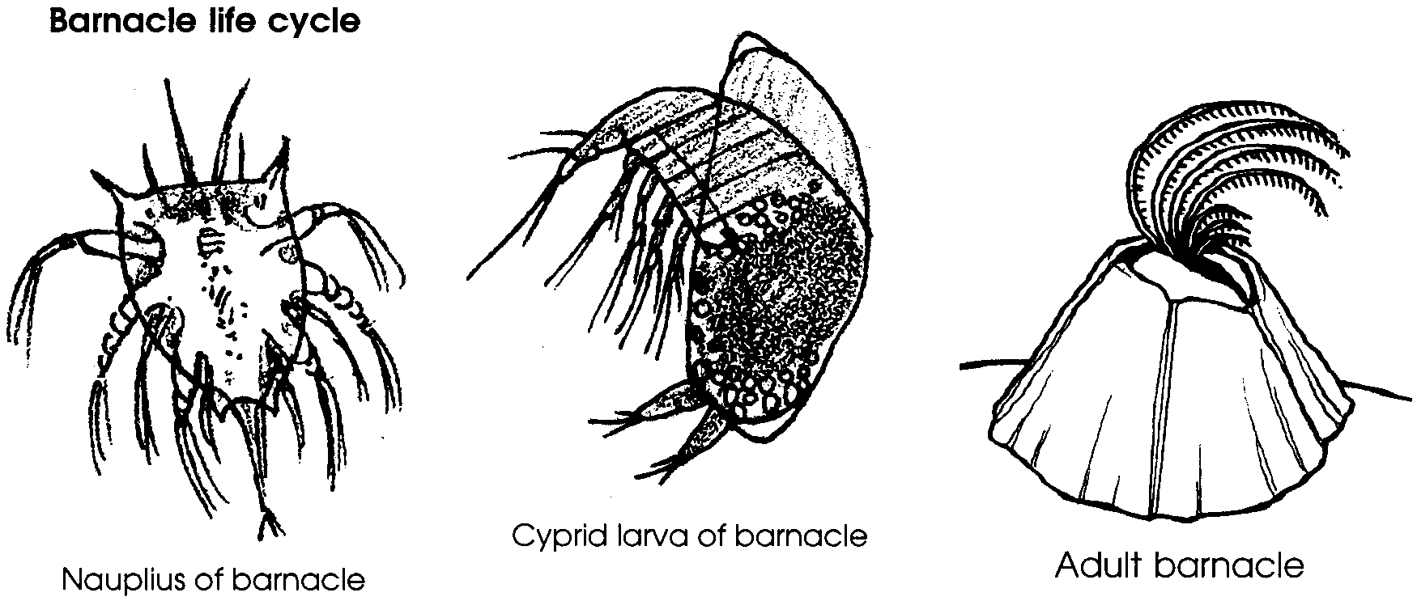

With its head secured to a rock, a barnacle uses its feet, or cirri, to gather food and oxygen from the water. The cirri are covered with gills to collect oxygen. The 6 pairs of cirri work together to sweep the water for planktonic food and oxygen.
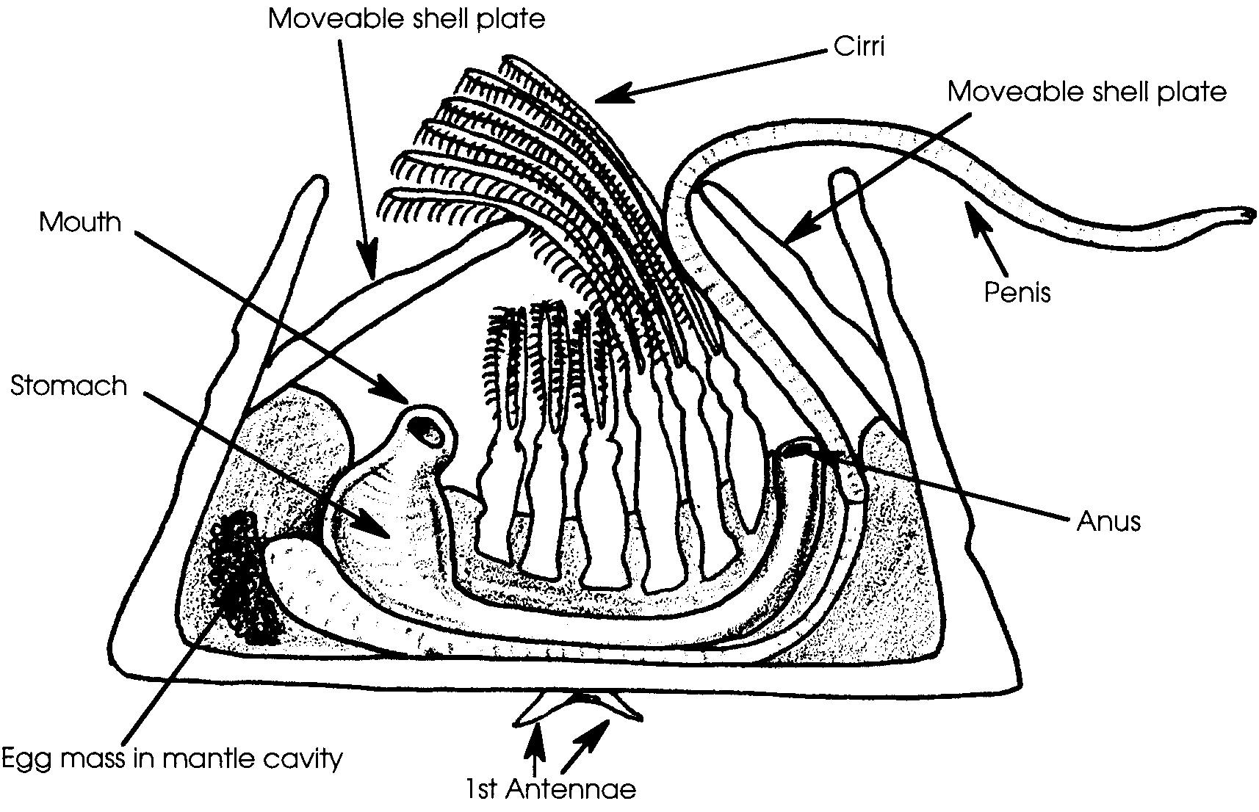

As the barnacle grows, its 5-8 plated shell is enlarged by secretions of a calcareous substance. The body and legs of the barnacle molt as it grows. Life spans of barnacles can be up to 15 years, depending on the species.

Like a snail, a barnacle has an operculum that opens and closes its shell. Made of four plates, the operculum quickly closes to protect the barnacle if danger or low tide approach.

Two primary predators of barnacles are seastars and snails. Mussels pose problems, too, by competing for available space in favorable environments. In days past, Native Americans roasted the largest species, Balanus nubilus, over a fire and ate a hearty meal of these giant barnacles which can measure 4 inches across.

Materials

Activity #1 - Observing Barnacles

For each group of 2-4 students:

• live barnacle clump (collected intact on a small rock or shell)

• clear plastic cup (big enough to house barnacle clumps covered with water)

• saltwater to cover the barnacles (collect plenty)

• magnifying glass, if available

Activity #2- Barnacle Cirri Beating

For each group of 2-4 students:

• live barnacle clump

• clear plastic cup

• cold saltwater and room temperature saltwater (enough to cover the barnacles)

• thermometer

• clock or watch with seconds

Activity #3- Feeding Barnacles

For each group of 2-4 students:

• live barnacle clump

• clear plastic cup

• saltwater to cover the barnacles

• food for the barnacles (live brine shrimp, fine fish food or a plankton sample)

• eye dropper

• food coloring
Teaching Hints

In “Barnacle Beats”, students perform three separate activities to guide their barnacle observations:
1. Observing Barnacles
2. Barnacle Cirri Beating
3. Feeding Barnacles

Consider having students read through each worksheet before doing the activity so they can focus on the major concepts. Make sure they complete predictions before continuing with the activity.

These activities will be most effective if done on at least two separate days. Detailed observations and the recording of those observations requires time. Allow ample time for these activities so students do not feel rushed or hurried.

This activity works best if each two students have their own barnacle clump. Barnacles are easy to collect and an extremely low tide is not needed. Chthamalus dalli, a barnacle found in the splash zone, is small but abundant and is found relatively high on the beach. If you intend to collect barnacles for your classroom: BEFORE collecting, check to see if the state in which you live requires a collecting permit.

Note that barnacles can rarely be removed from their substrate without damaging the base and killing the animal. As such, a barnacle must be collected intact, along with the rock on which it lives. Barnacles are quite hardy invertebrates, but to make certain you will return them alive, replicate the environmental conditions from which they were collected. For example, if the water in which they live is normally cold, keep the barnacles covered with seawater and in the refrigerator.

As with any living organism, barnacles may not always behave in the manner expected. These activities have been successfully implemented in hundreds of classrooms and are designed to be successful. But what happens if your barnacles choose to not behave in a timely fashion? Here are a few pointers. Check your barnacles the morning of the day on which you plan to conduct student observations. If the barnacles are active, the likelihood is very high that they will be active for your students also. Since your students may have to wait a few minutes for the barnacles to become accustomed to their new surroundings, caution students to be patient.

If the barnacles are not active, check the water temperature - cold water holds more oxygen. Barnacles deal with warming and lack of oxygen by “closing up shop”. Oxygenating the water with an air pump or agitation while lowering the temperature can often coax reluctant barnacles to appear. If the barnacles boycott the activity once you’ve begun, fear not. Have students observe and draw the external anatomy of the barnacle including its attachment and lead a discussion about how the barnacle’s structure and behavior (i.e., not appearing) might be beneficial adaptations to life in the intertidal zone. This is also the time to have students hypothesize what may have caused these barnacles to not behave according to expectations and to discuss how experiments don’t always work the way we expect but that, even so, they can yield a lot of useful information.

Activity #1 - Observing Barnacles

Materials

For each group of 2-4 students:
• live barnacle clump
• clear plastic cup
• saltwater to cover the barnacles
• magnifying glass, if available

Students are usually fascinated with barnacles and self-discovery works best for this activity. Before a formal introduction on barnacles, distribute a barnacle clump in an empty, clear cup to each group. Have them observe closely and carefully. As the students’ get interested, and they begin raising questions, provide further information, including identification of the moving body part as legs or cirri that are collecting oxygen and food.

Activity #2- Barnacle Cirri Beating

Materials

For each group of 2-4 students:
• live barnacle clump
• clear plastic cup
• cold saltwater and room temperature saltwater
• thermometer
• clock or watch with seconds

Make certain there is room temperature saltwater available for this activity. Because at least a 10° C difference in temperature is needed to see a reaction from the barnacles, keep the cold saltwater in the refrigerator prior to use.

You might suggest that students count the cirri beats for 15 seconds and multiply that number by 4 to compute the beats per minute.

Discuss the reasoning for counting the beats in each water temperature three times. Your students may need some help with averaging.

Activity #3- Feeding Barnacles

Materials

For each group of 2-4 students:
• live barnacle clump
• clear plastic cup
• saltwater to cover the barnacles
• food for the barnacles
• eye dropper
• food coloring

Caution students not to touch the barnacles with the eyedroppers. If touched, the barnacles will pull in and will not feed. Rather, they should squeeze the dropper full of food next to the cirri.

Key Words

barnacle - any of several species of crustaceans; most with volcano-shaped shells, whose larvae cement themselves permanently to a hard surface

cirri - the jointed appendages or legs of barnacles used for straining plankton and oxygen from the water

operculum - in this case, the moveable plates of a barnacle’s shell

Answer Key

Activity #1 - Observing Barnacles

1. Answers will vary. Students may observe the barnacle operculum moving. Other animals, such as worms, small mussels, and snails, living in the clump of barnacles could be visible.

2. Predictions will vary.

3. While answers will vary, in most cases barnacle cirri will start sweeping the water, reaching out then curling in. Some live barnacles may not open, and some non-opening barnacles may be dead (in which case, the shell likely will be empty).

4. Answers will vary.

Activity #2- Barnacle Cirri Beating

1. a.- g. Experimental results will vary.

2. Usually the cirri beat most rapidly in the warmest temperature.

3. Discuss students’ ideas. The cirri beat most rapidly in the warmest temperatures because the amount of dissolved oxygen is lowest in the warmest water and the barnacles’ cirri must beat quickly to collect the available oxygen.

4. The relationship may be stated: The warmer the water, the faster the cirri beat.

5. Answers will vary. Many will suggest setting up an experiment in which water temperature is varied as the beats are recorded.

Activity #3- Feeding Barnacles

4. While answers will vary according to the observations made, usually the barnacles will sweep the water to collect the food.

7. Most students will agree that the cirri are effective in moving water past the barnacle. Movement of the cirri indicated by the food coloring usually shows a circular pattern; the barnacle easily grabs the plankton moving in this circular pattern.

8. Cirri collect the barnacle’s food and oxygen, items clearly essential to the life of the barnacle.

9. Students will probably discuss the fact that it would be harder for the barnacles to achieve the levels of oxygen and food required and that the diseased barnacles may die or fail to reproduce.

10. Adaptations of a barnacle include:

• cirri and their sweeping movement through the seawater, collecting food and oxygen

• operculum, the moveable shell plates or doors that can seal the barnacle’s body in the volcano-shaped shell plates

• shell plates, hard structures which protect the soft body of the barnacle

• hermaphroditic lifestyle which allows permanently attached barnacles to mate with each other

• antennae of the planktonic barnacle which secrete a “super glue”, enabling the barnacle to firmly attach to a hard surface so that it is not swept out to sea.

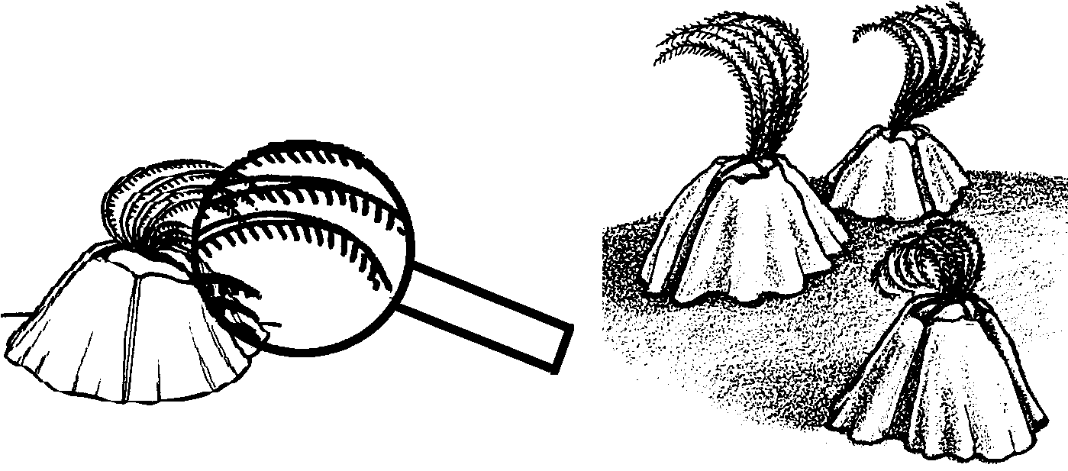
Barnacle Beats

Observing Barnacles

High and Dry

1. Observe the barnacle clump without water. Use a magnifying glass, if available.

a. What do you see?

b. What do you think the barnacles are doing?

c. What are the barnacles attached to?

d. Write down one question you would like answered about barnacles.

Prediction

2. a. What do you think will happen if seawater is added to the cup, covering the barnacles?

b. Which individual barnacles or how many will be affected by this change?

All Wet

3. Now pour seawater over the barnacles so they are covered. Observe the results. Be patient. Describe what you see.

4. a. Are all the barnacles active? Explain:

b. What does the part that is moving look like to you?

c. Why do you think barnacles have a moving part that grabs into the water?

d. How could you test your hypothesis about what the moving part is doing?

e. Take a closer look at the moving parts. Try breaking the movement into steps. Can you time each step? Do it!

f. Can you imitate the movement? Show your partner.

g. On the back of this sheet illustrate your barnacle clump. Be as detailed as possible. Include shading and texture in your drawing.
Barnacle Cirri Beating

The moving parts you've been observing are the barnacle’s legs. The legs are also called “cirri”. The movements are called “beating”.

The Challenge: How is cirri beating affected by water temperature?

1. a. Begin with a live barnacle clump in a cup of cold saltwater.

b. Record the temperature of the cold saltwater

c. Count and record the number of cirri beats per minute (bpm):
trial 1 bpm
trial 2 bpm
trial 3 bpm

d. Calculate the average cirri beats per minute. This is easy. Add all three trial bpm’s and divide that number by 3.

The average cirri beats per minute in cold saltwater is bpm

e. Replace the cold saltwater with room temperature saltwater. Record the temperature of the water

f. Count and record the number of cirri beats per minute:
trial 1 bpm
trial 2 bpm
trial 3 bpm

g. The average cirri beats per minute in room temperature saltwater is bpm

h. Return the barnacles to the cold saltwater.

Use your results to answer the following questions.

2. At which temperature did the cirri beat most rapidly?

3. Why do you think they beat most rapidly at this temperature?

4. Describe the relationship between water temperature and barnacle cirri movement:

5. How could we prove that your conclusion is accurate?

Feeding Barnacles

The Challenge: How does cirri beating help a barnacle to feed?

1. Begin with a live barnacle clump in a cup of cold saltwater.

2. Wait until some of the barnacles open and begin sweeping their cirri through the water.

3. Fill an eye dropper with the food you have available. Carefully squeeze a drop of food close to the barnacles’ cirri.

4. Describe how the barnacles react to the food:

5. Again squeeze a dropper full of food close the cirri. Quickly add a drop of the food coloring to the same spot where you placed the food.

6. Carefully, observe the food coloring. In which direction are the cirri moving the coloring? Draw the movement pattern in the space below. Include arrows to show direction.

7. Do you think the cirri are effective in moving water past the barnacle?

Explain:

8. How are cirri important to a barnacle? Explain:

9. Imagine a new barnacle disease. It keeps barnacles from being able to sweep their cirri. They can only move their cirri in and out of their shell. What do you think will happen to the barnacles who catch the disease?

10. Think about how barnacles are adapted for life between the tides. List three adaptations and their advantages.
a.

b.

c.

Challenge: List three more adaptations and their advantages.

a.

b.

c.

