A Starfish and a Few Barnacles

Key Concepts
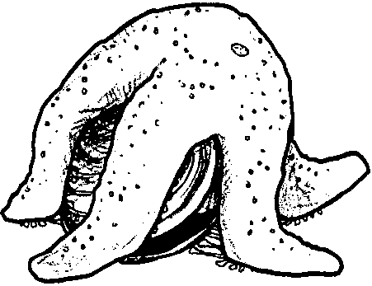
1. Seastars eat many things including mussels and other shellfish.
2. Seastars open shellfish by using their suction-cup tubefeet.
3. Barnacles are crustaceans.
4. Barnacles are actually relatives of crabs, standing on their head and raking food into their mouth with feathery legs.

Teaching Hints

Read chapter 6 of Pagoo with students. Have students add information or drawings of seastars to their Pagoo Field Guides.

Chapter Summary

Pagoo is in a rocky place called “Mussel Ridge”. He meets a purple starfish (seastar) who is too slow to catch him. Pagoo then encounters barnacles, also crustaceans, and finally realizes they will not make a good home for him.

Key Words

barnacle - any of several species of crustaceans; most with volcano-shaped shells, whose larvae cement themselves permanently to a hard surface

crustacean - one of a group of animals characterized by jointed legs, segmented bodies, and hard external skeletons (exoskeleton)

seastar - a star-shaped animal with a central disk and five or more rays or arms, and which use tubefeet for movement and to hold firmly to rocks

