Papier-mâché Tidepool Creatures

Lesson by Patty Enright, Stillwater, MN

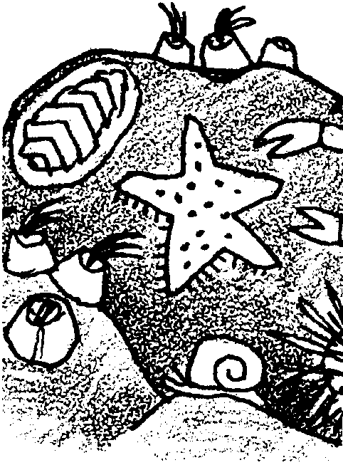
Key Concepts
1. Tide pools provide habitat for many plants and animals of the sea.
2. Plants and animals that live in the intertidal zone, including tide pools, have behavioral and structural adaptations which help them to survive in this harsh environment.
3. Tide pools are heavily populated communities, with a wide diversity of organisms.

Materials

For the class:

• cardboard, large and small pieces

• brown paper bags, various sizes

• newspaper, several bags

• paper towels (brown works best), several packages

• 8-10 boxes Metylan or Ross Papier-mâché Powder, or wheat paste

• masking tape, several rolls

• stapler

• scissors

• tempera paint

• brushes

Teaching Hints

“Papier-mâché Tidepool Creatures” is a time consuming, but worthwhile, activity. It provides a wonderful culmination to the research conducted in the previous activities, “Staying Wet” and “Wave Withstanders”. The creations from this lesson make great inhabitants for the tide pool constructed in Unit 2, “Tide Pools in the Classroom”.

Have students decide which animals they would like to make. It is helpful if each student has a picture of her or his particular animal available for reference throughout the “sculpting” process.

Note that while Metylan or Ross Papier-mâché Powder is recommended because they keep well, wheat paste works fine.
Sculpting the Creatures

The sculpting process is a matter of stuffing, taping, stapling, and rolling newspaper, tagboard, and cardboard until the animal has the right shape and form.

This process is time consuming and is spread out over several days. Everyone will probably need some individual help. Parent volunteers (particularly artistic ones) can be invaluable!

It is important that all appendages, such as legs, fins, antennae, are well secured with tape BEFORE beginning to papier-mâché. When the model is wet, repair of detached parts is difficult.

Papier-mâché' Process

1. Read the directions on the Metylan or Ross Papier-mâché Powder or wheat paste and mix accordingly.

2. Tear lots of 1"-2" strips of newspaper and paper towels.

3. Cover desks with newspaper or plastic.

4. Have students work in groups of four, sharing the papier-mâché paste mixture and piles of strips.

5. Begin to papier-mâché' with newspaper strips, followed by paper towel strips. This method helps students keep their layers straight!

6. After two layers, one each of newspaper and paper towel, allow to dry well for a day or two.

7. Repeat step 5., applying one layer of newspaper and ending with a layer of paper towels.

8. Allow to dry several days.

9. Have students paint their creatures with tempera paint, light colors first, followed by dark. To avoid colors running together, be sure neighboring paint is dry before adding additional colors.

10. Details can be added with a glue gun. For example, an otter can hold a shell, food can be placed in a fish’s mouth, birds can be mounted on bases so they stand, etc. Some students like to use beads, buttons, or wiggly eyes for their creatures’ eyes.

