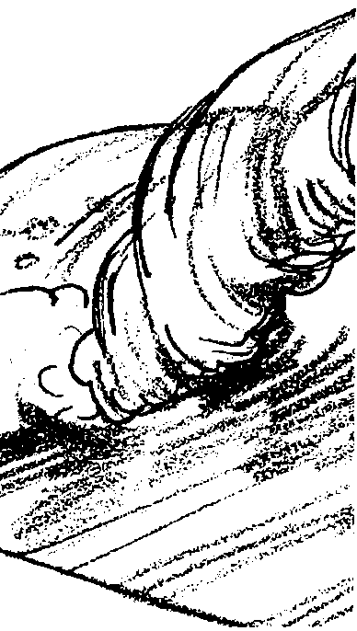
Wave Withstanders

Lesson by Sue Brimhall, Seattle, WA

Key Concepts
1. Intertidal organisms cope with many stress factors.
2. Intertidal organisms have many and varied structural and behavioral adaptations to withstand waves that pound this habitat.

Background

Avoiding drying is only one of the challenges of life in the tidal zone. The force of pounding waves is another. Background material covering some of the adaptations intertidal animals use to meet this challenge is found in the previous activity, “Staying Wet”.

Materials

For the class:

• sponges (cut into rectangles approximately 1/2" X 1")

• string (cut to 5" lengths; limit 2 per student)

• rubber bands (limit 3 per student)

• paper fasteners

• paper clips

• straight pins

• safety pins

• suction cups

• other workable materials

Teaching Hints

In “Wave Withstanders”, students adapt a sponge “animal” to withstand the force of a water wave. This fun activity may be completed over three days:

Day 1 - Have pairs or small groups of students research the structural and behavioral adaptations of intertidal organisms to avoid being pounded by the waves. Have some students dramatize these adaptations, using simple props, while the other students guess the animal and summarize the adaptations used to withstand waves.
Day 2 - Students prepare their tide pool critters for the challenge of withstanding the oncoming “big wave”! As students prepare their critters, make sure they use only one other material in addition to the sponge. Limit the string and rubber bands used. Be aware that the people-made products and technology can take away from the basic idea of tide pool animal survival techniques.

Day 3 - Once the students have invented their critter and tested it, they are ready for the “big wave”. You can be the wave or select a student. Either way, have several buckets and coffee cans filled with water and ready to go. This allows things to clip along and minimizes waiting for buckets to be filled. If a hose is available, you may choose to use it to produce the “wave”. Hold students responsible to make certain all the “appendages” are brought in, sorted, or thrown away.

One great way for students to learn is through trial and error. If time permits, you may choose to add the following modification. Before any knowledge of adaptations is imparted, complete the Day 3 activity as "a pre-test". Next, complete the Day 1 to Day 3 activities as outlined above. The discussion about adaptations and the results of the first experiment provide a great opportunity for the students to better adapt their critter for the second “wave”!

Key Word

adaptation - modification of an organism or its parts that makes it more fit for existence under the conditions of its environment

Answer Key

Prediction

1.,2.,3.,4. Answers will vary depending upon the confidence of students regarding the ability of their constructions to withstand wave forces.

Analysis and Interpretation

1.,2.,3. Answers will vary depending upon the experimental results.

4. Problems which tide pool animals face if they can’t hold up to the wave force include crushing or other physical damage and being swept away, perhaps to a less hospitable environment such as the stomach of a predator!

5. Answers and reasons for the choices will vary depending upon the experience and preferences of the students.

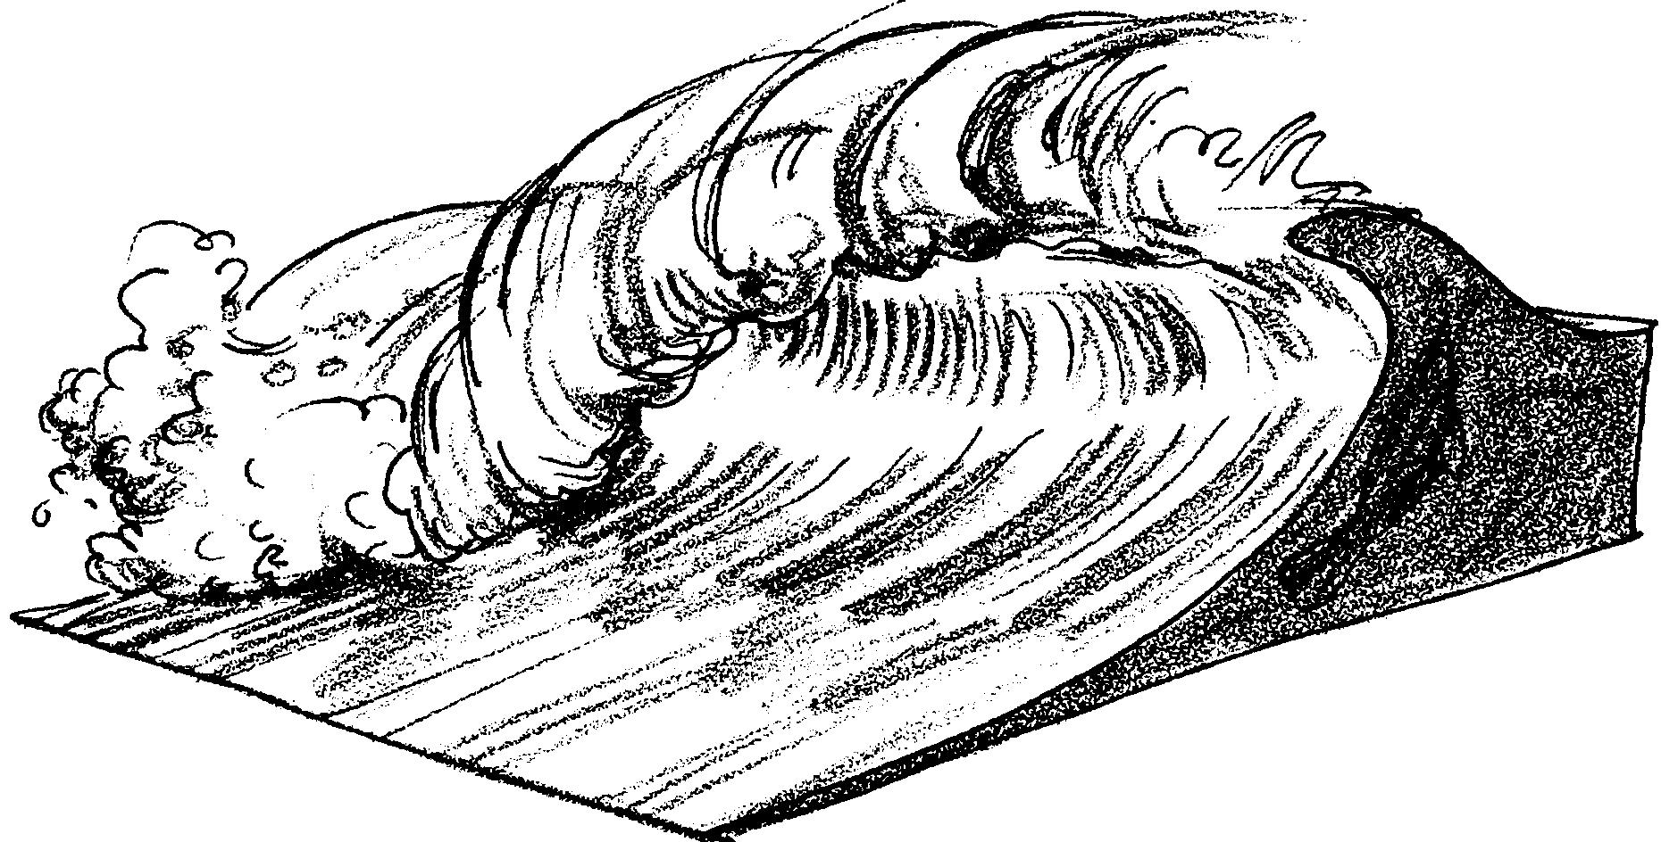
Wave Withstanders

During low tide, many animals in the tidal area face the threat of drying out. During high tide, these same animals are covered with water. Life must be easy then. Not always. During high tide, intertidal animals have to deal with incoming waves. The waves can thrash and batter the animals. How do the animals deal with the daily pounding? How do they deal with the giant waves from severe storms or strong winds? Just as they cope with drying, there are many ways intertidal animals deal with this problem. You may already know some of them.

1. Identify three intertidal animals. For each, state how they avoid being swept away or thrashed by the pounding waves.

a.

b.

c.

The Challenge

Adapt a sponge to withstand the stress and force of an incoming wave (a bucket of water thrown directly onto your animal!).
Part I - Adapting the Sponge Body

1. Obtain a sponge piece. The sponge will simulate an intertidal animal.

2. Choose ONE of the materials displayed by your teacher for addition to your sponge.

3. Adapt your sponge piece. Use the materials to change your sponge in ways that will help it withstand wave forces. Make a change and ask yourself, “Will this help the sponge withstand the wave force?” If you think not, change the things you’ve added or add more. What? You’re not happy or confident with your first choice of material? Choose another and start over. The best ideas are not always the first!

Prediction

1. What you think will happen when the wave hits your adapted sponge body?

2. How do you think your sponge will do compared to others in the class? Will it fare better than most sponge bodies or worse? Explain.

3. Draw your sponge body “wave withstander”. Label the parts and give your “wave withstander” a name. (Use your imagination.)

4. Think about real intertidal animals. Which real intertidal animal is your “wave withstander” most like? Explain.

Part II - The Wave Test

Set your sponge body up and get ready for the wave! Good luck!

Analysis and Interpretation

1. a. How did your sponge do compared to others in the class?

b. Did you predict correctly?

2. Explain two things that happened to your sponge body as the wave hit.

a.

b.

3. Think about doing this experiment again. How might you improve your sponge body? Do it!

4. Imagine you are a tide pool animal. What problems will you face if you can’t hold up to the wave force?

5. Imagine you are an intertidal animal that has to live in an area of heavy waves. Which animal would you choose to be and why?

