Staying Wet

Lesson by Sue Brimhall, Seattle, WA

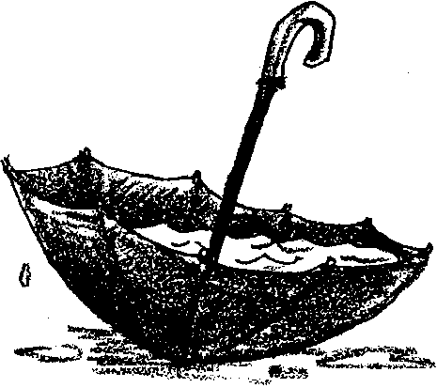
Key Concepts
1. Intertidal organisms cope with many stress factors.
2. Intertidal organisms have many and varied structural and behavioral adaptations to avoid drying out (desiccation).

Background

All marine animals are subject to stress: predators, competition for food and finding the right conditions for reproduction are the most common stress factors. But animals living in the intertidal zone face additional problems. You need only look at a tide table and compare the amount of time an intertidal animal is submerged with the time it is exposed to see that these animals reside in a highly changeable environment.

• Each day, when the tide goes out, exposure to the sun’s heat increases the threat of desiccation (drying out). Intertidal animals have developed several methods for dealing with this problem. They bury themselves in the moist sand, hide in the shade of a rock, retreat into a moist shell or climb into the folds of wet seaweed.

• Intertidal animals face competition in securing these protected habitats. Sometimes speed is an advantage in finding and keeping such niches as the tide goes out. Organisms that are immobile have developed other devices and behaviors to secure a safe place on which to live.

• The force of the waves themselves may dislodge an animal, removing it from its chosen habitat. In addition, waves crashing against the shore often dislodge rocks, sending them rolling onto intertidal organisms.

• When low tide is accompanied by rain, the salinity of the water in the tide pools decreases, potentially to levels which are dangerous for the tide pool’s inhabitants.

Each of the organisms described below has developed adaptations to help it survive the above stresses:

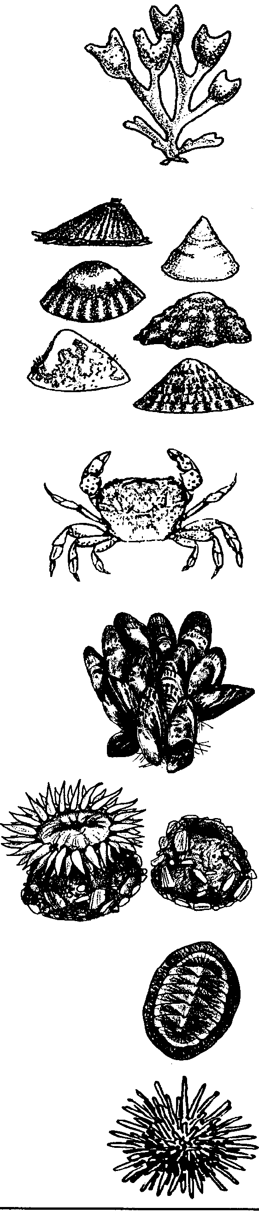
Rockweed, an algae, has thick cells and high concentrations of sugar, both which retard drying out. Small air bladders are located at the end of the blades, helping the blades to float near the surface thereby maximizing the light captured for photosynthesis.

Limpets, hold on to rocks with their foot. They search for depressions and ledges that can shield them from the sun. A sticky mucus is secreted that seals the animal to the surface upon which it clings. This seal offers protection from drying out. Some species of limpets actually excavate a depression for their shell, using a file-like organ called a radula.

Purple Shore Crabs have flattened bodies that allow them to slide between or under rocks to avoid the sun and other exposure. These crabs are most active at night and at high tide, thereby avoiding dangerous exposure.

Mussels have the ability to clamp shut, keeping some water inside, and shutting out the elements and enemies. They usually clump with lots of other mussels. A tangle of byssal threads attaches them firmly to rocks and to each other.

Aggregating anemones have another clumping strategy. They clump because it reduces water loss! They often cover their bodies with bits of shells and rocks when the tide is low, further reducing exposure.

Chitons have eight shell plates that flex, allowing them to better conform to the rock surface on which they are attached. A chiton holds on firmly by the suction created by its foot.

Purple Sea Urchins survive the pounding surf by excavating a pit-like depression with their spines. Their spines protect them from predators.

Materials

For the class:

• scale that weighs in grams

For each pair of students:

• sponges cut in rectangles (about 1/2" X 1")

• tweezers

Teaching Hints

In “Staying Wet”, students working in pairs moisten two pieces of sponge, one to represent an intertidal animal seeking protection from exposure at low tide, and the other as a control organism. They then place the sponges outside and leave them untouched. If possible, start the experiment in the early morning and finish it at the end of the same school day. That period of time will represent a low tide cycle, the time when animals are more exposed to air and possible desiccation.

Encourage the students to weigh the sponges carefully so that changes can be noticed. They can make their own simple data sheets. At the end of the experiment, have them compare their results and discuss any variations found. Since the sun’s position changes during the day, they may have some unexpected results!

This activity can be separated into three days:

Day 1 - Have pairs or small groups of students research ways intertidal animals avoid desiccation. Have some students dramatize these techniques, using simple props, while the other students guess the animal and summarize the technique used to avoid desiccation.

Day 2 - Perform the outdoor activity with the two pieces of sponge

Day 3 - Complete the follow-up questions. The day wait mitigates the excitement and anticipation level sometimes present on the day the activity is performed, allowing students a less hectic environment for analyzing and interpreting the experiment.

Key Words

byssal thread - thread-like material secreted by mussels and which is used for attachment to rocks, etc.

intertidal - between the low and high tide marks
Answer Key

Analysis and Interpretation

1., 2., 3., 4. Answers will vary depending upon experimental results. If students have chosen well, sponge 1 (experimental) will weigh less, and have lost a smaller percentage of weight, than sponge 2 (control).

5. When tide pool animals leave a protected area they face increasing risks of desiccation (drying) and predation.

6. If time allows, give students the chance to repeat the experiment with the changes they suggest.

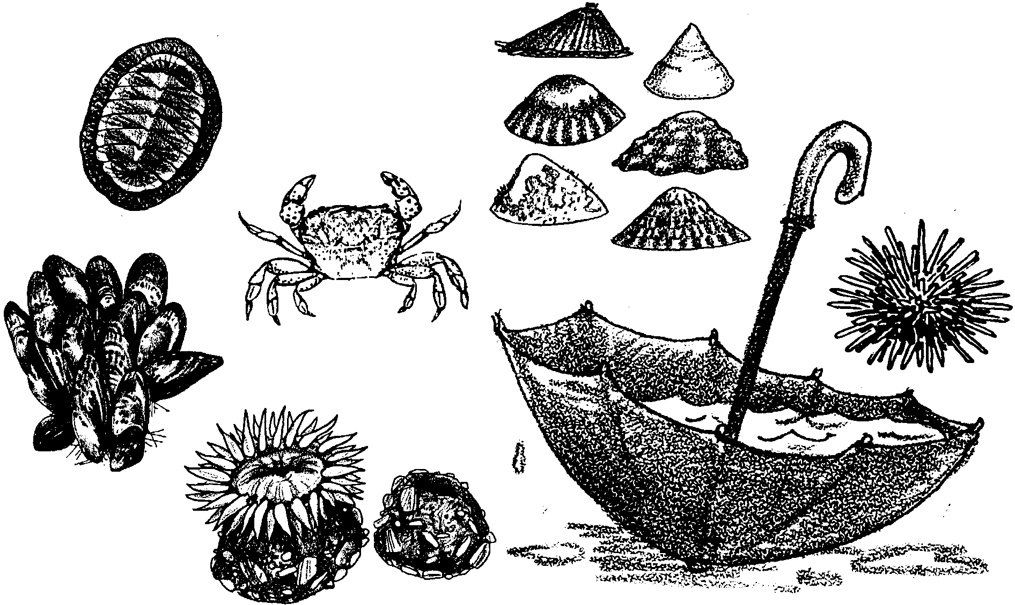
Staying Wet

During low tide, many animals in the tidal area are out of the water. There, they are exposed to the drying air. How do intertidal animals deal with the threat of drying out? There are many ways they cope with this problem. You may already know some of them.

1. Identify three intertidal animals. For each, state how they avoid drying out.

a.

b.

c.

The intertidal environment may look pretty much the same from place to place. Actually, there are many different, small intertidal environments. In the following experiment, you will look at how much “animals” dry out in different environments.
Materials

• two sponges, each about 1/2" x 1"
• tweezers
• scale that weighs in grams
• dish of water
• paper towels

The Challenge

Find an environment in which a wet sponge will not lose more than half of its water during a “low tide” (the five hours of a school day).

1. Moisten a piece of sponge. Here’s how. Use the tweezers and place the sponge in the dish of water. Let the sponge soak for one minute. Use the tweezers to pick up the wet sponge. Let the water drip until no additional drops form.

2. Using the tweezers, place the wet sponge on the scale. Record its weight on your data sheet. Remove the sponge from the scale. Use a paper towel to wipe off any excess water left on the scale.

3. Imagine that the wet sponge is an intertidal animal trying to avoid drying. Find a spot outdoors that you think will keep that sponge wet. Use the tweezers to place it there.

4. Repeat steps 1 and 2 with your second piece of sponge. Since this is a control, place this sponge in an unprotected location outdoors.

5. At the end of the day, use the tweezers to pick up your first sponge. Use the scale to weigh the sponge. Record the weight on your data sheet.

6. Now, use the tweezers to pick up your second sponge. Use the scale to weigh the sponge. Record the weight on your data sheet.

Analysis and Interpretation

1. How much weight did each sponge lose?

a. sponge 1

b. sponge 2

2. For each sponge, calculate the percentage of weight lost. Here’s how:

Weight of water lost ÷ original weight of wet sponge x 100 = percent

a. sponge 1 per cent weight loss

b. sponge 2 per cent weight loss

3. Think back to the beginning of this experiment. You tried to choose a place where your “experimental” sponge would not dry very much.

a. Look at the per cent weight losses. How does the loss by the experimental sponge compare with that of the control?

b. How do the results compare with your predictions? (Was your choice a good place?)

4. Compare your results with those of other students. Talk about the similarities or differences you find. As you do, think about similarities or differences in the locations chosen.

5. Imagine you are a tide pool animal. What problems would you face if you had to leave your protected area?

6. Think about doing this experiment again. What else would you try to slow the drying? Do it!

