A Ride and a Fall Far, Far From Home

Key Concepts
1. Hermit crabs protect their soft abdomens by living in the abandoned shells of univalves.
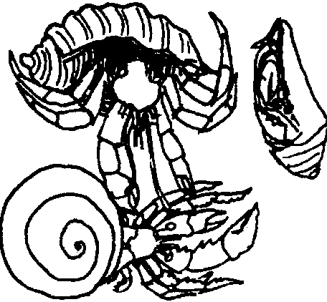
2. If a hermit crab loses a feeler, claw, or leg, it can regenerate a new one, as can all crustaceans.
3. Mollusks are invertebrate animals with soft, unsegmented bodies and most have calcareous shells (i.e. snails, clams, mussels, etc.)
4. Mollusks with two shells are called bivalves (i.e., mussels). Those with one shell are called univalves (i.e., snails).

Teaching Hints

Read chapter 5 of Pagoo with students. Have students make entries to their Pagoo Field Guides, focusing on univalves and bivalves.

Chapter Summary

Although unable to compete, Pagoo joins in the fight with the adult hermit crabs. The crabs stumble into a sea anemone but escape before they are clutched in its tentacles. Pagoo tires and withdraws. Instinct suggests Pagoo needs a shell to live in which will protect his naked back end. Pagoo tries mussel shells, but as bivalves, their two shells are clamped together too tightly. Pagoo almost loses his feelers, but because he is a crustacean, he can regenerate feelers, legs, and claws. He realizes he needs a univalve home, and the search begins.

Key Words

bivalve - a mollusk with two shells

byssal thread - thread-like material secreted by mussels and which is used for attachment to rocks, etc.

crustacean - one of a group of animals characterized by jointed legs, segmented bodies, and hard external skeletons (exoskeleton)

mollusk - one of a group of animals characterized by a very soft body, a mantle and foot and, in most cases, a covering of shell

regenerate - to replace lost body parts by growing new ones

univalve - a mollusk with one shell

