When the Oxygen is Gone

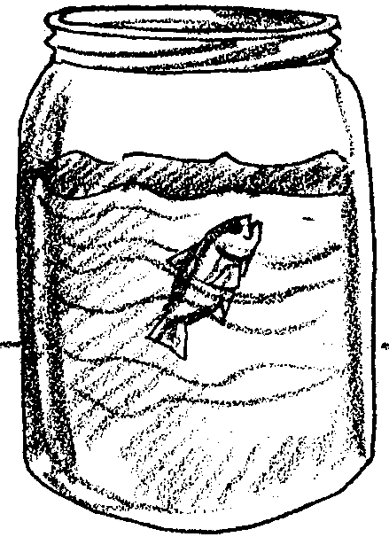
Adapted with permission from Living In Water

Key Concepts
1. Fish become stressed when subject to environments low in oxygen.
2. When stressed, they may increase the rate of water movement over their gills or move to a location that has more oxygen.

Background

Most animals, whether on land or sea, require oxygen to live. While some aquatic animals, such as whales, breathe atmospheric air directly to obtain oxygen, most marine animals have evolved ways to extract oxygen directly from the water around them. Fish and some aquatic insects use their feather-like gills to perform that function, spreading them apart to maximize the water flow over the gill filaments. Some fish, like trout or pike, require high levels of oxygen to survive, while others can survive in waters having low levels of oxygen.

Water conditions in a bay, pond or stream may temporarily or permanently change, resulting in a lowered oxygen level which may stress the inhabitants. Some of them may even die. A lowered oxygen level can be the result of a higher water temperature or an increase in the number of oxygen consuming bacteria due to increased organic wastes or pollution.

While oxygen levels in any body of water, from a home aquarium to the ocean itself, can be monitored by conducting chemical tests, sometimes the results of a decreased oxygen level are first noticed in the behavior of fish or other animals. This experiment permits students to study that phenomenon. For a low-oxygen environment, students will use water that was recently boiled and then cooled. Fish placed in such water may move their gills more rapidly or come to the surface to gulp air. In a small container, the effects will show up quickly.

In a natural body of water, fish would swim to try to find an area having a greater concentration of oxygen. Sessile animals (those which cannot move, such as oysters, mussels, barnacles and tube worms) would not have that option. They might die during periods of very low dissolved oxygen.

Materials

For each group of 4-6 students:

• 2 small (1 inch) guppies or goldfish (Do not substitute other kinds of fish) in a healthy, balanced aquarium

• small nylon fish net, available in aquarium stores

• 1 quart jar filled with tap water that has sat uncovered overnight (so that any chlorine can “gas out”)

• 1 quart covered jar filled to the top (no air space) with water that has been briefly boiled, then covered and allowed to cool to room temperature - can be prepared the day before

• watch or clock that has second timer

Teaching Hints

In “When the Oxygen is Gone”, students investigate the responses of fish to exposure to low oxygen levels by comparing the number of times the fish opens its gill covers in oxygenated water and in oxygen poor water.

The fish will respond quickly to the low oxygen environment. It is important that students make observations quickly so that the fish can be returned to their aquarium home without being damaged. Discuss this issue with the students before doing the experiment so that they understand the importance of keeping the fish healthy. If time permits, conduct the experiment with a second fish so that students can compare results.

Procedure

1. Ask the students if they have ever felt out of breath and discuss those experiences with them. What did they do to get “more breath?” Do not ask them to hold their breath. Have they ever run out of breath while playing or swimming underwater? What did they do?

Explain the importance of oxygen to human life and to the lives of other animals as well. Animals on land obtain their oxygen from the air just as we do, but marine animals have other adaptations to enable them to survive. Discuss these.

2. Ask: What would a fish do if it suddenly was unable to get enough oxygen? How could we find out?

Part I

Explain the procedure before handing out the materials. Students will first place a fish in an open jar of tap water that has been exposed to normal room air and observe its behavior. They will time, and record, how many times it opens and closes its gill covers (opercula) and/or mouth in one minute. This will serve as an indicator of how much water it is passing over its gills.

They will then use the net to remove the fish from the first jar and place it in the newly opened jar of boiled and cooled water. Have them watch the fish closely for a few seconds and then count the number of times per minute it opens its opercula. Do not leave the fish in the oxygen-depleted water more than 3 minutes. Cover the jar immediately after removing the fish.

Now, hand out materials while reminding students to be careful handling the fish. Have them conduct the experiment and then discuss their numerical observations.

Part II

Place one fish in each of the jars and observe differences and similarities in their behavior. Where in the water do they go? How do their rates of movement compare? After students make their observations, have them remove both fish and return them to their aquarium home promptly.

Key Words

dissolved oxygen - oxygen found in water, usually stirred in by wind and waves on the water surface

gill - in this case, an organ found at the side of the throat of fish that provides needed oxygen to the fish’s blood supply

operculum - the bony flap that covers a fish’s gills

oxygen depletion - a condition in which oxygen is in short supply

Extensions

1. Students may want to try the same experiment with a small crab or shrimp. It may be more difficult to actually count the gill movements but qualitative changes may be observable.

2. You may know of a problem in your local bodies of water caused by low oxygen. Ask local authorities (Water Department, Fish and Wildlife Department, Adopt-A-Stream or local conservation organizations) for suggestions. If possible, have a field trip so that students can see the conditions themselves. They might even conduct dissolved oxygen tests with equipment borrowed from local agencies.

Have the students interview knowledgeable sources to learn about the causes of the problem. They should get as much detailed information as possible before considering possible preventive measures or solutions to the problem. Problem-solving and brainstorming as a group will result in many ideas which can then be shared and discussed with local authorities.

Answer Key

1. Answers will vary. One possible answer, “We are putting fish in water that does not have much oxygen to see how they react to low oxygen.”

2. Possible observations.
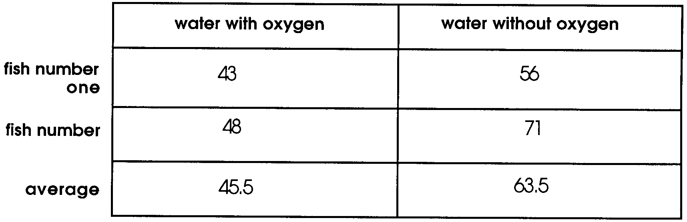

number of times gill covers are opened per miinute

3. Answers will vary. One possible response, “This seemed to upset the fish, and it swam around fast. Then it went to the surface of the water and seemed to gulp air.”

4. Answers will vary. One possible response, “After getting used to the jar, these fish just sat there in the water.”

5. Answers will vary. One possible response, “Fish seem to need oxygen in their water. In water with low oxygen, the fish acted differently than fish in water with oxygen. The fish in water with low oxygen seem to move more and look upset.”

When the Oxygen is Gone
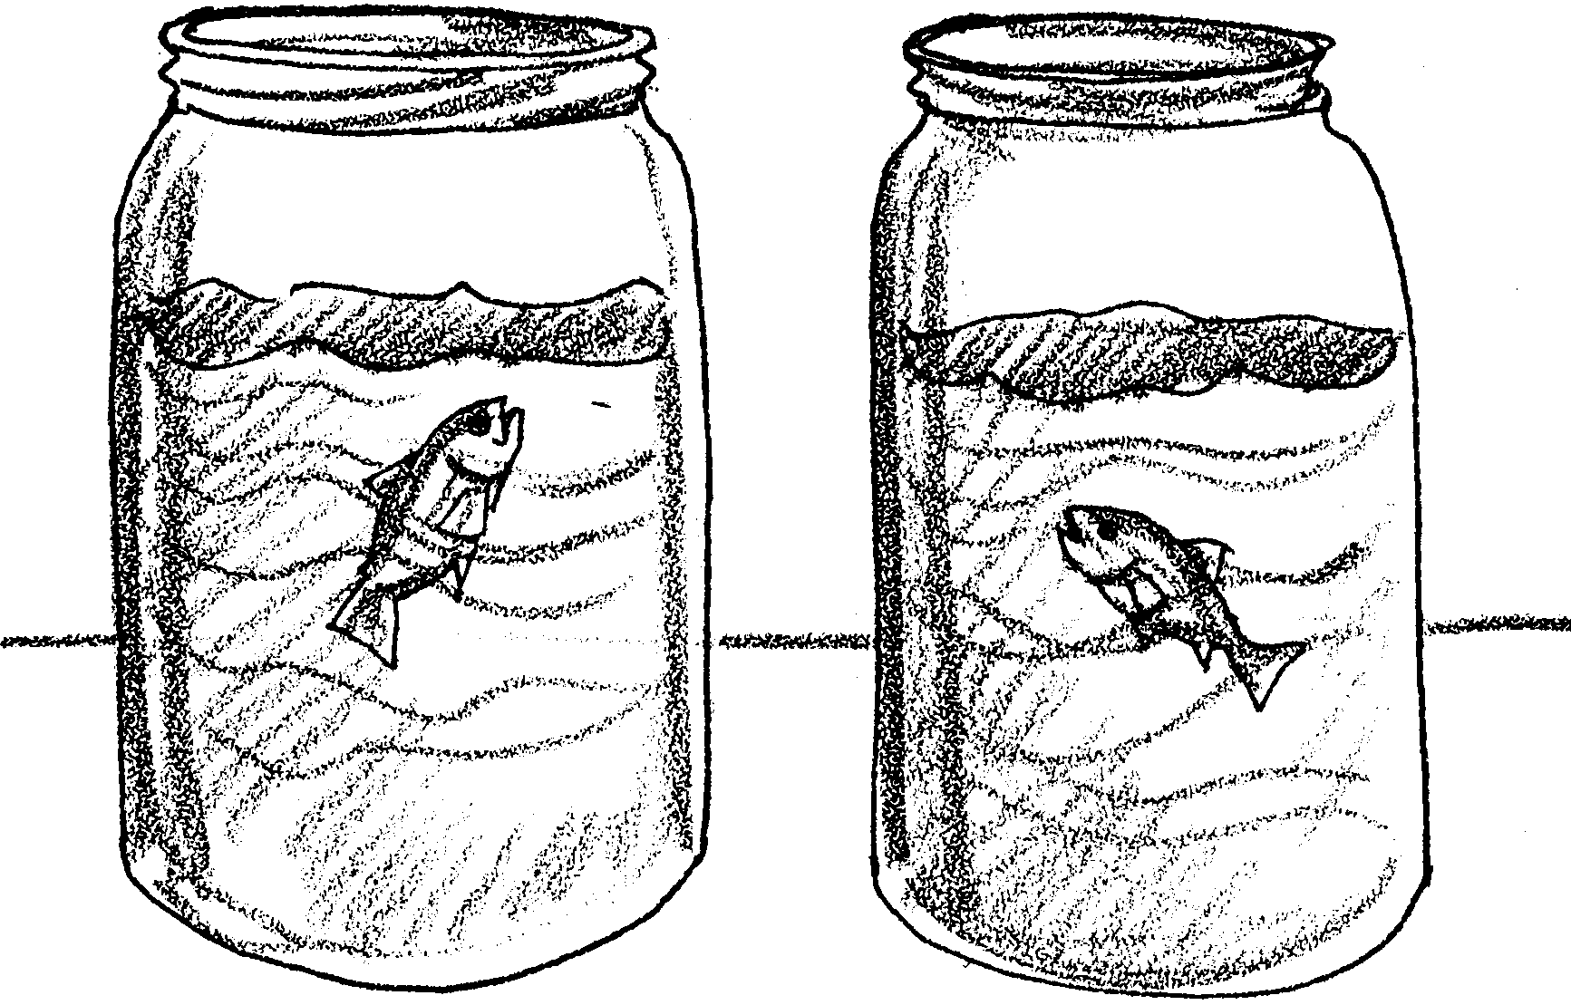

1. Describe the experiment you are going to do.

2. Use the chart below to record your observations.

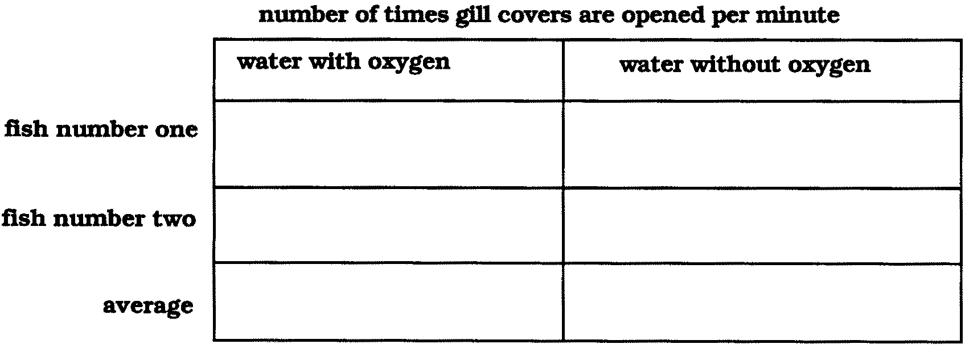
3. Describe the behavior of fish in water without oxygen.

4. Describe the behavior of fish in water with oxygen.

5. What tentative conclusions can you draw from your experiment?

