As the Plankton Bloom

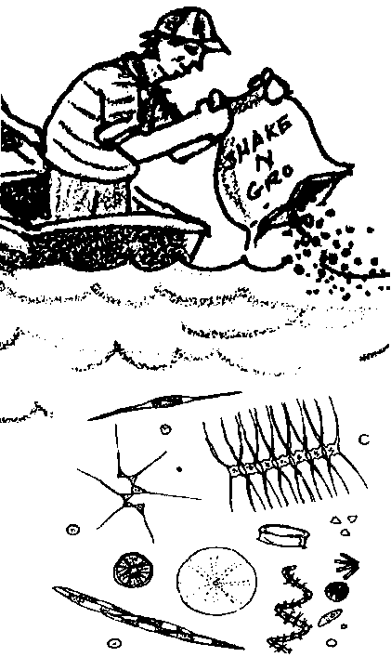
Adapted by Sue Brimhall, Seattle, WA and Laurie Dumdie, Poulsbo, WA
from “Plankton and the Food Chain ”, part of the Oregon State University
Sea Grant Marine Advisory Program, Marine Science Education Tips series.

Key Concepts
1. The addition of phosphate detergents to a marine system can increase the productivity of phytoplankton.
2. Waste water high in phosphates may cause excessive plankton blooms and as they die, may cause a reduction in the amount of dissolved oxygen.

Background

Phytoplankton are the primary producers in the aquatic food chain. Zooplankton are the primary marine consumers. Other invertebrates, fish, mammals, and people are also part of the aquatic community. Their survival depends on the availability of nutrients, obtained by eating either other creatures or the waste products falling from above as floating and swimming animals die or decay.

In central ocean systems, these nutrient cycles do not operate efficiently because only surface layers receive enough sunlight for photosynthesis to occur. Since most of the nutrients are on the bottom and the sunlight is on the top, relatively little life can survive in the central ocean.

Estuarine systems and coastal regions, unlike the central oceans, are continuously fertilized by nutrients from the land or from the upwelling of deep ocean waters. In shallow bays and estuaries, decaying plants, marsh grasses and algae also provide important nutrients to the food webs.

Oddly enough, too many nutrients can be detrimental. In some coastal regions and freshwater systems like lakes and rivers, phosphates from waste water can create an excessive plankton bloom. As the plankton die, the processes of decomposition can use up the dissolved oxygen, causing a reduction of available oxygen to other creatures.

Materials

For the class:

• two ten gallon aquariums (transparent plastic containers may be substituted)

• 20 gallons of seawater or freshwater from a lake or pond

• phosphate detergent or fertilizer

• 1/4 teaspoon measure

• thermometer

• optional: artificial sunlight source, such as Grolux plant lights, if no sunlight is available

Teaching Hints

“As the Plankton Bloom” is designed to help show the importance of plant life in the marine ecosystem. While reinforcing the material on food chains, the role of nutrients and fertilizers in aquatic plant growth is also investigated.

Have groups of students take turns recording daily changes using a data sheet created by the class.

In this activity, students are challenged to create a tool or a test to determine how turbid or cloudy the water is becoming in the aquariums. Allow them time to problem solve and devise their own methods.

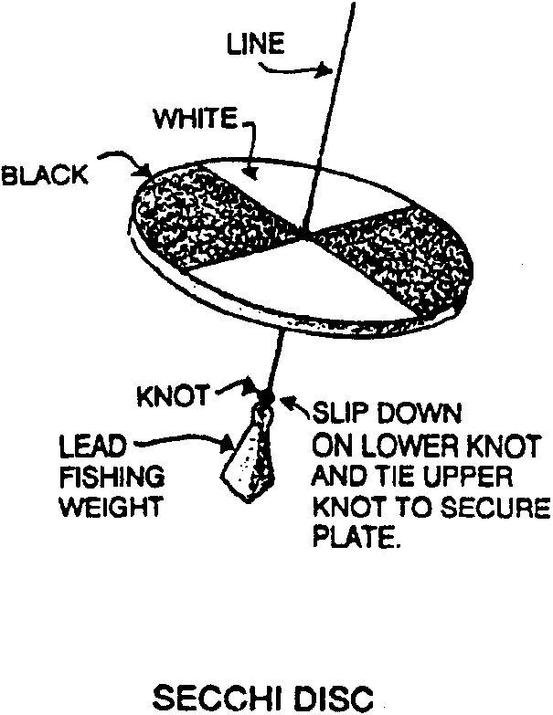
Scientists use a very simple tool called a secchi disk to measure turbidity.

The secchi disk is lowered into the water until it just disappears from view. The depth of disappearance is recorded as the secchi disk depth and is related to the water transparency.

A very simple, miniature secchi disk can be made:


1. Run a sheet of transparency film through a copy machine to print a simple pattern or message onto the film.

2. Cut a 2" circle of the film containing the pattern and attach it to the end of a ruler with rubber cement or a tack. The numbers on the ruler should read smaller to larger away from the disk.

Key Words

photosynthesis - formation of food (carbohydrates) in the chlorophyll-containing tissues of plants exposed to light

turbidity - a measure of the distance light can travel in water and which is related to the amount of sediment suspended in water

Extensions

1. Have students compare the turbidity of aquariums that contain different detergents with varying amount of phosphates.

2. Check with a middle or high school science teacher about the availability of a water test kit for dissolved oxygen to measure the amount of dissolved oxygen in the two aquariums. Try to have a middle or high school student come to your classroom daily to conduct the dissolved oxygen test on the two aquariums.

3. Have a group of students build the following closed aquarium system and collect the oxygen released.

Materials

• 2 clean 2-liter soft drink bottles (clear)

• 450 grams of aquarium gravel

• 1 bunch of aquarium plants (Vallisneria)

• 2 liters of aged water (let water stand for 24 hours, uncovered, to allow the chlorine to escape)

• 1 tube contact cement

• 1 permanent marker

• 1 lamp (gooseneck type)

• 1 small balloon

• 1 ruler

• scissors or sharp knife

Procedure

1. Measure about 22 cm. up from the base of one of the 2 liter bottles. Mark and draw a line around the bottle at this level.
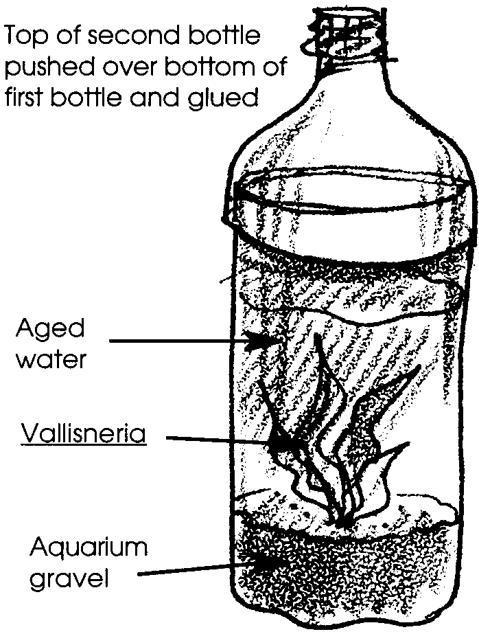
2. Cut the bottle along this line.

3. Fill the bottom of the container with gravel. Add 1/3 liter of the aged tap water and the plants.

4. On the second 2 liter bottle, measure up 21 cm. from the base and draw a line around the bottle. Cut the bottle along this line.

5. Put a thin layer of contact cement along the inside edge of the top half of the second cut container.

6. Add another 1/3 liter of the aged water and fit the top with the contact cement onto the water-filled half.
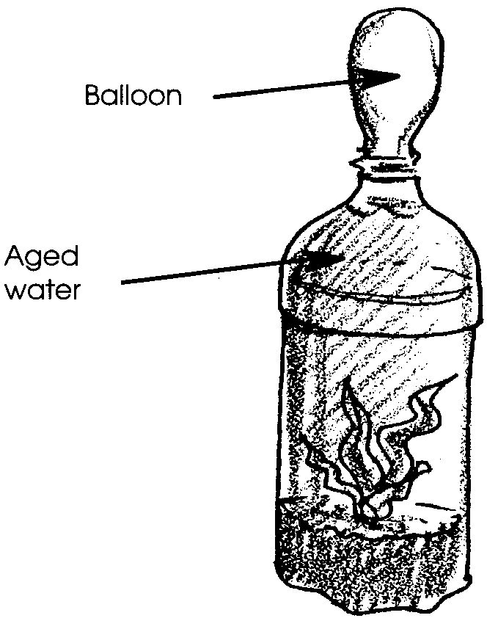
7. When the glue is dry, add the remaining water.

8. Place the balloon on the top of the bottle. As the plant produces oxygen, it should send the excess oxygen out of the water and the balloon should slightly fill.

This activity adapted from the Two-Liter Aqua-Vivariums in the article, “Same Play, Different Actors: The Aquatic Community” by Ira B. Kanis and Joseph Saccente

Answer Key

1. Depends upon experimental results. The aquarium will probably turn light green.

2. Depends upon experimental results. The aquarium will most likely become very green and turbid.

3. The greener aquarium has the greatest numbers of phytoplankton.

4. The greener aquarium would have the highest oxygen following the reasoning given; probably the experimental aquarium in this case.

5. Sketches will vary. One possibility:
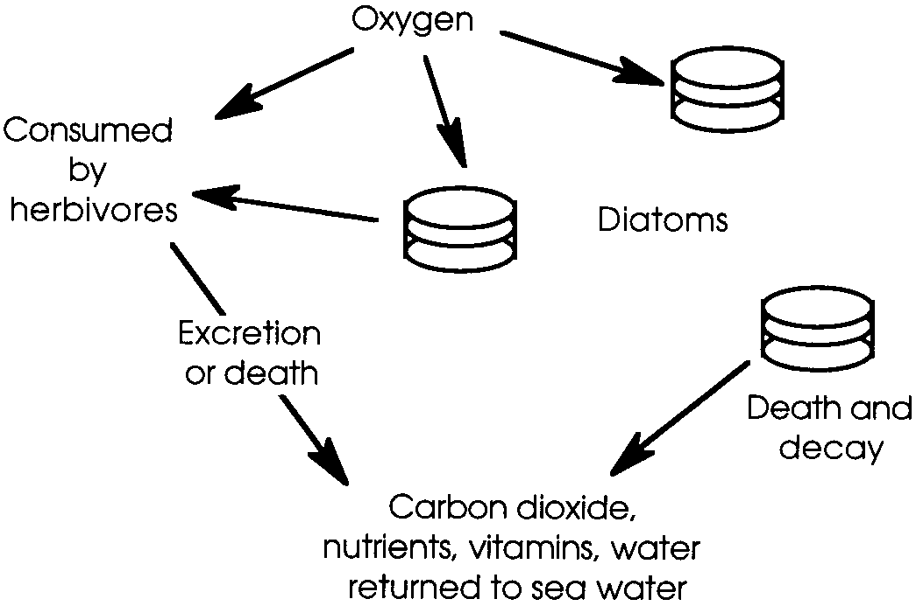
6. If the oxygen level in a lake is greatly reduced, the fish might die.

7. Waste water high in phosphates from detergents may cause plankton blooms which can cause a reduction in oxygen level as they die. The reduced oxygen level could cause local fish kills. This is usually a problem in lakes and rivers and occasionally in isolated saltwater bays.

As the Plankton Bloom
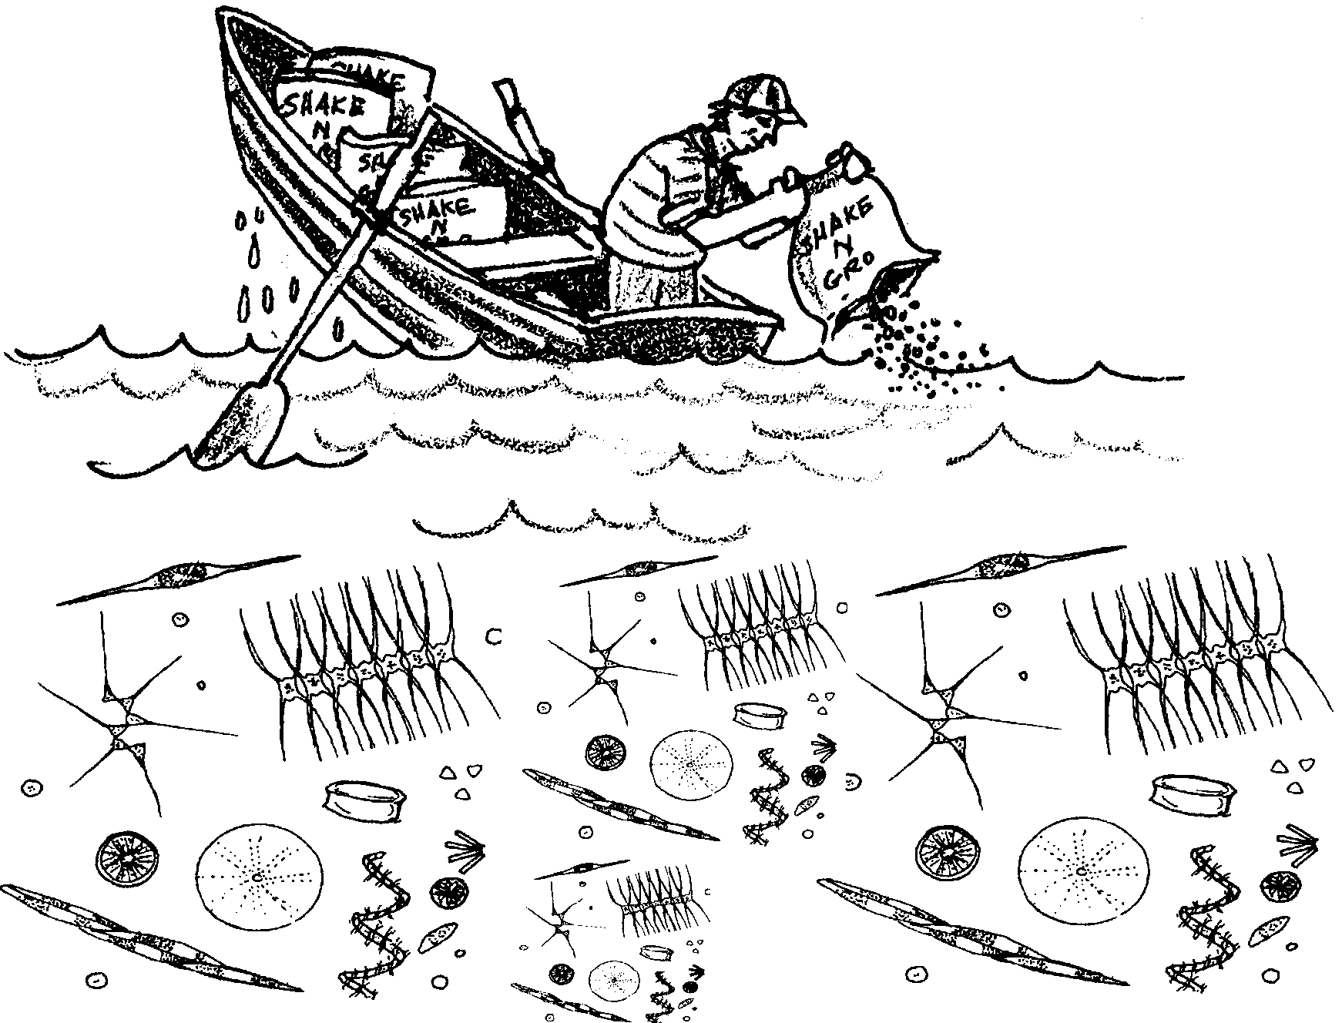
Plants in the sea include large, attached seaweeds and tiny drifters. These microscopic drifting plants are called phytoplankton.

Phytoplankton, like the green plants of the land, make food. They combine carbon dioxide with water, using energy from the sun, to produce simple sugars. This process is called photosynthesis. It could be pictured like this:

sunlight → green plants + CO2 = H2O → simple sugars

Almost all other life in the sea depends on the food produced by phytoplankton. Clearly, phytoplankton are pretty important.

Phytoplankton do another great thing! One of the by-products of photosynthesis is oxygen. Animals, including humans, need oxygen to survive. Scientists think that from 40% - 70% of the oxygen in our atmosphere is produced by phytoplankton!

In the following activity, you’ll have a chance to become a “phytoplankton gardener”.
Materials
• two ten gallon aquariums
• water - 20 gallons
• phosphate detergent or fertilizer
• 1/4 teaspoon measure
• thermometer

Procedure

1. Place the tanks in a location where they will receive sunlight.

2. Label one of the aquariums as “CONTROL”. Label the second aquarium as “EXPERIMENTAL”.

3. Fill each tank to the same level (about one or two inches from the top) with water. Your teacher will tell you the source of the water. It may be from the sea or a pond or lake.

4. Each day, add 1/4 teaspoon of household phosphate detergent or fertilizer to the experimental aquarium. Do nothing to the control aquarium.

5. Record daily water temperature and general appearance of each aquarium.

6. The Challenge - Create a tool or a test to determine how cloudy the water is becoming in the aquariums. Record this information each day.

7. Continue the experiment until the water becomes cloudy and green with a plankton bloom.

8. Keep the water for further studies.

Results and Interpretation

1. Describe what happened to the water in the control aquarium.

2. Describe what happened to the water in the experimental aquarium. How did this differ from what happened in the control aquarium?

3. Let’s say that the cloudiness in the aquariums is due to the number of phytoplankton. If that is the case, which tank had the most?

4. Phytoplankton produce oxygen. Which tank do you think would have the higher level of dissolved oxygen? Why?

Fertilizer and phosphate detergents can increase the growth of phytoplankton. Lots of phytoplankton. That sounds like a good idea - lots of food, lots of oxygen. As usual, things aren’t so simple. If phytoplankton reach large numbers, many phytoplankton below the surface layer cannot get enough sunlight. These phytoplankton die. When they die they begin to decay. Decay removes oxygen from the water. Large phytoplankton blooms, therefore, can decrease the oxygen in the water.

5. Make a drawing with labels to show how large phytoplankton blooms can decrease oxygen in the water.

6. What might happen to fish in a lake where the oxygen level is greatly reduced?

7. Why might waste water that contains detergents be harmful to the balance of life in the ocean or in a lake?

The Super Challenge

Visit a supermarket and research the dish washing and laundry soaps. Which products contain the greatest amount of phosphates? the least?

