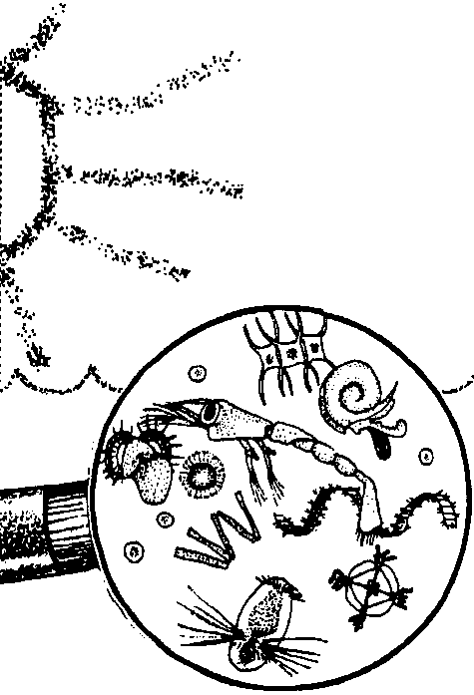
Sea Feasts

Edited by Sue Brimhall, Seattle, WA

Key Concepts
1. Phytoplankton form the basis of most food chains and webs in the ocean by converting solar energy to food energy.
2. The organisms in the marine food cycle depend on a constant flow of energy from the sun and the recycling of materials.

Background

Primary Producers

Like other plants, phytoplankton contain pigments (usually chlorophyll) that use the sunlight’s energy to turn carbon dioxide and water into sugars and other complex organic molecules (carbohydrates, proteins, fats, etc.). Phytoplankton are, therefore, considered the primary producers of food in the sea.

Consumers

Most zooplankton depend on phytoplankton as a source of food; some forms of zooplankton may eat smaller forms of zooplankton. These animals are called consumers because they need food to support their life processes. Their energy comes from the metabolism of food by respiration, during which complex molecules are combined with oxygen and “burned”. Carbon dioxide and water result as end products of respiration and energy is released.

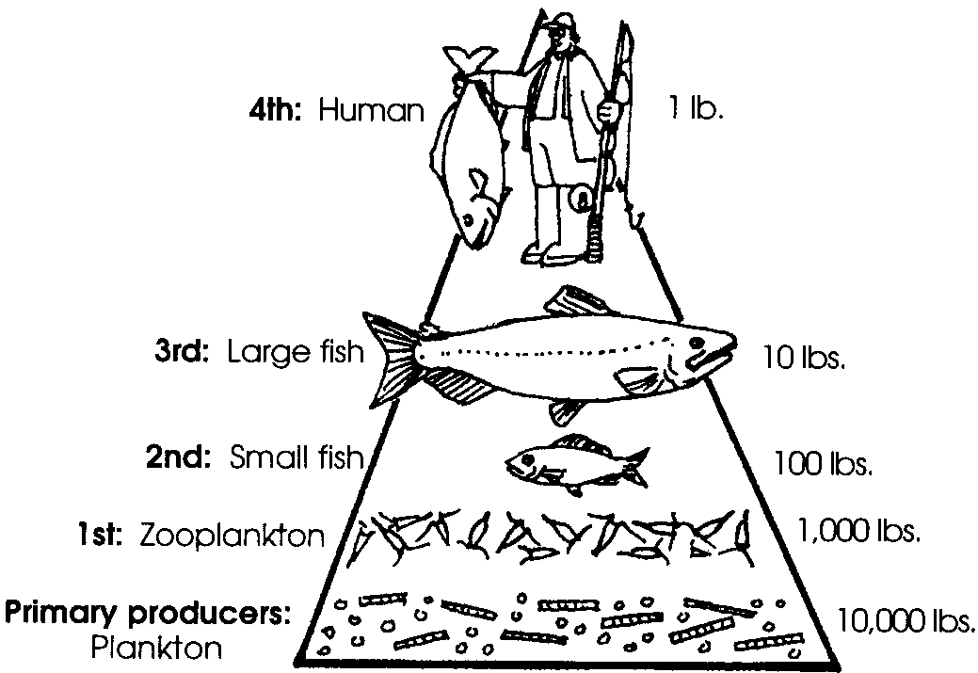
The Food Cycle

A single copepod, a common type of zooplankton, can have more than 120,000 diatoms in its stomach at one time. In turn, a small fish such as a herring or smelt might be able to collect 50,000 copepods in a very short time, only to find itself eaten by an even larger predator. This feeding relationship can be diagrammed as a food pyramid.
It is estimated that it requires 10,000 pounds of phytoplankton to produce 1 pound of a large predator (in this case, a fourth order consumer). This is based on a 10 % conversion efficiency going up from each level. Each additional step causes a net loss of organic material. One reason is that not all of what we eat is converted to new body tissue; much is indigestible. Additionally, much of the energy in an organism is used to run life processes and is never available to the next level up the food chain. Generally, therefore, there is a low degree of efficiency in the transfer of organic matter from the phytoplankton to the higher level consumers.

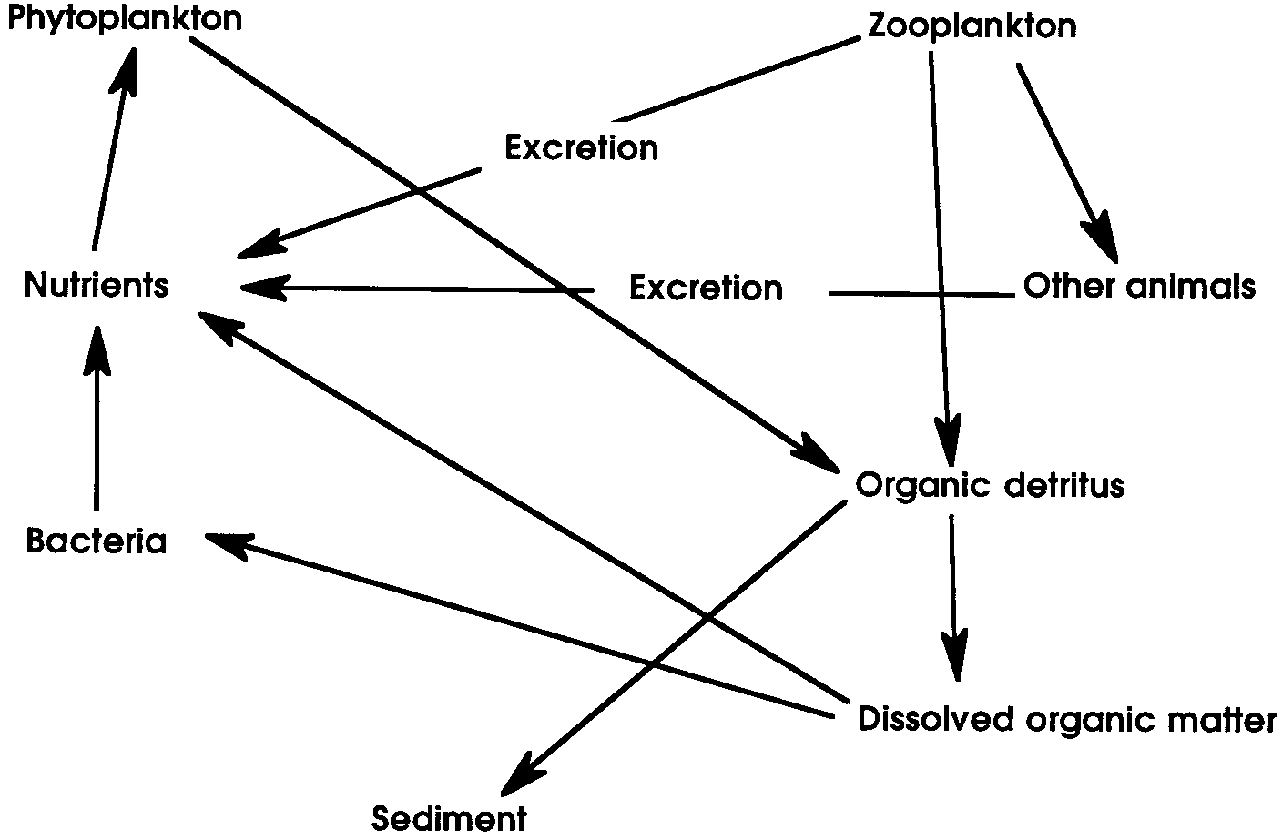
There are many other complex relationships that exist in the sea. For example, the complete food cycle includes wastes and dead organisms which are decomposed by bacteria and which, in turn, supply phytoplankton with nutrients or food material.

Additional plankton background information can be found in the activity, “Getting to Know Plankton”.

Materials

For each student:

• “Sea Feasts” student reading

Teaching Hints

“Sea Feasts” builds on students’ prior knowledge of plankton. Unit One contains lessons to teach the necessary content for this lesson.
Key Words

consumer - an organism which cannot produce its own food, but eats other organisms to obtain the energy necessary to sustain its life

food chain - a diagram, based on who eats whom, showing the path of energy transfer among plants and animals in a community

food web - intertwined food chains

food pyramid - a food web diagram showing feeding relationships including the relative numbers or weights of organisms at each energy level

producers - in this case, green plants which make their own food

Answer Key

1. The floating plants in the ocean are called phytoplankton.

2. Possible answers include:

a. There are two main types of phytoplankton: diatoms and dinoflagellates.

b. Diatom means “cut in two”; the diatom exists within a shell of silica. They come in many different geometric shapes and can be found alone or chained together in groups or colonies.

c. Diatoms have interesting adaptations which keep them on the surface to continue capturing sunlight. Many have spikes and other projections to disperse their weight.

d. Dinoflagellates are unusual plants because they can propel themselves with their flagellum, a tail-like appendage.

e. Phytoplankton use energy from the sun to produce food.

3. This question has been included to solicit similes from your students. Did they include ideas about being a garden?

4. Possible answers include:

a. Some zooplankton exist in planktonic form their whole lives (holoplankton).

b. Other zooplankton are members of the zooplankton a short while before drifting off to become adults such as barnacles, crabs, shrimps, mussels, sea stars, etc. (meroplankton).
c. Zooplankton can be carnivores, herbivores or omnivores (animals which eat both meat and plants).

d. Zooplankton are often found near the surface. Ideally, they must not float at the surface, but must remain buoyant enough not to sink. These little organisms can not fight the strength of the current, so they have adapted in other ways.

5. Students should color the phytoplankton a greenish-golden color.

6. Phytoplankton are found in the sunlit layer of the sea near the surface.

7. phytoplankton → zooplankton → small fish

8. Answers will vary for the 3rd order consumer. For example,

phytoplankton → zooplankton → small fish → sea anemone

producer 1st order consumer 2nd order 3rd order

9. Answers will vary.

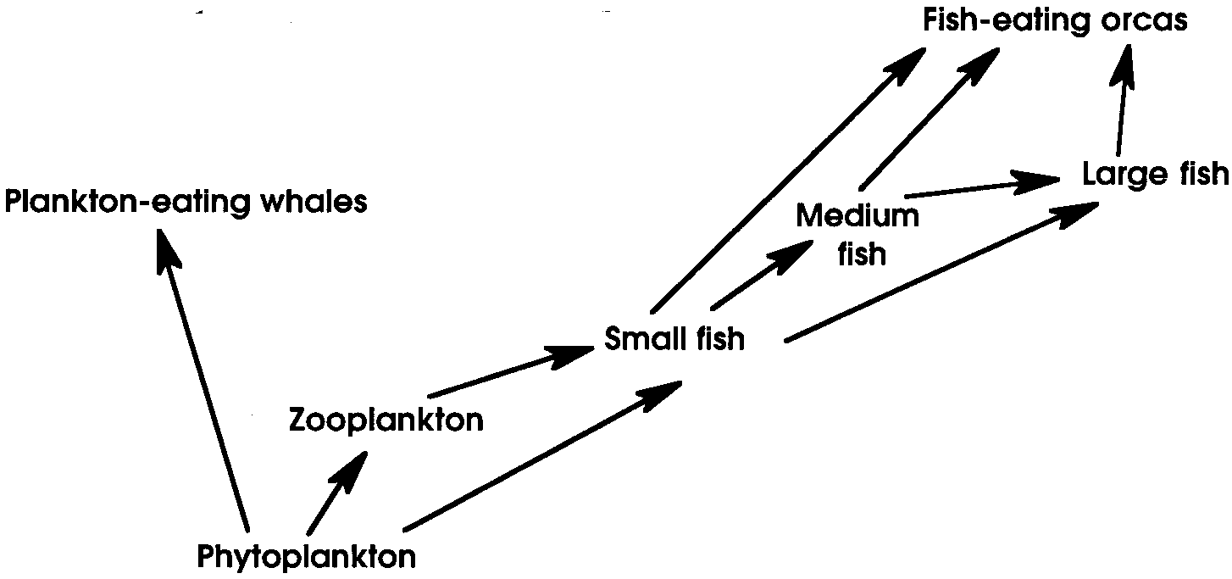
10. One possible answer is:

11. Answers will vary. As students attempt to label the consumers in their food web, they may discover that a single consumer can appear at several levels.

12. More than likely, the small fish can be 1st or 2nd order consumers. If they eat phytoplankton they are 1st order consumers. If they eat zooplankton, they are 2nd order consumers. The large fish can be 3rd or 4th order consumers, if they eat both small and medium fish.

13. The ORCA is a 4th order consumer.

14. The ORCA would indirectly eat 20,000,000 pounds of phytoplankton. The problem may be solved as follows:

10,000 pounds of producer X 2,000 pound 4th consumer = 20,000,000 lbs. = 10,000 tons
1 pound of 4th consumer whale

15.
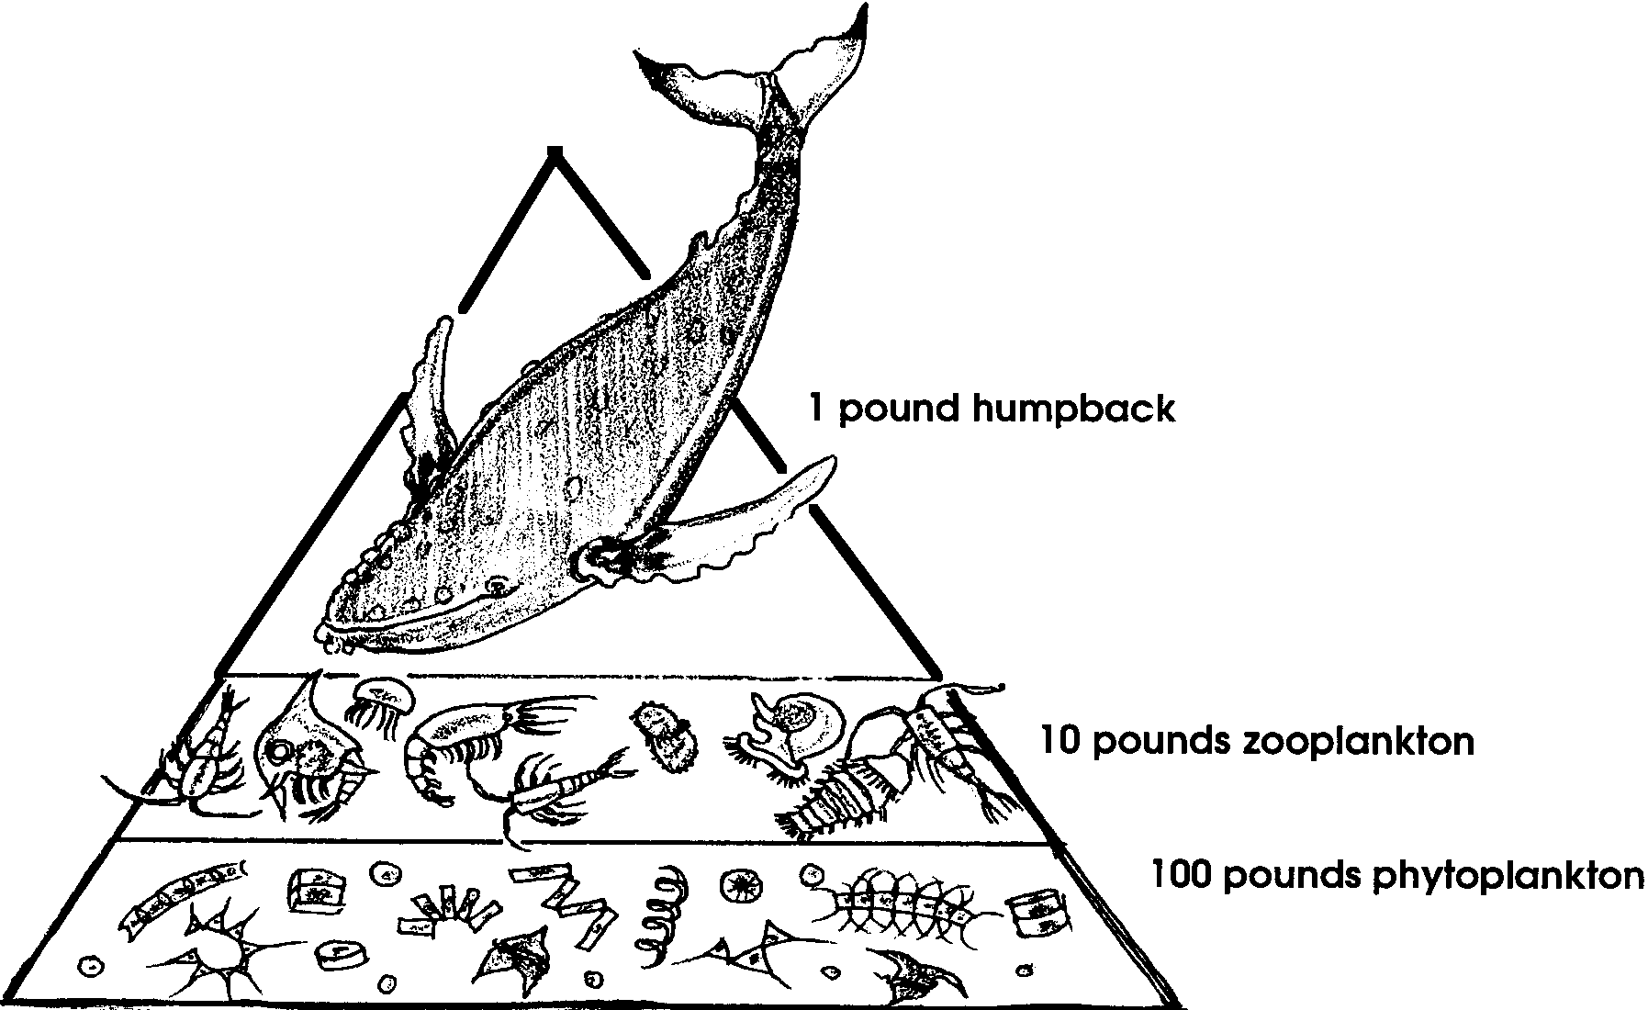

16. Answers will vary. Discuss the energy loss at each step. The shorter the food chain, the more efficient the use of energy.

17. Without phytoplankton, we would have no fish to eat. Phytoplankton are the foundation of most of the food webs in the ocean.

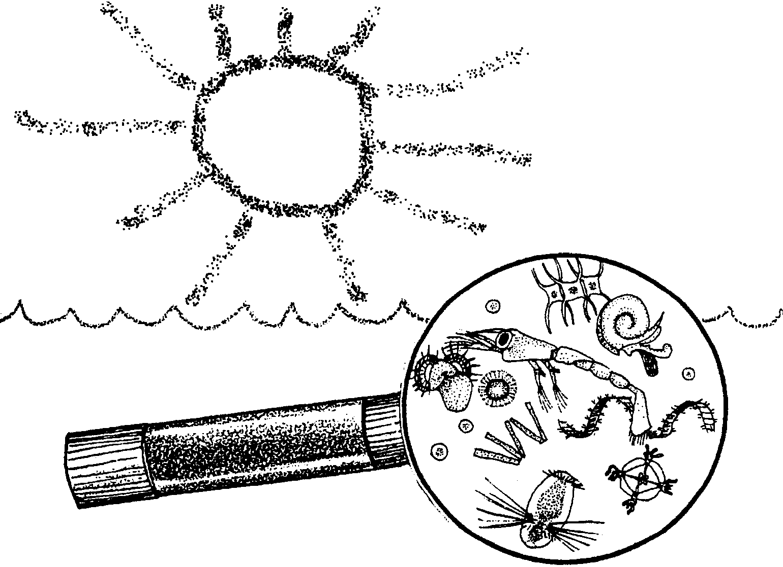
Sea Feasts

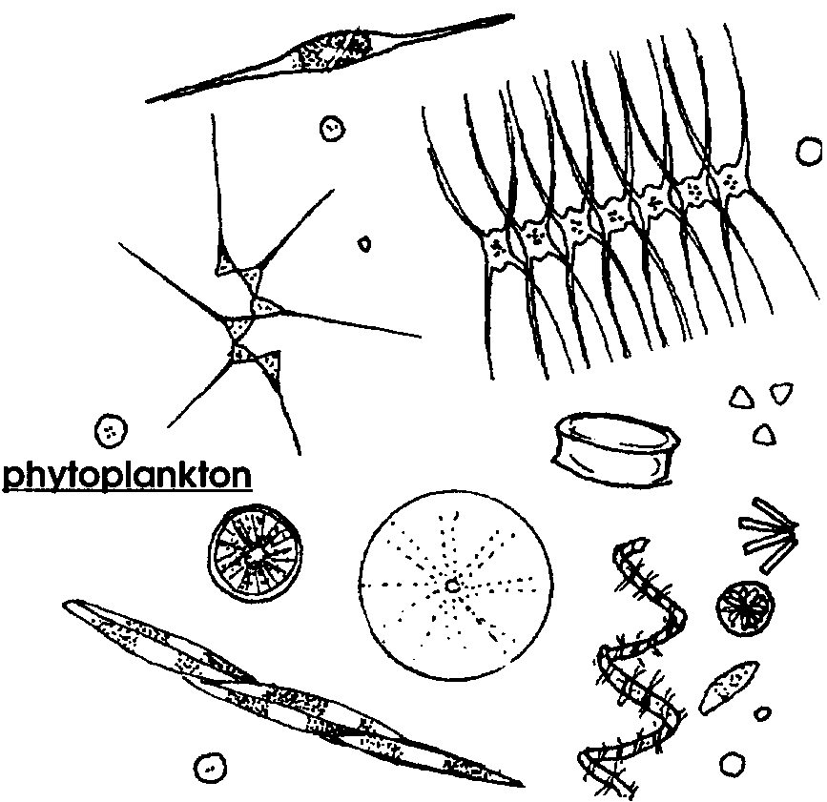
1. What are the floating plants of the ocean called?

2. List 3 things you know about phytoplankton.

a.

b.

c.

The great mass of tiny phytoplankton floating with the currents in the water is like ..... Like what? Like... a bowl of vegetable soup. Or, like... a cow’s green pasture. This is what some people think.

3. What do you think? Finish the following statement in your own words. You may choose to be poetic, humorous, or serious.

The great mass of tiny phytoplankton floating with the currents in the water is like .....

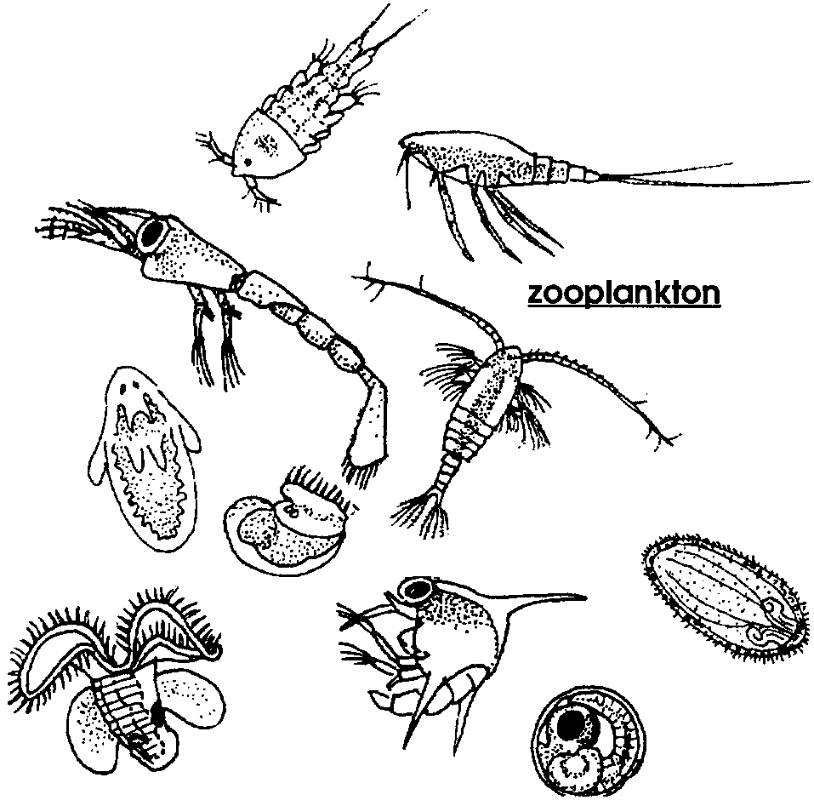
Included in the plankton are also the zooplankton.

4. List 3 things you know about zooplankton.

a.

b.

c.

Where It All Begins
Phytoplankton is often called the “grass of the sea”. They serve much the same purpose that grass and other green plants do on land. Land plants trap and store energy contained in sunlight. When animals eat the green plants, they get the energy that the plants have stored. Because plants store energy and produce food for other creatures in this way, they are called producers.
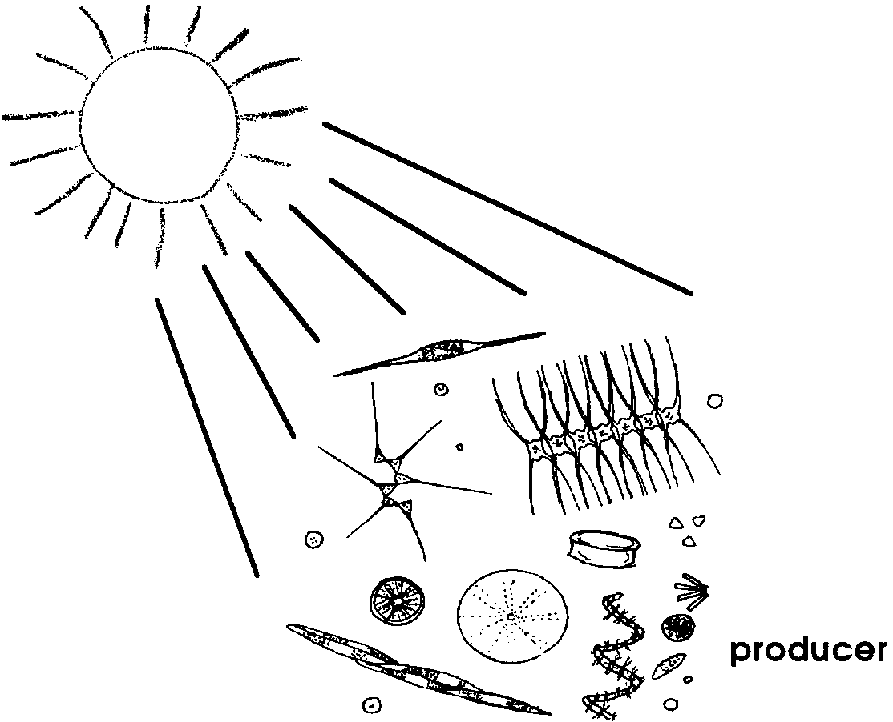

5. Like other plants, phytoplankton contain chlorophyll. That’s why they look greenish-golden when viewed under a microscope. It’s the chlorophyll in the plants that uses sunlight to produce sugars that provide food energy. Color the phytoplankton shown above.

6. Phytoplankton require sunlight to produce food. Where do you think they are found in the ocean?

Where It Goes
Zooplankton feast on the phytoplankton, or on each other. When zooplankton eat the phytoplankton, they get the stored energy in the phytoplankton. Because these animals consume this stored food, they are called consumers. Remember, phytoplankton are called the producers. They are at the base of most of the food chains in the sea.
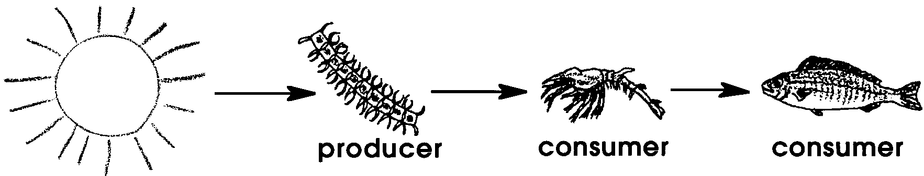

7. Complete the food chain below. Write in the names of the producer and consumer. (Hint: Look at the drawing of the food chain above.)

sun → → → small fish

producer consumer consumer

This is a very simple food chain. The arrows show which way the energy that the phytoplankton stored is moving.

A consumer that eats a producer is a 1st order consumer. It is the first to get the energy from the producer. A consumer that eats a 1st order consumer is a 2nd order consumer, and so on.

8. Look at the food chain in question 7.

a. Label the 1st and 2nd order consumers.

b. Add a 3rd order consumer.

9. Draw a simple food chain with at least three links. (Hint: What did you have for dinner last night? What did it eat? Remember that the arrows show which way the energy that the plants stored is moving.)

A food web is made up of several food chains. Sometimes they become very complicated.

10. Draw a food web containing these organisms: phytoplankton, zooplankton, small fish, medium fish, large fish, fish-eating orca whale, plankton-eating whale.

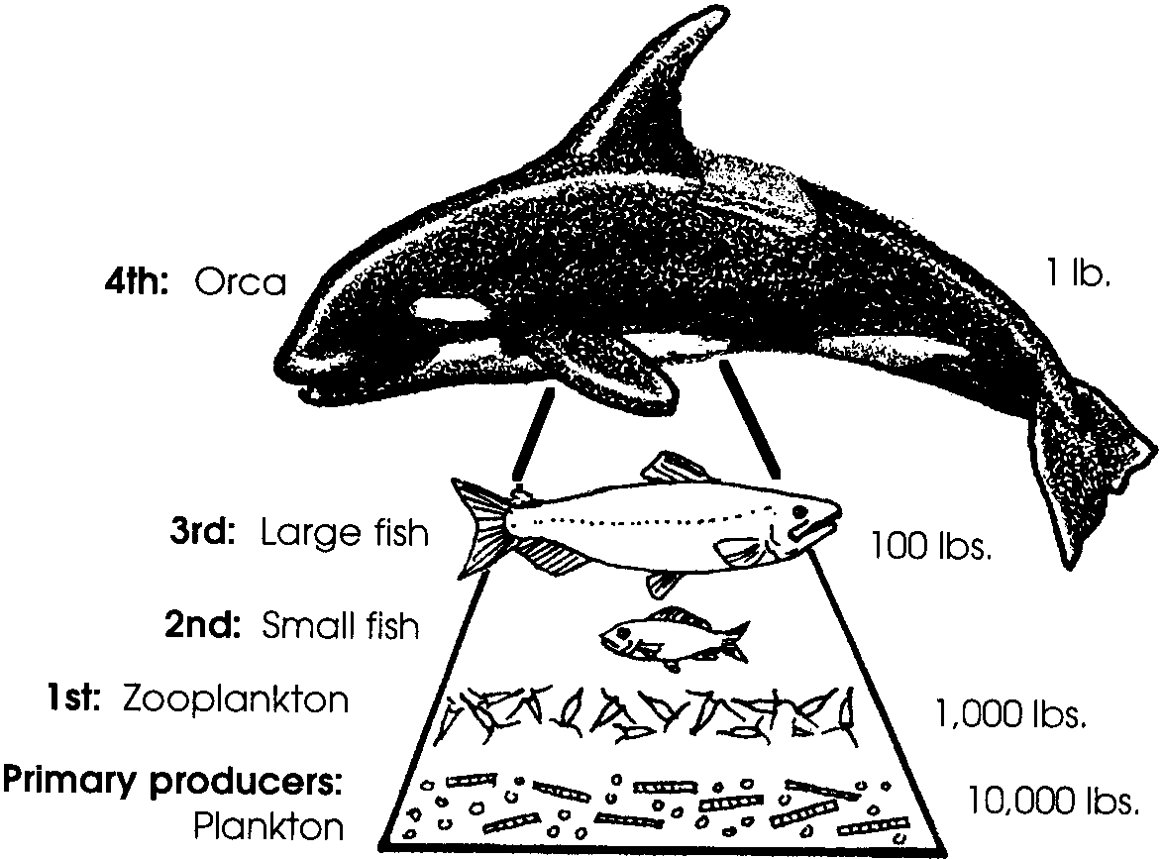11. Look at the food web you have just drawn. Label the producers and consumers. Include the order (1st order, 2nd order, etc.) for each consumer.

12. Is any animal both a first and second order consumer in your food web? If yes, which one(s)?

Wow! Giant orca whales depend on tiny phytoplankton. How much phytoplankton does it take to feed an orca? Let’s look at one food chain in this food web and see if we estimate how much.

The way energy passes through a food chain may be shown in a diagram like the one above. Such a diagram is called a food pyramid. As a general rule, it takes 10 pounds of producer to build one pound of 1st order consumer. It takes 10 pounds of 1st order consumer to build one pound of the 2nd order consumer, and so on. Notice that there is an energy loss of 90% with each link. This means that only 10% of the stored energy is transferred to the next level. Why is this? One reason is that not everything eaten makes new body tissue. Much of what is eaten can’t be digested. Additionally, much of the energy in an organism is used in moving, breathing, and other life processes. Energy used in these ways is not available to the next level up the food chain.

13. What level consumer is the orca shown in the food pyramid above?

14. How many pounds of phytoplankton does it take to “build” a one ton orca? (Hint: Look at the drawing above. How many pounds of producer does it take to produce one pound of fourth order consumer? One ton is 2000 pounds). Please show your work.

15. Complete the following food pyramid for the humpback whale, a plankton-eating whale. Remember to follow the general rule of 10% energy transfer.
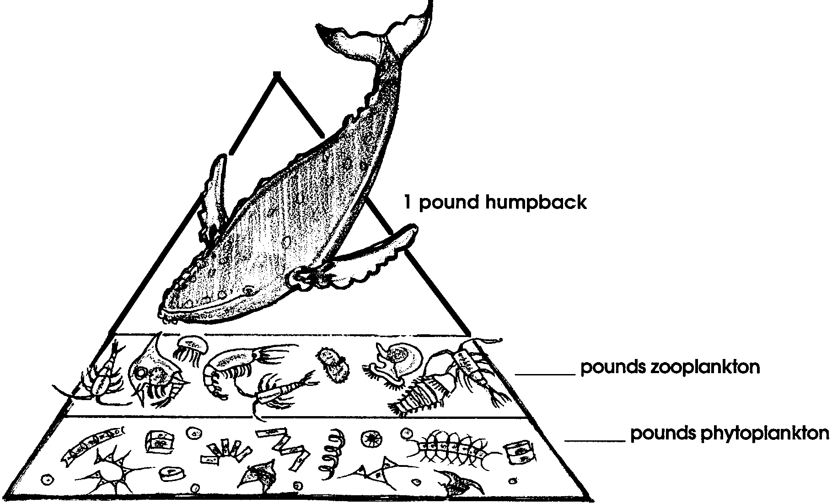

16. Look at the two food pyramids above. Compare them and discuss your observations in the space below.

17. Why do we say that plankton is the basis of life in the ocean?

