At the Ringside

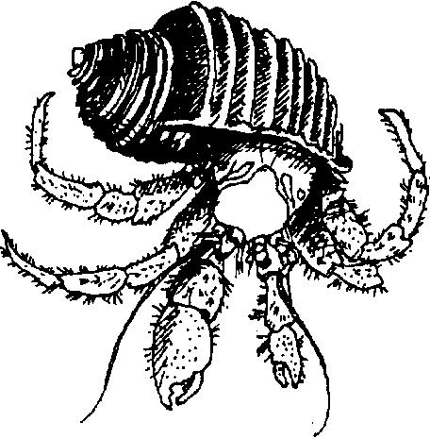
Key Concepts
1. Oxygen is filtered out of the water as it passes over a hermit crab’s gills and is absorbed into the blood. For short periods of time, crabs can take oxygen directly from the air.
2. Hermit crabs use their claws as feeding tools.

Teaching Hints

Read chapter 4 of Pagoo with students.

Chapter Summary

Pagoo is living on the ocean bottom, always struggling to stay safe and alive. He breathes oxygen by filtering it from the water or getting it directly from the air. He continues to eat by whipping water past his mouth with his claws and long, feathery feelers. Pagoo discovers he can use his claws for cutting, pinching, and plucking. He watches the sparring of grown hermit crabs.

Key Words

carnivore - a flesh-eating animal

gill - an organ (as of a fish) that can extract oxygen from water

Extensions

1. Have students try using chopsticks to lift food items such as peas, raisins or grapes. Then have them try again, using scissors. Try pliers now. Discuss the similarities and differences between these tools and the crab’s claws.

2. In this chapter, Pagoo notices that two adult hermit crabs near him are 12 times his height. Provide yardsticks, rulers and string and have students measure each other’s height, writing it down in their Field Guide. Then ask them to calculate 12 times their height. Have them look around the room (or outside the building) and estimate how high that would be in comparison to themselves.

