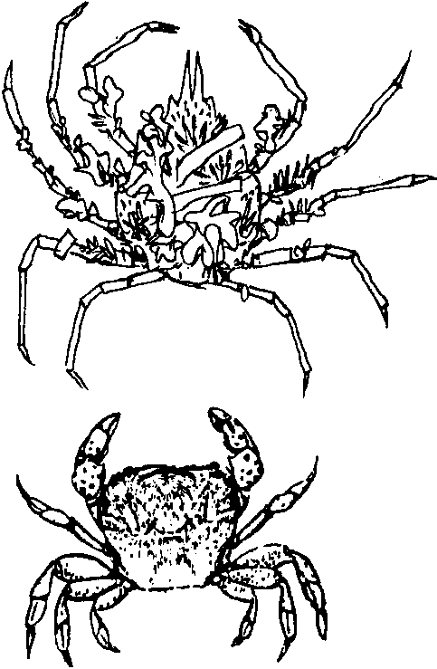
Crustacean Key

Key Concepts
1. The larger the group of animals to be identified, the longer the key. Crustaceans form an especially large, complex group.
2. Keys developed for localized areas and particular groups of organisms are easier to use than more generalized keys.

Background

Crustaceans have been important to people from earliest time. Early Babylonians, Greeks and Egyptians living near the Mediterranean no doubt ate both fresh and salt water crabs frequently. The crab had an even greater significance, since one of the signs of the zodiac, Cancer, is named after the Latin word for crab. Crabs are accurately depicted on ancient coins, murals and wall carvings throughout the area.

Crustaceans include many animals other than crabs. Among the more familiar are shrimp, hermit crabs, lobsters, barnacles, garden pillbugs, water-fleas and krill (one of the blue whale’s major food sources). They form a huge and important class of animals, found in almost every possible habitat on earth. Of the more than 26,000 species in this class, some are found on land and some are found in water, either salt or fresh.

Their identification is a challenge. Although the word “crustacean” derives from the Latin word for “shell,” unfortunately not all crustaceans actually have shells. Some have segmented bodies and legs but some do not at certain stages of their lives. Some have gills, some do not. Some have a flexible chitinous cuticle (covering), some do not.

Linnaeus’ development of a systematic classification scheme in 1758 was perhaps the first attempt to reconcile and categorize the many variations in appearance of the animal kingdom.

Shrimp, crabs and hermit crabs are all members of the order Decapoda, meaning “having ten legs.” Hermit crabs like Pagoo are different from shrimp and true crabs in the following ways:

• They do not make their own shell, but rather live in abandoned shells made by snails or worms.
• The abdomen is not segmented and is coiled (twisted).

• The first pair of walking legs (chelipeds) are claws, with the right one larger than the left.

• The second and third pairs of walking legs are long, slender and pointed. The fourth and fifth pair are smaller.

• Abdominal appendages (pleopods) are present on only the left side of the body and in females are used for carrying eggs.

• Appendages at the tip of the abdomen (uropods) are used to grasp the inside of the snail shell in which the hermit crab lives.

Marine hermit crabs can be found on the ocean bottom, from the high tide mark to very deep water. Like all crabs, they crawl along the bottom, scavenging for food. In some tropical areas, they are also found on land.

Materials

For each pair of students:

• “Crustacean Key” activity sheet

• ruler

• scissors (optional - they may cut apart the crab drawings if desired)

Teaching Hints

In “Crustacean Key”, students follow a greatly simplified key that focuses on crabs, one that might be useful on a Pacific beach in the state of Washington. In the process, they learn to recognize some important physical features and develop useful observation skills.

The drawings on the student activity sheet are life size depictions of several types of crabs found in the Pacific Northwest. Some are found on rocky coasts, some on kelp and some on pilings. They have been selected for the clear, measurable differences in their appearance, making it easier for students to use the key.

Pagoo contains lots of information about hermit crabs, barnacles and decorator crabs. After using this Key, students might enjoy referring back to those sections to learn more about these animals and to look at the drawings more closely.

Key Words

antennae - feelers; crustaceans may have only one set or many sets
carapace - hard shell covering the back of crabs and shrimp

chitin - a flexible protein substance secreted by some animals

crustacean - one class of the phylum Arthropoda

cuticle - body covering

decapod - a crustacean with 10 legs

segmented - composed of several similar parts, joined together in a flexible manner

Extensions

1. Students would enjoy caring for a land hermit crab in a dry, sand-filled aquarium. They can be purchased from Carolina Biological Supply Company or other similar scientific suppliers.

2. If you live in an area where live lobsters can be obtained, bring one into the classroom for a lesson. Students will find the animal’s size and movement exciting and will be able to examine the carapace, claws, antennae, etc. closely.

3. Have students research the word “cancer,” to try to understand the connection between its present use in referring to a disease and its original meaning of “crab.”

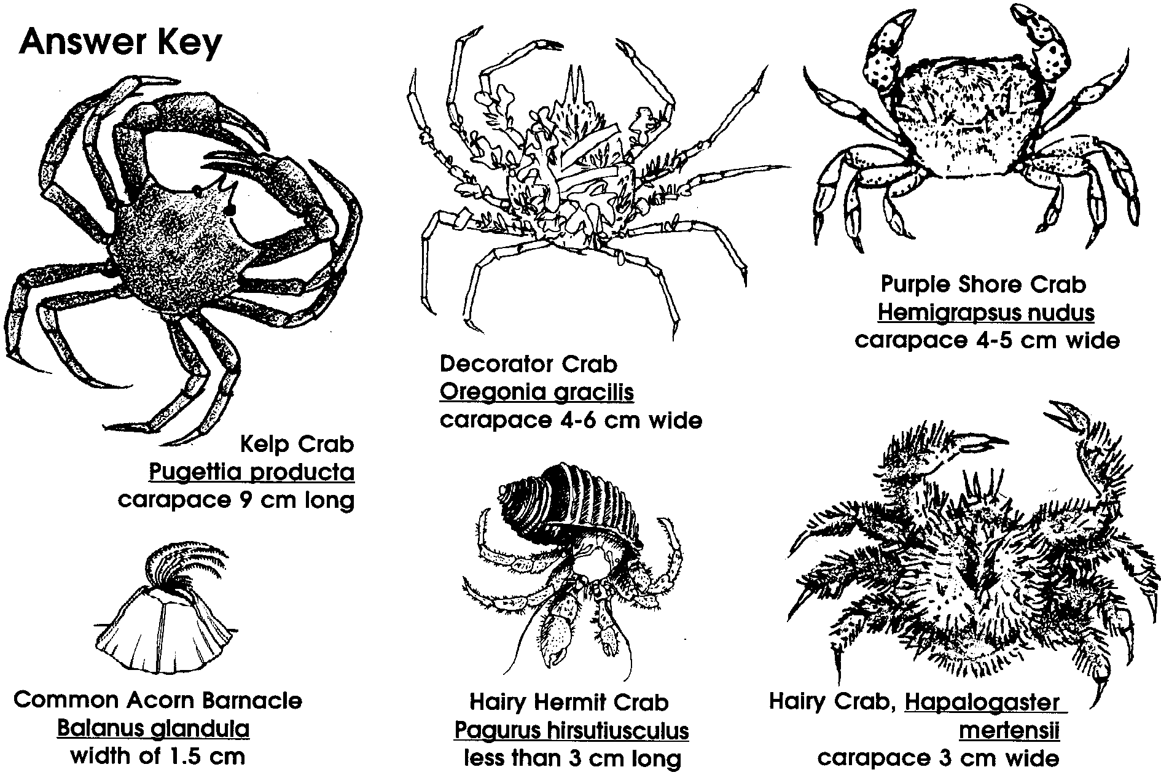

Crustacean Key

