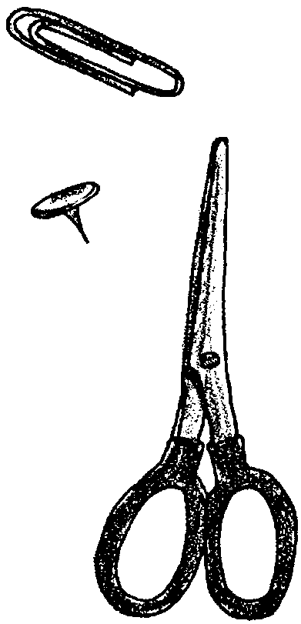
Who's Got the Key?

Key Concepts
1. Keys are used to identify unfamiliar objects (natural or human-made).
2. Keys are based on the distinguishing features of any object. It is possible to construct different keys based on a variety of different characteristics.
3. Keys pose questions that lead one from general to more specific characteristics.

Background

An ordinary household key usually allows you to unlock a door and enter a room. A scientific key permits you to proceed in a simple, stepwise fashion through a confusing maze of physical or behavioral features of an organism, finally allowing you to positively identify the organism. This is important since knowing the precise name of an organism is essential to any further research you might care to conduct.

Most keys are dichotomous, (di-kot’-e-mus), i.e., you are given a choice of two statements at every level. Here are some examples:

• “The flower is red.” or “The flower is not red.”

• “The body is less than 1 inch long.” or “The body is one inch or greater in length.”

Only one of each pair of statements can be true. You choose the correct one and the key then directs you to the next pair of statements for another choice. Each succeeding pair of statements is more specific in describing the organism, so that, as you choose, you get closer to a positive identification.

In making up a key, it is important to use features that can be verified by observation and that are clear and, if possible, quantifiable (“it has 8 legs”). Avoid words that are vague or open to many interpretations (“big” or “beautiful”). Also avoid descriptions that are true only at certain times in an organism’s life cycle or that are true only of one sex.

Because of the vast number of organisms on this planet, it would be impossible to have one key to identify them all. Keys that are restricted to one locality may be the most useful ones since they limit the number of possibilities and reduce the number of choices that need to be made. Using a key from your area can help you identify a fish you catch, a bird seen swimming offshore or a plant found on a walk in the woods.

Materials

Part I

For the whole class:

• one set of objects typically found on a desk: metal thumb tack, pencil, eraser, paper clip, stapler, pair of scissors, fountain pen

For each pair of students:

• “Who's Got the Key?” activity page 1, containing Key #1

Part II

For the whole class:
• same set of objects as above

For each small group of students:
• “Who's Got the Key?” activity page 2, containing Key #2

Part III

For each pair of students:

• a plastic bag containing an assortment of 10 common, different hardware items (nuts, bolts, screws, washers, nails, wing nuts, cotter pins, etc.) Have all items vary in length as well as function. Some should be familiar to the students while others may raise curious questions.

• ruler

• paper and pencil for writing the Key

Teaching Hints

“Who’s Got the Key?” introduces students to the concept of identification keys. There are three parts to this activity. In Parts I and II, students practice using keys supplied by the teacher. In Part III, they construct their own key.

Part I

Following a key requires care and a willingness to work step by step. To warm up for this activity, we suggest that you first select any one item on the desk, hold it up and ask the class to name as many observable characteristics of that object as they can. For example, holding up the paper clip might yield the following descriptions from the students: metal, made of wire, flat, has both curved and straight parts, 3 cm. long, used to hold things together.

Write their descriptive phrases on the blackboard as they are given. Stress that all are equally correct. Then look at each statement and ask students to say an opposing statement, such as “not made of metal” or “not made of wire.” This will help them understand the logic of the descriptions found in dichotomous keys.

For additional practice, point to each description in turn and ask them if they can think of any other object that satisfies that description. For example, “Name another object made of metal” or “Name another object made of wire.” This will help them see that one description is never enough to completely characterize an object.

Now ask them to turn to Key #1 on the student worksheet and work through it with the whole class until students are satisfied that every object has been identified. Logical questions may arise or students may disagree with the description of some characteristics. Be sure their concerns are addressed so that they feel comfortable before moving on to the next part of the activity.

Part II

After the practice in Part I, students should feel more comfortable with the use of a Key. Ask small groups of students to each choose one item and have them work through Key #2 for that one item. Have them notice and discuss the different types of characteristics used in Key #2. This key has several weaknesses:
• words such as “long” and “small” are vague
• description of attaching papers in steps 4, 5 and 6 is unclear.

Ask students if they noticed any other weaknesses. Were they still able to positively identify each item? Did it depend on their prior familiarity with the objects.

Part III

Students working on their own may want to start by just observing different characteristics of their collection, as you did earlier in Part I. Have them select one major difference between the objects. That will determine the first step of their key. Ask them to separate the objects into two groups based on that difference.

Then have them examine each group separately and subdivide them by some other characteristic. Ask them to keep doing this until each item is in a group by itself (positively identified).

Have them take notes as they work, writing down the characteristic at each step. At the end, ask them to write the key formally, following the pattern established in Keys # 1 and 2.

Ask each pair of students to switch keys and objects with another pair. Have them use this new key to identify the objects and then evaluate its effectiveness as an identification tool.

Key Words

dichotomous key - a key that repeatedly divides items to be identified into two groups.

key - a systematic classification, usually in table form, of the significant characteristics of the members of a group of items or organisms used to facilitate identification

Extensions

1. Research classification methods used by other cultures. For example, in some cultures a coyote might be identified by its trickster behavior or a raven by its wisdom. Plants used as medicine may have names that indicate the body part they help to heal. Constellations may be identified by their association with a season.

Students might like to make up a similar classification scheme for a group of animals they know well, such as dogs, cats, chickens, goldfish, etc.

2. Provide puzzles and games of logic for students to play in their spare time. Here are two samples:

All dogs have four legs.
Rex is a dog.

What can you conclude?

All dogs have four legs.
Goldie has four legs.

What can you conclude?

Answer Key

Students will know when they are successful when all objects have been identified. Answers to the other questions will vary.

Who's Got the Key?
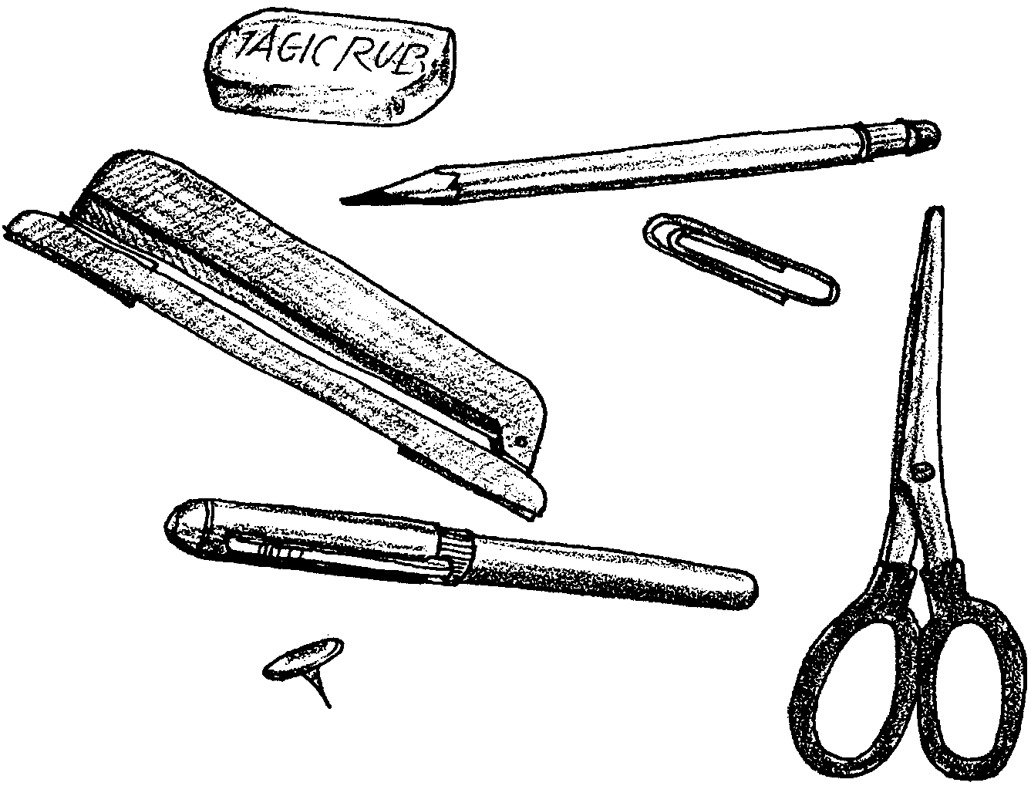
Part I - Key #1

The Keys below have been specially written to help you identify the objects on the teacher’s desk. To use the Key, choose one object at a time. Work through the Key for that object. Follow the “path” outlined. You will eventually reach a positive identification of each object.

A Key to Common Objects Found on a Desk

1a Object made entirely of metal 2
1b Object not made entirely of metal 5

2a Object does not have small, sharp metal point(s) 4
2b Object has small, sharp metal point(s) 3

3a Flat end is less than 1 cm in length thumb tack
3b Flat end is 1 cm or greater in length stapler

4a Object made of bent wire paper clip
4b Object not made of bent wire 5

5a Object made entirely of rubber eraser
5b Object not made entirely of rubber 6

6a Object partly made of wood pencil
6b Object contains no wood 7

7a Object contains fluid pen
7b Object does not contain fluid scissors

CONGRATULATIONS!!!
Part II - Key #2

A Key to Common Objects Found on a Desk

1a Object used for writing 2
1b Object not used for writing 4

2a Object uses fluid to make an image pen
2b Object does not use fluid 3

3a Object makes dark mark on paper pencil
3b Object does not make mark on paper 7

4a Object used to attach papers together 5
4b Object not used to attach papers together 6

5a Object has several completely separate parts stapler
5b Object does not have completely separate parts paper clip

6a Object used to cut paper scissors
6b Object not used to cut paper 7

7a Object removes marks from paper eraser
7b Object does not remove marks from paper 8

8a Object used to attach paper to wall thumb tack
8b Object not used to attach paper to wall .......

CONGRATULATIONS !!!

How does Key #2 compare with Key #1? Which is easier to use? Are any of the statements too vague? What improvements would you make?

PART III - Write Your Own Key

Your teacher will give you a set of objects commonly found in a hardware store. You may recognize some. Others may be unfamiliar. Your partner or other students may recognize the unfamiliar ones. If necessary, ask the teacher for the names and use of the really tough ones.

Your job is to write a key that positively identifies each item.

1. Start by just looking at the objects. Notice as many characteristics as you can. Then choose one characteristic and separate the objects into two groups, depending on whether they have that characteristic or not. Write that characteristic on your paper.

2. Now look at each of those groups in turn. Choose a different characteristic and divide each group into two groups based on that new characteristic. Write that characteristic down.

Repeat that process.

3. When you finally have each object alone in a group, you are finished. Congratulations. Now write your key, following the pattern of Key #1 and Key #2.

4. Exchange keys and objects with another pair and try using the new key to identify the new objects. Evaluate this new key. What are its strengths and weaknesses?

