Observing Crustaceans

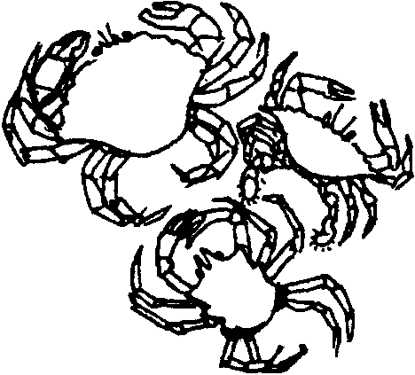
Key Concept
1. Crabs have unique structural and behavioral adaptations which help them survive in their habitat.

Background

Where to Get Crabs

If you live near the coast, you may be able to obtain a permit to collect crabs. Call your state’s Department of Fisheries to check on collecting regulations and permits required. Shore crabs are easily obtained by turning over rocks at low tide (please turn all rocks back to their original position). With a little work, larger crabs can be taken with a scoop or crab pot. Be sure to check local regulations for season, size and number limits. Crabs may also be obtained from fish wholesalers and some supermarkets. A live crab is best, but a dead, whole crab will allow much of the exercise to be completed. Biological supply houses such as Carolina Biological Supply, 2700 York Road, Burlington, North Carolina 27215, supply live crabs at a reasonable cost. Most of the exercise could also be completed using hermit crabs.

Keeping Crabs Alive

It is important to remember that you must replicate the natural environment of the crabs to keep them alive and well. For example, shore crabs are not completely submerged in saltwater all the time. They need access to saltwater, but they also need a place to crawl out. Other crabs do very well totally submerged in saltwater.

Materials

For the class:

• aquarium, 10 gallon
• saltwater
• sand for the bottom of the aquarium (to observe digging behavior)
• copies of student activity sheet, “Observing Crustaceans”

For each group of three or four students:

• a clear container in which to keep the crab
• living crab (shore crabs are fine)
• ruler
Teaching Hints

Crabs are used as the focus crustacean in this lesson. Adapt this lesson and use crayfish, lobsters or whatever crustacean is most available. Crayfish used in conjunction with crabs provide opportunity for a comparative study of a freshwater organism.

This lesson may take one or two hours to complete. Crabs are an ideal specimen in most areas because:

1. They are easy to keep alive and are relatively available.

2. They are large enough so that the various parts can be seen without the aid of a microscope.

3. They show outstanding specialization of appendages (legs, pincers, etc.). Form and function can be easily related.

Crabs can have a strong grip. To avoid being pinched, grasp the crab across the back. Watch the action of the pincers. Demonstrate proper handling methods to the students and observe the handling carefully. Help instill in your students a respect for life. The easiest way to do so is by modeling your attention and interest in living things.

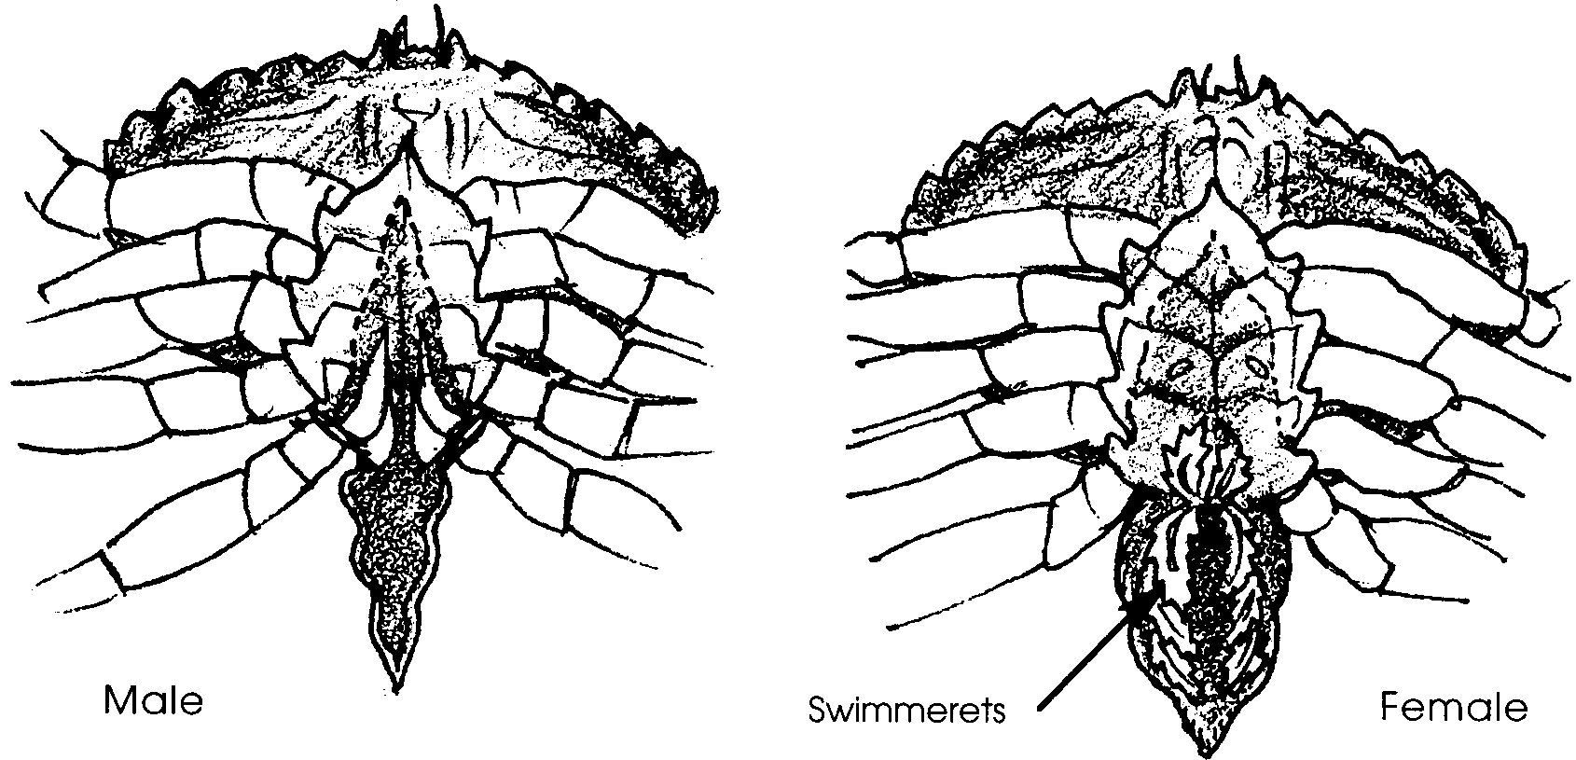
You may choose to show students the swimmerets, located under the abdomen flap. They are easiest to observe on a female crab. Get a good grasp on the crab. Turn her over and find the wide abdomen flap between the legs.

Gently pull back the flap (not too far) to observe the feather-like appendages below the flap. These are the swimmerets.

But What If I Can’t Get Crabs Where I Live?

If crabs are hard to come by where you live, think about substituting other crustaceans in the activity “Observing Crustaceans”. Crayfish, also known as “crawfish” or “crawdads”, are a good choice. There are more than 200 kinds of these freshwater crustaceans in North America. They inhabit streams or ponds where they scavenge for food, eating almost any plants or animals they can find or catch.

Much can be learned about crayfish in particular, and crustaceans in general, through careful observation. Crayfish have several pairs of legs. The first pair is modified and possesses claws or pincers used for protection, digging burrows, and catching and eating food. They also have four pairs of walking legs. The front two pairs are for grasping, chewing, and locomotion. The last two pairs are used only for moving from place to place.

Crayfish have other paired appendages, as well. Special appendages on the underside of a crayfish beat rhythmically to push water into the opening in the exoskeleton (the crayfish’s “shell”) which houses the gills. Swimmerets, paired appendages on the abdomen (“tail”) are used by the female as points of attachment for the eggs which are laid in the spring.

Like all crustaceans, a crayfish must shed its exoskeleton in order to grow. The exoskeleton, once it is formed, does not continue to grow. A new shell grows to replace the old one. The new shell is formed under the old and is soft and pliable at first, taking four or five days to harden. Very young crayfish molt several times while still hanging on to their mother’s swimmerets. A young, free-swimming crayfish will molt every two or three months until it reaches adulthood at about two years of age. Adults usually only molt in the spring.

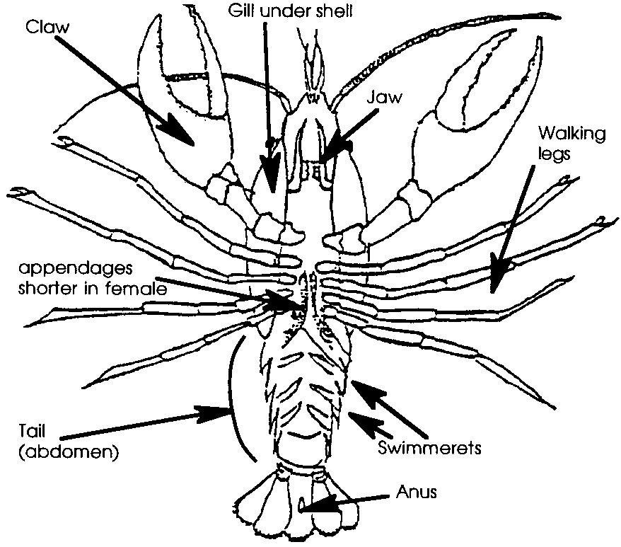
Crayfish often can be caught in neighborhood ponds and streams. During the day, crayfish hide under rocks, in burrows, or beneath snags, avoiding currents. During the night they dig their burrows. If you (or your students) opt to catch and keep crayfish for this activity, be sure to provide adequate water which is frequently changed or is aerated. Feed them only once or twice a week - overfeeding, which often fouls the water, is a common cause of captive crayfish demise. Avoid hamburger, hot dogs, and other fatty meats in favor of bits of fish, rabbit food, or crayfish or turtle food.
Key Words

antennae - a pair of jointed sense organs on the head of a crustacean; feelers

appendage - any external part or organ joined on to the trunk or main body, such as legs, arms, etc.

average - the number obtained by dividing the sum of a group of quantities by the number of quantities in that group

crustacean - one of a group of animals characterized by jointed legs, segmented bodies, and hard external skeletons (exoskeleton)

habitat - the place where a plant or animal lives; home

pincers - claws on a crab’s front two legs

stalks - long, slender supports

structures - something made up of parts

survive - to continue to live in spite of difficult conditions

swimmerets - a series of small abdominal appendages in some crustaceans, used mostly in swimming and in carrying eggs

Extensions

1. Research two different crustaceans, in the same or different habitats. Compare and contrast behavioral and structural adaptations. Present findings in a rap, poem, song, interview, poster, etc.

2. Research and report on techniques for harvesting crabs for sport and commercial purposes, including regulations and restrictions. Why do students think harvesting crabs is regulated?

3. Have students find out how big the world’s biggest crab is or how much it weighs.

4. Cook and eat fresh crab.

Answer Key

1. Answers to this and following questions depend upon observation. Crabs walk sideways using specialized walking legs in “pull-push” style.

2. Generally, crabs have 10 appendages.

3. Some species swim quite well. Others barely at all.

4. Usually the crab uses all legs in walking except for those bearing the pincers.

5. Answers depend upon the particular crabs.

6. Most crabs dig using their back legs.

7. Crabs catch live food with their pincers.

8. Pincers also serve to move food to mouth.

9. While it is not always possible to see where water enters the gill chamber, close observation often reveals the location. A drop of food color placed near the mouth can be helpful in disclosing the opening. If you elect to use the dye technique, place the crab in clean saltwater before continuing with number 10.

10-15. Answers will vary depending upon crabs observed by class.

16. Most crabs can hold up entire weight with one pincer.

17. Few students can lift themselves up with one arm.

18. Pound for pound crabs are stronger than fifth graders!

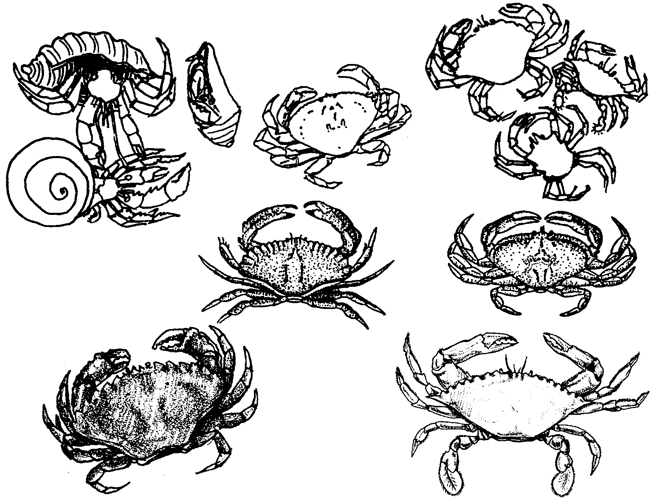
Observing Crustaceans

The crab is a very interesting creature. In this activity you will carefully observe this animal. As you watch, think about this question: How do a crab’s body structures and behaviors help it survive?

Observe a crab in the aquarium.

1. How does the crab move?

2. How many appendages (legs, etc.) does the crab have?

3. Can the crab swim?

4. What appendages does the crab use in walking?

5. Are any of the crabs forming new appendages?

6. How does a crab dig in the sand? Why does it dig in the sand?

7. How does the crab catch live food?

8. What appendages are used in getting food to the mouth?

Collect one of the crabs in a small, plastic container for observation. Sketch the crab on the back of this page. Make your drawing large. Label body parts. Include details.

9. Can you see where water enters the crab’s body? The moving water carries the oxygen the crab needs to live.

10. Look at the shape of the triangular flap on the underside. What sex is your crab?

Sketch the abdomen.

11. How wide is your crab (across the back)?

12. How wide is the widest crab in the class?

13. How wide is the narrowest crab in the class?

14. Estimate the width of the average crab. (Hint: a good guess would be a width about halfway between the widest and narrowest crabs.)

15. Find the true average. Do the following:
a. add all of the widths.
b. divide by the number of crabs measured. The answer is the average.

Test the power of the crab’s pincers by placing a pencil between the pincers. DO NOT PUT YOUR FINGER BETWEEN THEM. Try to lift up the crab using your pencil. Be careful not to lift the crab too high. You only want to see if it is powerful enough to lift its own weight.

16. Can your crab hold up its own weight with one pincer?

17. Can you lift yourself up from the ground with only one arm?

18. Pound for pound, who do you think is stronger, crab or person?

