Pagoo Is a Hermit Crab!

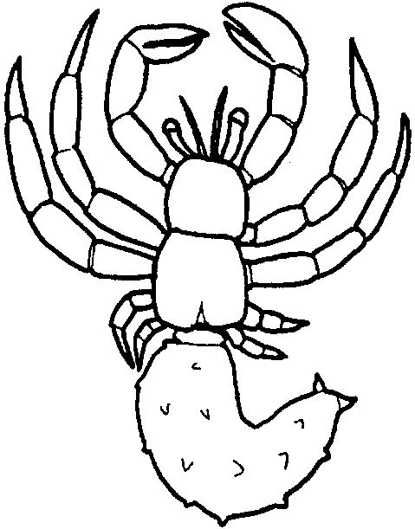
Key Concepts
1. As hermit crabs grow, they develop eyes on stalks, ten jointed limbs (five on each side), and claws.
2. Hermit crabs have a reduced abdomen and are not considered to be “true crabs”.
3. Hermit means one who lives alone, and hermit crabs usually do.

Teaching Hints

Read chapter 3 of Pagoo with students. Continue work on the Pagoo Field Guide, perhaps adding drawings of Pagoo’s jointed limbs or stalked eyes. The students might notice the resemblance of Pagoo to drawings or photographs of robots they have seen. Discuss the similarities and differences.

Chapter Summary

Pagoo continues to molt and grow. He develops jointed limbs, claws, long legs, feelers, and a strong abdomen ending in a soft tail-paddle. Pagoo is an anomuran, not a true crab. He has grown enough to drift down to the rocky shore. Old Pal warns him to protect his bare, tender behind!

Key Words

anomuran - a member of a group of crustaceans that are not true crabs but have a reduced abdomen; the term means “with an unusual tail”

Brachyura - the true crabs; with a short, broad, usually flattened carapace, and a small abdomen that curls forward beneath the body, short antennae, and anterior limbs modified as grasping pincers

crustacean - one of a group of animals characterized by jointed legs, segmented bodies, and hard external skeletons (exoskeleton)

hermit - one that retires from society and lives in solitude

Extensions

1. Research and report on other animals that live alone, rather than in social groups, e.g., blue whale, grizzly bear, spotted owl.

2. Write a story about a person who chose to be a hermit.

