Tidepools in the Classroom

Activity by Pat Williams, Eugene, Oregon

Key Concepts
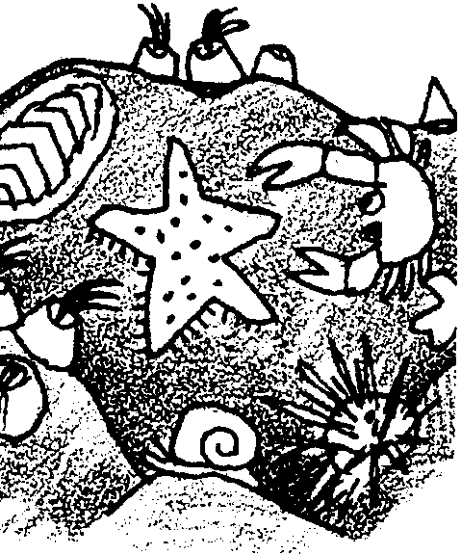
1. The periodic rise and fall of saltwater up and down the beach (or shore) is called the tide. The area of the beach affected by these changes in water level is called the intertidal zone.
2. A tide pool is formed when receding seawater is trapped in a hole or depression in the rocky shore.
3. Tide pools provide habitat for many plants and animals of the sea, often supporting heavily populated communities with a wide diversity of organisms.
4. Plants and animals that live in the intertidal zone, including tide pools, have behavioral and structural adaptations which help them to survive in this harsh environment.

Background

Life in the intertidal zone, the area affected by the periodic rise and fall of sea level that we call the tides, is difficult. The rise and fall of the tides alternately expose the intertidal rocky shore and its tide pools to varying amounts of sun, air, and water. Plants and animals are exposed to great variations in temperature, sunlight, and drying. These conditions can vary from place to place on the shore.

Areas within the intertidal region can be divided into four zones which reflect their different exposures to the elements:

The Spray Zone. Occasionally exposed to spray and water carried in by the highest tides and storms, the spray zone is basically a dry, terrestrial area. Animals and plants in the spray zone must adapt to both fresh water from the rain and salt water from the ocean. They must withstand extremes in heat and retain moisture during long dry periods.

High Tide Zone. This zone is usually uncovered except during high tides. Plants and animals in the high tide zone must also adapt to elements and forces outside the marine environment, as well as to the marine conditions which exist when they are submerged. They need to tolerate wave action, changes in temperature and salinity, and exposure to air and water. Many organisms in this zone cling to rocks and rely on the tides to bring food to them. More species are found in this zone than in the spray zone.

Mid Tide Zone. Alternately covered and uncovered during most tide cycles, conditions in the mid tide zone are more moderate with fewer changes in temperature and salinity. More food and oxygen is available than in the high tide zone and, as a result, this zone has more species. Animals and plants living here must anchor themselves against wave action.

Low Tide Zone. The low tide zone is covered by seawater except during the lowest of low tides. Here, conditions are more constant in terms of salinity, temperature, and exposure to air and water. Most organisms found in the low tide zone are not able to survive in the upper zones. It is a crowded area that contains more species than any of the other intertidal zones. Abundant seaweed creates a layer of protection for the inhabitants of this zone when the tide is low. Stresses are lower from environmental change, but greater from predators and competitors.

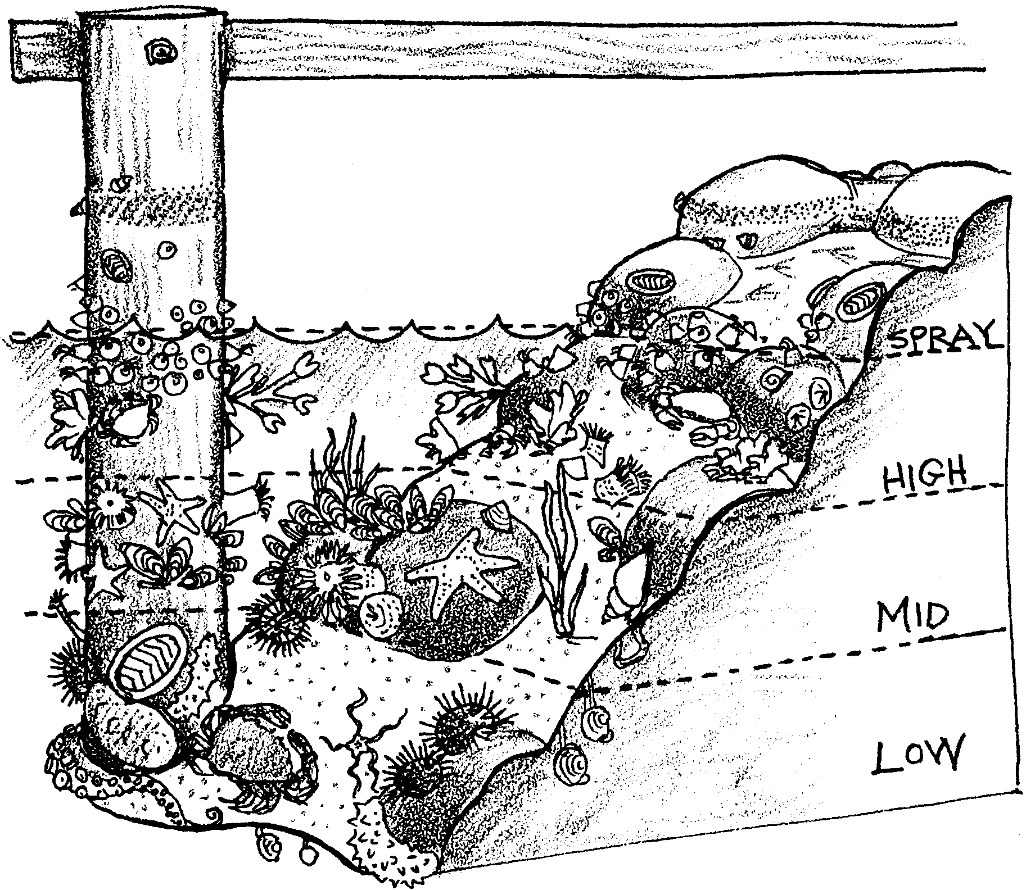
Adaptations for Life in the Intertidal Zone

The plants and animals of the intertidal zone face harsh and continuously changing conditions. These organisms have developed special behaviors and structures to assure their survival in the tide pools of the intertidal zones. Organisms must adapt to wave force and desiccation (drying out). When the tide is out, water remaining in the pools is not refreshed, so inhabitants must adapt to changing water temperatures (warming in summer, cooling in winter) and depleted oxygen levels. Evaporation and rain may also change the salinity of the water. Organisms must also adapt to predation and competition for space and food.

Waves — “The need to hold on”. To withstand the constant push and pull of waves and tides, animals and plants in the intertidal zones must be able to anchor themselves in some manner. A variety of mechanisms are employed to keep from being washed away. Sea stars and urchins use suction; mussels attach themselves to rocks using sticky threads called byssal threads. Barnacles glue themselves to rocks and surround themselves with shell plates. Snails, chitons and limpets hold tight with muscular feet. Seaweeds hold their ground with structures called holdfasts, which look like roots, but serve as anchoring devices, not as means of getting nourishment. Seaweeds are also flexible so that they can flow with the motion of the tides and waves.

Desiccation — “The need to keep wet”. Plants and animals also possess a wide variety of structures and behaviors to avoid drying. For example, some animals such as snails, limpets and barnacles adapt to the drying effects of sun, air and wind by clamping down tightly on a marine surface (e.g., a rock, another animal) and trapping moisture inside their shells. Bivalves such as clams and mussels shut their shells. Sea anemones spread sand over themselves and close up to conserve water. More mobile animals retreat to dark, cool hiding places in the rocks or under wet, moist seaweed. Some seaweeds have leathery skins to prevent moisture loss and some can become quite dry without dieing. The color of an animal or plant also affects the absorption and drying effects of sunlight.

Predators — “The need to avoid being eaten”. Other adaptations offer protection from predators. Many animals like limpets and barnacles have hard shells. Others, like sculpins, use color as camouflage. Still others, like crabs, can scamper away and hide.

Food — “The need to eat”. In addition to avoiding damage from waves, drying, and predators, intertidal animals have to eat. A large number of eating styles is seen in the intertidal zone. Filter feeding organisms, such as the barnacle, filter food from the water. The barnacle uses little feathery feet that reach out to grab plankton. Scrapers, such as chitons and snails, have raspy tongues that scrape algae from rocks. Scavengers, like crabs, feed on the remains of dead plants and animals. Predators use a variety of means to capture their prey; sea anemones sting their prey, while sculpins catch small prey in their mouths. Seaweeds absorb nutrients from the sea through all surfaces of the plant.

Materials

Materials requirements vary depending on the number and size of tide pools constructed.

For constructing the tide pool:
• heavy cardboard or plywood for the base, approximately 4' X 4' (one for each tide pool to be constructed). Cardboard bases are easier to move than plywood bases. The size of the base is not critical.

• newspaper

• masking tape (three rolls)

• papier-mâché adhesive (thin flour and water mixture)

• dish pans or buckets

• drop cloth or tarps for working area(s)

• tempera paints and brushes

For seaweed:

• green cellophane

• brown, green and red tissue paper

Teaching Hints

In “Tide Pools in the Classroom”, students create a life-sized replica of a coastal, rocky shore tide pool. This wonderful, “hands-on” activity is especially good for kinesthetic learners. The activity brings abstract ideas into concrete form.

While this activity can be messy, it uses easily acquired materials and provides a great process and product. Students work together and learn from each other in cooperative learning groups. The project reinforces and demonstrates what students will learn about the tide pool habitat as they move through Pagoo. It can be used for evaluation of the unit. The tide pools also make excellent displays for “Back to School Night” and similar events.

This project will take from 4 to 10 days, depending on the length of each session.

Constructing the Tide Pool

Phase 1: Building the Base (1-3 sessions)

1. Put the plywood or cardboard base on a horizontal stand or table. Allow walking room around the table. Place a tarp or drop cloth underneath.

2. To begin forming the tide pool, have students wad up single sheets of newspaper and tape down the wads with long pieces of masking tape. Shape the pool on the base using the wads of newspaper, making one side of the pool higher than the other. Wads can be stacked on each other to create the irregular shapes of natural, rocky tide pools. The result should not look like an inner tube. All of this is done with dry, wadded newspaper. The messy part comes next.

Phase 2: Papier-mâché (1-2 sessions)

1. Before class, mix water and flour into a glue with a consistency of very thin pancake batter. Mix enough for two buckets per tide pool, and about two quarts of the mixture per bucket. (Parent helpers can make excellent mixers.)

2. Have students tear newspaper into six inch wide strips.

3. Proceed with the papier-mâché molding. (Here comes the mess - see hints below.)

Have students hold a newspaper strip by one end and dip it into a bucket of glue. To remove excess glue from the strip; hold up the strip with one hand; place the first and second fingers of the other hand around the strip, near the top; grip the paper gently with fingers and slide the fingers gently (to avoid tearing) down the strip. Students may need some guidance. One approach involves taking turns: have them form a circle around the table with one child dipping, one stripping, one applying; then, rotate to the next step.

4. Place the wet strips over the wadded newspaper. Create a natural look by leaving rock-like humps, holes, and crevices.

HINT: If the tide pool is too smooth and round, squish it and poke it with your hands to make it more irregular and natural looking, like rocks.

5. Let the structure dry overnight.

6. Repeat steps 3 & 4, as needed.
Phase 3: Painting the Tide Pool (1-2 sessions)

Have students paint the tide pool with tempera paints. Use rock-like colors (gray, brown, green-browns) and various shades of blue for water.

Phase 4: Constructing the Animals and Seaweed (1-3 sessions)

1. Cut green cellophane and brown, green, and red tissue paper to represent seaweed. Place (tuck or scatter) in the tide pool.

2. Directions for construction of papier-mâché creatures can be found in Unit 5, activity 4, “Papier-mâché Tide Pool Creatures.” You may wish to assign construction of specific animals to students now or wait until animals are highlighted in the Pagoo storyline. Provide pictures and other resources for visual references as students create their tide pool organisms. You will find some patterns for construction of animals included in the units as the animals are highlighted in the storyline. Encourage students’ creativity.

Key Words

adaptation - an alteration or adjustment, often hereditary, by which a species or individual improves its condition in relationship to its environment

habitat - the area or type of environment in which an organism or biological population normally lives or occurs

intertidal zone - the area affected by the periodic rise and fall of the sea level (tides)

tide pool - a depression which retains receding seawater as the tide ebbs, often providing a suitable habitat for many marine plants and animals

