Time and Tides

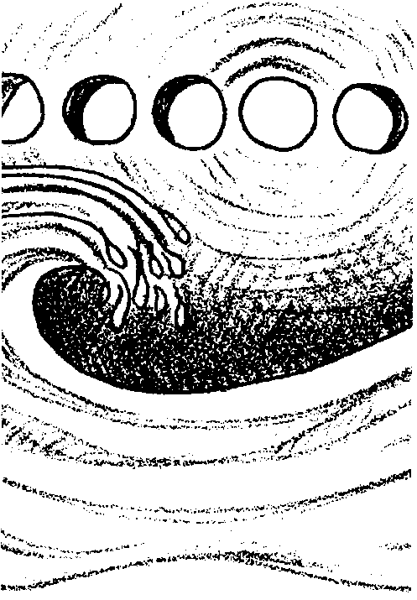
Key Concepts
1. Tides are the periodic rise and fall of the waters of the ocean and its inlets.
2. While tides can differ greatly from place to place, they can also be similar in widely separated places.
3. Using astronomical information and observations of past tides, scientists can predict the time and heights of tides.
4. Knowing, in advance, the times and heights of tides is important to people in many different walks of life.

Background

The tides, that periodic rise and fall of the sea around the edge of the land, are caused by the gravitational attraction between the earth and the sun and between the earth and the moon. For sailors on the open sea, tidal changes usually go unnoticed. In contrast, for people who make their livings or recreate along the shores and beaches, tides often govern their water-related activities. For thousands of years, food gathers searching the shore for edible plants and animals have used the tides to their advantage. Sailors still beach their boats on low tides to accomplish below-the-waterline repairs on dry land. Tides also provide navigational challenges or aids to navigators.

The amount that the sea rises and falls varies from place to place around the world. Tides can vary greatly from place to place, or be similar in widely separated places. Some coastal areas, for example the U.S. Gulf states, show a regular pattern of one high tide and one low tide each day. Other areas show a regular pattern of two high tide-low tide sequences each day. In some of these areas, for example the mid-Atlantic seaboard, the two highs reach the same height and the two lows drop to the same level. In other areas, for example the U.S. Pacific coast, the two highs reach different heights and the two lows drop to different levels.

It is difficult to measure tidal changes accurately since the ocean bottom near shore is always changing, as well as the amount of water above it. To provide a reference point, a standard zero mark is chosen and tides are considered to be positive above that mark and negative below that mark. In the United States, Mean Lower Low Water is chosen as that reference mark.
Using astronomical information and observations of past tides, scientists can predict the time and heights of tides. These predictions are compiled by the National Oceanic and Atmospheric Administration (NOAA) into tide tables for North and South America, Hawaii, and the coast of Asia. These tables give the dates, times and water levels for high and low water for 196 sites and the correction figures for an additional 6,000 sites.

While tides are clearly complex, it is important for a lot of people to be able to know the times and heights of tides in advance. Tide tables provide the information people need.

Materials

Part 1 - Tidal Action in the Classroom

For the class:

• glass baking pan or similar low profile, clear container

• sand

• dowels (several, slightly longer than container is deep)

• water

Part 2 - Tide Tables

For each student:

• “Tide Tables” activity sheets

Part 3 - Comparing Tide Curves

For the class:

• transparency of the blank graph with clocks at the top

• transparency of the tide data for one of the 10 locations

• transparency of the dock template

For each group of 3 or 4 students:

• 4 blank graphs with clocks at the top

• tide data for assigned location/s

• blue crayon or marker

• dock template

• “Analysis and Interpretation” questions

Teaching Hints

“Time and Tides” has three parts. The first part is best done at a real beach, but a classroom substitute can be found at the end of Part 1. The second and third parts give the students practice reading tide tables and charts. To give these activities more life, first create a dramatic setting, such as one of the following:

“You are a fisher and know that the best time to catch fish in your area is during a slack tide (between a high and low tide), in dim light. How can you use a tide chart to find the best time to go fishing?”

or,

“You are the captain of a large freighter and are about to enter a bay having a very shallow inlet. You want to arrive during a high tide. How can you use tide tables to plan your entrance.”

In your discussion, ask students to think about how people kept track of tides before our present sophisticated measurements were developed. Some cultures used verbal descriptions or pictures of the tides. Others, such as ours, used numerical measurements. Help students to realize that, regardless of the precise strategy used, careful observation was (and is) the key to understanding tides.

Part 1 - Observing Tidal Changes

If possible, teach this unit after a visit to the intertidal beach or make certain the concepts introduced in the classroom activities are reinforced with actual observations in a field trip after this unit. There is nothing that can replace the experience of taking your students to the intertidal zone to see the tides changing and to observe how intertidal organisms have adapted to the rise and fall of the tides. Unit 17 outlines safety and conservation issues and provides ideas for activities to guide students’ observations at the beach.

Tide Markers at the Beach

The following three activities provide opportunities for students to directly investigate tidal changes.

Vertical Tidal Changes - Changes in water depth can be measured by recording water depths at different times on a single stake. How the tide is changing while you are at the beach will determine where you place the stake at the beginning of your field trip. If the tide is flooding (coming in), place the stake at the water’s edge. If, on the other hand, the tide is ebbing (going out), wade into the water and place the stake in the sand at a depth where a few inches of the stake is above the water’s surface. Push the stake into the sand. Mark where the surface of the water is touching the stake with a rubber band. Immediately before the stake is recovered, place a second rubber band at the new water level on the stake. Pull the stake out. Measure the distance between the two rubber bands. The distance is the net gain or loss in water height during the time the stake was planted.

Horizontal Tidal Changes - At the beginning of the field trip, mark the highest point currently reached by the incoming wave wash with two stakes. By the end of the field trip, the tide stakes will either be standing above or below the incoming wave wash. Move one of the stakes to the new highest point reached by the incoming wave wash. Replant the stake in line with the remaining stake. Measure the distance between the two stakes. The distance is the horizontal tide change during the field trip. Discuss with students how the slope of the beach can greatly affect these measurements.

“Personal” Tidal Changes - Have students write their names in the sand near the waters edge. Wait 10 minutes or more. Discuss what happened to the water in relation to their names.

Tidal Action in the Classroom

To demonstrate tidal action in the classroom, use sand to build a sloping beach covering approximately 3/4 of the bottom of a clear, flat container, such as a glass baking pan. Stick a few dowels or similar objects in the sand to represent pilings in the water.

Add water to the end of the container opposite the beach so that it covers just the edge of the sandy beach. To show the effects of low and high tides, alternately lift, then lower, the end holding the water. Discuss observations of water movement and the potential effects the changes seen might have on organisms living in the intertidal zone or on the pilings.

Part 2 - Tide Tables

Materials

For each student:

• “Tide Tables” activity sheets

“Tide Tables” provides an introduction to the use of tide tables as a prelude to plotting tidal data from assorted U.S. coastal locations. The tide tables provided are simplified from NOAA publications. The procedure is found in the introduction to the student activity.

Part 3 - Comparing Tide Curves

Materials

For the class:

• transparency of the blank graph with clocks at the top

• transparency of the tide data for one of the 10 locations

• transparency of the dock template

For each group of 3 or 4 students:

• 4 blank graphs with clocks at the top

• tide data for assigned location/s

• blue crayon or marker

• dock template

• “Analysis and Interpretation” questions

In “Comparing Tide Curves” groups of students plot and interpret tidal data from assorted U.S. coastal locations.

Procedure

1. Using the overhead projector, demonstrate how to read the tide data for Neah Bay, Washington (or some other specific U.S. location) and how to plot it on one of the blank graphs with clocks at the top. The data plotted for 12/12/93 and 12/13/93 for Neah Bay, Washington should look like this:

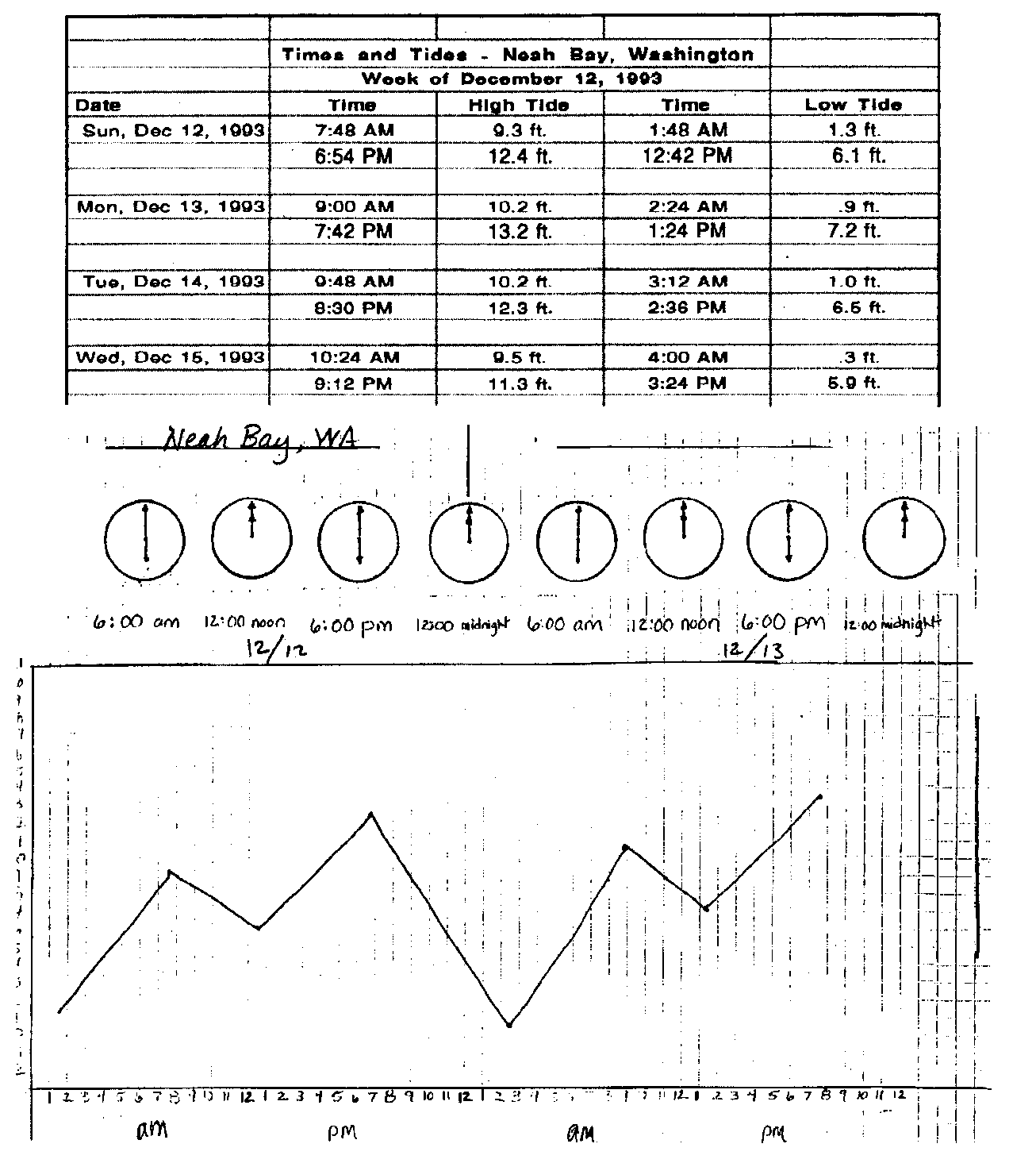

2. Divide the class into groups of 3 or 4 students. Assign each group a specific U.S. location. The group will do the plotting for that location for the entire week of December 12, 1993.

NOTE: There are 10 different locations, including a location in Hawaii and Alaska, as well as coastal cities in the contiguous U.S.

Help students find their assigned location/s on a map. Recommend to students that they plot the data points for a specific day, then go back and connect the points to make a tidal curve for that day.

NOTE: The generalizations asked for in questions 2 and 12 will be hardest to infer from examination of the tide curves for Galveston, Texas. The NOAA data from this location does not follow the “text book” example of diurnal tides (one high and one low tide in 24 hours), which is frequently true for the Gulf Coast. You may choose to give this data to a group that can handle ambiguity or, alternatively, to not have this data plotted. In your discussion of the results of this activity, use the deviation between what is observed and what is expected to stress the point that a generalization typically covers most, but not all, cases.

3. When each group is finished plotting their data, have them color the part of each graph that represents the water (i.e., the bottom part of the graphs) with a blue crayon or marker.

4. Demonstrate how to connect all four of the tidal curves from a specific location to show the rise and fall of the tides for that location for an entire week in December of 1993.

5. The dock template provides a useful frame of reference to help students see the rise and fall of the water in relationship to the pilings and the organisms that inhabit the pilings. You may choose to demonstrate the use of the dock template at the overhead.

Note: For students to see how the dock template works when placed over the tidal curve, it is necessary to have the part of the demonstration tidal graph that represents water, colored blue.

6. Challenge students to use the dock template and the tidal curves they have created to answer the questions on the “Analysis and Interpretation” sheet.

7. When individual groups have completed the Analysis and Interpretation questions, discuss with the class how the tide curves for the different locations in the U.S. are alike and how they are different.

8. Display the completed tide curves for each location so that students may continue to observe and compare tidal action at different locations in the U.S.
Key Words

diurnal tide - a pattern of one high tide and one low tide each day; the tidal pattern often seen in the Gulf of Mexico

high tide - the tide at its highest point of elevation; time of high water

low tide - the tide at its lowest point of elevation; time of low water

minus tide - a low tide that falls below the Mean Lower Low Water value, exposing shoreline usually covered by seawater

mixed tide - a pattern of two high tides and two low tides in 24 hours with a difference between the heights of consecutive high and low tides; the tidal pattern typical of the west coast of the U.S.

semidiurnal tide - a pattern of two high tides and two low tides in 24 hours with little or no difference between the consecutive highs and lows; the tidal pattern typical of the east coast of the U.S.

tide table - tabular or graphic presentation of predictions of the dates, times and water levels for high and low water for a particular site or sites

tides - periodic rise and fall of the waters of the ocean and its inlets, occurring about every 12 hours

Extensions

1. If you live near a sea coast, use local newspapers or similar sources to modify the activity to utilize local tide tables.

2. The predictions produced by NOAA may be presented in many formats. Introduce your students to some of the other styles of presentation.

Answer Key

Part 2 - Tide Tables

1. Answers will vary depending upon students’ experiences. It is helpful to know the time and height of the tide for gathering marine plants and animals, construction in the intertidal zone, navigation in shallow water, recreation, etc.

2. a. There are two high tides on December 12.

b. Ten hours and 48 minutes pass between high tides on December 12.

c. The time between tides on December 12 is shorter than the average (by 97 minutes; i.e., 10 hrs 48 mins vs. 12 hrs 25 mins).

d. There are two low tides on December 12.

e. Thirteen hours and 25 minutes pass between low tides on December 12.

f. The first high tide occurs at 2:46 AM on December 13.

g. The second low tide on December 13 occurs at 8:20 PM.

h. There is a zero foot tide on Wednesday, December 14.

3. a. The first high tide on December 13 is 9.5 feet above the average (often called “above zero”, rather than “above the average”).

b. The second high tide on December 13 is 10.9 feet above the average.

c. The difference between the heights of the two high tides on December 13 is 0.6 feet (i.e., 10.9 feet - 9.5 feet).

d. During the week of December 11, the lowest tide (-1.0 feet) occurs on December 17.

e. This lowest tide occurs at 10:35 PM.

f. The water level changes 11.3 feet (i.e., 10.3 feet - (-1.0 feet)) from the second high tide to the second low tide on December 17.

4. a. There are two high tides on December 12.

b. Twelve hours and 24 minutes passes between high tides on December 12.

c. The time between high tides on December 12 at Portland, Maine is greater by 96 minutes than the time between high tides on December 12 at Seattle, Washington.

d. The difference between the heights of the two high tides on December 12 is 1.1 feet.

e. The water level changes 10.6 feet (i.e., 19.2 feet - 8.6 feet) from the first high tide to the first low tide on December 12.

f. Answers will vary. Both Portland, Maine and Seattle, Washington have two high and two low tides daily. Neither appears to have consecutive high tides or low tides that are vastly different. For many, the data is somewhat difficult to compare in tabular form. This fact can lead to a discussion of ways to graphically represent tidal change which may serve as an introduction to the next activity.

5. Answers will vary. People picnicking (or playing volleyball) on the beach, school field trips, photographers and lots of others might want to know the times and heights of tides.

Part 3 - Comparing Tide Curves

1. Answers will vary but should reflect tide data assigned to the group.

2. Tide curves and general observations for East Coast, West Coast, and Gulf Coast locations are found below.

NOTE: The generalizations that follow hold true for these locations for the week of December 12, 1993!

EAST Coast Locations (Portland, ME; Charleston, SC; Cedar Key, FL)

• generally, two high and two low tides in a 24 hour period,

• consecutive high tides and low tides are very similar in height (At Cedar Key, Florida, there is some minor difference in the height of the consecutive high and low tides, although the differences are minimal in comparison to the West Coast.),

• a high or low tide approximately every 6 hours (except for Cedar Key, Florida), and

• all locations had more tidal range earlier in the week.

Answer Key is continued on following page.
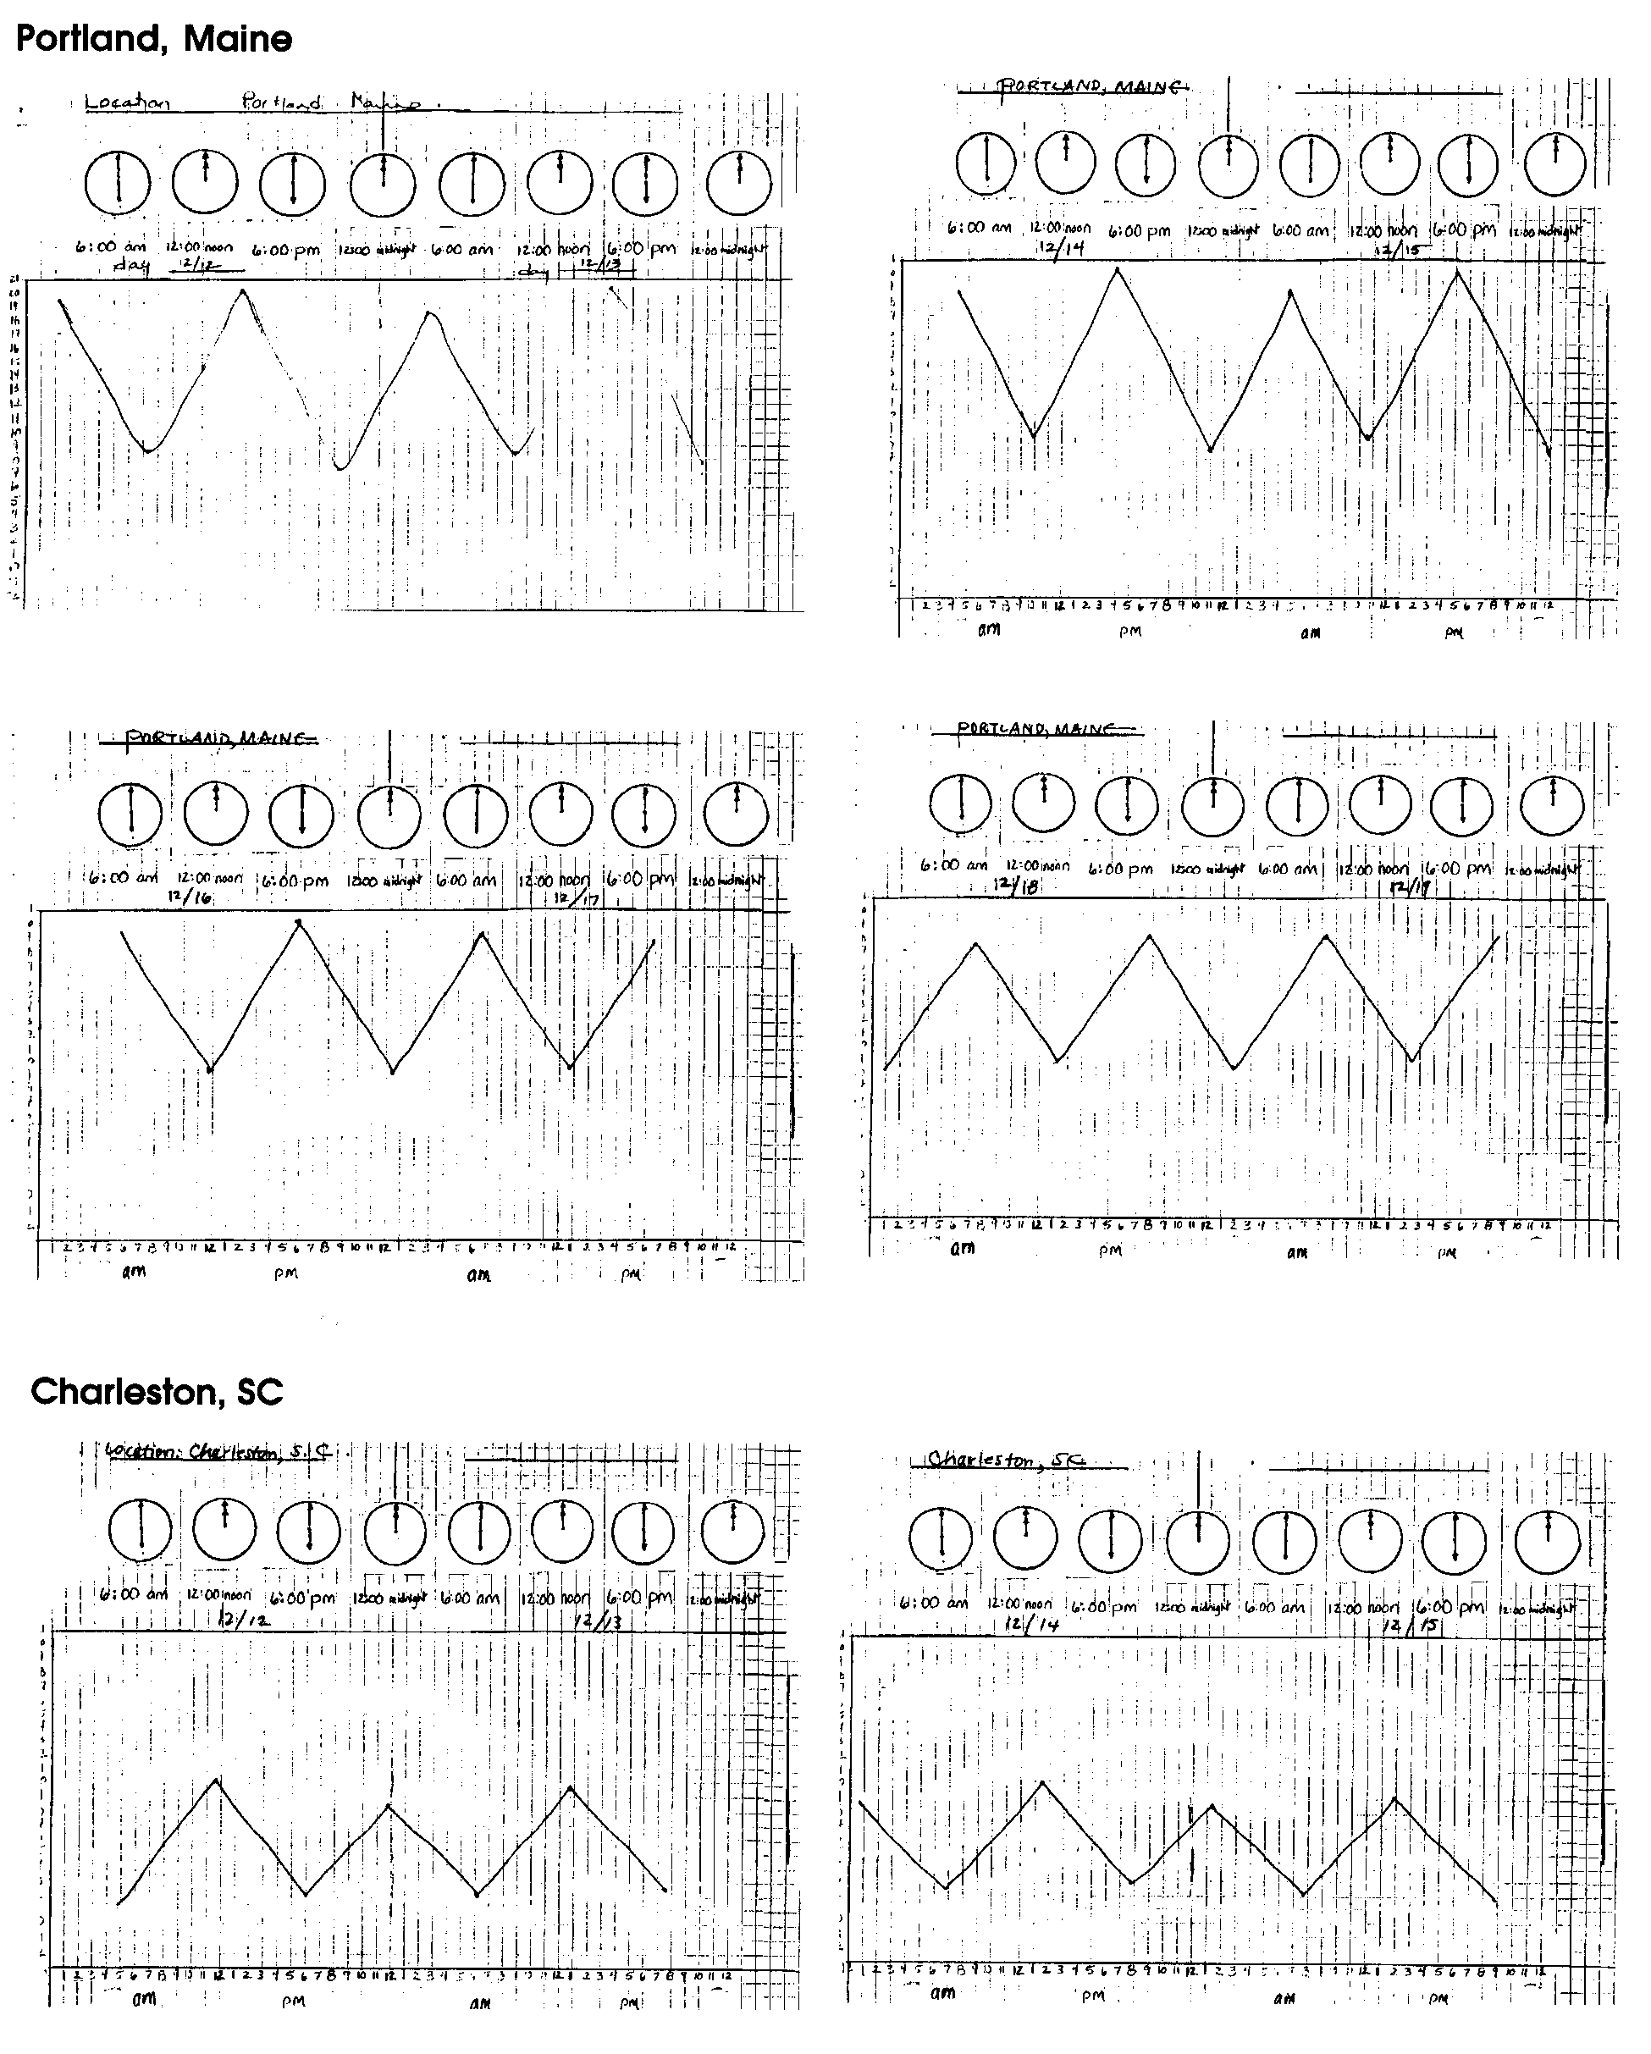

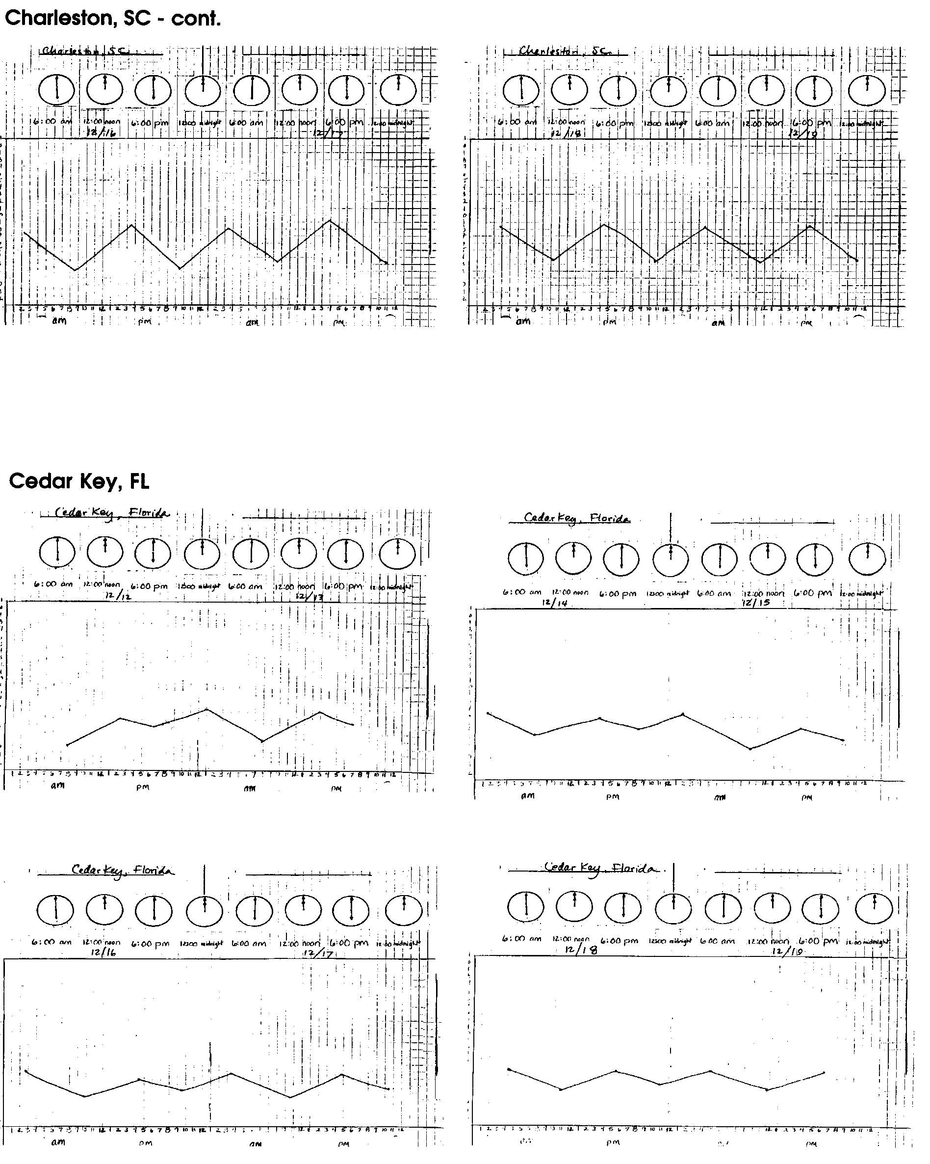

West Coast Locations (Los Angeles, CA; Astoria, OR; Neah Bay, WA and Seward, AK)
• two high and two low tides in a 24 hour period
• unequal consecutive high tides and low tides; in Astoria, Oregon the consecutive highs did not vary in height as much as the consecutive lows
• a high or low tide approximately every six hours; Los Angeles, Calif. shows the greatest variance from the six hour spread
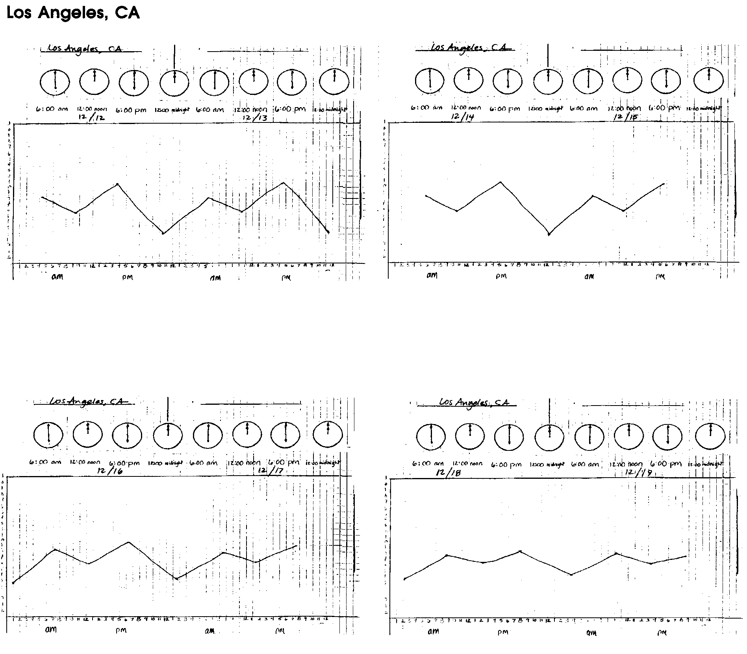
• all locations had more tidal range earlier in the week.

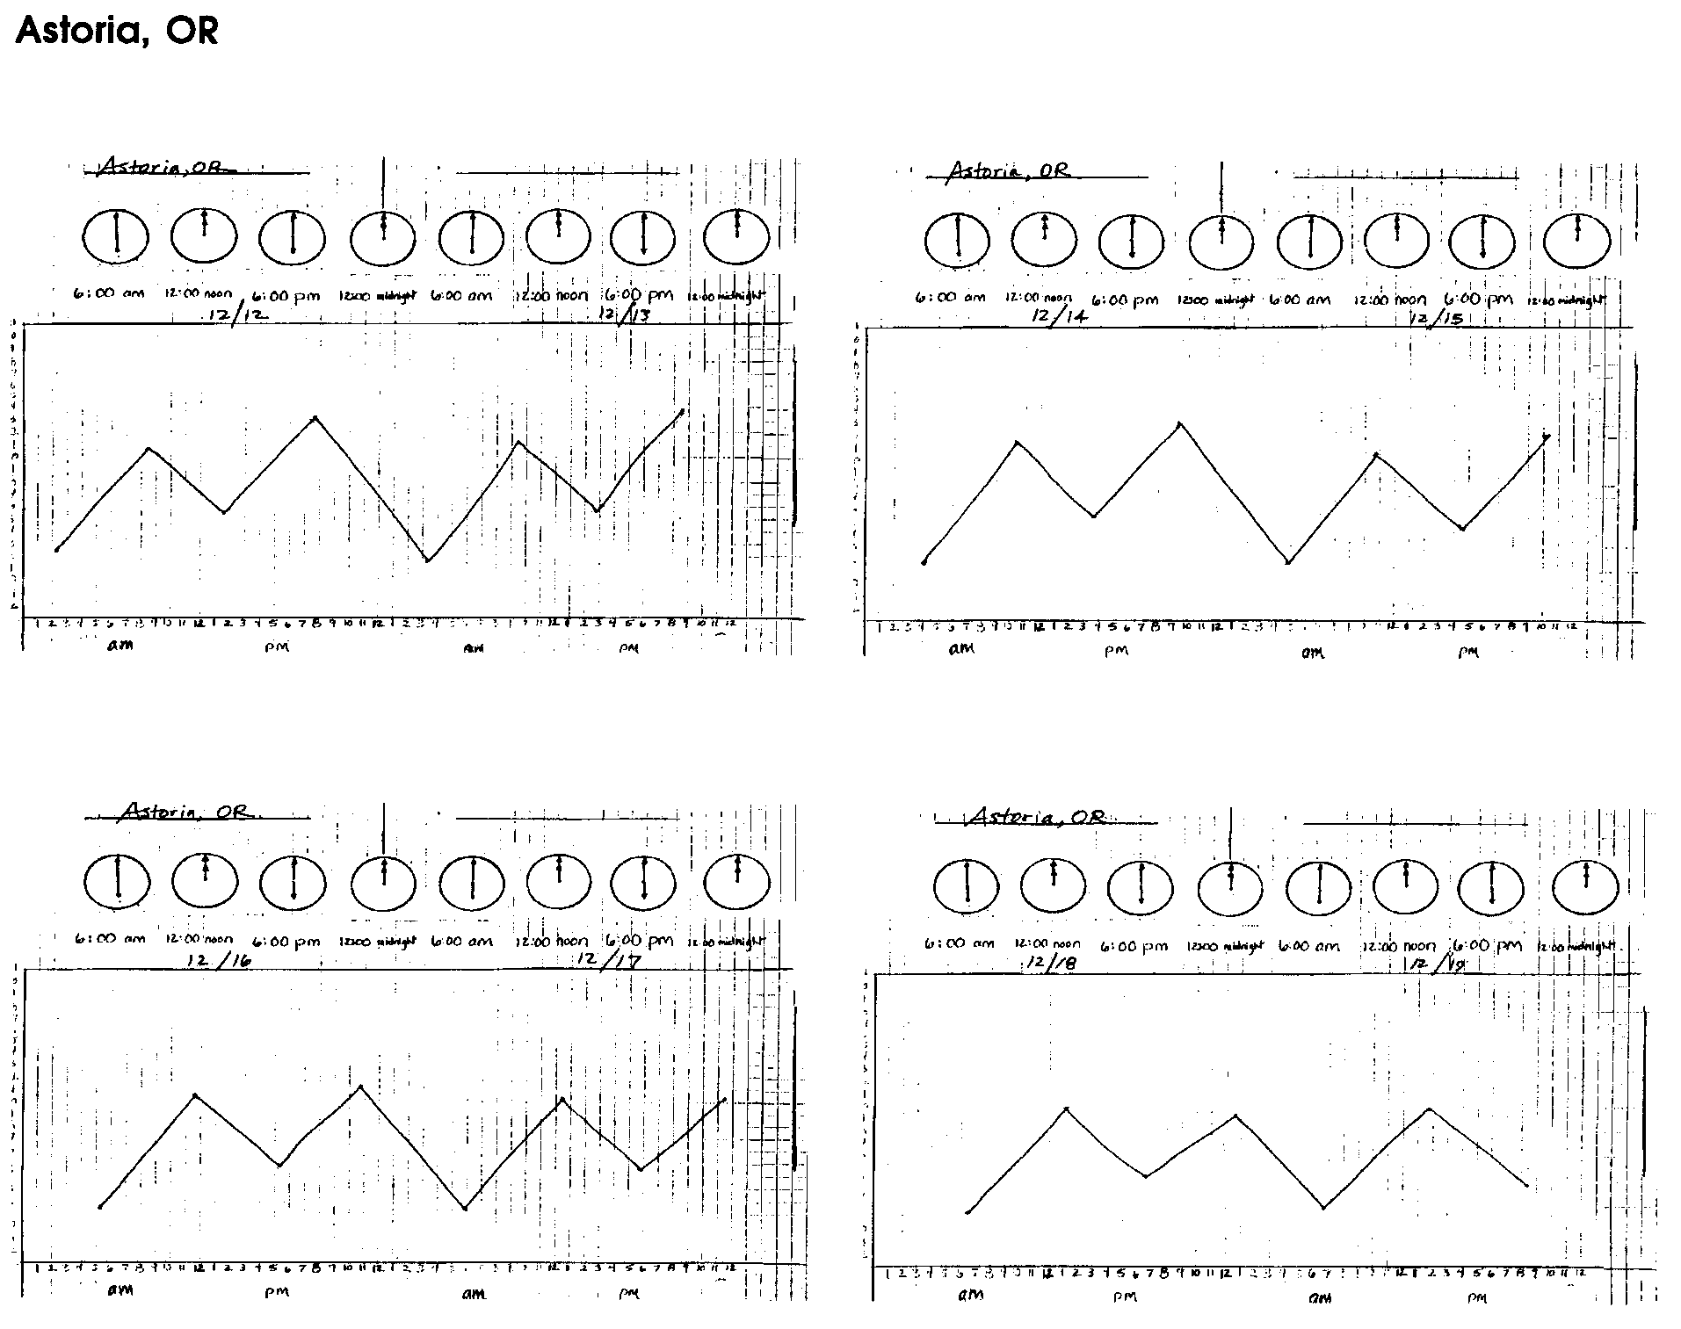

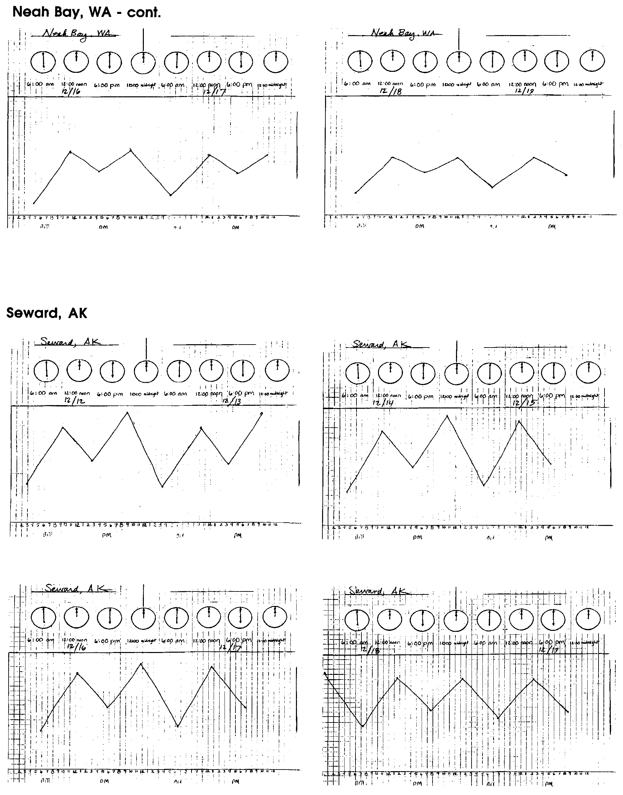

Gulf Coast Locations (Galveston, Texas - Pleasure Pier and Pier 2)

The NOAA data from these locations do not follow the "textbook" example of diurnal tides (one high and one low tide in 24 hours), which is frequently true for the Gulf Coast. Instead,
• there is not a consistant number of high and low tides a day,
• the number of hours between a high and low tide varies, and
• there is more tidal range earlier in the week.
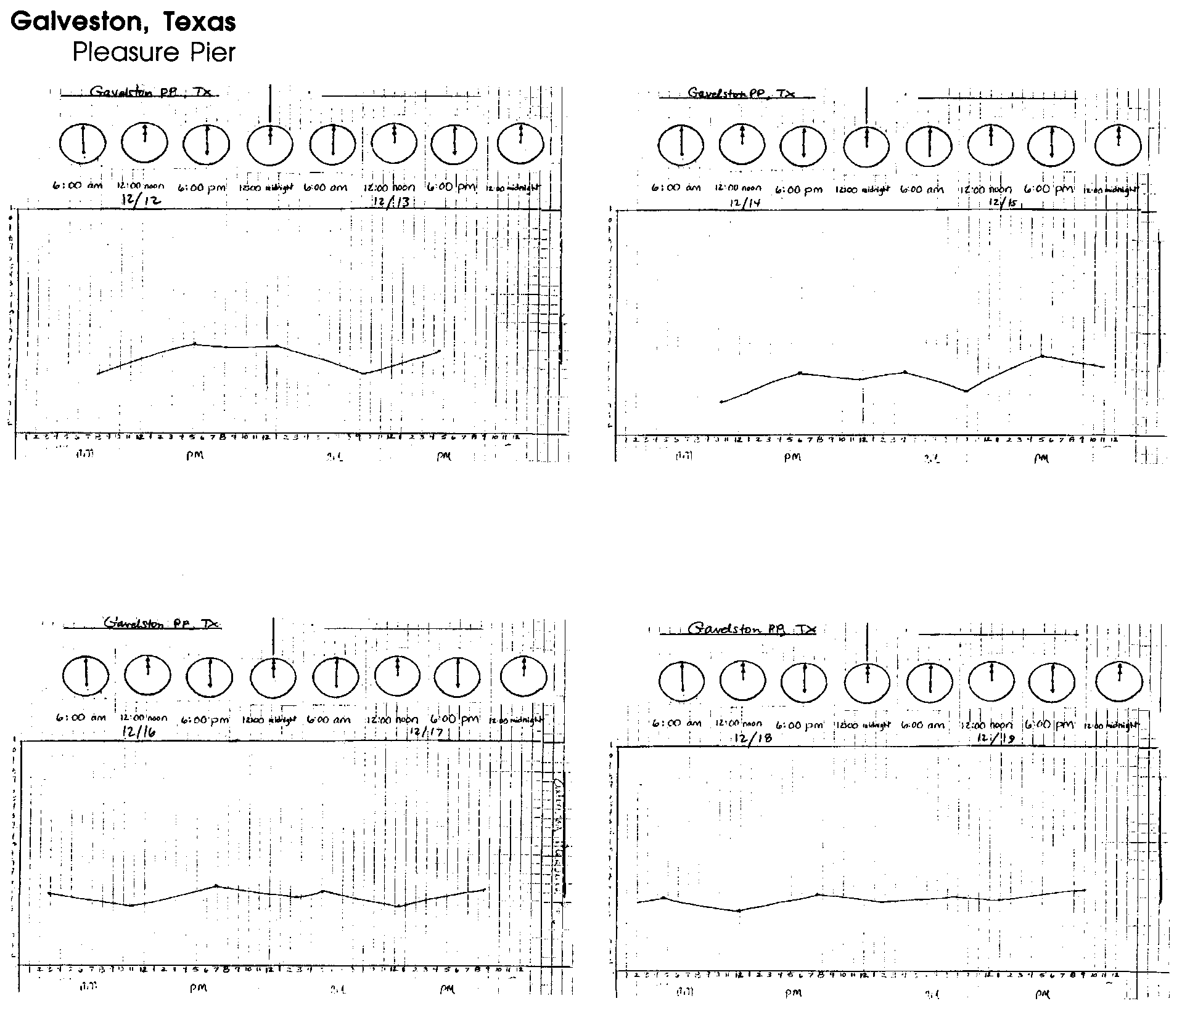

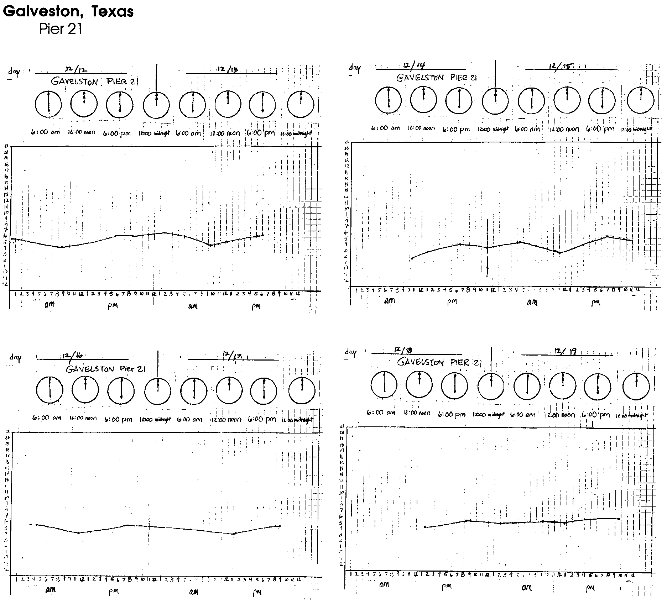
Honolulu, Hawaii

• generally two highand two low tides in a 24 hour period,
• consecutive high tides and low tides are very similar in height,
• very minimal change in height of tide betweenthe high an low tides, especially at the end of the week, and
• there is more tidal range earlier in the week.
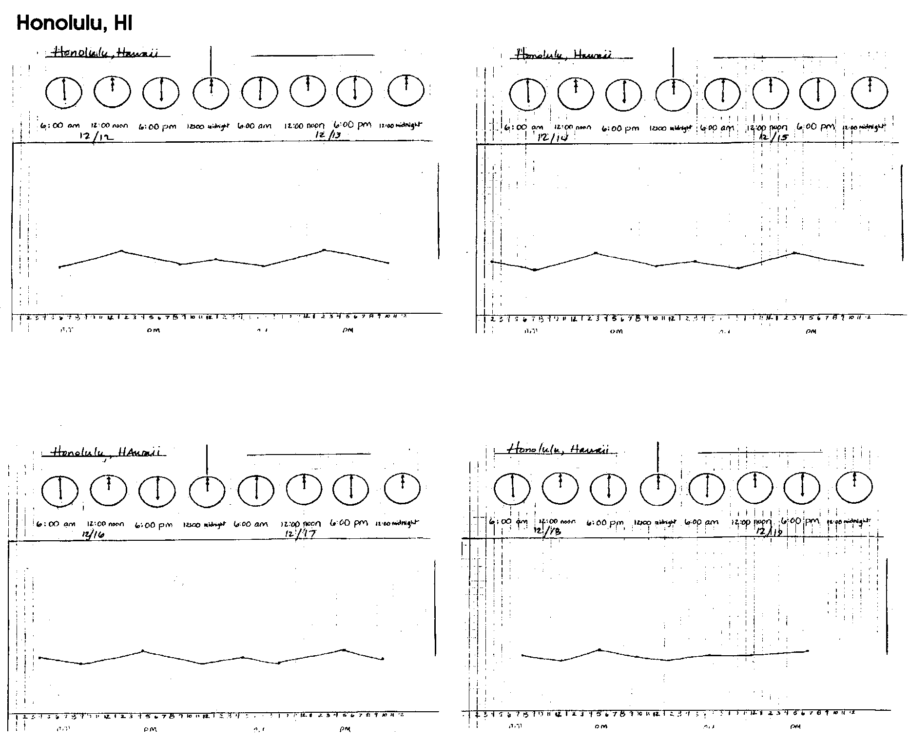

3. High tide information for each location follows:
Portland, ME - two high tides each day
Charleston, SC - two high tides each day
Cedar Key, FL - two high tides each day
Galveston PP, TX - most days have two highs others have one
Galveston P21, TX - most days have two highs others have one
Los Angeles, CA - two high tides each day
Astoria, OR - two high tides each day
Neah Bay, WA - two high tides each day
Seward, AK - two high tides each day
Honolulu, HI - two high tides each day

Note: In locations which typically experience two high and two low tides each day, some dates have only one high or one low tide because the length of a tidal day (12 hours and 25 minutes) differs from the length of a "regular" day (technically called a "solar day", of 24 hours), causing tidal days and calendar days to be out of phase.

4. Low tide information for each location follows:
Portland, ME - two low tides each day
Charleston, SC - two low tides each day
Cedar Key, FL - two low tides each day
Galveston PP, TX - most days have two lows, others have one
Galveston P21, TX - most days have two lows, others have one
Los Angeles, CA - two low tides each day
Astoria, OR - two low tides each day
Neah Bay, WA - two low tides each day
Seward, AK - two low tides each day
Honolulu, HI - two low tides each day

5. a. Comparable high tide dates for each location follow:
Portland, ME - December 19
Charleston, SC - December 19
Cedar Key, FL - December 19
Galveston PP, TX - no comparable high tides
Galveston P21, TX - December 16
Los Angeles, CA - no comparable high tides
Astoria, OR - December 17
Neah Bay, WA - no comparable high tides
Seward, AK - December 19
Honolulu, HI - no comparable high tides

Note: "Close" is a relative term; here the term was defined as 0.1 ft. Your students may have chosen to use other definitions, in which case their answers may differ slightly.

b. High tide dates with a difference greater than two ft. for each location follow:
Portland, ME - no dates
Charleston, SC - no dates
Cedar Key, FL - December 15
Galveston PP, TX - no dates
Galveston P21, TX - no dates
Los Angeles, CA - December 12, 13, 14, 15
Astoria, OR - December 12, 13, 14
Neah Bay, WA - December 12, 13, 14
Seward, AK - December 12, 13, 14
Honolulu, HI - no dates
6. a. Comparable low tide dates for each location follow:
Portland, ME - no comparable low tides
Charleston, SC - December 17
Cedar Key, FL - no comparable low tides
Galveston PP, TX - no comparable low tides
Galveston P21, TX - no comparable low tides
Los Angeles, CA - no comparable low tides
Astoria, OR - no comparable low tides
Neah Bay, WA - no comparable low tides
Seward, AK - no comparable low tides
Honolulu, HI - no comparable low tides

Note: Again, the term "close" was defined as 0.1 ft. Your students may have chosen to use other definitions, in which case their answers may differ slightly.

b. Low tide dates with a difference greater than 2 ft for each location follow:
Portland, ME - no dates
Charleston, SC - no dates
Cedar Key, FL - December 12, 13
Galveston PP, TX - December 12, 14, 15
Galveston P21, TX - December 12, 14,
Los Angeles, CA - December 12, 13, 15, 16, 17, 18, 19
Astoria, OR - December 12, 13, 14, 15, 16, 17, 18, 19
Neah Bay, WA - December 12, 13, 14, 15, 16, 17, 18, 19
Seward, AK - December 12, 13, 14, 15, 16, 17, 18
Honolulu, HI - no dates

7. a., b. Lowest tide during the week of December 12 for each location follows:
Portland, ME - December 12 7.2 ft
Charleston, SC - December 12 1.3 ft
Cedar Key, FL - December 12 0.3 ft
Galveston PP, TX - December 14 0.5 ft
Galveston P21, TX - December 14 1.6 ft
Los Angeles, CA - December 12 2.1 ft
Astoria, OR - December 16, 17 1.4 ft
Neah Bay, WA - December 15 0.3 ft
Seward, AK - December 14 3.7 ft
Honolulu, HI - December 12 3.2 ft

8. a., b. Highest tide during the week of December 12 for each location follows:
Portland, ME - December 13, 16 20.4 ft
Charleston, SC - December 14 10.0 ft
Cedar Key, FL - December 14 6.6 ft
Galveston PP, TX - December 13 6.6 ft
Galveston P21, TX - December 13 6.7 ft
Los Angeles, CA - December 12 10.8 ft
Astoria, OR - December 13 13.6 ft
Neah Bay, WA - December 13 13.2 ft
Seward, AK - December 12 19.6 ft
Honolulu, HI - December 12, 13 5.9 ft

9. a., b. The greatest change between a high and a low tide during the week of December 12 for each location follows:
Portland, ME - December 12 13.1 ft
Charleston, SC - December 12 7.7 ft
Cedar Key, FL - December 15 4.9 ft
Galveston PP, TX - December 13 3.4 ft
Galveston P21, TX - December 13 2.3 ft
Los Angeles, CA - December 12 8.7 ft
Astoria, OR - December 14 9.5 ft
Neah Bay, WA - December 13 9.3 ft
Seward, AK - December 13 12.4 ft
Honolulu, HI - December 13 2.2 ft

10. a., b. The least change between a high and a low tide during the week of December 12 for each location follows:
Portland, ME - December 19 8.5 ft
Charleston, SC - December 18, 19 4.5 ft
Cedar Key, FL - December 12 1.0 ft
Galveston PP, TX - December 18 0.1 ft
Galveston P21, TX - December 12 0.1 ft
Los Angeles, CA - December 19 1.1 ft
Astoria, OR - December 18, 19 5.6 ft
Neah Bay, WA - December 18 3.0 ft
Seward, AK - December 18 6.8 ft
Honolulu, HI - December 17 0.4 ft

11. Answers will vary but should note that organisms living on a piling will periodically be underwater, then exposed to air. For those organisms high on the piling, these changes may happen as often as twice daily. For others, the changes are much less frequent. Besides drying, organisms in air are exposed to greater temperature changes and different predators.

b. Organisms living in the intertidal zone on a beach would face many of the same tidal effects as piling organisms. While animals and plants living on a piling are concentrated in more or less obvious bands, those bands are also seen on an intertidal beach, but spread out over a greater horizontal distance.

12. Answers will vary depending upon the locations compared.

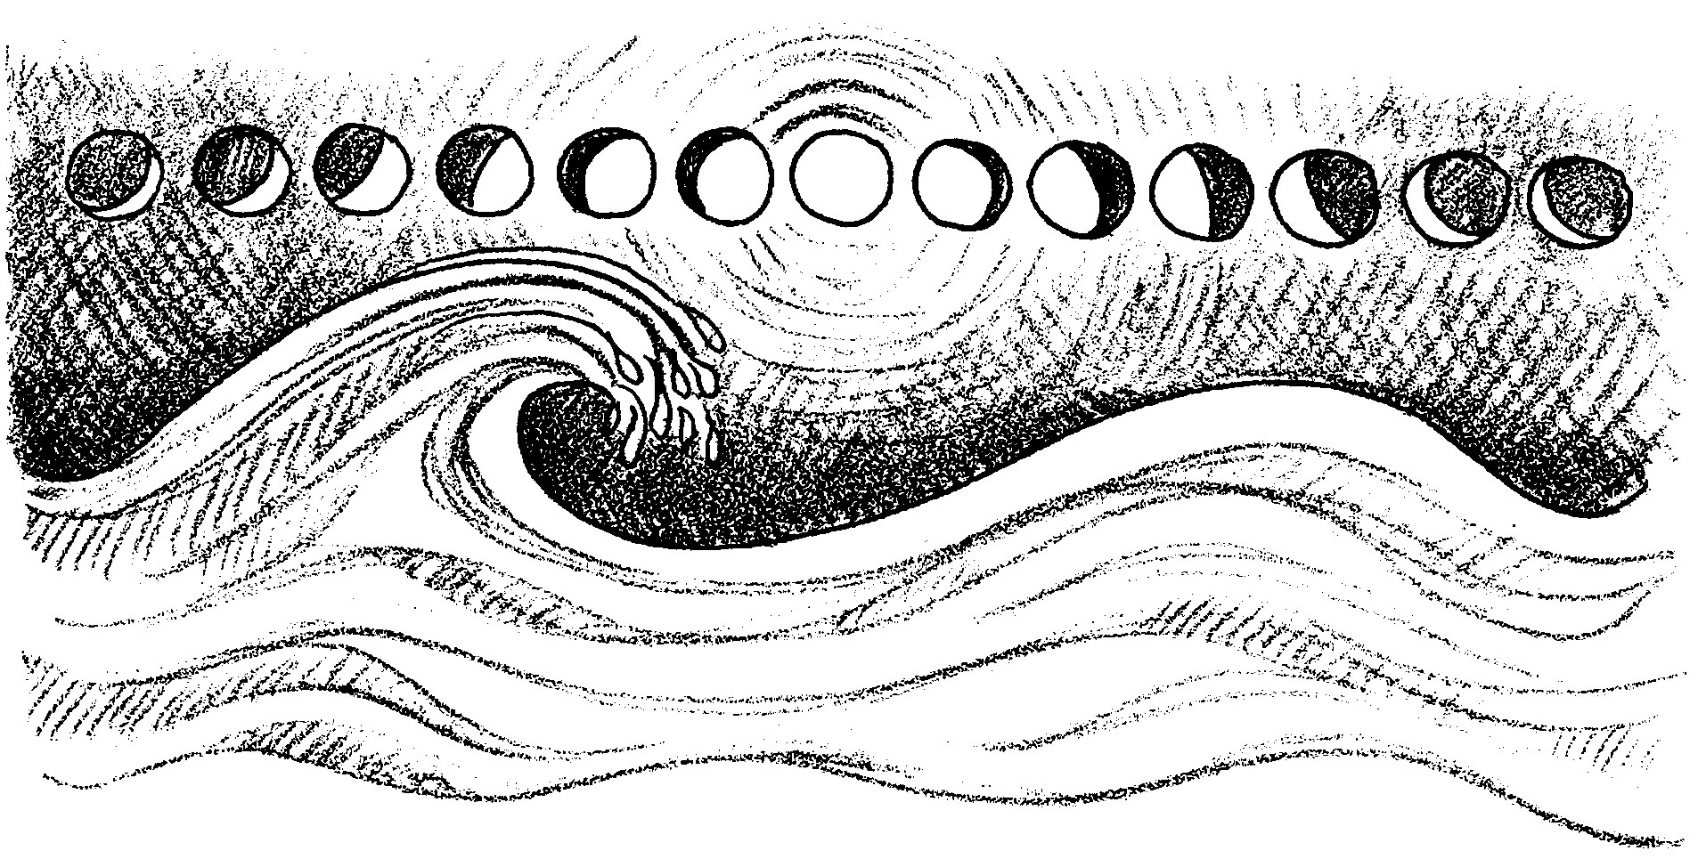
Time and Tides

Tide Tables

Every day the waters of the ocean rise and fall. Along most of the ocean’s shorelines the water rises and falls twice each day. This means that the shorelines are covered with water, then exposed to sun over and over. People that live along the ocean often need to know whether the water will be “high” or “low” at a certain date and time.

1. When might it be helpful to know the time and height of the tide?

For thousands of years, people wondered “What causes the tides?”. We now know the tides are largely caused by the action of the moon and sun on the ocean. This information and the observation of past tides help scientists predict the time and heights of tides. These predictions are printed in tide tables.

Tides differ from area to area. Because of this, tide tables are made for local areas. For example, on the following page is a tide table for Seattle, Washington.

Times and Tides - Seattle, Washington
Week of December 11, 1994

Date Time High Tide Time Low Tide

Sun., Dec 11, 1994 12:05 AM 8.0 ft 5:04 AM 4.8 ft
11:43 AM 11.5 ft 6:54 PM 2.2 ft

Mon., Dec 12, 1994 1:36 AM 8.6 ft 6:15 AM 5.9 ft
12:24 PM 11.2 ft 7:40 PM 1.4 ft

Tue., Dec 13, 1994 2:46 AM 9.5 ft 7:25 AM 6.6 ft
1:02 PM 10.9 ft 8:20 PM 0.6 ft

Wed., Dec 14, 1994 3:41 AM 10.3 ft 8:27 AM 7.1 ft
1:37 PM 10.6 ft 8:56 PM 0.0 ft

Thu., Dec 15, 1994 4:26 AM 10.9 ft 9:19 AM 7.3 ft
2:11 PM 10.5 ft 9:30 PM -0.5 ft

Fri., Dec 16, 1994 5:04 AM 11.4 ft 10:03 AM 7.4 ft
2:45 PM 10.4 ft 10:02 PM -0.8 ft

Sat., Dec 17, 1994 5:38 AM 11.8 ft 10:42 AM 7.4 ft
3:19 PM 10.3 ft 10:35 PM -1.0 ft

2. Let’s see what we can learn from this table.

a. How many high tides are there on December 12?

b. How much time passes between high tides on December 12?

c. The average time between high tides is 12 hours and 25 minutes. How does the time between tides on December 12 compare to this average?

d. How many low tides are there on December 12?

e. How much time passes between low tides on December 12?

f. What is the time of the first high tide on December 13?

g. What is the time of the second low tide on December 13?

h. On which day is there a zero foot tide?

“Water Level” changes as the tides rise and fall. Averaging hourly water levels over a 19 year period gives the local average sea level. This average is called Mean Sea Level. “Fine”, you say, “but there are two low tides a day in Seattle. Which low tides are averaged?”

The tide heights shown in the tide table are compared to the average of the lowest daily tides. This average is called Mean Lower Low Water. Mean Lower Low Water is the average of the lowest daily tides over the 19 year period. Sometimes the tides are higher than the average. Sometimes they are lower. Tides lower than the average are called minus tides. They are written with a minus sign in front of them.

3. Let’s see what else we can learn from the tide table.

a. How high above the average is the first high tide on December 13?

b. How high above the average is the second high tide on December 13?

c. What is the difference between the heights of the two high tides on December 13?

d. During the week of December 11, on which date does the lowest tide occur?

e. At what time of day does this lowest tide occur?

f. How much does the water level change from the second high tide to the second low tide on December 17?

Tides can differ greatly from place to place. They can also be similar in widely separated places. Here is part of a tide table from Portland, Maine.

Times and Tides - Portland, Maine
Sunday, December 12, 1994

Date Time High Tide Time Low Tide

Sun., Dec 12, 1994 2:12 AM 19.2 ft 8:18 AM 8.6 ft
2:36 PM 20.3 ft 9:12 PM 7.2 ft

Let’s see how these compare to Seattle tides.

4. a. How many high tides are there in Portland on December 12?

b. How much time passes between these high tides on December 12?

c. Look at the time between tides on December 12. How does this compare with the time between tides on December 12 in Seattle?

d. What is the difference between the heights of the two high tides on December 12?

e. How much does the water level change from the first high tide to the first low tide on December 12?

f. How do the tides in Portland, Maine compare with those in Seattle, Washington?

Sometimes, knowing the times and heights of the tides is very important. People that grow oysters on the beach can only see them at low tide. People that tie boats up to docks need to know how much the water level changes. If it changes a lot, their boat may end up on dry ground when the tide goes out! People with tall boats need to know the water level when they go under bridges. The aircraft carrier Enterprise, for example, can only sail under the Golden Gate Bridge on a low tide. Tide tables provide all of these people the information they need.

5. Who else might want to know the times and heights of tides?

Time and Tides
Comparing Tide Curves

Materials
• completed tide graphs for your groups’ assigned location/s
• dock drawing
• scissors

Procedure

1. Fold the dock drawing on the dashed ( - - - - - - ) line.

2. Cut out the area on the piling marked (/ / / / / /).

3. Cut the top of the dock drawing off along the dotted line ( . . . . . .).

4. Now you can observe the height of the tide on the piling below the dock. Simply line up the top of the dock drawing with the heavy black line on one of your completed tide graphs. The height of the tide can be read on the tide gauge indicator on the piling.

5. Use the dock drawing and the tidal graphs your group has created to answer the questions that follow.

Analysis and Interpretation

1. Our group is looking at tide data from .

2. Look at your tide data. What are some general observations you can make about the tides at your location?

3. How many high tides does your location usually have each day?

4. How many low tides does your location usually have each day?

5. a. On any day, are the high tides equal, or close to equal, in height?

b. On any day, are the high tides more than 2 ft different in height?

6. a. On any day, are the low tides equal, or close to equal, in height?

b. On any day, are the low tides more than 2 ft different in height?

7. a. During the week of December 12, on which date did the lowest tide occur?

b. What was the height of that tide? feet

8. a. During the week of December 12, on which date did the highest tide occur?

b. What was the height of that tide? feet

9. a. On which day did the greatest change between a high and low tide occur?

b. How many feet did it change?

10. a. On which day did the least change between a high and low tide occur?

b. How many feet did it change?

11. a. You may have noticed plants and animals pictured on the piling on the dock drawing. Describe how the tidal activity at your location may affect organisms living on a piling there.

b. Now, think about plants and animals living in the tide zone on a beach. Compare the effects of the tides on organisms living on the beach with those living on a piling.

12. Compare the tidal observations at your location with the observations other groups have made for different locations. Record some of the similarities and differences.

