Shifting Tides and Changing Hides*

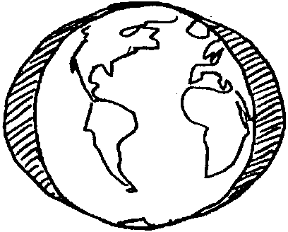
Key Concepts
1. Tides are the periodic rise and fall of the waters of the ocean and its inlets, produced by the attraction of the moon and the sun on the earth.
2. Survival is difficult for plankton.
3. Hermit crabs and other crustaceans molt as they grow.

Background

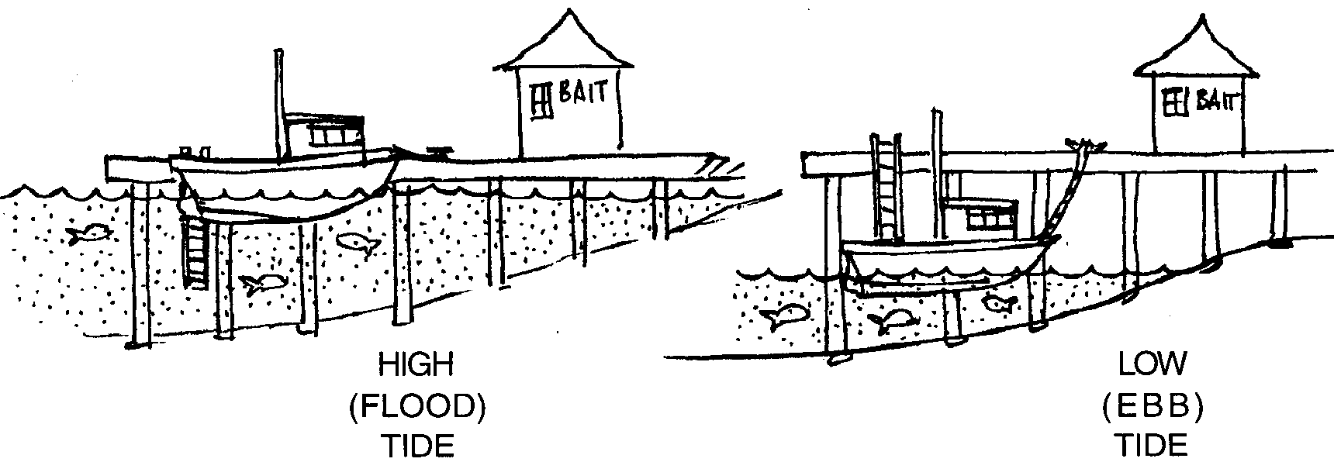
Tides are the daily rise and fall of the sea level along the shore. If you live near the saltwater, you may have seen the motion. Sometimes rocks and parts of the beach are covered with water. Other times these same areas are not covered. What you are seeing are the tides. When the water level is high, more of the beach is covered with water. The beach may appear to be a very small or narrow beach. This is called high tide. When the water level is low, less of the beach is covered with water. The beach appears to be larger or wider. This is called a low tide.

In most coastal areas of the United States, the tidal rises and falls occur twice each 24 hours and 50 minutes (referred to as a lunar day). In some places both high tides reach about the same height and both low tides drop to about the same level in a tidal cycle. In other areas, the two high tides are not the same height, nor are the low tides equal.

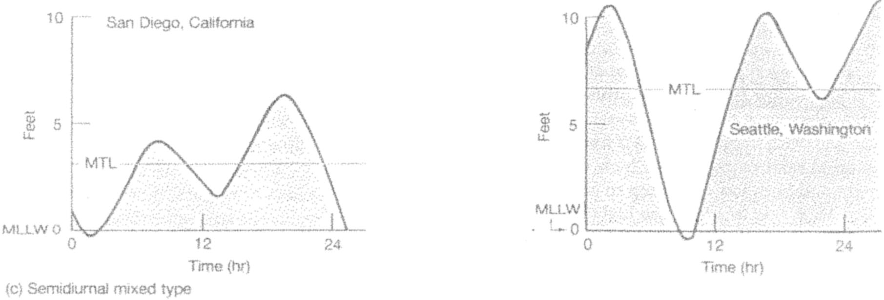
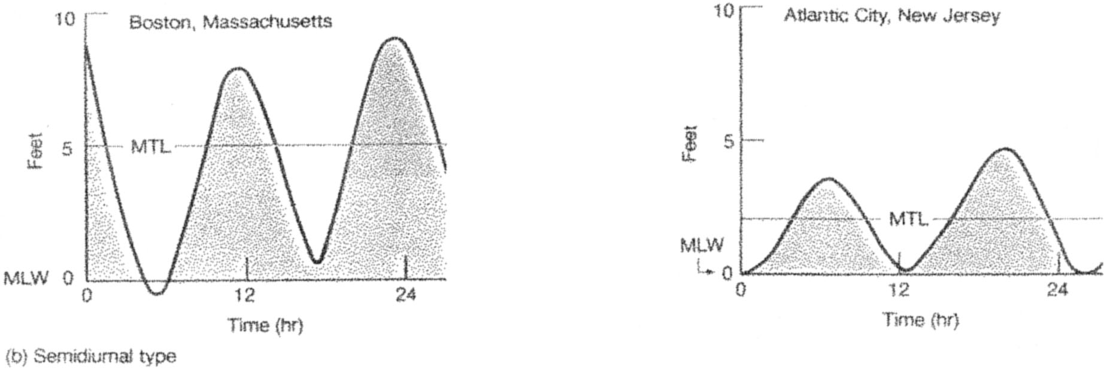

In some coastal areas, like the Gulf of Mexico, there is a pattern of only one high tide and one low tide each lunar day.
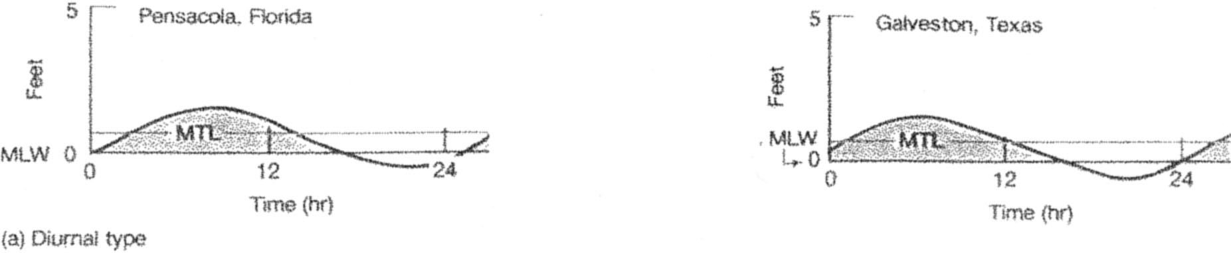

The difference between the high tides and the low tides may be only a few inches. However, it may be as much as 40 feet. Tide types and ranges vary from one coastal area to another.
What Causes the Tides?
The background information that follows is intended for your use and reference. Causality of the tides is very difficult for most primary students (adults, too!) to grasp due to the abstract concepts involved. Observation of beaches at high and low tide and understanding how tidal action affects inhabitants of the intertidal are more appropriate concepts for primary students.
The tides we see are largely a result of gravity. The moon and the sun exert attractions on the waters of the earth. Even though the moon is much smaller, the moon, because it is so close to the earth, exerts the major pulling force on the water causing a great bulge in the ocean directly under it. This tidal bulge tends to follow the moon as it orbits around the earth. The centrifugal force from the earth’s rotation creates a second bulge in the ocean on the opposite side of the world.
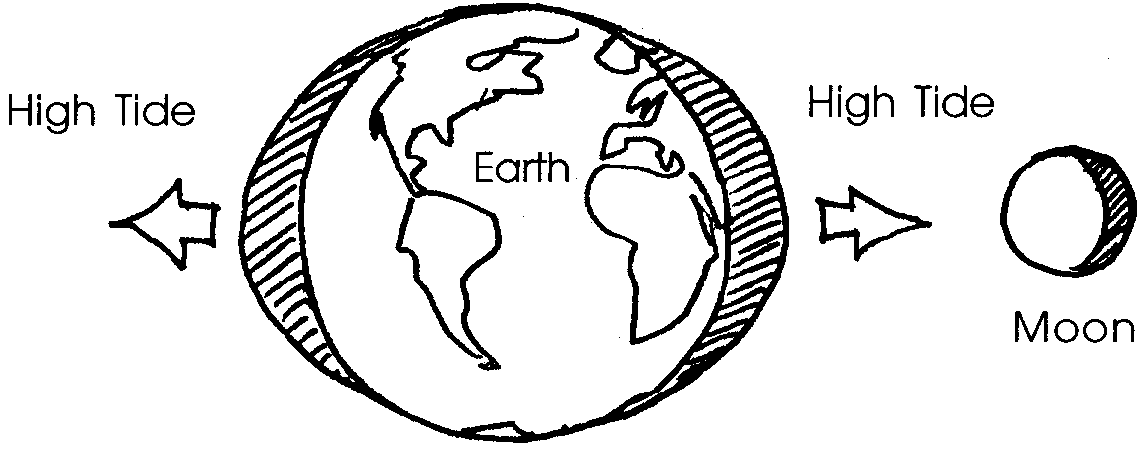

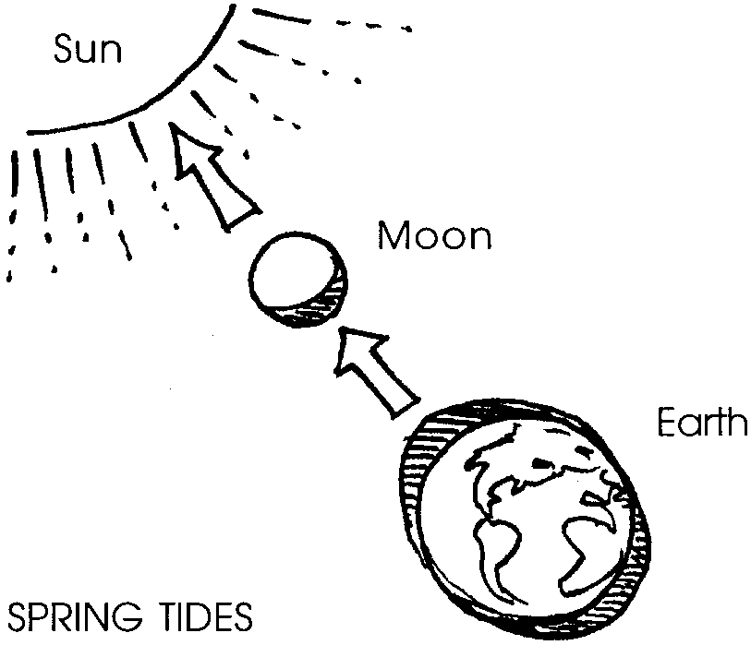
The effect of the sun is to increase or decrease the size of the bulge created by the moon. Twice every 28 days the sun and the moon are in line with each other. At this time, the combined pulling forces of both the sun and the moon on the earth produce the highest rise in water levels along our coasts. These tides are called spring tides. Spring tides occur all year long. The term “spring” comes not from the season but rather from the “springiness” of the water movement.

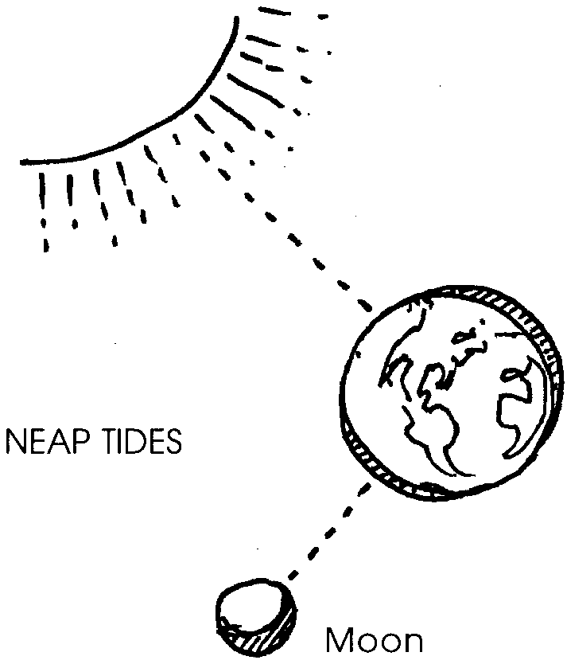

Twice every 28 days the moon is at right angles to the sun. The attraction of the moon for the earth cancels out the sun’s attraction for the earth. At these times, there is the smallest rise in water levels. We call these tides neap tides.

Chapter 2 - Shifting Tides and Changing Hides Summary

Pagoo meets copepods, jellyfish, sandhoppers, and water fleas. He experiences flood and ebb tides and life in a tide pool. Old Pal explains that life in the sea can be dangerous. Instinct “encourages” Pagoo to eat and grow. The molting process is explained.

Materials

For the class:

• Pagoo, award-winning children’s book by Holling C. Holling

Teaching Hints

Read chapter 2 of Pagoo with students. Have students make additions to their Pagoo Field Guides.

Key Words

copepod - microscopic crustacean which is a member of the zooplankton and is common in marine and fresh waters

crustacean - member of a group (class) of mostly aquatic arthropod animals possessing a hard shell and including lobsters, crabs, and barnacles

ebb tide - a tide which is receding from a high toward a low

flood tide - a tide which is advancing from a low toward a high

instinct - an inborn pattern of activity or tendency to action common to a biological species

molt - in this case, to cast or shed the hard outer covering of a hermit crab or other crustacean

plankton - the mostly microscopic plants and animals that drift in water; singular = plankter

tide pool - a pool of water remaining on a reef, shore platform, or beach after the tide has receded (also called tidepool, tidal pool)

tides - periodic rise and fall of the waters of the ocean and its inlets, produced by the attraction of the moon and sun and occurring about every 12 hours

Extension

1. There is nothing that can replace the experience of taking your students to the intertidal zone to see the tides changing and observe how intertidal organisms are adapted to cope with the rise and fall of the tides. “There’s No Place Like Home”, found in unit 17, outlines safety and conservation issues and provides ideas for activities to guide students’ observations at the beach.

