Design and Construct a Plankter
Adapted by Sue Brimhall, Seattle, WA
from “Sinking Slowly” in Living In Water.

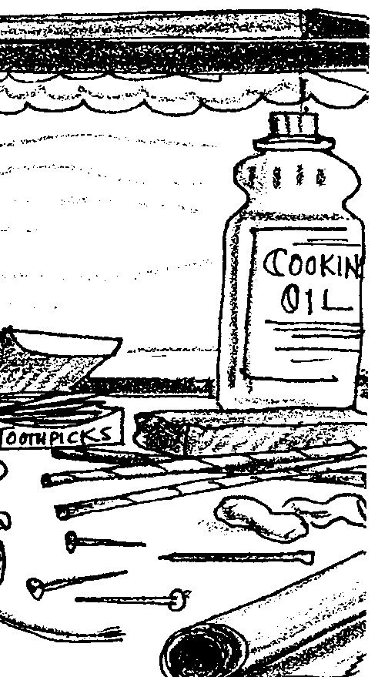
Key Concepts
1. Plankton can be divided into two broad categories: plant plankton (phytoplankton), and animal plankton (zooplankton).
2. Planktonic plants and animals cannot swim against a current and are usually microscopic (but there are large planktonic jellyfish).
3. Phytoplankton have specific structures that enable them to float near the surface so they can photosynthesize, grow and reproduce.

Background

Microscopic plant plankton play a critical role as the basis of most marine food chains. Phytoplankton often have very regular, geometric shapes and specific structures that enable them to float near the surface so they can photosynthesize and reproduce.

The two main types of phytoplankton are: diatoms and dinoflagellates.

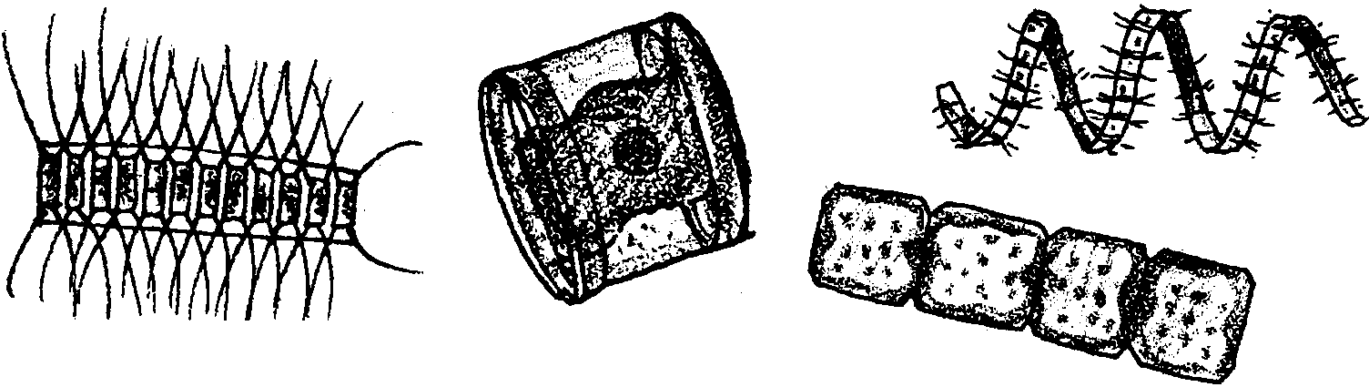
Diatoms have a cell wall made of silica, a glass-like substance. Diatom means “cut in two”; the diatom exists within a two-part shell of silica, with one half fitting over the other half, like a box. Diatoms are so minute that millions may exist in as little as a gallon of sea water. They come in many different geometric shapes and can be found alone or chained together in groups or colonies.

Diatoms

Adaptations which help keep diatoms at the surface include: spikes and other projections to disperse their weight; production of oil, which is lighter than water and, hence, keeps them from sinking; and air-filled floats.
Dinoflagellates lack silica in their cell walls, although some have armored plates of cellulose. In addition to the adaptations seen in diatoms to keep them near the surface, dinoflagellates can propel themselves with their two flagella (whip-like appendages). While they usually produce their own food like other plants, dinoflagellates can consume other plankton. This ability to consume food like an animal allows dinoflagellates to exist at lower light levels than diatoms.

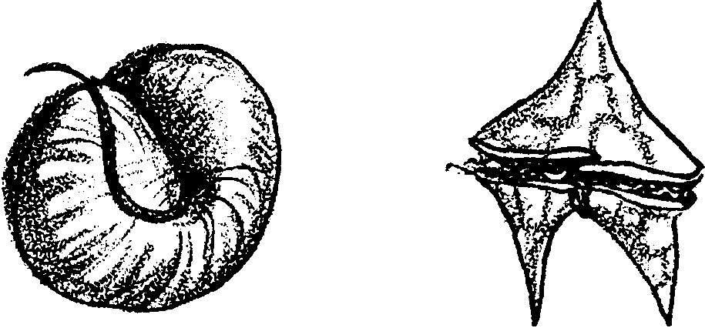

Dinoflagellates

Additional background is found in the preceding lesson, “Getting to Know Plankton”.

Materials

For the class:

• buckets of water (for trials)

• aquarium, filled with water (for final time trials)

• stopwatch

For each student or pair of students:

• waterproof clay

• soda straws

• toothpicks

• small nails (various sizes)

• string

• Styrofoam “peanuts”

• coffee stirrers

• aluminum foil

• cooking oil (if you are adventurous)

• “Design and Construct a Plankter” student sheet
Teaching Hints

“Design and Construct a Plankter” readily serves as a culminating activity for your plankton study. In this activity, students construct phytoplankton models. The challenge is to replicate a plankter that is neutrally buoyant, staying near the surface (but not floating) or which sinks very slowly.

As students make modifications to their plankter design, encourage them to share their results with each other. Stress that the goal is to come up with working models and that many are possible. Promote a cooperative rather than competitive mood by eliminating phrases such as “do it faster” or “better your time”.

This activity provides a rich opportunity for students to create sketches of their creations for inclusion in their field guides. You may wish to have students do a detailed drawing of their most successful plankton model and then use reference books to locate an illustration of the “real-life” plankton that most closely resembles their model.

Procedure

1. Discuss/review the benefits to phytoplankton of staying near the sunlit water surface. Use this introduction as a springboard for a discussion of some of the adaptations phytoplankton have to keep them near the surface so that they may continue to photosynthesize.

2. Explain to students that they are to use the materials provided to create a plankter that does not float, but “hangs” below the surface or sinks very slowly. Help the class agree on a specific amount of time allowed for the plankter to remain on the surface before it starts to sink. For example, the plankter must begin to sink in 5 seconds or it is a “floater” and not a legitimate phytoplankton model.

3. Set up several areas with buckets of water for students to test their plankton. Outside stations work perfectly. Encourage students to keep modifying and improving their creations.

4. Distribute the student worksheet and let the creation begin.

Key Words

diatoms - minute, planktonic, one-celled or chained phytoplankton with “glass” (silica) skeletons; found in both fresh and saltwater habitats

photosynthesis - a process which occurs in the presence of sunlight in the chlorophyll-containing tissues of plants in which carbon dioxide and water are combined to yield a simple sugar and oxygen

phytoplankton - plant plankton; the primary producers (“photosynthesizers”) of the sea

plankton - the mostly microscopic plants and animals that drift in water; singular = plankter

zooplankton - animal plankton

Extensions

1. Although microscopic, plankton are so numerous that their presence in the world ocean may be detected and recorded by satellites in earth orbit. The activity “Viewing the Ocean Planet From Space - Plankton Patterns”, found in the next level FOR SEA guide, Investigating the Ocean Planet - Grade Six, provides additional information about this topic.

Answer Key

1.- 7. Answers depend upon experimental results.

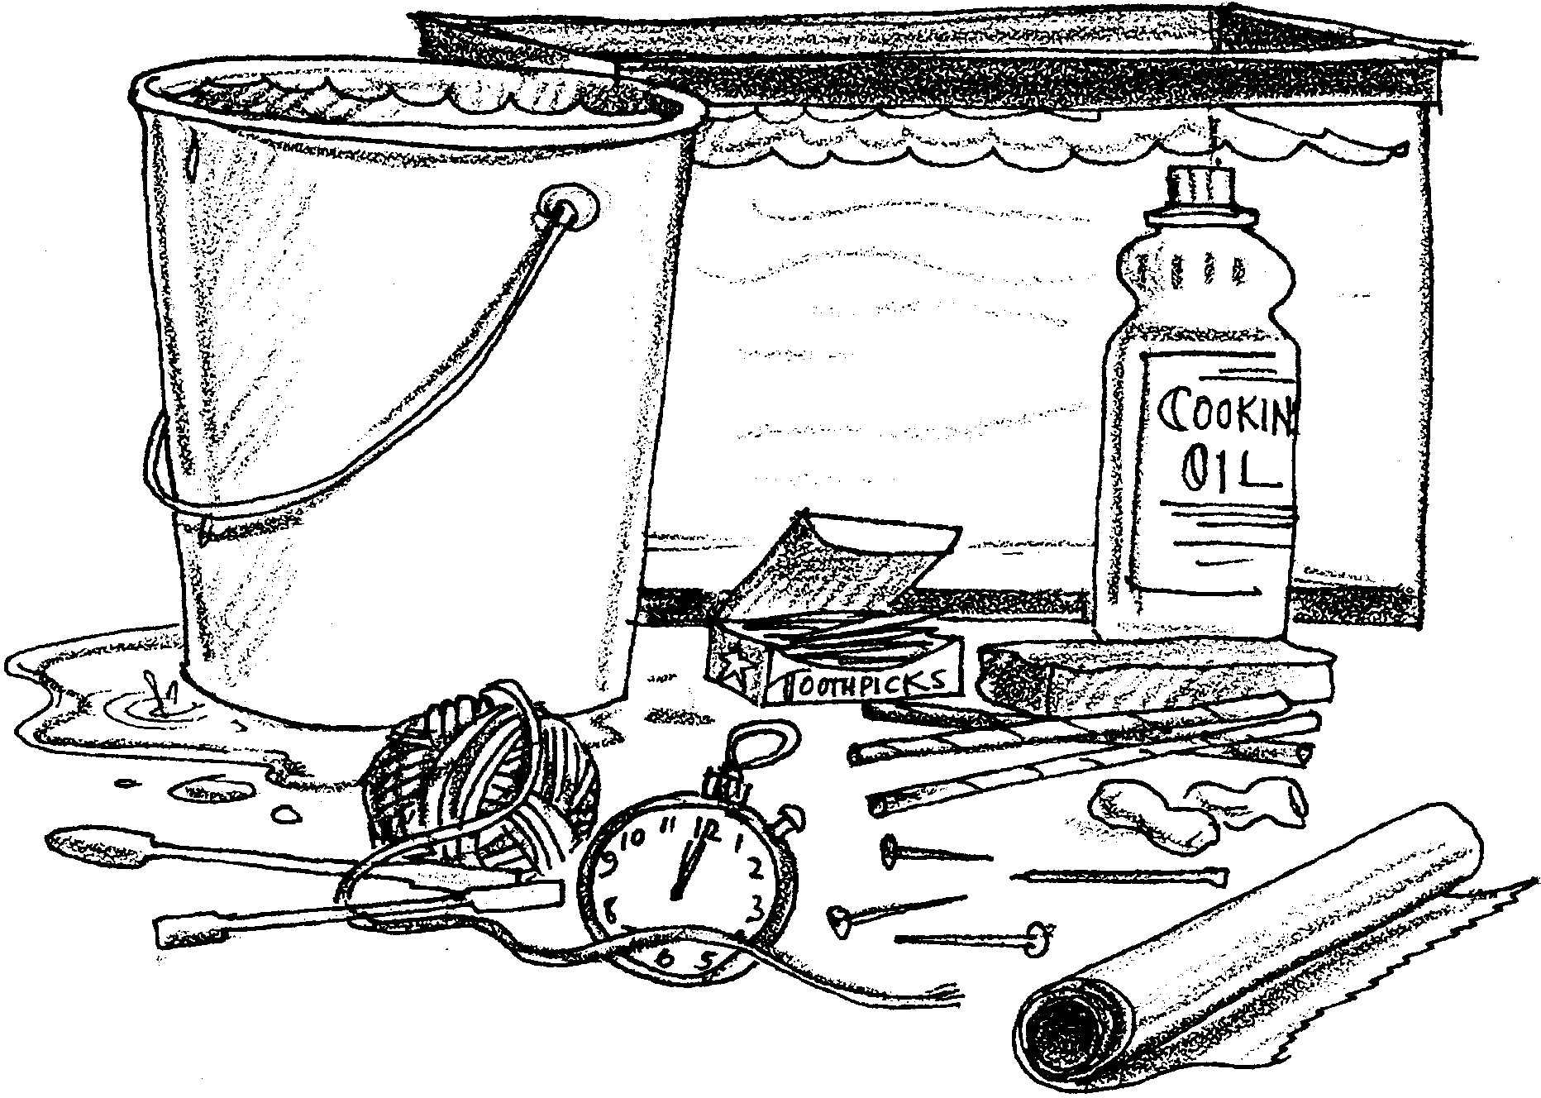
Design and Construct a Plankter

The Challenge
Build a plankter that stays near the surface (but does not float) or which sinks very slowly.

Procedure
1. Construct a plankter using the materials provided. Remember it must not float. It should stay near (but below) the surface or sink very slowly.

2. Test your plankter. How long did it take to sink? seconds. What can you do so it will sink more slowly? Describe your changes in words or with a drawing.

First changes:

3. Test your plankter again. How long did it take to sink? seconds. What can you do so it will sink more slowly? Describe your changes in words or with a drawing.

Second changes:

4. Test your plankter again. How long did it take to sink? seconds. What can you do so it will sink more slowly? Describe your changes in words or with a drawing.

Third changes:

Analysis and Interpretation

1. a. What change helped slow your plankter down the most?

b. Why do you think this change worked so well?

2. Compare your plankter with another plankter that sank faster than yours. What is the major difference?

3. Compare your plankter with another plankter that sank more slowly than yours. What is the major difference?

4. What improvements could you make to your plankter?

5. Draw your completed plankter on the back of this sheet. Name it. Label it. Be creative with the name and labels.

