Getting to Know Plankton*
Edited by Sue Brimhall, Seattle, WA
and Karen Mattick, Poulsbo, WA

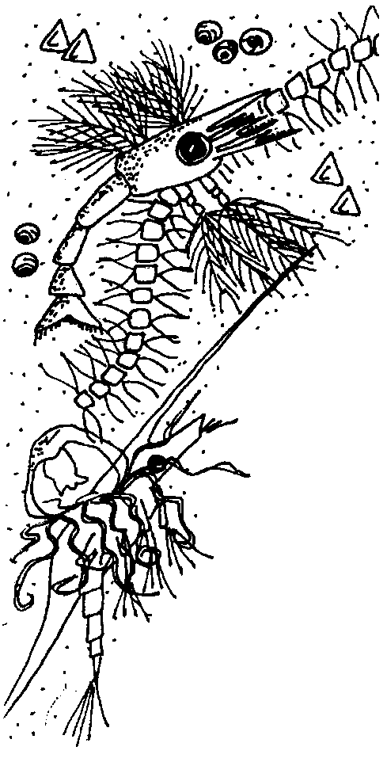
Key Concepts
1. The two major classifications of plankton are: phytoplankton (plant) and zooplankton (animal).
2. Phytoplankton, as viewed in a microscope, often have very regular, geometric shapes and are a greenish-golden color due to the presence of chlorophyll used to capture energy from sunlight.
3. Many of the zooplankton are larval forms of common invertebrates like: barnacles, clams, snails, etc.
4. Phytoplankton have specific structures that enable them to float near the surface so they can photosynthesize and reproduce.

Background

Plankton means wandering and indeed these mostly microscopic organisms “wander” endlessly throughout the seas of the world. To be a part of the group called plankton, an organism must not be able to swim or move against the power of a current in the water; they are controlled by the sea’s surges. Depending upon environmental conditions, plankton may be extremely abundant (millions per liter) or very scarce (tens per liter). These little organisms are largely responsible for coloring the seas and, in some cases, making them cloudy or murky. Crystal clear waters indicate a lack of plankton life, a kind of aquatic desert.

Plankton show a great range in size from .005 mm (at this size, 200 could line up side-by-side on a line about this long -) to more than one meter (about three feet) in size. Size is often used to classify plankton:

Nanno plankton ranges from .005 mm to .060 m

Micro plankton ranges from .060 mm to 1.0 mm

Macro plankton includes plankton larger than 1 mm

Mega plankton which includes the jellyfish and relatives with sizes up to one meter across.

Plankton are also grouped according to how they obtain energy. Using this system, the two main types of plankton are: zooplankton (the animals) and phytoplankton (the plants).

Zooplankton

Incredible diversity exists among animal plankton. In a single quart of sea water some 3,000 different kinds of zooplankton have been found! Some animals exist in planktonic form their whole lives. These are called permanent plankton, or holoplankton. Others, such as barnacles, crabs, shrimps, mussels, and sea stars, are members of the zooplankton a short while before drifting off to become adults. Organisms living only part of their lives as plankton are called temporary plankton, or meroplankton.
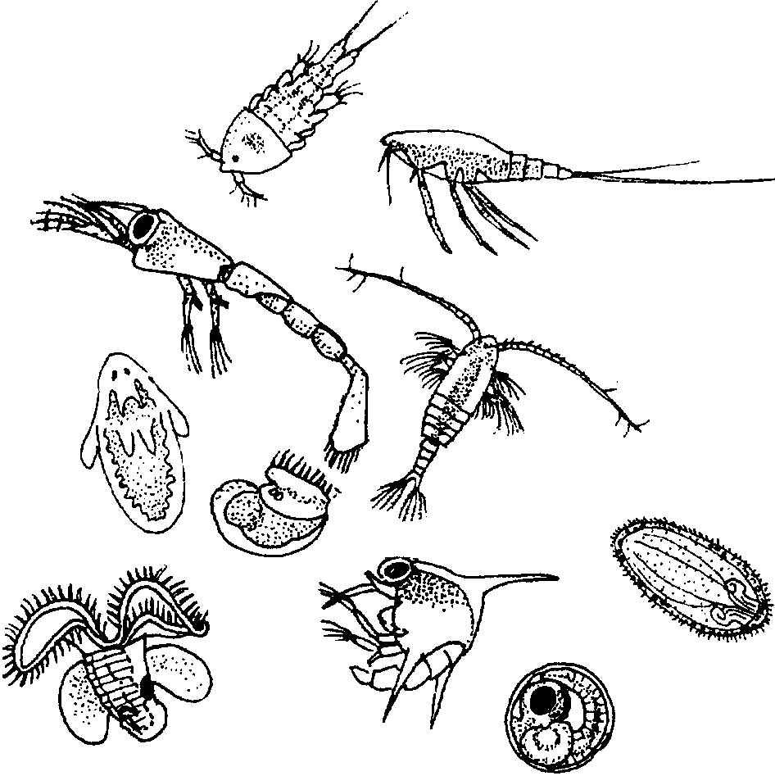

Zooplankton

Some fish also spend their early days maturing and growing as part of the zooplankton. As soon as the fish are able to swim against the current or water flow they are no longer considered part of the plankton. Being planktonic for a part of their lives proves advantageous to these fish as it provides opportunities for dispersal into new areas as the ever constant ocean swirls these beings to and fro, to and fro.

Zooplankton may be carnivores, herbivores or omnivores (animals that eat both plants and other animals). Regardless of their precise dietary preferences, zooplankton are dependent on phytoplankton (plant plankton). If they do not eat the phytoplankton directly, they eat other zooplankton that do eat phytoplankton, and so on. Phytoplankton, for their part, strive to stay near the lighted surface of the water to maximize their ability to photosynthesize. As a result, it is vital that zooplankton also remain close to the surface of the water to be near their food, the phytoplankton.
Zooplankton often must struggle to remain near the surface. They must not quite float at the surface, but they must remain buoyant enough not to sink. While these little organisms can not fight the strength of the current, they have adapted other ingenious ways to remain near the surface. For example, many zooplankton decrease their rate of sinking by having “feathered” appendages. The advantage of such appendages in increasing “drag” and slowing the rate of descent can be easily demonstrated by simultaneously dropping two sheets of paper: one unfolded; the other crumpled into a tight wad. The unfolded paper, which represents an animal with appendages, takes considerably longer to fall to the ground.

Although zooplankton are not much of a match for ocean currents, they actually do perform some rather amazing swimming feats. Many zooplankton migrate considerable distances vertically each day. As the sun rises, they settle to less lighted depths where their predators cannot see them as well as they could if they remained near the surface. As the sun sets, these zooplankton return to the surface waters to again feed on the “phytoplankton soup”.

Phytoplankton

The sunlit layer of water is dominated by single-celled plants known as phytoplankton. There are two main types of phytoplankton: diatoms and dinoflagellates. Both types use nutrients, such as carbon, nitrogen and phosphorus dissolved in the water. Most phytoplankton engage in photosynthesis, using energy from the sun to produce food. However, some dinoflagellates do eat other plankton.

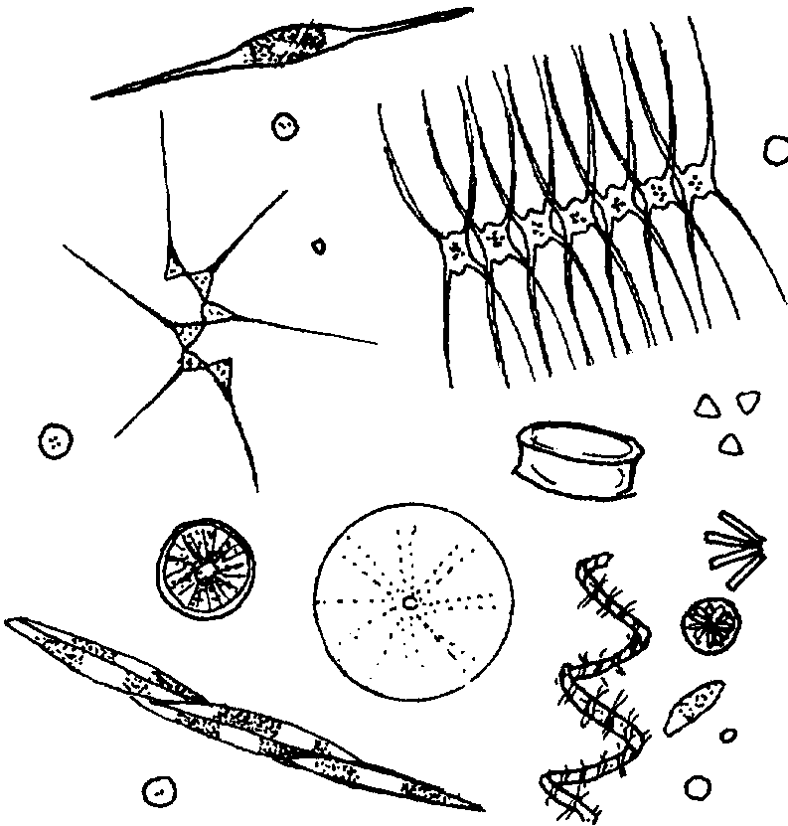

Phytoplankton

Diatoms have a cell wall made of silica, a glass-like substance. Diatom means “cut in two”; the diatom exists within a two-part shell of silica, with one half fitting over the other half, like a box. Diatoms are so minute that millions may exist in as little as a gallon of sea water. They come in many different geometric shapes and can be found alone or chained together in groups or colonies.
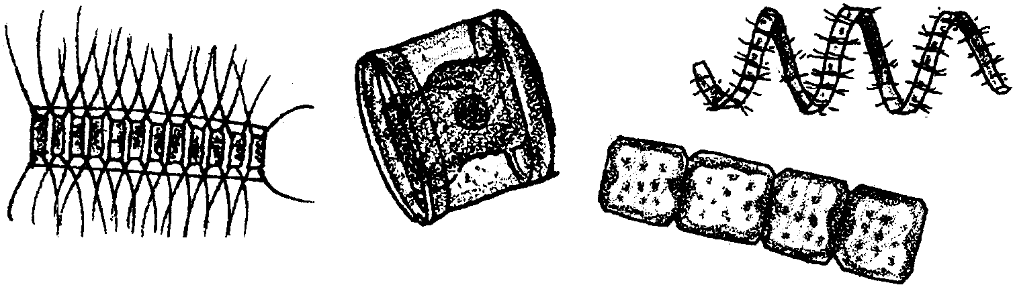

Diatoms

Diatoms have interesting adaptations which keep them at the surface to continue capturing sunlight. Many have spikes and other projections to disperse their weight. Some produce oil, which is lighter than water, to keep them from sinking. Some use air-filled floats to stay afloat.

Dinoflagellates are very unusual plants because they can propel themselves with their two flagella, or whip-like appendages. Although they usually produce their own food like other plants, dinoflagellates can consume other plankton.
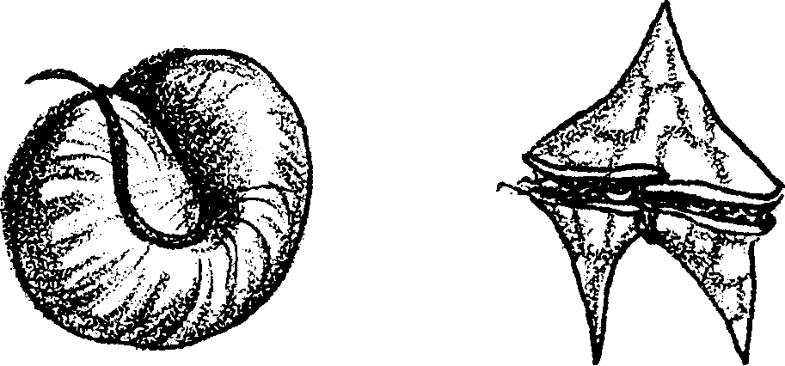

Dinoflagellates

Dinoflagellates are often responsible for “Red Tides” and incidents of Paralytic Shellfish Poisoning (PSP). Under the right conditions, these organisms reproduce rapidly, creating a “bloom”. Some dinoflagellates have a toxin. In a bloom situation, when filter feeders like clams and other shellfish consume huge amounts of the toxic dinoflagellates, the toxin can accumulate in their tissues. The toxic dinoflagellates do not harm these original filter feeders. Organisms that consume the filter feeders, however, may be harmed. If enough toxin is present it can cause paralytic shellfish poisoning, a disease which can result in paralysis or death in humans, and harm other animals consuming the shellfish.

Note: the term “Red Tide” can be deceiving. A bloom of some species of dinoflagellates can give a reddish tinge to the water. These organisms may or may not be toxic. Some dinoflagellates or other plankton that are toxic may not affect the color of the water. It could appear to be perfectly normal but be highly toxic. Reinforce the importance of checking the status of shellfish before collecting and consuming the meat. Read and heed all “Red Tide” warning signs posted on beaches. Some states have taken additional steps to protect shellfish harvesters. For example, in Washington, the Red Tide Hotline phone number is 800-562-5632. Check to see if your state has a similar program.

Materials

Material lists are also included at the beginning of each of the individual activities described below.

Activity 1: Classifying Plankton

For each student:

• plankton picture set

• “Classifying Plankton” student sheet

• scissors

• glue

• colored pencils or crayons

Activity 2: Constructing A Plankton Net

For the class:

• pliers (at least three pair)

• wire cutters (may need one pair)

For each pair of students:

• “Constructing A Plankton Net” student sheet

• nylon stocking (discarded panty hose work well)

• metal coat hanger

• needle and strong thread

• small bottle with lid (baby food jars work well)

• string or twine

• scissors

Activity 3: Observing Plankton and Estimating Plankton Populations

For each group (group size depends on availability of microscopes):

• collected plankton samples

• a tool to view the plankton, such as: stereo microscopes, Discovery Scopes, microfiche projector, or video microprojector

• plastic petri dishes

• eyedroppers

For each student:

• “Observing Plankton” student sheet

• “Estimating Plankton Populations” student sheet

Teaching Hints

Included in this lesson are the following separate activities:

Classifying Plankton

Constructing a Plankton Net

Observing Plankton

Estimating Plankton Populations

The first two parts, “Classifying Plankton” and “Constructing a Plankton Net”, can be done in the classroom before a plankton sample is actually collected. If possible, involve all of the students in collecting the sample. If that is impossible, one student who lives near a pond, stream or dock might volunteer to collect the sample. Or, if necessary, you can bring in the sample yourself. In any case, conduct the third and fourth parts of this activity, “Observing Plankton” and “Estimating Plankton Populations”, very soon after collecting the sample.

Sampling live plankton for students to observe makes this lesson most successful. There is nothing like seeing living plankton under a microscope! The students’ enthusiasm will make it well worth the extra energy required to collect and provide good viewing of the plankton.

Preparation

Collecting a Live Plankton Sample

Collection of a live plankton sample (from coastal waters, by a dock, or in fresh water ponds) for observation gives students a concrete experience with plankton. A collection net is quite easily constructed using the directions in “Constructing a Plankton Net.”

Tow the net through the water, gently sweeping back and forth, several times. Once the plankton is collected, remember that, to keep the plankton alive, you will need to keep it in an environment as much like the environment from which you collected it as possible. This may mean refrigerating the sample. The less time that passes between collection and observation by students, the more vibrant the viewing.

Viewing the Plankton Sample

Obtain microscopes for students to observe plankton. Good microscopes greatly increase the success of students’ observations. “Discovery Scopes” work quite well, particularly for zooplankton. See the bibliography for details on Discovery scopes.

If you do not have access to good microscopes, try borrowing one or two from a middle or high school. Stereo or dissecting microscope (10-20 power) are easier to use than compound scopes. If using microscopes with your students, be sure to provide an orientation to the proper care and use of the microscope. Remind them that spilled salt water must be wiped off the scope immediately. If you are lucky enough to have access to a video projecting microscope, it is ideal for whole group observation of the plankton samples. Microfiche readers, once widely used in libraries and which still may be sitting on shelves in storage, work amazingly well for plankton observation.

Other ways to share plankton with students include:

• live brine shrimp from the local pet store

• video footage of plankton such as that included in the Monterey Bay Aquarium Video Treasury (see bibliography for details)

Activity 1: Classifying Plankton

Materials

For each student:

• plankton picture set

• “Classifying Plankton” student sheet

• scissors

• glue

• colored pencils or crayons

Procedure

1. Have students cut out each picture on the plankton picture set. Suggest that students sort the plankton pictures into groups based on their observable physical characteristics. You may need to explain that an “observable physical characteristic” is something everyone can see and agree upon; (e.g., “has appendages” is an observable physical characteristic; on the other hand, “is pretty” is a value judgment, not an observable physical characteristic).

2. Discuss the groupings and the observable characteristics of the plankton used to determine the groups. Remind students that the pictures are simple line drawings and that if the organisms were observed in a living sample in a drop of water, they would have three dimensions. The organisms might also move and exhibit specific behaviors.

3. Now challenge students to sort all the plankton drawings into just two groups. While the basis for the groupings will likely vary, they may include characteristics such as: regular shapes and irregular shapes, legs and no legs, etc. If students choose “plants and animals” as the basis for separation, ask them to identify the observable physical characteristics that made them label an organism as a plant or animal. Explain that they are using the skills of classification to group the drawings.

4. Have students play “What’s My Rule?”. Explain that to play “What’s My Rule?”, one student will sort the plankton into two groups and record the “rule” used to effect the separation. The rule should remain concealed from the partner. The partner tries to guess the rule used for sorting. If a correct guess is made, the first player must reveal the concealed “rule”. Students then reverse roles and continue.

5. Discuss and list the “rules” used to sort plankton in the class. Distribute copies of the student worksheet, “Classifying Plankton”, and have students compare their list with the classification scheme used by marine scientists .

Activity 2: Constructing A Plankton Net

Materials

For the class:

• pliers (at least three pair)

• wire cutters (may need one pair)

For each pair of students:

• “Constructing A Plankton Net” student sheet

• nylon stocking (discarded panty hose work well)

• metal coat hanger

• needle and strong thread

• small bottle with lid (baby food jars work well)

• string or twine

• scissors
Procedure

1. Divide the class into pairs and distribute the student sheet, “Constructing A Plankton Net”. Explain the basic function of a plankton net so students will have an understanding of how the tool they will be constructing works.

2. Have students construct the nets, then arrange a time and place for the samples to be collected.

REMEMBER: If the samples are collected and you are not able to observe them immediately, you must keep the samples in an environment that will keep them alive. This may mean refrigerating the samples or adding air with a soda straw or air pump. Observation of the sample is much more interesting when the zooplankton are alive and moving through the sample.

Activity 3: Observing Plankton and Estimating Plankton Populations

Materials

For each group (group size depends on availability of microscopes):

• collected plankton samples

• a tool to view the plankton, such as: stereo microscopes, Discovery Scopes, microfiche projector, or video microprojector

• plastic petri dishes

• eyedroppers

For each student:

• “Observing Plankton” student sheet

• “Estimating Plankton Populations” student sheet

Procedures

1. Demonstrate the preparation of the sample for viewing. Use an eyedropper to place six individual drops of the water on the petri dish. Remind students that the plankton must be captured and that if they see nothing in their drops on the dish the first time, they should discard the drops and try other drops from the collected sample.

Sometimes finding, or “catching”, the zooplankton ahead of time can speed up the process of viewing if you have limited scopes. This technique, is also highly successful for students that have a difficult time using a scope. Once the contents of the drops are determined, a trained student standing by the microscope can introduce the different animals to the novice and also review microscope handling.

2. Have students prepare and observe the plankton samples.

3. Distribute the student sheet, “Observing Plankton”.

While a simple plankton guide is found at the end of this lesson, you may wish to acquire A Guide to Marine Coastal Plankton by DeBoyd L. Smith, an excellent pictorial guide to plankton (see bibliography).

4. Finally, have students practice their estimation skills using the “Estimating Plankton Populations” worksheet.

Key Words

diatoms - minute, planktonic, one-celled or chained phytoplankton with “glass” (silica) skeletons; found in both fresh and saltwater habitats

photosynthesis - a process which occurs in the presence of sunlight in the chlorophyll-containing tissues of plants in which carbon dioxide and water are combined to yield a simple sugar and oxygen

phytoplankton - plant plankton; the primary producers (“photosynthesizers”) of the sea

plankton - the mostly microscopic plants and animals that drift in water; singular = plankter

zooplankton - animal plankton

Extensions

1. Read “Pagoo’s Recipe for Sea Soup”, found at the end of this background section, and have students illustrate the recipe steps.

Answer Key

Activity 1: Classifying Plankton

1. The marine biologist sorted the plankton according to whether they were plants (phytoplankton) or animals (zooplankton).

2. Physical characteristics of the zooplankton include: appendages, eyespots, more complex bodies, and antennae. The zooplankton have some characteristics you cannot see in the drawings. Like most other animals, the zooplankton can move. They dart, twist, and swim through the water. Brightly colored organs may be visible through their transparent bodies.

3. Physical characteristics of the phytoplankton include: geometric shapes, often chained or repeated. Dinoflagellates have tails. Like many land plants, phytoplankton observed under the microscope are pale green, brown-green, or yellow.

Activity 3: Observing and Estimating Plankton Populations

1. Answers will depend on the plankton sample. Mesh size plays an important role in determining the composition of the sample. Often, the larger zooplankton will be more numerous.

It is worth noting that both numbers and kinds of plankton vary over time. Typically, plankton growth is cyclical. After spring or fall wind and rain stirs nutrients in the water, phytoplankton bloom. The size and duration of the bloom are related to the amount of daylight and the availability of nutrients. After the phytoplankton bloom, the phytoplankton-feeding zooplankton proliferate. Feeding on smaller animals, the larger plankton then increase in number. As nutrients are consumed, the phytoplankton eventually die, followed by the zooplankton populations. The dead plankton are fed upon by decomposing bacteria, releasing nutrients to start the cycle anew.

2. Answers will vary depending on the plankton sample.

3. a. Juvenile forms of barnacles, crabs, snails, and worms are common temporary zooplankton in marine waters.

b. Copepods are probably the most common permanent zooplankton in both fresh and salt water.

4. a. Answers will vary. The most common technique employs the use of a sampling procedure to estimate the number of plankton in a gallon of seawater. For example, count the number of plankton in a known size drop and multiply the number of plankton times the number of drops in a gallon.

b. For the entire body of water, “just” estimate the number of gallons in the body of water and multiply that number times the answer in 4. a. These manipulations assume uniform distribution of plankton in the larger samples. They also assume that the drop is representative of the larger body of water from which it was collected. Discuss these assumptions with your class.

Even if we knew the number of gallons in the body of water sampled, these answers are not very realistic because they ignore the fact that the plankton net concentrates the plankton. For a more accurate answer one would also need to know the size of the net, the distance the net was towed, at what water level, during which season, at what time of day, at what location, etc. The important thing to emphasize is that a sampling procedure can be used to estimate large quantities and that every sampling procedure is based on a set of assumptions which determine the veracity of the results.

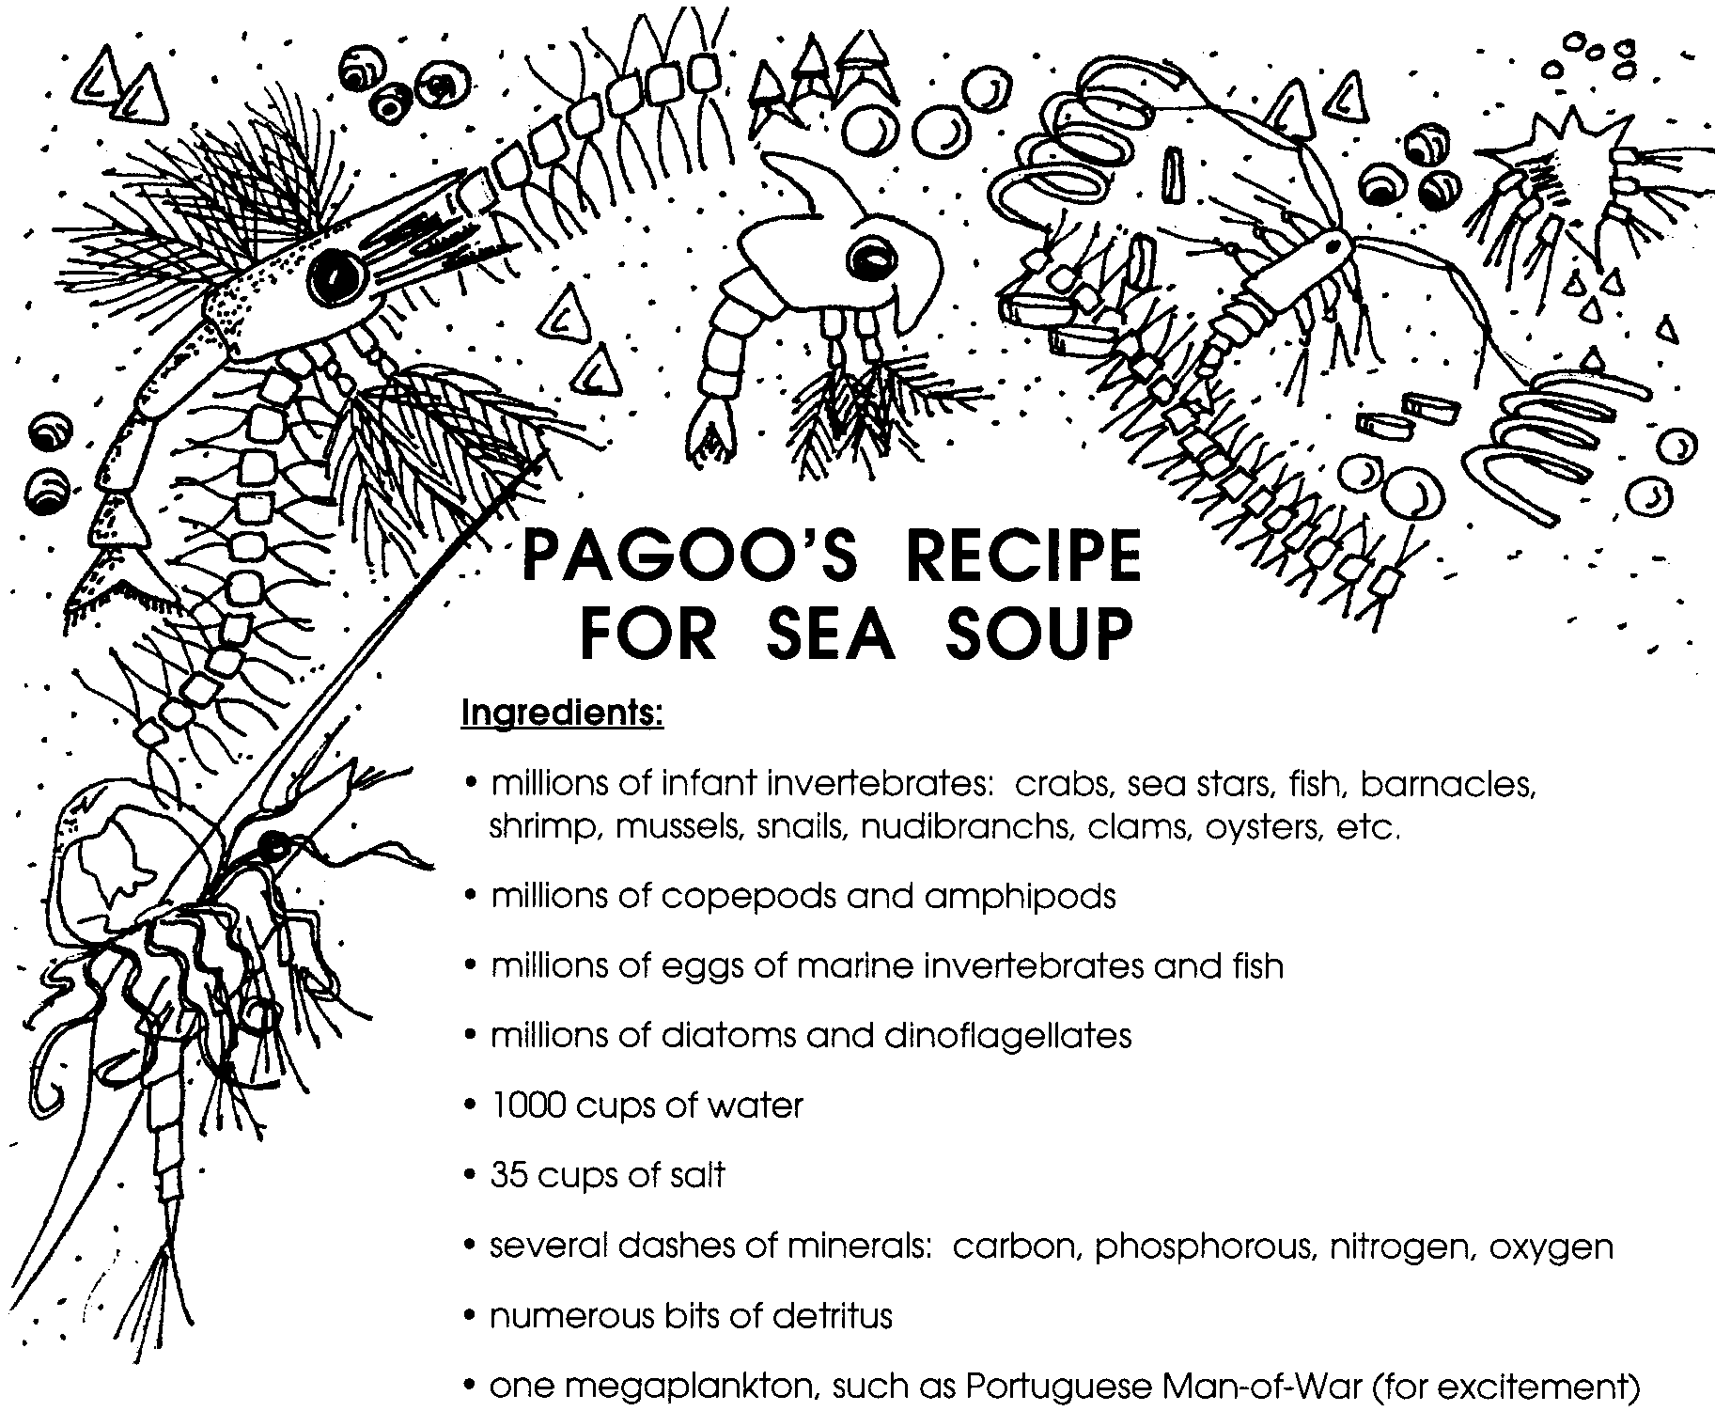

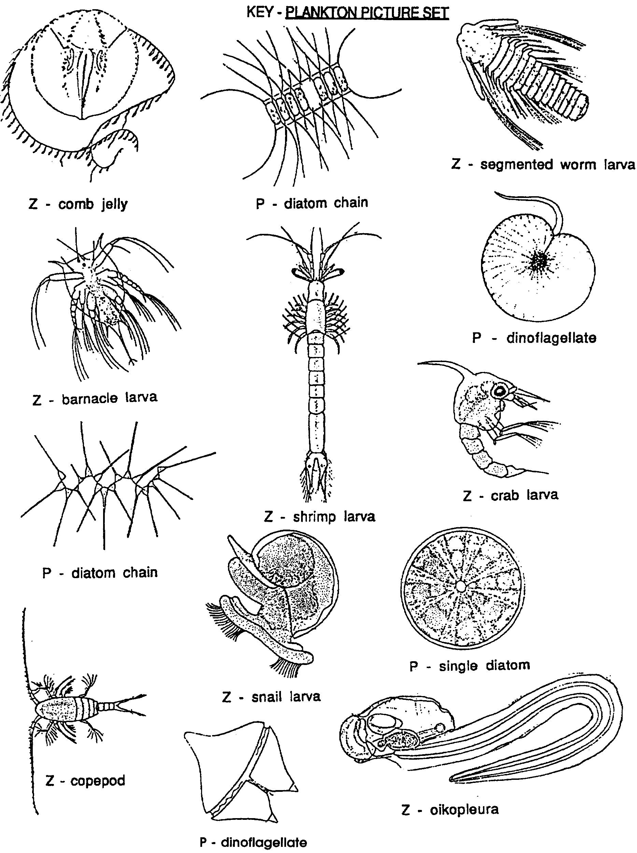

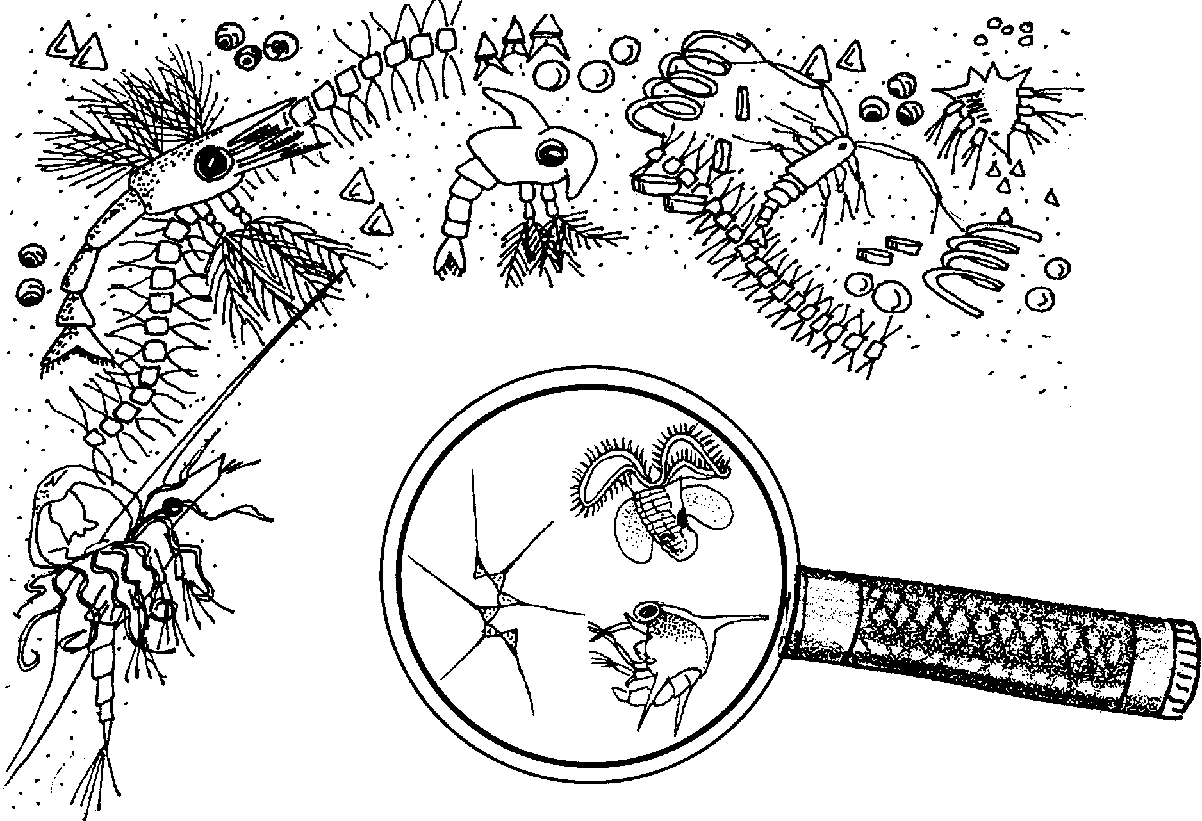
Getting to Know Plankton

Classifying Plankton

Materials
• “Plankton Picture Set”
• scissors
• glue
• paper
• colored pencils or crayons

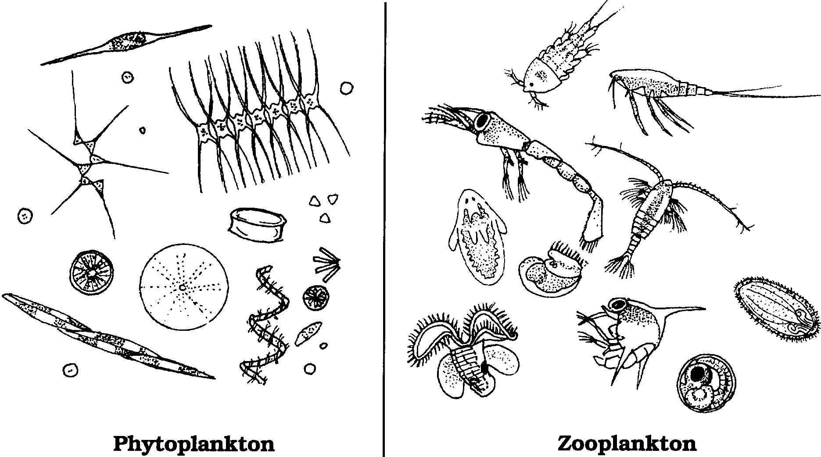
The following drawing shows how a marine biologist grouped the plankton pictures:

The Challenge

1. What “rule” did the biologist use to sort the plankton pictures?

2. List 3 physical characteristics of animal plankton.

a.

b.

c.

3. List 2 physical characteristics of plant plankton.

a.

b.
Constructing a Plankton Net

Materials
• nylon stocking
• metal coat hanger
• needle and strong thread
• scissors
• small bottle with lid
• string or twine
• pliers
• wire cutters

The Challenge

Use everyday materials to make a net to catch plankton. Here’s how:

Procedure

1. Use the pliers to unwind the coat hanger so it is a straight piece of wire.

2. Bend about 1/3 of the wire to form a circle. This will form the opening to the net.

3. Bend the remaining 2/3 of the wire back on itself to form a handle. The handle will help you move the net through the water.
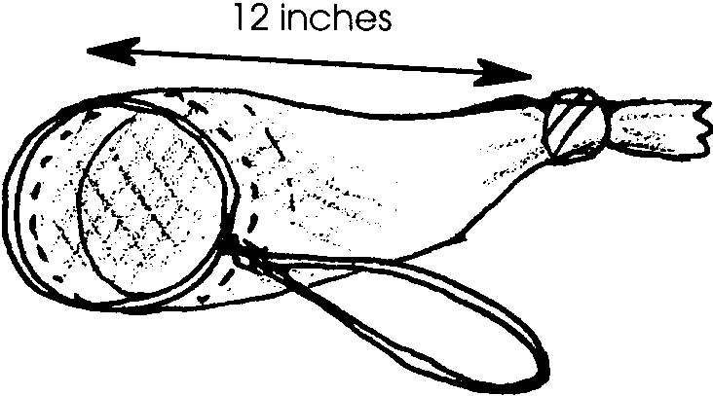
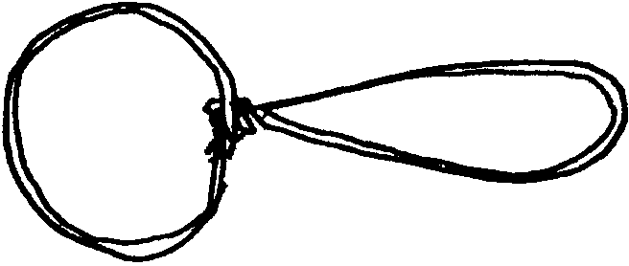
4. Fold the top of a nylon stocking over the circle. Sew around the rim. The wire should be firmly fastened into the stocking. Be sure that the wire is completely covered by the stocking top.
5. Tie a knot in the stocking so that the distance from the opening of the net to the knot is about 12 inches.

6. Remove the lid from the jar. Put the jar into the net so that the bottom of the jar is touching the knot. This is the collecting jar.

7. Tie a string around the neck of the collecting jar to hold it in place.
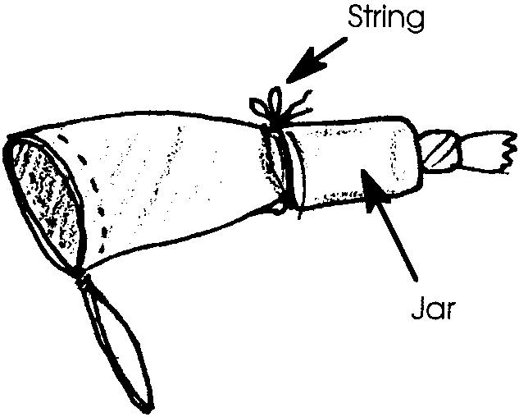
8. Your net is ready. Tow the net through the water. When the net is towed, the water will run through the net. The running water funnels the captured plankton into the collecting jar. The jar of captured plankton is called the sample.

Observing Plankton
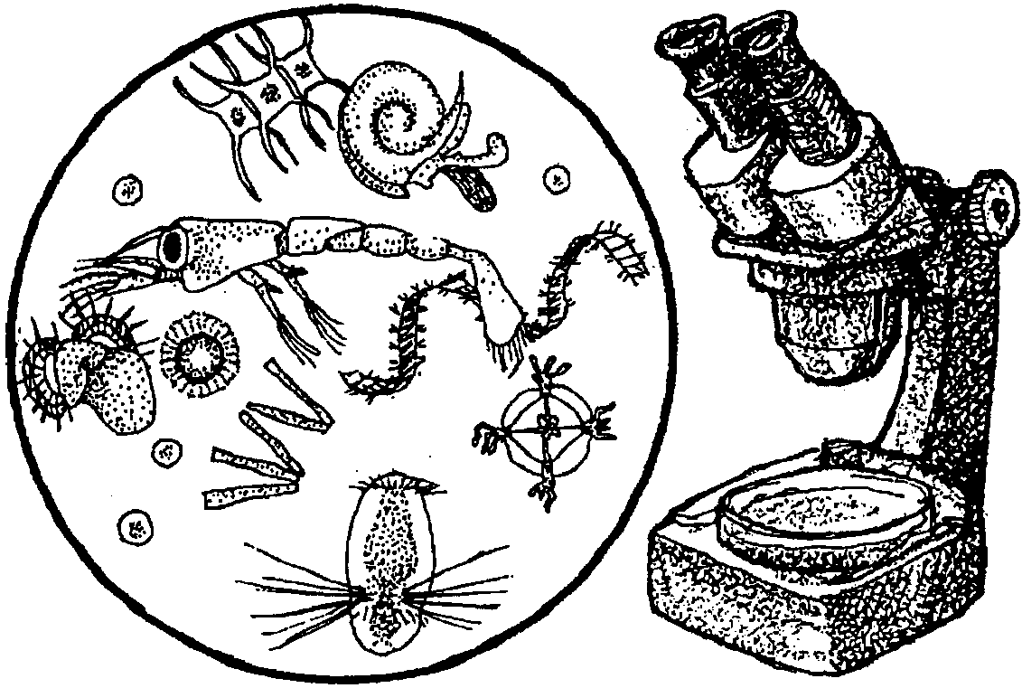

Materials
• plankton sample
• tool to magnify and view the plankton
• eyedropper
• petri dish
• identification guide

The Challenge

Catch, view, and draw plankton. Here’s what to do:

Procedure

1. Obtain an eyedropper. Place six separate drops of the plankton sample in a petri dish. Be sure the drops don’t touch each other. Each drop forms a “plankton prison”. The zooplankton are kept in a small area. This lets you to observe them as they swim around the drop of water.

2. Magnify the drops. Scan the drops and observe the plankton.

3. Select the plankton you think are most interesting. Sketch at least four on the back of this sheet. Make each drawing as large as the palm of your hand. Add details, such as colors, numbers of legs, etc.

4. Decide which of your drawings are zooplankton. Decide which are phytoplankton. Label each picture.

5. Under each plankter, list at least two observed characteristics.

6. Find an identification guide. Use it to help you identify the plankton you have drawn. Write the names by your drawings.

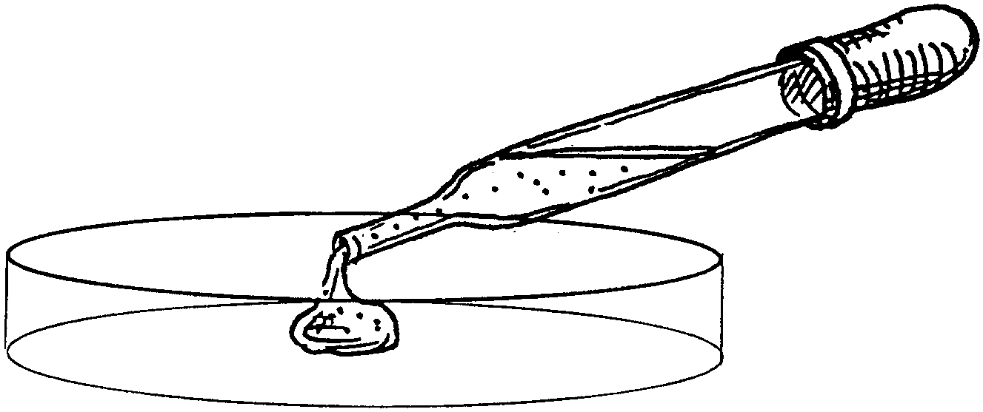
Estimating Plankton Populations

Materials
• plankton sample
• microscope
• eyedropper
• petri dish

The Challenge

Find out how many plankton are in your sample. Here’s how:

Procedure

1. In your sample, which is more numerous, zooplankton or phytoplankton?

2. Which animal or plant (crab larvae, copepod, diatoms, etc.) is most abundant in your sample?

3. Some animal plankton, like crab larvae, are temporary zooplankton. These plankton grow into adult forms which look very different from their planktonic forms.

a. Which organisms in your sample are temporary plankton?

b. Identify a permanent zooplankton (copepods, comb jellies, etc.) in your sample.

4. a. How could you estimate the number of plankton in a gallon of water?

b. In the entire body of water the sample was collected from?

c. Estimate the number of plankton in a gallon of the water from which your sample came. (Hint: Use your answer from 4. a.)

