Pagoo Might Be a Hermit Crab

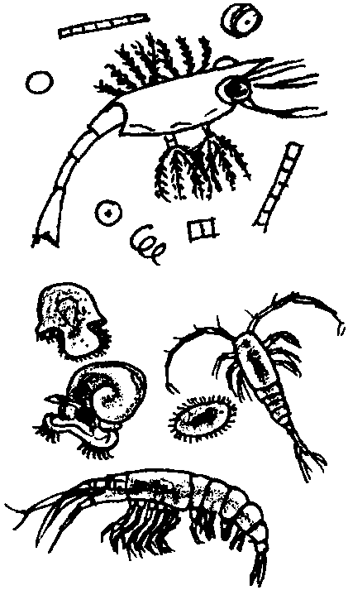
Key Concepts
1. Plankton are the mostly microscopic plants (phytoplankton) and animals (zooplankton) that drift in fresh and saltwater.
2. Pagoo begins life as a tiny zooplankter in saltwater.
3. As zooplankton, hermit crabs eat phytoplankton such as diatoms.

Background

Marine science may be taught in many ways. Investigating Marine Science: Life with Pagoo uses the award-winning children’s book Pagoo by Holling C. Holling as the thread which unifies and integrates science, reading, language arts, and art activities. Pagoo is a scientifically accurate story about the life history of a hermit crab, called “Pagoo”, and his adventures in Tidepool Town. This book serves as an extraordinary introduction to the magical world of tide pools. The detailed information included in the delightful prose, along with the exquisitely detailed margin drawings, quickly engage fifth graders.

The units in this curriculum follow a similar pattern. After reading one or two chapters of Pagoo, interdisciplinary activities reinforce the concepts presented in Pagoo.

Creating a Pagoo Field Guide

Pagoo and the corresponding interdisciplinary activities provide a wonderful opportunity for students to create their own field guides. A field guide is a record of what one knows at a particular time. One of a scientist’s or naturalist’s greatest tools for research and observation is a field guide. A field guide may take the form of a large, loose leaf notebook or envelope.

The guide your students create may be used to record data and observations they collect in the field or the classroom.

To introduce this topic, have students share their experiences of using field guides as they examine a variety of field guides. In your discussion, call attention to the margin drawings found in Pagoo.
Help students generate a list of the manners in which information may be included in a field guide:

• illustrations of animals, plants, etc. Sketches of an organism may or may not include the surrounding habitat. The media used for creation of the illustrations are a matter of individual preference and desired effect.

• notes most certainly accompany the illustrations or are found in close proximity. Written descriptions can elaborate or fill in details not expressed in picture forms.

• photographs

• samples, such as plants, sand, a feather, etc.

These records are a valuable, permanent source of information for later reference by a scientist or naturalist.

It is both highly motivational and environmentally friendly to have students construct their own field guides as the chapters of Pagoo are presented rather than making photocopies for the students.

Please note that in the following curriculum, the activities whose titles are marked with an asterisk (*) include material which lends itself well to entry in students’ Pagoo Field Guides.

Review the format suggestions below. Choose a format you can get excited about promoting and that will be easy to implement.

Basic Pagoo Field Guide

The "basic field guide" gives a cross-curriculum dimension to the lessons as it combines the elements of composition and illustration.

1. Read and discuss a chapter of Pagoo. Provide background information on the featured concept or animal to the students.

2. Students summarize what they have learned in a paragraph.

3. Students illustrate the paragraph including the margins.
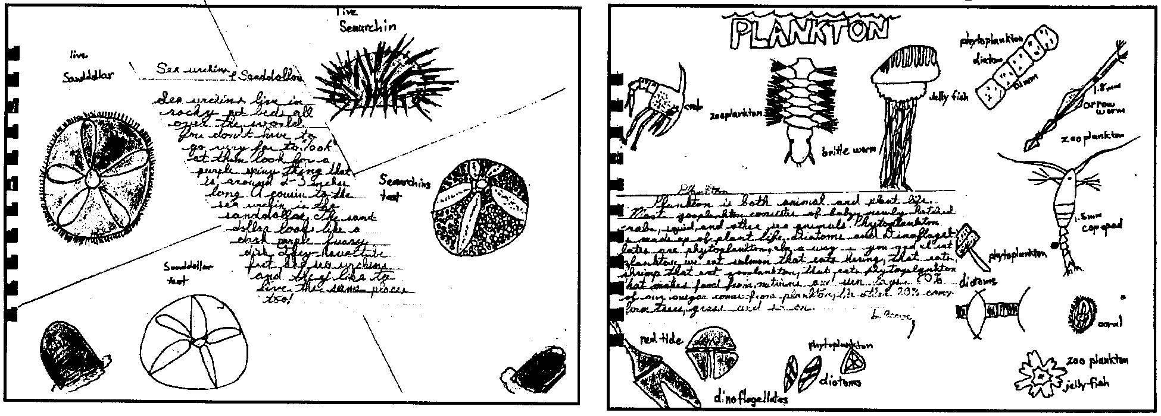

Pagoo Guide Focusing on Multiple Intelligences

Instead of doing the same thing for each chapter, change the approach with each chapter. For example:
• poetry with illustrations
• writing a short story using the featured animal
• creation of a full page illustration
• a cartoon strip emphasizing a concept from the chapter
• a play or puppet script based on the chapter
• compose a rap or song
• write a newspaper article about one of Pagoo’s adventures

Pagoo Lessons Notebook

This “field guide” includes all the written assignments and experiments the students complete in their study of Pagoo. Individual worksheets or papers are collected into a booklet format or students present the lessons in a more summarized form in their guide.

Cooperative Pagoo Guide

This guide utilizes a division of labor approach to create a group guide. Students specialize in text, illustration, samples, etc. Although a bit of a departure from traditional field guides which are prepared by a single individual, this method allows each student to contribute from her or his strength while providing direct exposure to the work generated by teammates from their areas of strength.

Multi-media Pagoo Guide

Computers, video cameras, tape recorders and the like may be effectively used by students to record and preserve information. These electronic devices also provide for a variety of creative ways to display and manipulate the information.

The master drawings of the principal characters of Pagoo which follow may be helpful in any of the above field guide styles. Note that the number in the lower right-hand corner of each drawing indicates the number of the chapter in Pagoo with which the drawing correlates.

Chapter 1 Summary: Pagoo Might Be A Hermit Crab

Pagurus (Pa-GOO-rus), nicknamed “Pagoo”, is a newly hatched, microscopic, hermit crab. He must rely on instinct, known as “Old Pal”, to tell him what to do and how to do it as his parents do not raise him. Old Pal’s first message is, “You’re hungry”. Pagoo’s first foods are diatoms and algae. He soon realizes he has neighbors in the sea: young spiny lobsters, crabs, jellyfish, and squid. Some planktonic creatures grow large and strong enough to swim far out into the ocean. Others, like Pagoo, will eventually drop to the ocean floor to continue the growing process. For the time being, Pagoo wanders the sea in his transparent, planktonic state.

Materials

For the class:

• Pagoo, award-winning children’s book by Holling C. Holling

Teaching Hints

Read chapter 1 of Pagoo with students.

Key Words

algae - one-celled or many celled aquatic plants that have no root, stem, or leaf systems

diatoms - minute, planktonic, one-celled or chained phytoplankton with “glass” (silica) skeletons; found in both fresh and saltwater habitats

photosynthesis - a process which occurs in the presence of sunlight in the chlorophyll-containing tissues of plants in which carbon dioxide and water are combined to yield a simple sugar and oxygen

phytoplankton - plant plankton; the primary producers (“photosynthesizers”) of the sea

plankton - the mostly microscopic plants and animals that drift in water; singular = plankter

zooplankton - animal plankton

Extension

1. Show your students the film, “The Story of a Book”, which tells how the book Pagoo was made.

