Marinated Language Murals

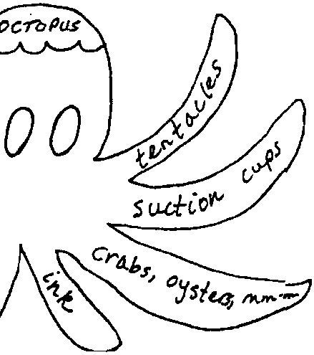
Lesson by Patty Enright, Stillwater, MN

Key Concept
1. Marine vocabulary and concepts can be reinforced through art activities.

Background

From “being crabby” to “squall”, the marine environment and maritime culture have produced a rich and varied vocabulary. This vocabulary, as well as marine related concepts, can be expanded and reinforced through art activities.

Materials

For each group of students:

• one large piece of rolled paper, tagboard, etc.

• crayons or markers

• a list of water-related words

Teaching Hints

In “Marinated Language Murals”, students work in small groups to design and construct a mural using marine related pictures and words.

Procedure

1. Brainstorm a list of water-related words.

Examples:

sailing seep aquarium cruises
blue heron whales porpoises silt
bridges sand typhoon fresh
limnology ski oil spill kelp
oceans lakes wetlands seaweed
sewage floods chlorine Titanic
ferries ships canoes salt
lily pads turtles life cycle umbrella
current tide oxygen fish
pH gulls acid rain SCUBA diving
algae bubbles crustaceans brackish
nitrites safety waves storm
snow ducks rain forest squall
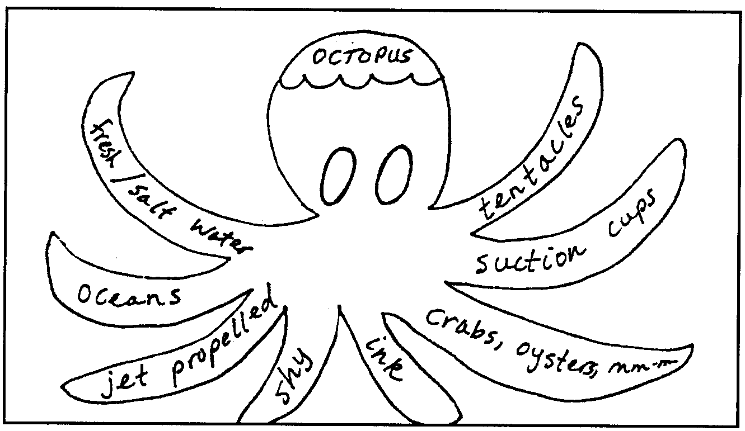
2. Have students work in small groups to design a mural using pictures and/or words. The following are two student examples:
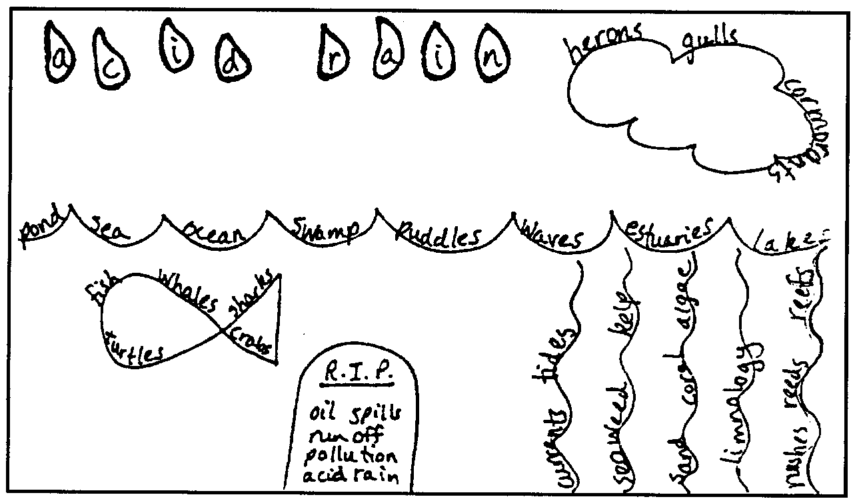

3. You may choose to make topics more specific, for example: tide pools, storms, sources of pollution, recreation or transportation on the water, wetlands, fresh water food chains, etc.

4. Display the murals and have each group present and discuss its mural.

