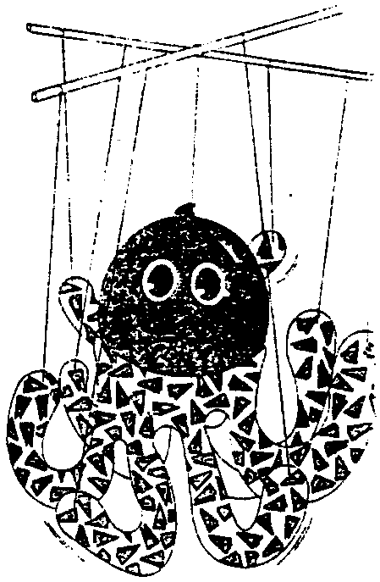
Octopus Marionette

Lesson by Patty Enright, Stillwater, MN

Key Concepts
1. An octopus has many structures and behaviors which help it to survive in its habitat.
2. An octopus has powerful suction cups on its arms and a hard, strong beak in the center of eight arms, which it uses to eat shellfish, including hermit crabs.

Background

Octopuses (one form of the plural, as are octopi, octopods, and octopus) are fascinating marine animals. With well-developed brains and eyesight, they are effective predators. They move gracefully, on eight, suction cup-laden arms, or rapidly, by forcing water through a funnel siphon.

Additional background information is found in the preceding activity, “Octopus Escape”.

Materials

For each student:

• one round balloon*

• wrapping paper*

• tape measure

• scissors

• tape

• string

• construction paper

• tape measure

• two 12" pieces of thin dowel or sticks

* To construct a sturdier puppet, use a Styrofoam ball for the body and felt for the arms.

Teaching Hints

In “Octopus Marionette”, students work in pairs as they explore form and function during construction of an octopus marionette.

Have students follow the construction procedure outlined below:

Procedure

1. Blow up the balloon and tie it off with a knot to construct the head of the octopus.

2. Measure the circumference of the balloon at the widest part.
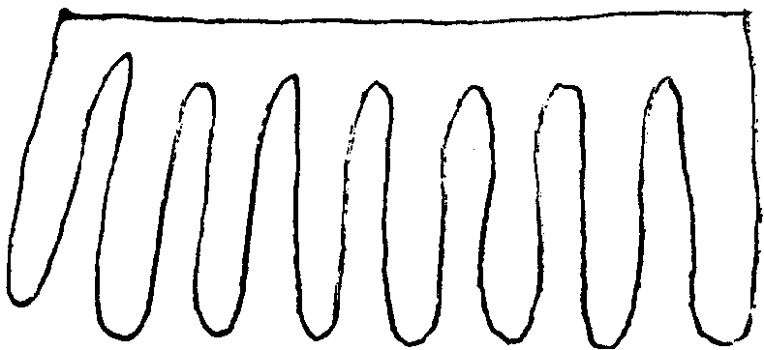
3. Cut an octopus“arms” pattern from a piece of wrapping paper the same length as the circumference of the balloon.

4. Wrap the “arms” pattern around the balloon, with the knot of the balloon at the bottom. Tape this piece in place.
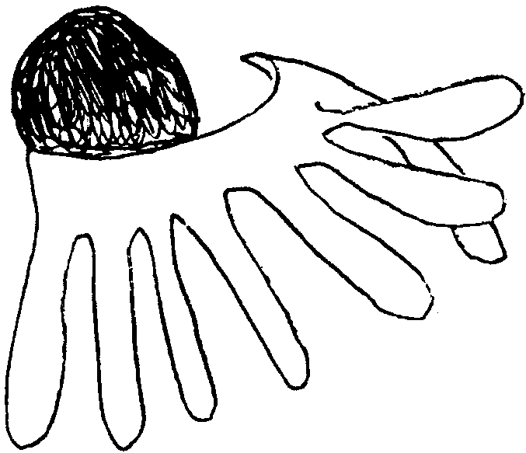

5. Cut out eyes and a mouth from paper and tape to the balloon. (Remind students that the eyes are just above the arms, not at the top!)

6. Tie or tape the two pieces of dowel together to form a +.

7. Tape a piece of string, about 20" in length, to the top of the balloon.

8. Cut eight more pieces of string in various lengths. Tape or tie one end of a string to the end of each “arm” and the other to a dowel. Each dowel should have four strings attached to it, two on each side of the intersection of the two dowels.
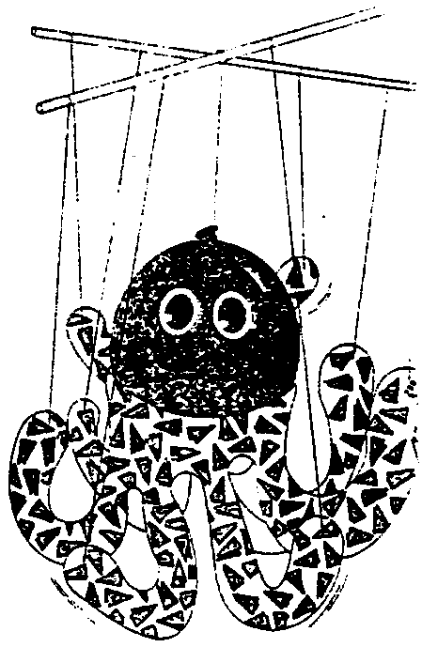
9. Practice manipulating the crosspieces to make the octopus move.

Extensions

Challenge students to create a tide pool marionette show and to perform it for younger students. The children’s book, My Very Own Octopus by Bernard Most (see bibliography) provides a good model. In this story a young boy dreams about having his own pet octopus. Each page presents what he could do with his very own octopus with all those arms! Have students brainstorm other plots (e.g., The Shy Octopus, an octopus that rescues a diver, etc.).

Such a production affords lots of opportunities for student participation; some students may be good script writers, others may compose a song, others may construct and manipulate the puppets or the theatre.

