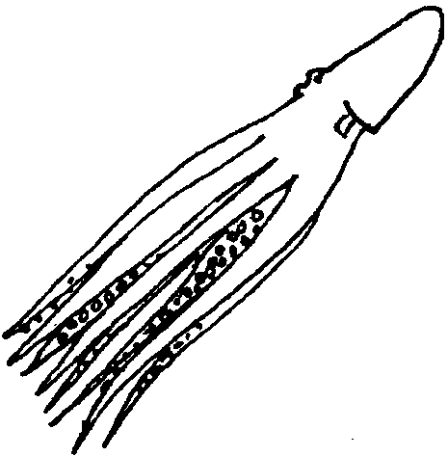
Octopus Escape*

Lesson by Sue Brimhall, Seattle, WA

Key Concept
1. An octopus uses a siphon to jet-propel itself through the water.

Background

Included in the large mollusk phylum is a well known, but often times villanized member, the octopus. This famous sea creature is often made out to be the “bad guy” in books and films. Even in Pagoo, the octopus is referred to as a witch! Of course to little Pagoo the octopus is an enemy. But, in reality, the octopus is a solitary, shy, and usually gentle animal, not a “witch” or “devilfish”.

Octopuses (one form of the plural, as are octopi, octopods, and octopus) are said to be the most intelligent invertebrate. Their brains are well developed and they have the capacity for learning. Their eye sight is excellent, the best of any invertebrate.

Although the octopus is a mollusk, related to clams, oysters, snails, etc., it does not have a shell. The arms of an octopus are really a modified foot, making its relationship to other mollusks and the origin of its scientific grouping as a “cephalopod” or “head-foot” a bit clearer. This modified foot surrounds the mouth, which, as in many other mollusks, contains a file-like radula. It also has a beak, much like that of a parrot. This sharp instrument is to be avoided as it is sharp and powerful.

An octopus usually hunts at night. After grasping its prey with its sucker-laden arms, an octopus bites down on the prey with its beak and, in many species, simultaneously injects a poison. Immediately, the octopus floods its victim with digestive enzymes. As the enzymes go to work, the octopus sucks up the partially digested tissues and discards the shell or bones of its dinner. A meal could consist of any of the following morsels: crab, shrimp, clam, fish, scallop, abalone, or another octopus. An octopus cave is often “marked” by a pile of the shells in front of the opening, the remains of past meals.

An octopus usually slides over the bottom pulling itself along using its 8 arms. With 250 suction cups per arm, there is a lot of power to their pull! When an octopus does swim, it propels itself through the water, body first, then head, then arms. With its funnel directed rearward, it is propelled forward by forcing a jet of water out the funnel.

Octopuses are unusual in the care given to their developing young. Males produce spermatophores, special gelatin-encased packets of sperm cells, which they place inside of the female’s mantle cavity. The spermatophores are transported by one of the male's arms which is specially adapted just for that purpose. The eggs are fertilized within the female's body. When it comes time to lay her eggs, she disperses them through her funnel, a few at a time. These she carefully distributes, attaching them to the rocky walls of her cave home. Remaining with the eggs, she guards them, constantly manipulating them and gently blowing water over them to keep them clean and oxygenated. When the eggs hatch, the young octopuses join the throngs of plankton. The female, who has not eaten for several weeks while brooding her eggs, then dies.

Seals, sea otters, sharks, larger fish, bigger octopuses, and people find octopus a tasty food. To avoid being eaten, octopus adaptations for survival are many. The sharp beak provides one form of protection. Another is the ability to make themselves look like their surroundings. Their camouflage skills are so well-developed that they can actually alter their skin texture, taking on the same texture as their surroundings! Simultaneously, special pigmentation in their skin allows them to change color to match the background of their habitat. Like other cephalopods (nautiluses and squids), the octopus also can eject a blackish ink from a special ink gland in the mantle cavity. The ink confuses the predator and makes escape possible.

Materials

For each team of 3 or 4 students:

• balloon (at least one per team; allow extras for breakage.)

• string (cut the length of the room)

• drinking straws

• tape

• tissue paper

• marking pens

• scissors

• twist-tie

• “Octopus Escape” activity pages

Teaching Hints

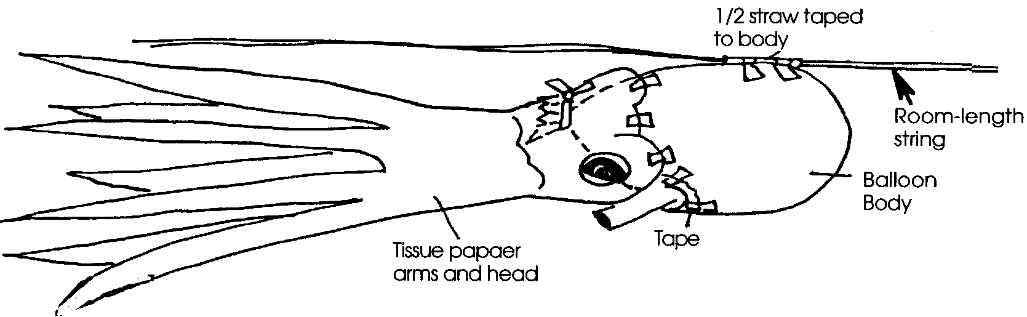
In “Octopus Escape”, students construct a self-propelling model of an octopus.

Have the students conduct this experiment through self-discovery. Allow students the time to try, fail, and experiment again. Provide helpful questions only when needed. Much of the best learning is reached through failing first.

Procedure

1. Divide the class into working teams of 3-4 students for construction and testing.

2. Distribute the student activity sheet outlining the challenge.

3. Suggest this procedure for testing the octopus balloon: After the octopus is attached to the string and inflated, have two team members each hold one of the ends of the string and pull the string taut. The third team member unties the twist-tie and pinches the end of the balloon filled with air. Before giving the signal to release, make sure all of the team members who will be releasing an octopus are standing behind the “starting line” you have chosen. At the agreed upon time, have students release the octopus balloons. The octopus travelling the greatest distance is the winner. If the room is small, conduct several races with the winners of the initial races competing against each other in subsequent races. Vary the activity by having students measure the time the octopuses take to traverse a given distance.

4. After the races, have each team blow up its octopus and tie it off for display.

Key Words

beak - a rigid, projecting mouth structure

octopus - a shell-less mollusk with a bag-like body, eight arms with suction cups on the undersides for grasping

radula - a horny band in the mouth of a mollusk, set with tiny teeth

Octopus Escape
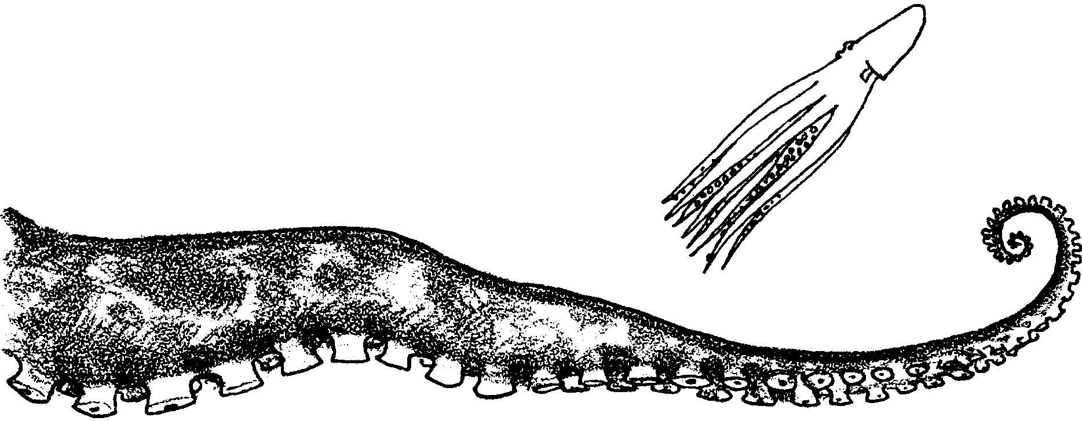

What does an octopus do when it is threatened or in danger? It has lots of ways to protect itself:

• Sometimes it changes the color of its skin so it matches the surroundings!

• Sometimes, it makes itself look two or three times bigger than it actually is! First it flattens itself out along the ocean bottom. Then, it removes all the color from its skin except for huge circles around its eyes and a border around its arm skirt.

• Other times, an octopus squirts ink into a predator’s face. The ink confuses the predator’s senses of vision and smell.

• Still other times, an octopus flees danger by jet propelling itself out of the area. Actually, for an octopus, it might better be called “water propelling!”

In the following activity, you will have a chance to make a self-propelling octopus. Here’s what you’ll need.

Materials
• balloon
• string (cut the length of the room)
• drinking straws
• tape
• tissue paper
• marking pens
• scissors
• twist tie
The Challenge

In “Octopus Escape”, your team will construct a self-propelling octopus. The object is to create an octopus which can escape the farthest and the fastest.
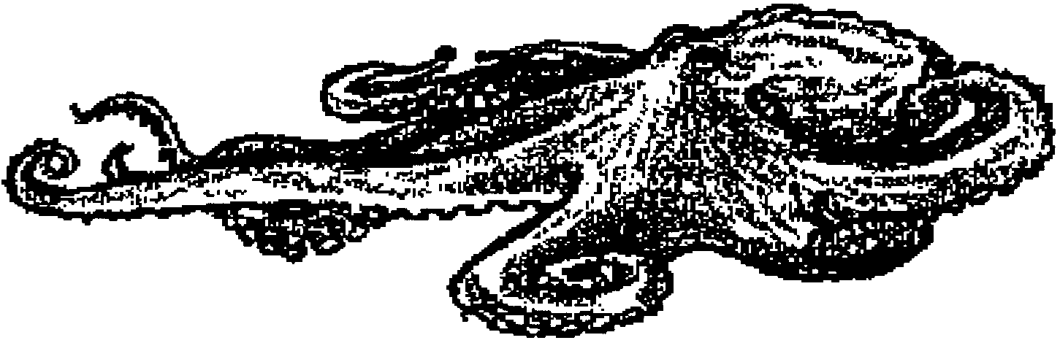

Working with your team members:

1. Study the body of an octopus.

2. Learn about the individual body parts. Record this information in your Pagoo Field Guide.

3. Use tissue paper, a balloon, and marking pens to make a model octopus. Recreate it as accurately as you can. If you blow up the balloon, use a twist tie to keep the air in the balloon. Do not tie the balloon shut!

4. Your next challenge is to adapt your octopus to move along a tight string. The string will be suspended and stretch from one end of the room to the other. Look at the other materials. Think of a way for your octopus to escape (travel) from one end of the room to the other. Try it!

5. When all the teams are ready, test to see which octopus can escape the farthest and the fastest.

