Can This Be the End of Pagoo?*

Key Concepts
1. An octopus has many structures and behaviors which help it to survive in its habitat.
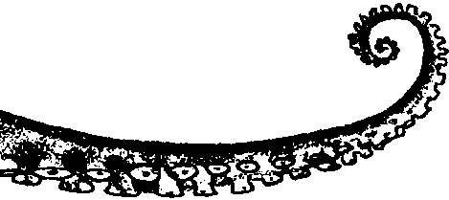
2. An octopus has powerful suction cups on its arms and a hard, strong beak in the center of eight arms, which it uses to eat shellfish, including hermit crabs.

Teaching Hints

Read chapter 19 of Pagoo with students.

Chapter Summary

Pagoo remains motionless, hoping he has not been seen by the octopus who was awakening. The octopus has not and moves out of the cave. Pagoo watches the octopus eat snails and decides to escape. The octopus, however, grabs Pagoo’s shell. Old Instinct believes the end is at hand.

Key Words

beak - a rigid, projecting mouth structure

octopus - a shell-less mollusk with a bag-like body, eight arms with suction cups on the undersides for grasping

