Down to the Depths of Deep Hole*

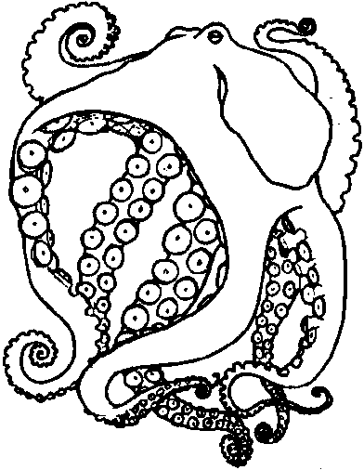

Key Concepts
1. Instinct helps animals survive.
2. An octopus is an eight-armed, shell-less mollusk, related to squid, clams, mussels, etc.

Teaching Hints

Read chapter 18 of Pagoo with students. Have them add drawings and information about octopus to their Pagoo Field Guides.

Chapter Summary

A Big Head Sculpin is swimming right towards Pagoo. Pagoo clings onto a Bryozoan over the edge of the Deep Hole. The Bryozoan snaps off, and the sculpin follows as Pagoo drifts downward. The sculpin misses him and swims away. Pagoo notices the animals in Deep Hole are larger. Instinct tells him not to fear the Moray Eel. Pagoo spies a heap of shells. Instinct warns, “Watch out”, but he does not heed the warning. Pagoo examines the shells then decides to rest in a cave. He realizes that an ancient enemy of hermit crabs lives in the cave; an octopus.

Key Words

bryozoan - a group of animals living together as a colony; some form thin, crusty patches on rocks and seaweeds; others branch, resembling a plant-like structure.

mollusk - any of a large roup of invertebrate animals having a soft, unsegmented body, usually covered with a hard shell, and a muscular foot

octopus - a shell-less mollusk with a bag-like body, eight arms with suction cups on the undersides for grasping

