Now You See It, Now You Don't!
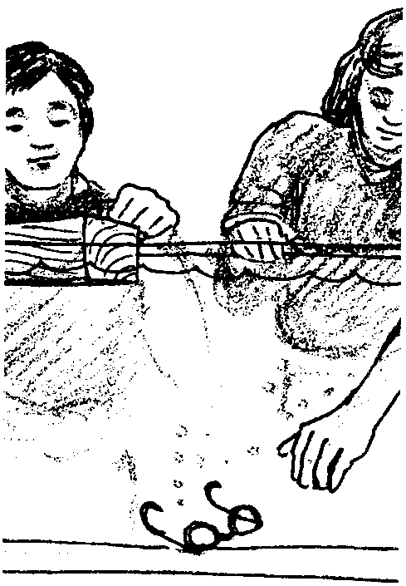
Edited by Sue Brimhall, Seattle, WA

Key Concepts
1. Fresh water and salt water have different properties.
2. Objects are more buoyant in salt water than in fresh water.
3. Whether an object sinks or floats in water is related to the weight of the liquid it displaces.

Background

An object sinks or it floats. Seems simple enough. However, whether an object sinks or floats is dependent on a combination of several variables: the object’s size, weight, design and the type of liquid surrounding the object.

An object floats in a fluid only if its weight is less than the weight of an equal volume of the fluid. An object sinks if it weighs more than an equal volume of the fluid. To state this in another way, if the density of the object is less than that of the fluid, the object floats; if the density of the object is greater than that of the fluid, the object sinks.

A floating object sinks deep enough to displace a weight of liquid equal to its own weight. An “egg amount” of fresh water will not support the weight of an egg, so the egg will sink. An “egg amount” of the denser salt water will support the weight of the egg, so the egg floats. In both cases, the volume (an egg amount) of the displaced water is the same but the weights differ significantly.

Because saltwater is denser and heavier than many other liquids, including freshwater, some things float in saltwater that will not float in freshwater or other less dense liquids.

Materials

For the class:

• sensitive balances or scales

• assorted additional materials as students design their own experiments to test their ideas

For each group of two students:

• drinking glass or beaker (400 ml)

• fresh egg

• table salt (sodium chloride)

• teaspoon

• tap water

• marking pen or tape

• eye dropper

• cup (for excess salt water)

• “Now You See It, Now You Don't” activity sheets

Teaching Hints

“Now You See It, Now You Don't” introduces the concept of displacement in relation to sinking and floating in water. It is divided into three parts, all of which can be done in one lesson.

Before starting the experiments, have a group discussion about sinking or floating. Start by asking students to suggest names of common fruits and vegetables. As you write them on the blackboard, ask whether they think each item would sink or float in water. Write S or F next to each one. Discuss the factors involved in students’ predictions. Suggest that they test their predictions at home.

Have students work in pairs, conducting the experiments described in each part of the activity page. When they have finished, have a whole group discussion in which students share their results. They may have developed interesting ideas for additional experiments to try. Encourage them to do so.

Note: Before your students complete these activities, be sure to try it first yourself! Water in a few locales has such a high mineral content that the salt tends to form other compounds rather than immediately dissolving. If this is the case, addition of extra salt plus allowing one or two minutes to pass before adding the egg usually corrects any odd results.

Key Words

Archimedes - a Greek scientist and mathematician

displace - to remove physically out of position

dissolve - the process by which a solid, liquid or gas is completely and uniformly mixed with a liquid
float - to remain suspended within or on the surface of a fluid without sinking

SCUBA - Self-Contained Underwater Breathing Apparatus; aqualung

solution - a homogeneous mixture of two or more substances where the substances are not chemically changed

Extensions

See the FOR SEA Grade 6 materials for continued exploration of the concepts of salinity and buoyancy.

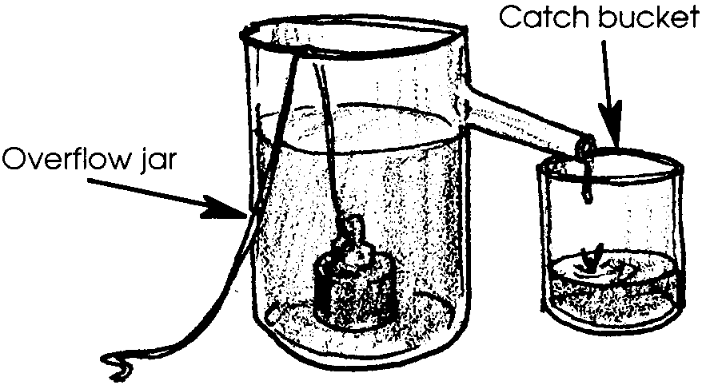
Answer Key

Part I

1. Answers will vary. The following is a diagram of one technique.

2. This question calls for an opinion. Any answer is acceptable.

3. The water weighs the same as the individual.

4. Since it sinks, a ten pound cement block must displace less than ten pounds of water.

Part II - Interpretation

1. The egg should sink.

2. The water level should rise.

3. This question serves as a student prediction.

4. The egg should float in the saltwater solution.

Part II - Interpretation Continues

1. The water level should rise.

2. The water level of the salt solution should be about the same as the mark for fresh water.

3. This question serves as a student prediction.

4. This question serves as a student prediction.
Part III - Interpretation

1. Ideas for experiments will vary.

2. Ideas for experiments will vary.

3. Encourage students to use their own words to describe the results. Basically, the “equal volume of water” from the salt solution weighed the most. While the volume of the water displaced remained equal, the weight of the water changed. Whether the egg floats or not dependent upon the weight (not volume) of the water displaced. The fact that the same volume of saltwater weighed more means that the weight of the displaced saltwater equals or is greater than the weight of the egg, whereas the weight of the displaced fresh water was less than the weight of the egg.

4. To dive in saltwater, a diver needs more weight. The diver is displacing “heavier” water and hence floats more easily in saltwater; just like the egg.

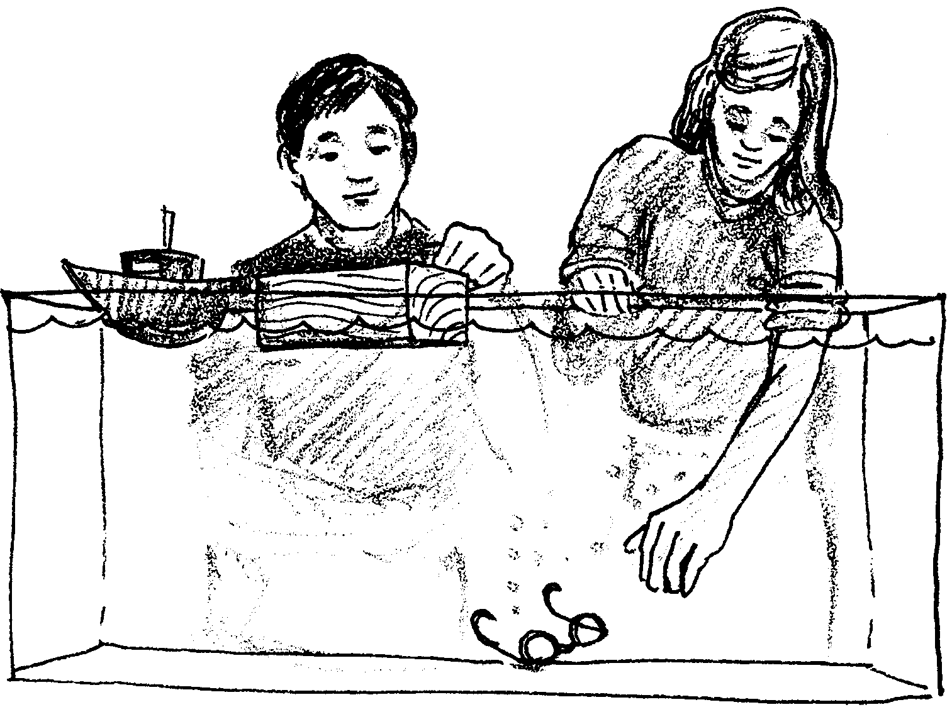
Now You See It, Now You Don't

Part I

Why do some objects float, while others sink?

Next time you drop an ice cube into a glass of water, notice what happens to the water level in the glass; it rises. When an object is placed in water, the object displaces, or pushes out of the way, some of the water. The weight of the water pushed out of the way determines whether the object sinks or floats.

Archimedes, an ancient Greek scientist, was also interested in why things float. He tried to float all kinds of things. He weighed the water displaced (pushed out of the way) by each of the objects.

1. What is one way Archimedes might have collected and weighed the water displaced by an object?

Archimedes also weighed all of the objects tested.

2. Before you read on, how do you think the weights of objects that float compare to the weights of the water they push out of the way?

Archimedes found that the weight of the water displaced by the floating object is greater or equals the weight of the object.

3. When you float in the water, how much does the water weigh that you are displacing?

What about objects that sink? Archimedes found that an object sinks if the weight of the water displaced by the object is less than the weight of the object.

4. A ten pound cement block dropped into a lake goes straight to the bottom. The block must displace less than pounds of water.

Now You See It, Now You Don’t

Part II, an experiment

From past experience you probably have a good idea of which things float and which sink in water. Does an object always behave the same way in all liquids? Let’s explore this question.

Materials
• drinking glass or beaker (400 ml)
• fresh egg
• table salt (sodium chloride)
• teaspoon
• tap water
• marking pen or tape
• eye dropper
• cup (for excess saltwater)

The Challenge - How does an object behave in fresh water?

1. Fill the glass with tap water until it is about 2/3 full.

2. Mark the water level using a marking pen or tape. Label it “ORIGINAL”.

3. Carefully lower the egg into the water.

4. Mark the water level with the egg in the water. Label it “FRESH WATER”.

Interpretation

1. What happened to the egg when you lowered it into the water?

2. What happened to the water level in the glass?

3. The weight of the water displaced by the egg must be:

equal to, or greater than, the weight of the egg
or
less than the weight of the egg.

Circle your choice. (Hint: Reread what Archimedes found out from his tests.)
The Challenge Continues - How does an object behave in salt
water?

1. Carefully remove the egg from the glass.

2. Check the water level. It should match the ORIGINAL water level. If not, add water.

3. Add five heaping (very full) teaspoons of salt to the water.

4. Check the water level. Use an eye dropper to remove water until the ORIGINAL water level is reached.

5. Stir the water until the salt is dissolved, or thoroughly mixed.

6. Carefully lower the egg into the water.

Interpretation Continues

1. What happened to the egg in the saltwater?

2. What happened to the water level?

3. Find the water level marked when you added the egg to fresh water. How does the present water level compare with this mark?

4. The weight of the water displaced by the egg must be:

equal to, or greater than, the weight of the egg
or
less than the weight of the egg.

Circle your choice. (Hint: Reread what Archimedes found out from his tests.)

5. We can assume that the weight of the egg did not change during the course of the experiment. What do you think can be said about the weight of the water displaced to cause the observed results?

Now You See It, Now You Don’t

Part III, molecules

Water is made up of sub-microscopic structures called molecules. Molecules have lots of space between them. Water molecules might look something like this:
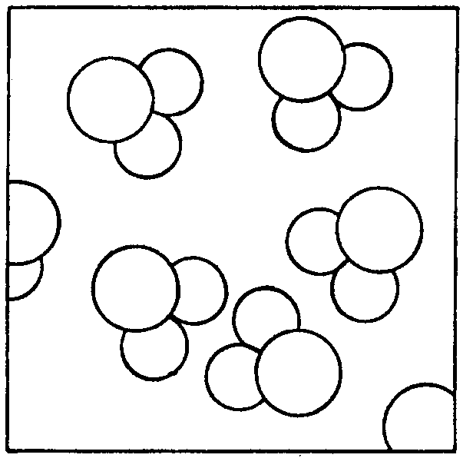
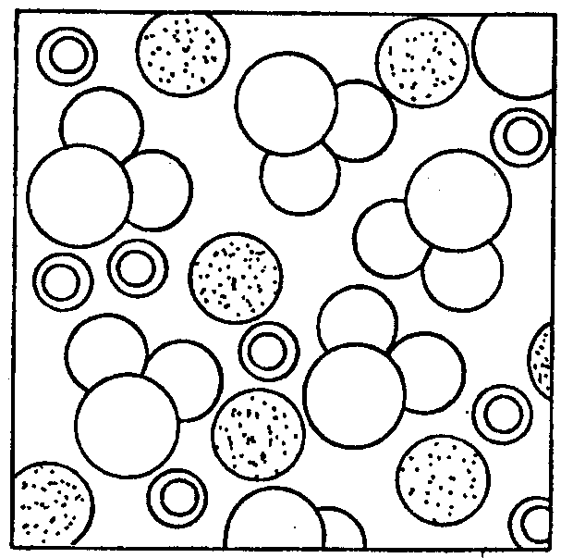
When salt dissolves in water, the salt “squeezes” in between the spaces in the water molecules. The salt squeezes in so well it hardly changes the volume, or amount, of the water. Water molecules with dissolved salt might look something like this:

The added salt does not change the volume much, but it does change the weight of the water. Saltwater weighs more than fresh water.

1. Check this idea for yourself. Describe your experiment, making a prediction about the weights of the two liquids:

2. a. Test your prediction or guess. Describe how you tested your prediction.

b. Describe your results. Which of the two equal amounts of water, salt or fresh, weighed the most?

3. Research the salinity in the open ocean, the Great Salt Lake in Utah, and the Dead Sea in Israel. What differences would you expect to find in the egg’s ability to float in these different bodies of water.

4. SCUBA divers wear weight belts to help them stay underwater. If you were going to dive in saltwater, would you need more or less weight than you would need in fresh water? Explain your answer.

