Death Trap!*

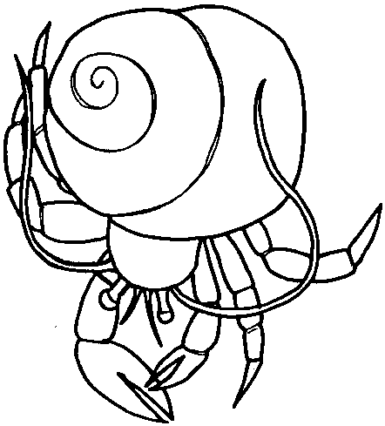

Key Concepts
1. Animals, including hermit crabs, have instincts which help keep them alive.
2. Tide pool plants and animals have to withstand large, and often sudden, environmental changes.

Teaching Hints

Read chapter 16 of Pagoo with students. Discuss the role of instincts in our lives. Have students give specific examples.

Chapter Summary

Pagoo becomes hungry for food other than plankton. He learns many things with his four feelers. With his two long ones, he explores. He uses his two, smaller, claw-like feelers edged in fine hairs, to sense changes in the water and in the smell of the air. Pagoo finds deeper water as he senses danger above him - but it’s only a flock of geese. He feasts on a dead limpet. Ripples in the tide pool and the change in behavior of the other creatures alert Pagoo to danger. It has begun raining. Instinct reminds him fresh water will kill him. As he attempts to protect himself, a torrent of rain washes Pagoo over a cliff.

Key Words

antenna - in this case, a long whip-like feeler used by a hermit crab for exploration

antennule - in this case, a short comb-like feeler used by a hermit crab to sense changes in its environment

instinct - a largely inheritable and unalterable tendency of an organism to make a complex and specific response to environmental stimuli without involving reason

