Make a Decorator Crab

Lesson by Patty Enright, Stillwater, MN

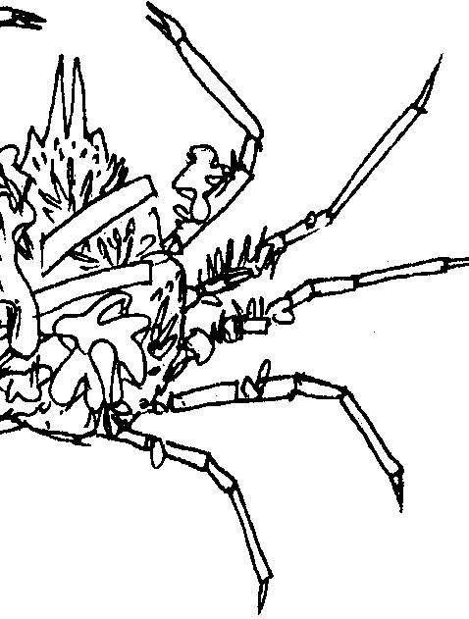
Key Concepts
1. Marine animals have physical features that help reveal how they are adapted to their environment.
2. The function of marine animal body parts is related to their form or shape.
3. Much can be learned about the life history of an animal by observing its physical features.

Background

At home in tide pools and seaweed beds are a variety of spider crabs. Among the most interesting is the well-camouflaged Decorator crab which actually picks up bits and pieces of seaweeds, colonies of bryozoans and small hydroids, and other materials and attaches them to its body with a sticky glue produced in its mouth. The rough and bristly shell which covers its body and legs provides a good attachment for these seaweeds and colonial animals, and these “decorator” plants and animals find the shell a suitable habitat for growth. Decorator crabs use their extremely long and thin legs to plant and tend their “back”-yard garden. In fact, the first legs are specially constructed for harvesting and handling seaweed and colonial animals.

As might be imagined, a Decorator crab’s traveling garden provides excellent camouflage, enabling the crab to blend in with its surroundings and become virtually invisible in tide pools. However, unlike protective coloration or other camouflage features which are inherited, these gardens are shed each time a decorator crab molts. During molting, therefore, Decorator crabs are particularly vulnerable to predation. As such, they must quickly and efficiently replace their camouflage garden each time they molt.

Materials

For each student:

• a 9" x 12" piece of drawing paper

• a piece of waxed paper, about 9" x 12"

• many 1.5" squares of colored tissue paper

• containers of a 60/40 white glue/water mixture

• pencil

• tape or stapler
Teaching Hints

In “Make a Decorator Crab”, students examine some of the specialized adaptations of Decorator crabs. Begin by eliciting camouflage strategies used by animals and plants in the tide pool. Refering to Chapter 14 in Pagoo, discuss the behavioral and structural adaptations which make Decorator crabs exceptionally well-camouflaged. Then, have students create their own Decorator crabs by following these directions:

1. Draw an outline of a decorator crab on the drawing paper. It should be fairly large, almost filling the page. (Alternatively, you may choose to enlarge and copy the outline drawing provided at the end of this teacher background section.)

2. Tape or staple waxed paper on top of the drawing.

3. Dip colored tissue pieces into glue/water mixture. Form wet tissue into loose balls and place on waxed paper within the outline according to colors desired in specific areas. Colors can be realistic or fanciful.

4. Continue placing wet tissue balls side by side until the outline is filled in.

5. Allow the picture to dry completely.

6. Peel the waxed paper carefully off the tissue decorator crab and display.
