Inflatable Tide Pool

Adapted by Patty Enright, Stillwater, MN
from “Inflatable Water Habitat” by Sharyn Fenwick;
similar idea from Alaska Seaweek

Key Concepts
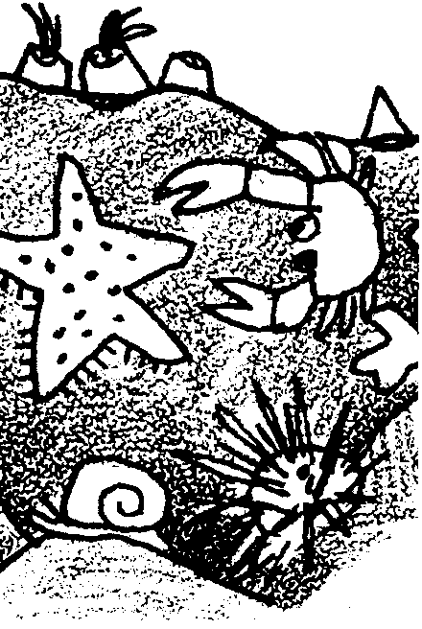
1. A tide pool is formed when receding seawater is trapped in a hole or depression in the rocky shore.
2. Tide pools provide habitat for many plants and animals of the sea.
3. Plants and animals that live in the intertidal zone, including tide pools, have behavioral and structural adaptations which help them to survive in this harsh environment.
4. Tide pools are heavily populated communities, with a wide diversity of organisms.

Background

Life in the intertidal zone, the area affected by the periodic rise and fall of sea level that we call the tides, is difficult. The rise and fall of the tides alternately expose the intertidal rocky shore and its tide pools to varying amounts of sun, air, and water. Plants and animals are exposed to great variations in temperature, sunlight, and drying. These conditions can vary from place to place on the shore.

Areas within the intertidal region can be divided into four zones which reflect their different exposures to the elements:

The Spray Zone. Occasionally exposed to spray and water carried in by the highest tides and storms, the spray zone is basically a dry, terrestrial area. Animals and plants in the spray zone must adapt to both fresh water from the rain and salt water from the ocean. They must withstand extremes in heat and retain moisture during long dry periods.

High Tide Zone. This zone is usually uncovered except during high tides. Plants and animals in the high tide zone must also adapt to elements and forces outside the marine environment, as well as to the marine conditions which exist when they are submerged. They need to tolerate wave action, changes in temperature and salinity, and exposure to air and water. Many organisms in this zone cling to rocks and rely on the tides to bring food to them. More species are found in this zone than in the spray zone.

Mid Tide Zone. Alternately covered and uncovered during most tide cycles, conditions in the mid tide zone are more moderate with fewer changes in temperature and salinity. More food and oxygen is available than in the high tide zone and, as a result, this zone has more species. Animals and plants living here must anchor themselves against wave action.

Low Tide Zone. The low tide zone is covered by seawater except during the lowest of low tides. Here, conditions are more constant in terms of salinity, temperature, and exposure to air and water. Most organisms found in the low tide zone are not able to survive in the upper zones. It is a crowded area that contains more species than any of the other intertidal zones. Abundant seaweed creates a layer of protection for the inhabitants of this zone when the tide is low. Stresses are lower from environmental change, but greater from predators and competitors.
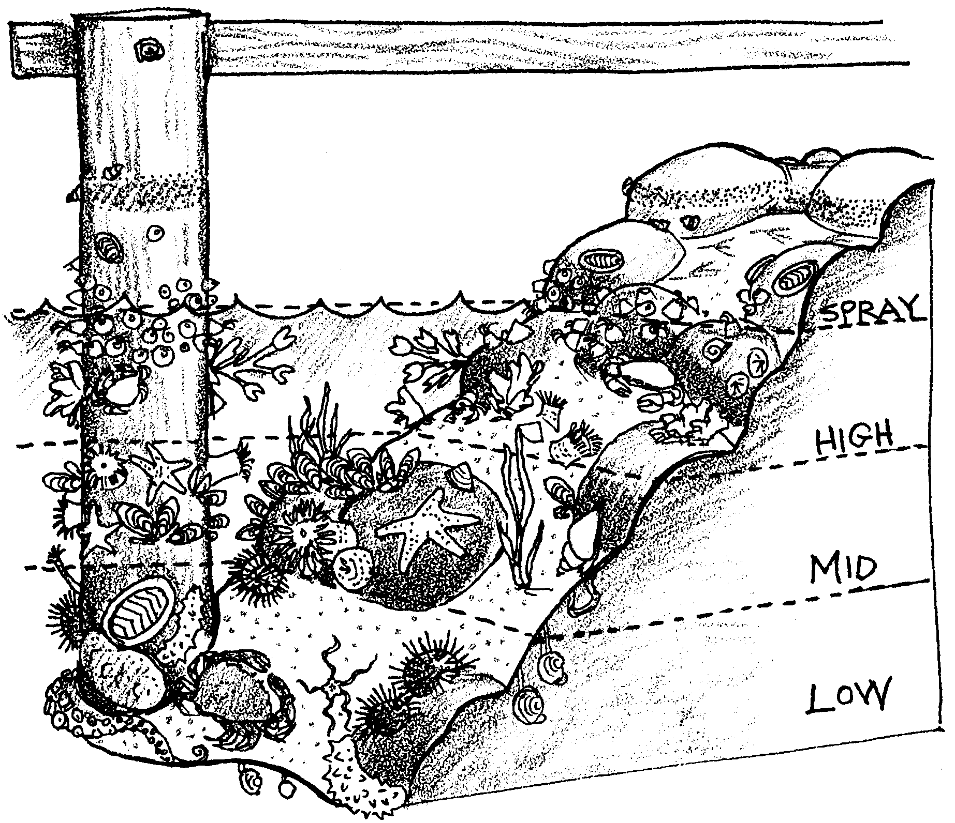

Adaptations for Life in the Intertidal Zone

The plants and animals of the intertidal zone face harsh and continuously changing conditions. These organisms have developed special behaviors and structures to assure their survival in the tide pools of the intertidal zones. Organisms must adapt to wave force and desiccation (drying out). When the tide is out, water remaining in the pools is not refreshed, so inhabitants must adapt to changing water temperatures (warming in summer, cooling in winter) and depleted oxygen levels. Evaporation and rain may also change the salinity of the water. Organisms must also adapt to predation and competition for space and food.

Waves — “The need to hold on”. To withstand the constant push and pull of waves and tides, animals and plants in the intertidal zones must be able to anchor themselves in some manner. A variety of mechanisms are employed to keep from being washed away. Sea stars and urchins use suction; mussels attach themselves to rocks using sticky threads called byssal threads. Barnacles glue themselves to rocks and surround themselves with shell plates. Snails, chitons and limpets hold tight with muscular feet. Seaweeds hold their ground with structures called holdfasts, which look like roots, but serve as anchoring devices, not as means of getting nourishment. Seaweeds are also flexible so that they can flow with the motion of the tides and waves.

Desiccation — “The need to keep wet”. Plants and animals also possess a wide variety of structures and behaviors to avoid drying. For example, some animals such as snails, limpets and barnacles adapt to the drying effects of sun, air and wind by clamping down tightly on a marine surface (e.g., a rock, another animal) and trapping moisture inside their shells. Bivalves such as clams and mussels shut their shells. Sea anemones spread sand over themselves and close up to conserve water. More mobile animals retreat to dark, cool hiding places in the rocks or under wet, moist seaweed. Some seaweeds have leathery skins to prevent moisture loss and some can become quite dry without dieing. The color of an animal or plant also affects the absorption and drying effects of sunlight.

Predators — “The need to avoid being eaten”. Other adaptations offer protection from predators. Many animals like limpets and barnacles have hard shells. Others, like sculpins, use color as camouflage. Still others, like crabs, can scamper away and hide.

Food — “The need to eat”. In addition to avoiding damage from waves, drying, and predators, intertidal animals have to eat. A large number of eating styles is seen in the intertidal zone. Filter feeding organisms, such as the barnacle, filter food from the water. The barnacle uses little feathery feet that reach out to grab plankton. Scrapers, such as chitons and snails, have raspy tongues that scrape algae from rocks. Scavengers, like crabs, feed on the remains of dead plants and animals. Predators use a variety of means to capture their prey; sea anemones sting their prey, while sculpins catch small prey in their mouths. Seaweeds absorb nutrients from the sea through all surfaces of the plant.

Materials

For the class:

• roll of 6ml plastic sheeting (painting supplies)

• roll of wide clear, cellophane tape

• a box type window fan

• Exacto knife

• permanent felt pens and/or acrylic paints

Teaching Hints

In “Inflatable Tide Pool”, students have an opportunity to synthesize their learning to date as they create and populate a model tide pool which they can actually enter. To construct the inflatable tide pool habitat:

1. Lay out the plastic sheeting.

2. Cut one 8' X 4' piece of sheeting for the tunnel which will be connected to the fan. With the remaining plastic, cut two large squares (the exact size depends upon the space available) which will be the habitat “bubble”.

3. Tape the two large “habitat” squares together, one on top of the other, leaving a 4' opening for the tunnel. Note: taping is easier if the tape is cut into 2' sections.

4. Fold the tunnel piece (8' X 4' piece of sheeting) in half, to form a 4' X 4' square. Tape the side opposite the fold together to form the tunnel.

5. Tape one end of the tunnel to the habitat. The other end provides the opening for the fan. Tape the inside and outside seams of the tunnel.

6. Tape the fan to the tunnel.

7. Inflate the habitat using a medium setting on the fan.

8. To make an entry way, cut a slit in the habitat opposite the tunnel with the fan. Reinforce the entry with tape.
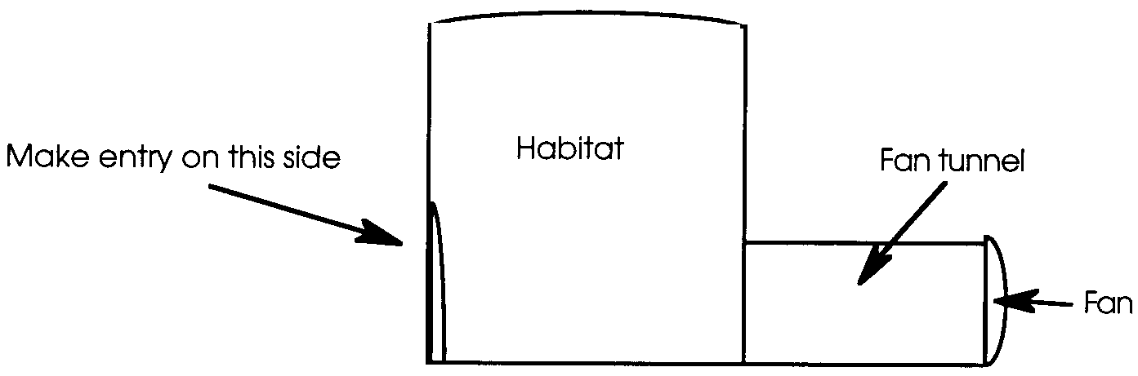
9. Have students decorate with permanent felt pens or acrylic paint on the plastic and add other features like hanging seaweed and creatures to complete the tide pool habitat.

Extensions

1. Have students create a poem, story, picture, or song about life in the constructed inflatable tide pool.

2. Challenge students to research existing underwater habitats. What are they used for? What would it be like to be an aquanaut? Have them write a story about an aquanaut in an underwater habitat.

3. Help students learn about deep sea archaeology and the salvaging of sunken ships.

4. Use the directions for the inflatable tide pool to make an inflatable kelp forest or some other underwater habitat.

