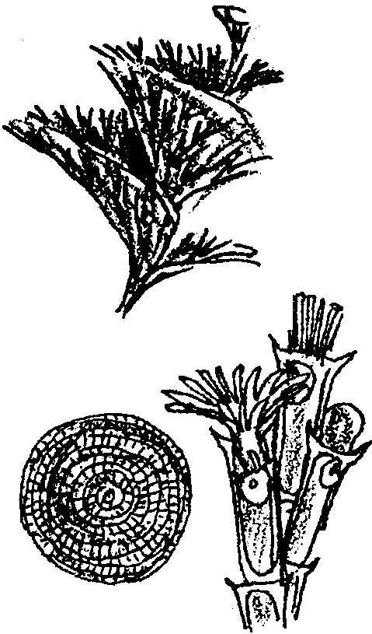
The Grotto of Eating Trees*

Key Concepts
1. Bryozoans and hydroids are colonies of animals that look like plants.
2. Hermit crabs eat larger plants and animals as they grow larger.
3. The competition for food is fierce in the tide pool.

Teaching Hints

Read chapter 13 of Pagoo with students. Discuss how colonies of animals differ from single individuals. Compare colonial living in sea animals with what is seen in human societies. Consider having students write a short science fiction story on this theme.

Chapter Summary

Pagoo decides to look for the shell that an anemone tosses out after eating a snail. In his pursuit, he finds himself in a grotto of bryozoan colonies and hydroids. Pagoo finds a periwinkle shell for his new home but discovers it does not protect him from his competitors; the opening is too wide. He discovers that competition for food is fierce in the tide pool.

Key Words

bryozoan - a colonial animal; some form thin, crusty patches on rocks and seaweeds

hydroid - a plant-like colonial animal with tentacles and stinging cells; related to sea anemones

periwinkle - a typically small snail that can tolerate long periods of exposure to air; found in the upper level of the high tide zone called the “splash zone”

Extension

Challenge students to write a short story or create a picture book in a format similar to Pagoo. Suggest they choose a totally different habitat and write the story from the perspective of a small creature in the habitat. Have students include stories in their Field Guides.

