Hermit House From An Ancient Jungle*

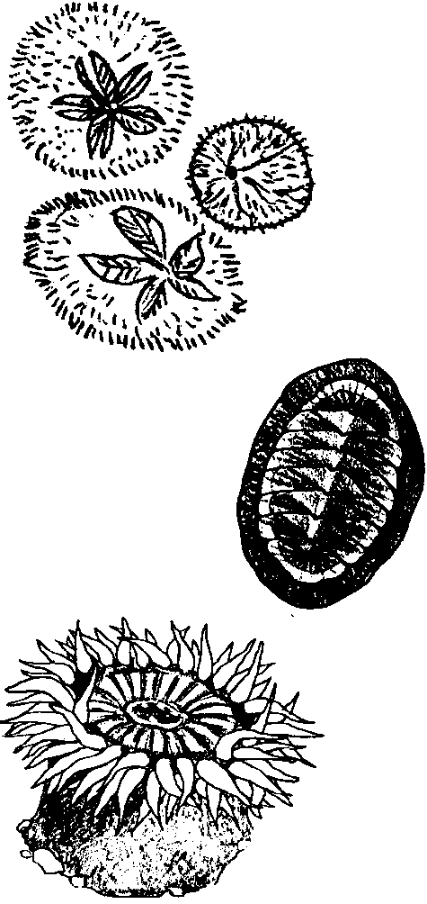

Key Concepts
1. A great variety of body shapes, structures, and behaviors have evolved to assure survival in the ever-changing tide pool environment.
2. Hermit crabs and other crustaceans must shed (molt) their hard outer skeletons in order to grow.
3. The limited availability of resources restricts the ability of tide pool organisms to grow and prosper.

Teaching Hints

Read chapter 12 of Pagoo with students. As you discuss the new animals Pagoo meets, compare and contrast the structures and behaviors they use to meet the challenges of the marine environment (e.g., soft-bodied or having a hard outer skeleton (exoskeleton), one foot or many, location of mouth, types of food, etc.).

Chapter Summary

Pagoo’s morale is low. He is back where he started. He molts again and does not fit into his tube. So he hides in the crack of a ledge and meets some new creatures:

• chiton - a sea animal having a body with a large foot and eight, overlapping, butterfly-shaped plates;

• sea cucumber - a sausage-shaped animal with a ring of mop-like tentacles around its mouth and five rows of tube feet running the length of its body;

• brittle star - a five-rayed sea star with thin and spiny rays (or arms) that move with an undulating snake-like motion. The common name “brittle star” is derived from the ability to cast off an arm when handled or threatened. Severed arms are later regenerated. Brittle stars are related to the other spiny-skinned animals (echinoderms): sea urchins, sea cucumbers, sand dollars, and common sea stars; and

• sea anemone - a flower-like animal with a ring of stinging tentacles surrounding its mouth and a hollow body. As an adult, a sea anemone attaches itself to firm surface, moving only infrequently, and using its tentacles to catch food.

Key Words

crustacean - a animal with a hard outside shell, jointed bodies and appendages, antennae, and compound eyes; including crabs, lobsters, and shrimps

echinoderm - a "spiny skinned" sea animal, usually with five arms arranged radially around a central disk and a body covering strengthened by hard spines or plates; including sea stars, sea urchins, sand dollars, and sea cucumbers

exoskeleton - any hard, external covering or structure which protects or supports the body, such as the shells of crabs and lobsters

