A Concrete Tile Can Crawl Both Ways*

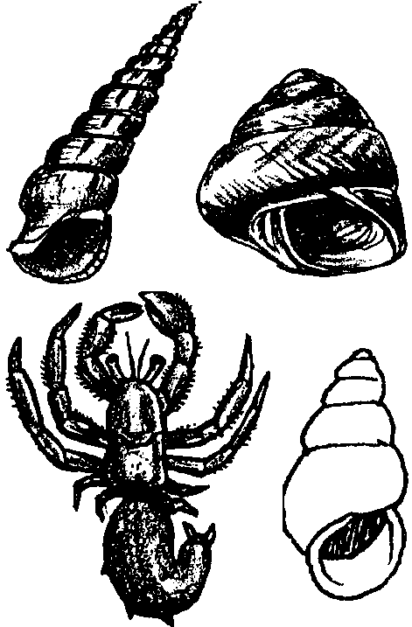

Key Concept
1. The struggle for survival by most sea creatures is constant.

Teaching Hints

Read chapter 11 of Pagoo with students.

Chapter Summary

Pagoo continues searching for a new home. He takes temporary refuge in an inch long tube of a “Tube Snail” (actually, the empty casing of a tube worm) but soon realizes another hermit crab occupies the other end. The two crabs battle. Pagoo proves himself stronger and wins a new home. Since young crabs molt and grow, he soon needs a new shell. He hops out of the tube and tries a Horn shell. In his excitement at finding a new home, he hops out of the Horn shell and performs a “victory dance”, an indiscretion that causes him to lose his new shell home to another crab. Pagoo must quickly retreat back into the “same old tube”.

Extensions

1. Play musical chairs or “Fruit Basket Upset” to simulate Pagoo’s plight of no shells for a home.

2. Have students look around the classroom for small spaces in which they can curl up (under desks, work tables). Allow time for each student to try at least two different spaces. Which do they prefer, and why? Relate their experiences to those of Pagoo.

3. Research dentalium (often called tooth shell), a shell prized by Northwest Coast Indians, or other shells used to show wealth, such as wampum. The term “wampum” describes the beads of polished shells strung in strands, belts or sashes and used by North American Indians as money, ceremonial pledges and ornaments.

