Houses Are Scarce in Tidepool Town

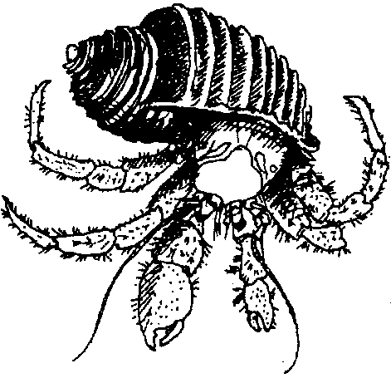
Key Concepts
1. As a hermit crab grows, it needs to find ever-larger shell “houses” since it does not make its own shell.
2. Many intertidal animals have hard, external skeletons, called exoskeletons.

Teaching Hints

Read chapter 10 of Pagoo with students. Make additions to the Pagoo Field Guide.

Chapter Summary

The gull drops Traveling Towers from the air, but nothing breaks, as it lands in the sand. The gull tries and fails again. This time, Pagoo and friends land in a tide pool. Pagoo is disgusted with life and all its dangers. He crawls off looking for food and a new home. He tries sponges, sea urchin and sand dollar tests (“shells”), and abalone, scallop, mussel and clam shells without success. His search for a new home continues.

Key Words

sand dollar - an animal having a very flattened, circular body covered with short spines and displaying a 5 petal or star pattern; related to sea urchins and sea stars

sea urchin - an animal with long, bristling spines, tube feet and five moveable mouth parts on the underside; related to sand dollars and sea stars

test - the hard shell of a sea urchin or sand dollar

tube feet - tubular attachment organs for movement and for collecting food, found on seastars, sea urchins and sand dollars

