Skedaddle To Seattle

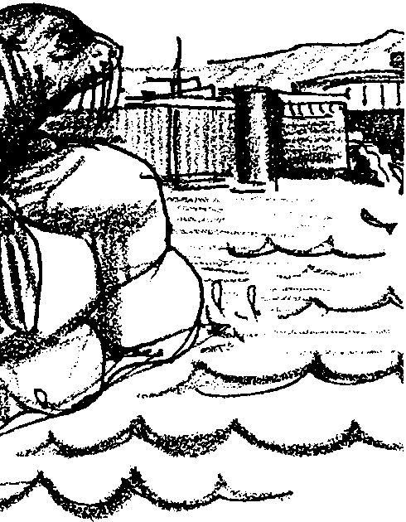
Key Concepts
1. Marine mammal interactions with people include competition for food resources.
2. Protection of marine mammals can conflict with the managing of other wildlife populations for maximum sustainable productivity.
3. Different special interest groups represent a variety of viewpoints about an issue.

Background

In the recent past, California sea lions and their relatives have been hunted for bounty because people felt they were a threat to fish resources. Since the Marine Mammal Protection Act of 1972, marine mammals have been protected from harassment and hunting. Although some populations of seals and sea lions remain threatened or endangered, the California Sea Lion population has increased under protection of the Act. The increase has been so dramatic that some people believe this animal is now a threat to fish resources and water quality.

The Marine Mammal Protection Act uses reauthorization procedures as a means to amend the Act. In the reauthorization scheduled for 1993, some people wanted to permit the killing of certain marine mammals if they are considered to be a “nuisance” animal.

In contrast to the Marine Mammal Protection Act, which seeks to protect a marine resource, the Fisheries Conservation and Management Act of 1976 seeks to manage marine resources for economic gain. The Fisheries Conservation and Management Act of 1976 mandates government agencies to “realize the maximum sustainable productivity from fishery resources”.

The conflict between the two Acts is a key dynamic in this particular environmental debate: the mammal Act seeks to protect the species (sea lions in this case) while the fisheries Act seeks to manage resources for economic gain (steelhead salmon in this case). We are faced with trying to save the steelhead salmon while not harassing or harming the predatory California sea lion.

The California sea lion has no natural predator at the locks or near most river mouths in the Pacific northwest. Under the provisions of the Marine Mammal Protection Act, the population of these predatory marine mammals is not currently managed by people.

The problems seen at the Ballard Locks in Seattle provide a case study of the dilemma of overly successful protection. The Ballard locks issue will likely be resolved in one of these ways:

1. Washington state will continue to pursue lethal remedies, which will be taken to court and defeated. Meanwhile, the sea lions will destroy the Lake Washington wild steelhead run.

2. Washington state will continue to pursue lethal remedies, and will seek new non-lethal control methods such as:

a. positioning the spillway gates to create a water-current pattern that guides the fish to the ladder with greater speed (and, hence, greater safety).

b. an “escape cover” may be installed - logs, concrete forms, etc. - that fish can dart under or behind as in a natural river mouth.

c. Abandon the fish ladder at the Ballard locks altogether. Build a new hatchery and a new fish ladder as part of a plan to have the fish enter Lake Washington via a different route. This would cost millions of dollars and the state would most likely prefer modification of the Ballard Locks.

Materials

For the class:

• map of Pacific coast showing Channel Islands, CA to Vancouver Island, Canada and Puget Sound, WA

• pictures of Steelhead salmon, California Sea Lions, locks, fish ladders from news articles or periodicals

• table for seating Congressional Representatives (panel of 5) during the hearing

• seating for participants at the hearing

• speaker table (desk) or standing area for those making presentations to the Congressional committee

For each role playing group:

• 1 “Interest Group” role card

• Role Players’ Worksheet

• materials for making banners, signs, props/costumes

For each student:

• “Part I - The Herschel Problem” activity sheets
Teaching Hints

“Skedaddle to Seattle” concludes this guide with a look at the relationship between fish and marine mammals and people, streams, and watersheds. Students role-play special interest groups concerned with a proposal to amend the Marine Mammal Protection Act to allow killing some marine mammals. Representing the group’s viewpoint, students present their opinions about an issue and offer their solutions to the problem in a mock congressional hearing. Based on the quality and the convincing nature of the presentations, the congressional representatives (a student panel) makes a decision.

Opportunities are here for students to problem-solve with their own proposals for solutions, using educated and informed responses rather than emotional reactions. This activity stresses group cooperation. It involves role-playing, oral speaking, visual displays, language skills and drama.

Note that the issues are complex for adults, not to mention for fourth graders. Before commencing this activity, read it in its entirety and think about the skills and abilities of your class. In “Part II- Appearing Before Congress”, you may wish to consider providing each group with a “mentor” to help them understand the issues and formulate their viewpoint. The mentor may be a parent or other adult or a middle school or high school student.

The issue under examination concerns California sea lions that have been feeding on great numbers of steelhead salmon as they return to their hatchery. The steelhead are bunched together at the Ballard shipping locks spillway near Seattle, Washington as they wait to enter a fish ladder. The challenge for the interest groups is to protect both the prey (fish) and the predator (sea lions). Something unique about this issue is that these steelhead go to streams in very urban areas in the city. Not all hatcheries are on pristine rivers.

While the issue can be used as a review or evaluation of concepts and skills learned in previous assignments, it can be a springboard for you and your students to find a real local problem to solve or affect by taking action. Use the real issue of sea lions and steelhead as a model for finding a local problem and getting your students involved in its solutions. Encourage young people to take action and make a difference in a real environmental problem.

Preparation

1. Read through the activity materials before beginning this lesson with students.

2. Duplicate materials you will need and make transparencies if you plan to use them. Cut the role cards apart from each other so they will be separate.

3. Review previous knowledge about hatchery raised salmon (see “Salmon Aquaculture”), the steelhead salmon, and dams and fish ladders.

Procedure

1. Introduce the problem by having students complete “Part I - The Herschel Problem”. Briefly discuss the text questions together.

2. Show students on a map where the event takes place and the migration route of the California sea lion from its breeding grounds in California to its feeding grounds at the Ballard Locks in Seattle, Washington. Discuss the technology at the locks, the fish run, changes in marine mammal populations, and the laws effecting this issue.

3. Summarize the information presented. Ask students to define the problem that they will attempt to solve. They may need some help from you, but they should be able to understand the problem. Their challenge is to find a solution that protects both the prey (steelhead) and the predator (sea lion) without harming either. Tell them that to date there has been no successful solution. This is their opportunity to come up with one.

You may wish to follow the discussion with a brainstorming session in which you elicit possible solutions. Ask students to quickly list ideas for solutions. Their ideas might be political or technological or both. At this time do not evaluate the likelihood of success for solutions, just list the ideas.

4. Explain that, during role playing, they are to act the role of an interest group, be part of the newspaper reporters corps, or a member of Congress. They need to understand that during role-playing, the role they act may not agree with their own opinion.

Share with them that after the simulation (role-playing), they will have an opportunity to say what they really feel and to offer their own ideas for solutions.

5. Hand out the role playing cards to groups of students. Select students for roles at which you think they will be successful. Note: The Newspaper Reports group and the U.S. Congress groups have tasks that differ from those of the interest groups. As members of the Congressional committee, select students who will be able to help keep order and run the hearing with little assistance from you. As members of the Newspaper Reporters group, select students who will be able to summarize the testimonies from the interest groups. The role playing cards for these two groups provide greater detail on their tasks.

6. Give students time to understand their character and role, research information, and complete their Role Players Worksheet. For some role cards the position is given but for others it is left up to the students to determine how their group will solve the problem. This can be fun and imaginative, as well as realistic.

As the interest groups are preparing their Role Players Worksheets, have the committee decide on the criteria that they think are important. Have them list those criteria and decide which criteria are more important. They will use the list as a way to score the group presentations.

If you allow students to make banners and signs or use dramatic props, give them time and materials to prepare. Have students set up the room for the hearing, making it as realistic as possible.

7. Conduct the hearing. During the hearing, keep the focus on the amendment and alternative solutions. The role card for the Congressional committee provides details about conducting the hearing. The criteria for the committee’s decision should be based on the group whose presentation shows a solution that protects both the prey (steelhead) and the predator (sea lion) without harming either. Style and whether the arguments are convincing are important too.

8. After all groups have made their presentations, have the Congressional committee deliberate and decide on their response. They can do this publicly or in a “closed session”. After they have announced their decisions and stated their reasons, let the class express their true feelings and offer individual solutions.

9. End by having students list local environmental/aquatic problems that they could affect through their actions. Then take action! Be creative in your solutions.

Key Words

biologist - a scientist who studies living things

fish ladder - a series of pools that are built like steps to help fish swim upstream

harassment - annoyance, aggravation

Herschel - a famous California sea lion who began fishing at the Ballard Locks

interest group - a group of people who have a special interest in a common concern or goal

locks - an enclosed chamber in a canal, dam, etc., with gates at each end, for raising or lowering vessels from one level to another by admitting or releasing water

marine mammals - mammals (vertebrate animals that nourish their young with milk) that live in marine waters

permit - an official certificate of permission; license

sea lion - a large seal belonging to the pinniped group

skedaddle - run away, scatter in flight

upstream - against the way the water flows

vote - an indication of one’s point of view such as a written ballot or signal

Extensions

1. Look at aquatic problems in your own community. Make an Action Plan and take action! Integrate science, social studies, and other disciplines. They could create a scientific study to get real data on which to base a solution; write letters to legislators; etc.

2. Create a post card that can be sent from sea lions that visit the locks. Illustrate one side of an index card. Then write a note and address on the other side. Exchange the postcards between Herschel and other sea lions.

3. Write a menu for steelhead dishes served to sea lions at the “Ballard Diner”.

4. Make an individual response. Write a “letter to the editor” or draw an “editorial cartoon” stating your own thoughts, feelings, and solutions.

5. Play tag games with California sea lions chasing after steelhead salmon. The sea lions can be handicapped, or harassed or tagged by people and natural predators. The playing area can be open, as in the ocean, or restricted as at the Ballard Locks. The tag and simulation games in this guide can be adapted for this tag game or you can add sea lions to those games.

6. If possible take a field trip to observe California sea lions at the Ballard Locks or a saltwater aquarium, zoo, or known sea lion haul out site near you.

7. Find or create an illustration that simply shows how locks and ladders work to move ships and fish. Many people will never have had experience with this technology.

8. Write the Army Corps of Engineers to find out the history of the Ballard Locks. When were they built? By whom? Research and graph a count of steelhead runs from before and just after construction of the locks. Research and graph fish counts from other years.

Answer Key

Part I - The Herschel Problem
1. Answers will vary. The question is included to start your students thinking about possible solutions to the problem of a protected predator (sea lions) that has come to feed opportunistically on a protected prey (steelhead salmon).

2. Answers will vary depending upon student knowledge and experience. This question is intended to make students think about what they have previously learned regarding salmon migration upstream in rivers with dams.

3. Sea lions eat steelhead at the Ballard Locks because the steelhead are easy to catch when they gather before the fish ladder.

4. For sea lions to be legally killed at the locks, the Marine Mammal Protection Act would have to be changed during its “reapproval” (actually, reauthorization) by Congress.

5. a. The population of sea lions is increasing by about 10,000 per year.

b. The population of steelhead has been decreasing.

6. If the trend in the numbers of fish getting by the locks continues, steelhead will likely disappear from the Lake Washington watershed.

7. Answers will vary depending upon experience and creativity. This question sets the stage for the role playing activity which follows in Part II - Appearing Before Congress.

SKEDADDLE TO SEATTLE
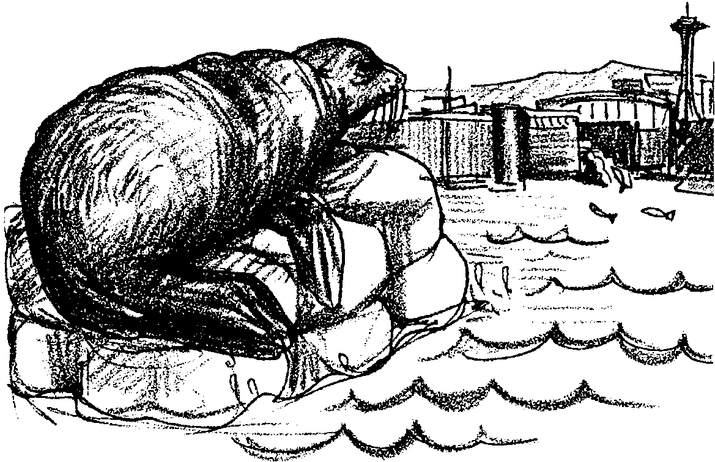
ROLE PLAYERS WORKSHEET

Use this work sheet to plan your presentation. You will represent the point of view of your interest group. Try to present a solution that will protect both the steelhead and the sea lions. After the meeting, you may tell how you really feel about the problem.

The meeting will let congress hear how groups feel about changing the Marine Mammal Protection Act. The change will allow the government to kill some marine mammals. Killing the marine mammals would only be done if nothing else works.

Names of students in your group:

Who will speak for your group?

What needs to be done?

Who will do which part to prepare for your presentation?
Note: Everyone should help research information to use.

Who will keep the group on task and on time?

What are some props you could use?

Who will make signs and prepare props?
Role Players Worksheet - Page Two

Describe your group’s point of view about the proposed change.

Describe the idea your group has for solving the problem. Explain why you think and feel this way.

List some arguments others might use against your position. Think about how you will defend your ideas.

Will you agree to the change to the Marine Mammals Protection Act or not? Explain your reasons.

Prepare a press release.
a. Tell if you agree to the change.
b. Write one sentence telling why you agree or do not agree.
c. Give the release to the “Newspaper Reporters” group

Have your speaker practice the presentation in front of your group.
Good luck!
UNITED STATES CONGRESS

You are members of the United States Congress. You are a committee deciding whether to change the Marine Mammal Protection Act. You are meeting to hear how people feel about the proposed changes.

You run the meeting. Start with a short review of the proposed changes. Then tell the groups that each will:
1. Say who they are.
2. Tell how they think you should vote on the changes.
3. Tell why you should vote that way.
4. Give you another solution they think might work.
5. Tell why they think their solution might work.
6. Limit their presentation to under five minutes.

You need to keep time. Tell speakers when they have only one minute left. You must keep order during the meeting. Listen carefully to every group. Allow for each group to answer two questions. Anyone may ask the questions.

After all the groups have been heard, discuss their feelings and ideas. Make a decision for or against the changes. Tell the groups your decision. Then, explain how you came to the decision.

MUCKLESHOOT AND SUQUAMISH TRIBES

You are members of the Muckleshoot and Suquamish tribes. Your ancestors fished for steelhead. You depend on steelhead for food. You also sell some of the fish you catch. You want to be able to catch steelhead. You know that steelhead also spawn in other streams.

You also want to protect the sea lions. You know they are part of nature. You think they are clever to find an easy meal. You think they are smart to outwit those who try to get rid of them. You want to protect them. You also do not want these steelhead to become extinct.

Will you support changing the Marine Mammal Protection Act? You have to hold a meeting to decide.

Appearing Before Congress:

When you speak before Congress, you will need to:
1. Say who you are.
2. Tell how you think they should vote on the changes.
3. Tell why they should vote that way.
4. Give them another solution you think might work.
5. Tell why you think your solution might work.
6. Limit your presentation to under five minutes.

GREENPEACE

You are members of Greenpeace. You protested the methods used to catch the sea lions. You were angry that some were killed. You oppose the killing of marine mammals. You think that the sea lions are not the problem. People should look at other problems the fish have.

You do not want the Marine Mammal Protection Act changed. You do not want to allow any marine mammals to be killed. Besides, the changes do not say which marine mammals might be harmed. It could mean that some whales would be hunted again.

You will use peaceful protest to protect the sea lions.

Appearing Before Congress:

When you speak before Congress, you will need to:
1. Say who you are.
2. Tell how you think they should vote on the changes.
3. Tell why they should vote that way.
4. Give them another solution you think might work.
5. Tell why you think your solution might work.
6. Limit your presentation to under five minutes.

THE PUBLIC

Some of you are regular visitors at the locks. You like to watch the boats and wildlife there. You have seen the seal bombs. You do not want them to be used. You do not want the sea lions to be harmed. You pay taxes to protect marine mammals. You think too much money is being spent on the problem.

Some of you are students from a school in Seattle. You have been studying about sea lions and steelhead. You have some ideas to share. You want adults to make good choices. You worry about your future and the future of these animals. You think adults should leave the sea lions alone.

Appearing Before Congress:

When you speak before Congress, you will need to:
1. Say who you are.
2. Tell how you think they should vote on the changes.
3. Tell why they should vote that way.
4. Give them another solution you think might work.
5. Tell why you think your solution might work.
6. Limit your presentation to under five minutes.

NEWSPAPER REPORTERS

You are newspaper reporters. Your news stories affect people. You tell people how their people in congress vote. You have written a lot of stories about sea lions and steelhead. You tell all about everything you know. You tell it as soon as you can. You are here to “get a juicy story”. You want people to read your newspaper. You ask a lot of questions.

Summary Before Congress:

When you speak before Congress, you will need to:
1. Say who you are.
2. Tell how many groups wanted the change.
3. Tell which groups wanted the change.
4. Summarize the reasons for the change.
5. Summarize the reasons not to change.
6. Limit your presentation to under five minutes.

BIOLOGISTS

You are from the National Marine Fisheries Service. Your job is to protect marine mammals. You also have to protect the steelhead. You have to enforce the law. You also must obey the law. You set up the net and then the traps to capture the sea lions.

You know a lot about sea lions. You also know much about steelhead and their habitat needs. You want to protect the fish runs.

You feel that some sea lions should be allowed to be killed. You think only the federal government should do the shooting. There have been a lot of cut backs in government spending. Already, you do not have enough workers or supplies to do your job well. You wonder how the government can afford to do more about the sea lions.

Appearing Before Congress:

When you speak before Congress, you will need to:
1. Say who you are.
2. Tell how you think they should vote on the changes.
3. Tell why they should vote that way.
4. Give them another solution you think might work.
5. Tell why you think your solution might work.
6. Limit your presentation to under five minutes.

FISHERS

Some of you are “plunk” fishers. You sports fish with bait and a weighted line. Your line “plunks” when you cast into the water. You fish near the fish ladder. You don't catch steelhead when sea lions are around. You pay $18 for a permit to fish for steelhead. You want to get your money’s worth. You want the sea lions kept from eating the fish. You are unwilling to stop sports fishing for steelhead. You say it is OK to pass the change to destroy the sea lions.

Some of you are commercial gillnet fishers. When salmon swim into your net they get caught and drown. They stay in the net until you bring it on board your boat. You hope to find many fish in the net when you check it. In the water, sea lions are sometimes near your net. They eat some of your fish before you can bring them on board. You have a permit from NOAA (National Oceanographic and Atmospheric Administration) to shoot marine mammals if they are threatening your catch. As a last resort, your crew is allowed to kill sea lions. First, you have to try everything else possible. You do not like to hurt animals. You just want to catch salmon. You also say it is OK to pass the change to destroy the sea lions.

Appearing Before Congress:

When you speak before Congress, you will need to:
1. Say who you are.
2. Tell how you think they should vote on the changes.
3. Tell why they should vote that way.
4. Give them another solution you think might work.
5. Tell why you think your solution might work.
6. Limit your presentation to under five minutes.

Skedaddle To Seattle
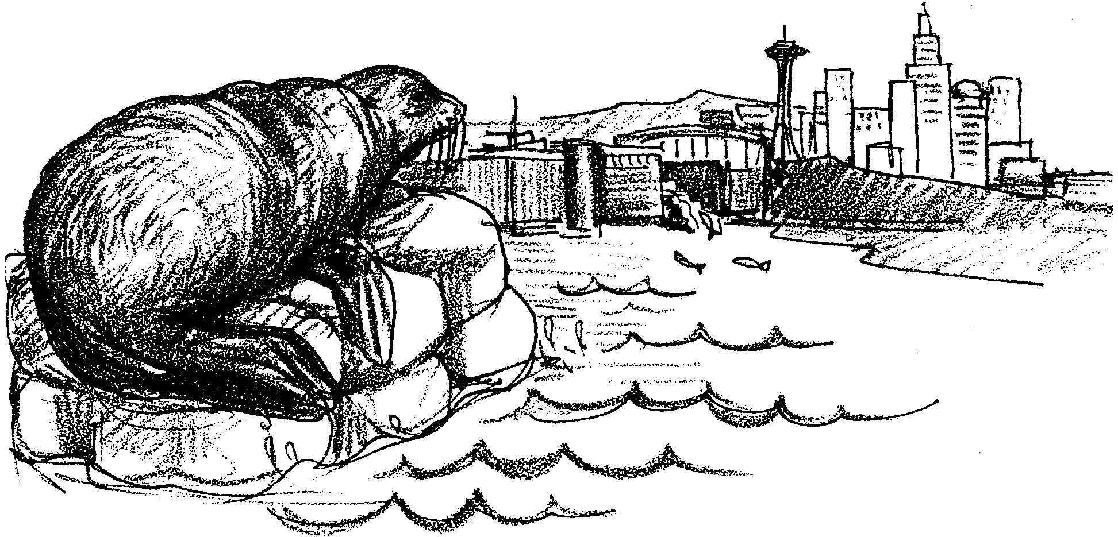

Part I - The Herschel Problem

Every year steelhead salmon skedaddle to Seattle. They swim through the Ballard Locks into freshwater to spawn. Every year California Sea Lions skedaddle to Seattle. They swim from the Channel Islands of California to the Ballard Locks. They are looking for a lazy feast of steelhead. Every year hundreds of people skedaddle to Seattle. They go to watch the sea lions eat steelhead salmon. Sounds as if everyone is having fun at the “Ballard Locks Diner”.

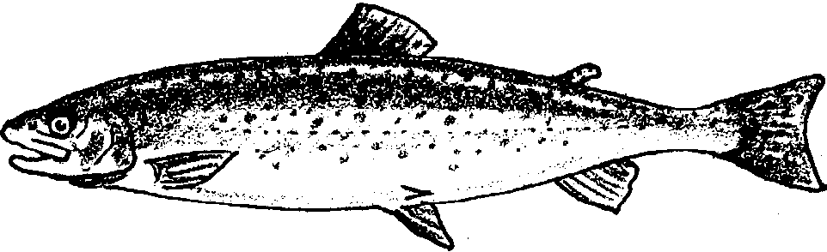
Well, not quite everyone. Some people think the sea lions are eating too many of the steelhead. They are afraid the steelhead will disappear. People have tried to stop the sea lions. They have tried lots of ways. Some say the only way to stop sea lions is to kill them. Others disagree.

1. Think about sea lions eating too many steelhead. What do you think people might do to solve this problem?

Let’s look at the problem. Here’s a simplified picture of the area.
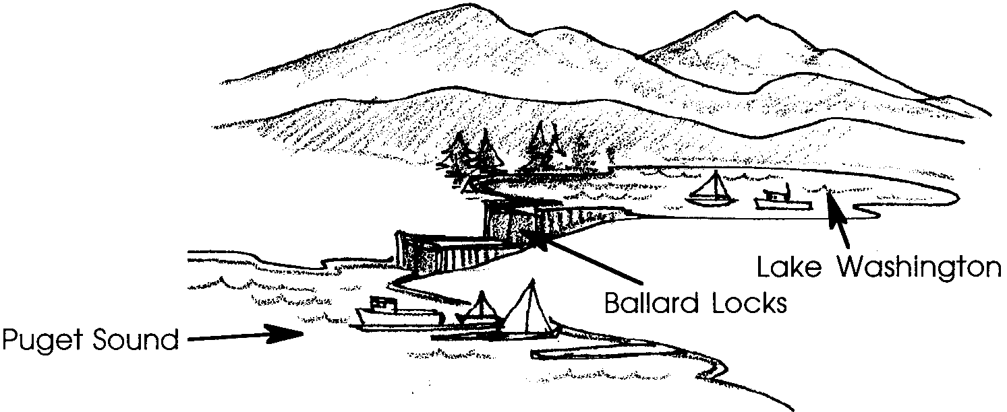

The Ballard Locks connect saltwater (Puget Sound) to freshwater (Lake
Washington). A “lock” helps ships go between bodies of water when the water is at different levels. It is like a box in a river. It has a gate at each end. The gates let a ship go into or out of the locks. They also let water go in or out.

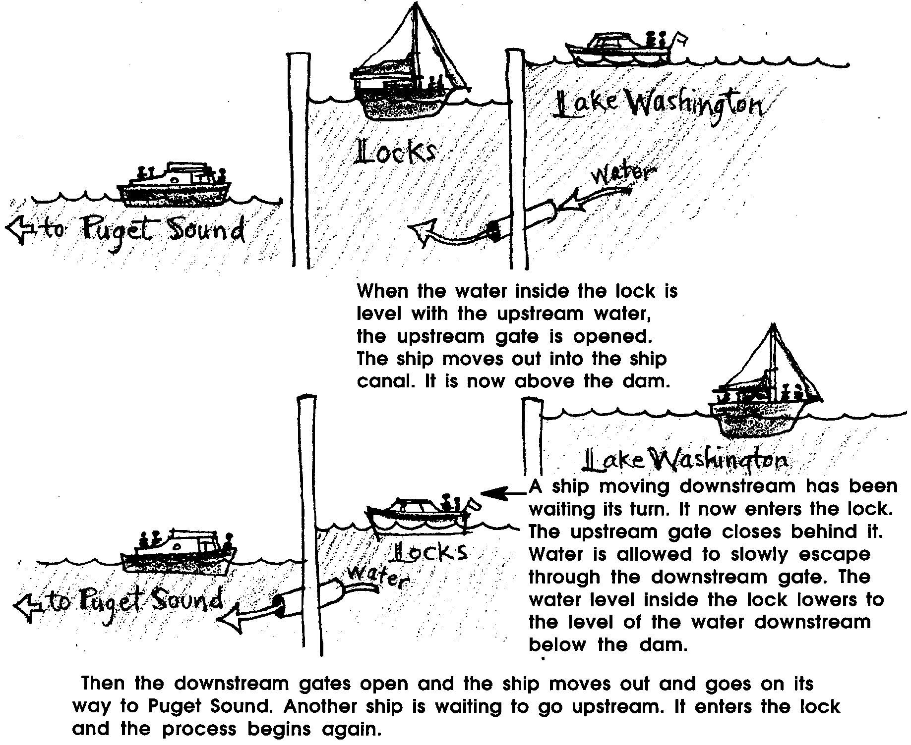
A ship moving upstream goes into the lock. The downstream gate closes behind it. Water is trapped inside the lock section with the ship. As the water slowly flows into the lock and is trapped, the water level rises. The ship floats up with the rising water level.

Some steelhead swim through the Ballard Locks. Most steelhead swim upstream past the locks in a “fish ladder.” A fish ladder is a series of pools. Each pool is a little higher than the one before it. Water flows through the pools from upstream. Salmon jump from downstream into the first pool. They rest there and then jump up into the next pool. Rest and jump, rest and jump. The salmon “climb” the fish ladder. Finally, they reach the level of water above the locks. Then they go on their way to Lake Washington and its streams.
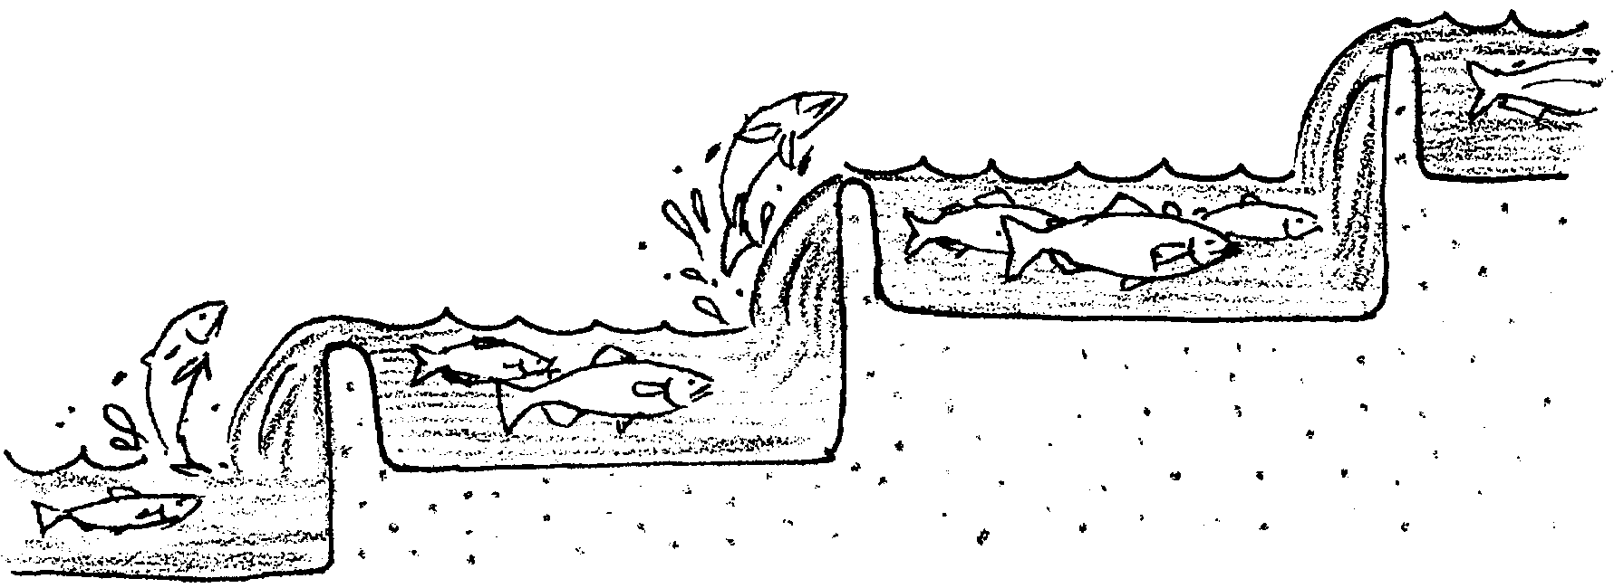
2. A fish ladder helps steelhead swim around Ballard Locks. Where else would fish ladders be useful?

Over three thousand salmon leap up the fish ladder at the locks each year. They wait below the first pool to get into the ladder. While waiting, hungry sea lions can easily catch them for dinner.

The sea lions that come to the “Ballard Diner” are young male California Sea Lions. They spend from October through March near the locks. Most weigh about 200 to 400 pounds. A few of them, weigh up to 600 pounds or more. They will grow to about 8 feet long. Sea lions this size eat a lot of fish.

A sea lion must catch its food with its sharp pointed teeth. It looks for the easiest prey to catch and handle. Usually it eats bottomfish. It can dive to 450 feet looking for a meal.

Steelhead are fast, slippery food. Sea lions only feed on them when they are easy to catch. They are easy to catch when they gather at the Ballard Locks. There, the sea lion can select and eat the biggest and best of the fish.

3. Sea lions usually eat bottomfish. How come sea lions eat steelhead at the Ballard Locks?


Only a few sea lions feed on the steelhead runs near the locks. Some of the busiest ones have nicknames. The first one nicknamed was Herschel. He first came to the locks in 1984. The first year he seemed to arrive alone. He brought friends with him the next year. In following years, they brought friends with them. The Ballard Diner is filling up with sea lions.

Not very many things eat sea lions. Sometimes sharks, orca whales, and polar bears do. Sea lions used to be hunted by people. Sea lion predators are not found near the Ballard Locks.

Sea lions are protected by a U.S. law. They may not be bothered or killed. The law which protects them is called the Marine Mammal Protection Act. This Act can be changed only when it is scheduled to be reapproved by Congress. Only the United States Congress can change the Act.

4. Some people want to kill the sea lions at the locks. How could this happen legally?

Sea lions have been protected since 1972. The population of California Sea Lions has increased by about 10,000 a year. The population is still growing. This means more sea lions to feed at the Ballard Locks Diner.

Steelhead are protected by Washington State law. People want steelhead to remain in the Lake Washington watershed. This means that at least 1,600 steelhead must get past the sea lions at the locks. About 1,200 of the fish returned in 1983. In 1984-1985, only 474 came into the lake. In 1985-1986, 1,812 fish entered the lake. In 1989, just 696 Steelhead got into the lake. The population of steelhead has been decreasing.

5. a. What is happening to the population of sea lions?

b. What is happening to the population of steelhead?

A sea lion can eat a lot of steelhead. Herschel ate 13 steelhead in one hour and 20 minutes. Over eight days, five sea lions ate 130 steelhead. In 1988, sea lions at the locks ate about 1,600 steelhead. Four or five sea lions at a time were watched eating at the locks that year.

6. Think about the future of steelhead in Lake Washington. What is likely to happen if the numbers of fish getting past the locks keeps decreasing?

Some people wanted to act. The Pacific Marine Fisheries Commission recommended a change to the Marine Mammal Protection Act. It wants to let the government kill some marine mammals. Killing the marine mammals would only be done if nothing else works.

Surely, killing sea lions isn’t the only answer. What has been tried to protect the steelhead from sea lions? Lots of things have been tried:

• Waterproof firecrackers have used to scare sea lions. People wanted to “train” the sea lions. The firecrackers were to say that “this is no longer a good place to live”. Sometimes workers threw the bombs for about 18 hours a day. The sea lions became used to the noise. They began to ignore it.

• A huge nylon net was strung across the opening to the locks. It rose six feet above the water. It hung 24 feet deep into the water. It had 8 inch by 14 inch webbing. Steelhead could swim through the webbing. Sea lions could not. Some sea lions swam under the net. One jumped over the net. Net was added to reach the bottom. It still did not keep the sea lions away.

• Underwater speakers played annoying sounds. Later sounds of orca whales were played. Even a radio station played some rock and roll tunes underwater. Herschel came to the boat to request a tune. The sea lions became used to the sounds.

• Sea lions were chased by a radio controlled model boat. It only scared them away when they were at the surface.
• Bad tasting, dead fish were thrown in the water. Some sea lions tried the fish. They learned to avoid the bad tasting fish.

• 39 sea lions were captured at the locks. They were let go as far away as California. Eleven returned from 230 miles away. Four returned from 285 miles away. Some even returned from California.

• Sea lions were shot with rubber tipped arrows. The sea lions stayed in the area.

7. Lots of things have been tried to protect the steelhead from sea lions. Think about these things. What else would you suggest trying?

Part II - Appearing Before Congress

The “Herschel problem” is how to protect both the steelhead and the sea lions. Neither should be harmed. Different groups of people see different solutions. Some of those groups are described below. Each group will “appear before Congress”. Some will ask to change the Marine Mammal Protection Act. Others will ask to keep the Act the same.

Here’s what to do:

1. Your teacher will assign you to an “interest group”. You will receive that group’s role playing card. Read the card.

2. Fill in the “Role Players Worksheet”. The information on the card and in Part I will help. Use the worksheet to prepare. Write down things/information you will want to use in your presentation.

3. Appear before Congress. Be ready to present your group’s point of view. Be sure to share ideas for a solution to the problem.

4. The “United States Congress” group will listen to all the groups. They will then decide which one offers the best solution.

Here’s what you’ll need:
• 1 “Interest Group” role card
• Role Players’ Worksheet
• materials for making banners, signs, props/costumes

