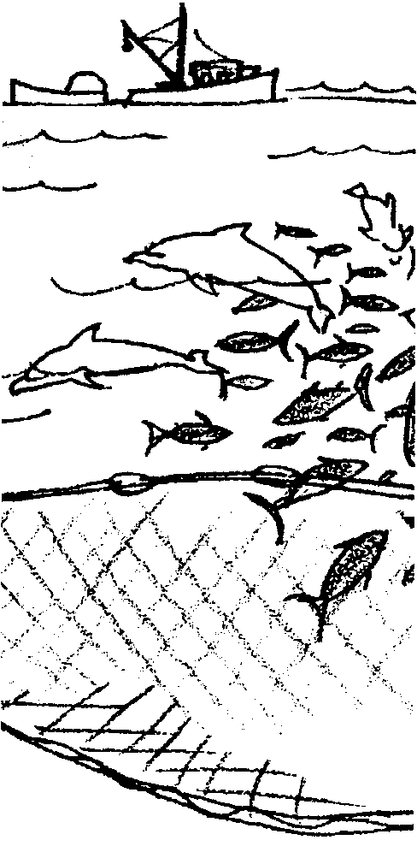
Hear Sighted

Key Concepts
1. Marine animals are adapted to their environment.
2. Some marine mammals use sound to sense their surroundings and to communicate with each other through a process known as echolocation.
3. Dolphins are adapted to breathe at the surface of the ocean.

Background

The issues surrounding the tuna/dolphin controversy are complex. People who study dolphins and those who have seen dolphins in the wild or in an oceanarium often wonder, how could dolphins come to be surrounded by the net? Could it be that the noise from the speed boats disturbs their ability to sense or to “see” the net?

Dolphins, along with some other marine mammals, sense their surroundings and communicate with each other through sounds. The process is called echolocation and might be likened to “seeing with your ears”. Scientists think that signals received through the jaw as sounds appear visually in the dolphin’s brain. Sound is the primary sense in the life of cetaceans (dolphins, porpoises, and whales). Many of these marine mammals navigate and hunt at night or below the zone of illuminated water. Whereas vision depends on the presence of light, sound signals can be made and used at all depths and at any time of the day or night. Sounds can be infinitely varied - high to low, loud to soft, and so on. The sounds can be pinpointed by producer and by listener. Cetacean sounds, as far as we know, are used for two purposes: 1) communication, and 2) sensing their surroundings through echolocation.

Dolphins and porpoises inhabit very diverse aquatic environments: rivers, lakes, estuaries, open seas and fjords. Echolocation is used differently under the different sea conditions found in these various environments. Animals living in clear seas may use their systems in ways quite different from those inhabiting turbid inshore waters. This variety is one reason that some scientists believe that echolocation behavior in marine mammals may include a great deal of learning. Every year, large numbers of dolphins and porpoises, including species known to have excellent sonar systems, become entrapped in nets set to catch fish or to protect swimmers from sharks. The mesh size of some of these nets should make them detectable. Scientists wonder if some of the dolphins caught this way are unfamiliar with the nets and if possibly they could “learn” to detect and avoid the nets.

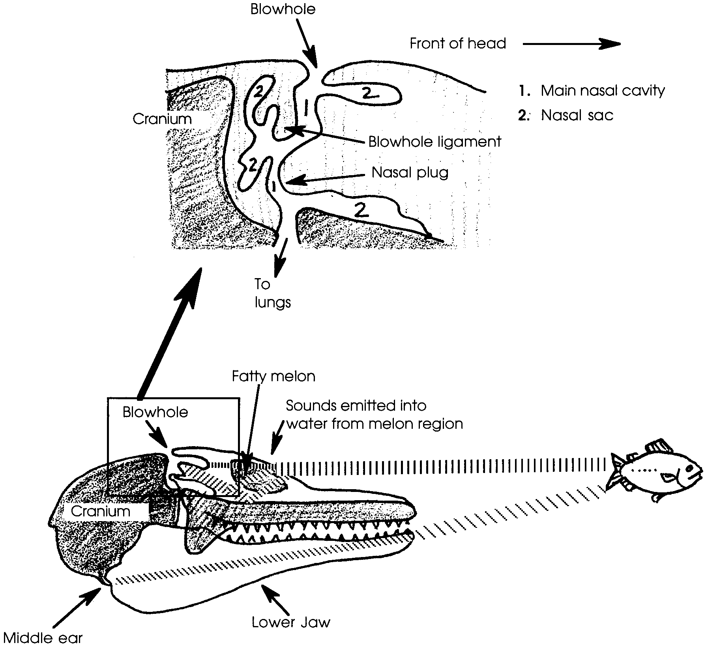
The way in which sounds are produced and the returning echoes received is an adaptive marvel. According to many biologists, the sounds are produced in the blowhole, usually when it is closed. The cavity inside the blowhole contains two flexible structures, a blowhole ligament and a nasal plug. The repeated coming together of the surfaces of the blowhole ligament and the nasal plug produce the “clicks” of sound.

Once the sounds are produced, the peculiar structure of the dolphin head plays a role in orienting the sound pulses before they leave the animal. The skull bones and other structures reflect high-frequency sounds and apparently direct them to the front of the head.

At the front of the head is the melon, a structure filled with a gelatin-like matter that looks and feels something like clear jelly. The melon seems to function as an “acoustic lens”, focusing the outgoing sounds into a directional beam as they leave the head.

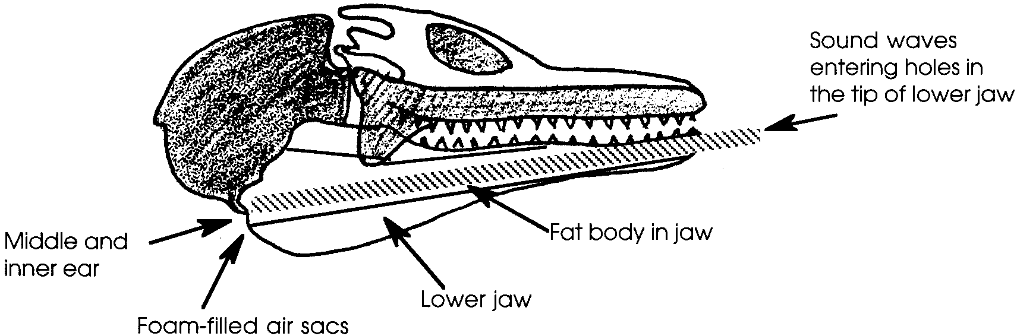
The sound beam travels out until it strikes a reflective object which bounces it back toward the dolphin. Collecting and directing the returning echo involves yet other unique adaptations. While dolphins do not have outer ears, they do have a middle and inner ear on each side of the head. These are encased in a hard bony covering that is separated from the rest of the skull. Each of these hearing units is, in turn, surrounded by extensive air sacs filled with foam. Since the foam is an effective sound barrier, the middle and inner ears are insulated from sounds in all directions. The design makes it apparent that the returning echoes are not received by the ears. What does receive them?

Investigation has shown that the dolphin’s lower jaw bone is hollow. The cavity of this bone contains a long fat body which conducts sound pulses in one direction. Also in the space is a nerve that runs to the tip of the jaw where it exits through holes in the bone.

When the sound waves return to the dolphin, the animal receives the sound signals through the tip of its lower jaw. To receive the sound signals in the tip of its jaw, the dolphin must point its jaw toward the source of the sound. The signal moves through the fat in the jaw to nerves near the ear. The nerves take the signal to the inner ear and the brain. In this way, the dolphin uses its inner ear for hearing but it does not receive sound through the outer ear as other mammals do.

It appears that most dolphins use two broad groups of sound. For information about the topography, low frequency clicks, which have great penetrating power, are used. For communication between members of the same species, somewhat higher frequency whistles are used. The use of sound for communication and echolocation have been instrumental in helping dolphins to live successfully in a wide variety of habitats.

Materials

For the class:

• pictures of dolphins

• pictures of whale/dolphin anatomy showing blowholes, melon, heads

• pictures showing echolocation by bats, whales, boats and human technology

For each pair of students:

• 1 “Circle Sheet”

• 1 blindfold

• scissors

For each student:

• “Hear Sighted” activity pages and data sheets

Teaching Hints

“Hear Sighted” introduces students to the concept of echolocation through several activities which test students’ echolocation abilities. The lesson builds on the preceding activity, “The Tuna/Dolphin Controversy”, by asking the question, “Why do dolphins allow themselves to be surrounded by the net?”

The issue of capturing and keeping marine mammals for study and exhibition may be raised by some of your students. This could provide opportunity for discussion about the ethics and purpose of capturing animals for science and/or entertainment. Students might write letters to aquariums and legislators about their feelings on this topic.

Duplicate the text and activity pages. Although students will be working in pairs, one set of pages is recommended per student. You may elect to do the background reading and questions as a separate assignment prior to the activities.

Prepare your students by asking “How do you think the dolphins come to be surrounded by the net?” Accept all reasonable answers. Tell your students that dolphins are quite visual animals living in clear waters. Discuss whether they think the wall of sound and bubbles the speed boats produce might disturb the dolphins’ ability to see the net. Ask your students to design experimental studies that could shed light on this question. The say, "Vision is only one of the senses possessed by dolphins, is there another way dolphins can detect things in their environment?”

Introduce echolocation by brainstorming and discussing the use and value of acoustics, such as sonar and radar, by bats, people and other animals. Examples include submarines, boats, airplanes, satellites, telecommunications (phone calls are transmitted by microwaves and satellites), ultrasound in hospitals.

Tell students that when they do the activities, they will need a quiet classroom environment, so that they may “see” with their ears. While you may choose to have pairs of students do the activities as demonstrations before the class, much is to be gained by having the entire class do them. Whichever approach you decide to use, plan to devote some time to a discussion of the questions and activities.

Key Words

accurate - free from error, correct, reliable

adapted - changed in order to survive in a particular habitat

blow hole - an opening on the back of the head of many marine mammals, used for breathing

click - a slight, sharp sound

dolphin - a small toothed whale, a marine mammal

echolocation - finding a place/object by sending out sound signals and receiving the echo at a sensory receptor

marine mammals - mammals (vertebrate animals that nourish their young with milk) that live in marine waters

melon - a fleshy, melon-shaped area in the front of the head of certain marine mammals

mesh - one of the open spaces between the cords or ropes of a net

navigation - the art or science of directing the course of a ship from one point to another

signals - signs to alert people/animals, a method of communication
Extensions

1. Help your students to find out more about acoustics. Bounce a small ball (golf, ping-pong, or rubber) off objects of different densities (cushion, carpet, sidewalk). The ball represents sound waves reflecting off objects of different densities. Notice the difference in the length of bounce. This represents the difference in the length of sound waves. Try these activities in different rooms to notice the acoustics of each room. Try rooms with lots of soft furniture and drapes. Compare sounds made in “soft surface” rooms to “hard surface” rooms. Try this outdoors near bushes and buildings. How does landscaping effect acoustics?

2. Make a tape recording of different acoustic surfaces you tried in Extension number 1 above. Have someone in hard soled shoes walk the same distances to and from the recorder but on different surfaces. How do the footsteps sound? Compare them. Play back the recording to someone who was not involved in taping it. Ask if s/he can identify the surface types (hard, soft, gravelly etc.)

3. For more information and activities about echolocation you might want to refer to:

Gentle Giants of the Sea curriculum, Unit 2, Lessons 2,4, and 5, by The Whale Museum, Friday Harbor, WA, 1993.

FOR SEA The Life of the Gray Whale Grade 7 curriculum, echolocation teacher background and activities from the Marine Science Society, Poulsbo, WA, 1994.

“Voyage of the MIMI”, Episode 6: “Home Movies” and Expedition 6: “Songs in the Sea”, a video series by the Bank Street College of Education, 1984.

The “Bottlenose Dolphin” sheet from the American Cetacean Society, duplicated with permission and found at the end of this teacher background section.

Answer Key

“Hear Sighted” Text Questions

1. Although dolphins are visual animals, two reasons that sound might be more useful than sight for dolphins in certain instances include:
a. dolphins hunt at night, and
b. dolphins hunt below the lighted zone of the ocean.
Both conditions render sight of limited value.

2. Answers will vary and they should be in the student’s own words. Basically, echolocation is an orientation mechanism based on an animal’s ability to detect objects at a distance by listening to the echoes of its own signals. It has to do with navigation because some marine animals use it to help them navigate and to avoid objects.

3. Three observations led to scientific study of dolphin echolocation. They were:

a.The dolphins never/sometimes swam into small mesh nets.

b.The dolphins would/would not jump over the nets in the dark.

c.The dolphins never/sometimes swam into large mesh nets.

(The correct answers are underlined).

4. Three things dolphins can judge about an object by listening to the echoes from the object include:
a. location,

b. speed, and

c. direction.

5. The diver’s lungs must have a density about the same as water. (The correct answer is underlined)

6. With an opening for breathing located at the back of the head, the dolphin can keep its face in the water while breathing. This allows the animal to maintain speed for swimming and hunting, while breathing.

Part I. Direction Analysis/Interpretation

1-2. Answers will vary depending upon experimental results. In general, the dolphins will be more successful using two ears and most successful using two ears with the added option of moving his/her head. The reasons for this are explained in the introduction to student question 3.
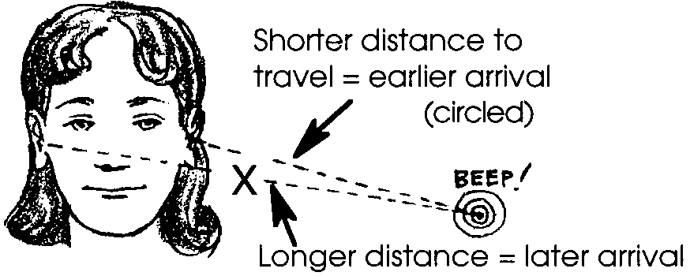
3. A correctly labeled illustration is shown at the right:

Note that, in the case of humans, sound strikes each ear at a different time. Our brain computes the difference in the time it takes the two signals to reach the brain and thus determines the location of the object. This is not the case under water. The body is the same density as water so sound received through the ears under water reaches each ear and the brain at the same time. The brain cannot compute the information as well when there is no difference. Dolphins receive the sound signals in the tip of its jaw by pointing its jaw toward the source of the sound. In effect, dolphins determine direction by turning toward the source of the echoes.

Part II. Judging Size: Analysis and Interpretation

1. a.-b. Answers will vary depending upon experimental results. In general, your students will be only as successful as they are lucky. In other words, few will be able to discriminate between the two circles by using their eyesight.

c. Most students will agree that their eyesight is less acute than the dolphins’ “earsight”.

Summary

1. People with hearing in only one ear have, among other difficulties, problems in locating the direction of sounds and of people and objects making those sounds. These individuals can compensate for some of their hearing loss by moving their heads around to better receive the sound signals.

2. She should turn to her left. When she hears the echoes increase in intensity, she will be heading right for the fish.

Bottlenose Dolphin
(Tursiops truncatus)
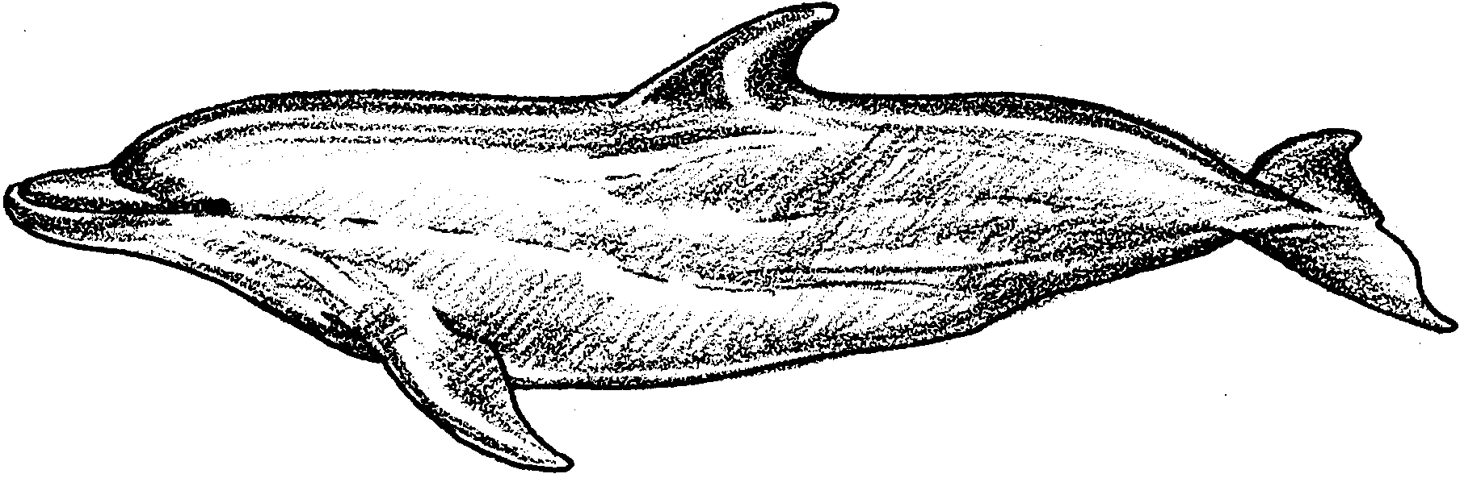

Class: Mammalia
Order: Cetacea
Suborder: Odontoceti
Family: Delphinidae
Genus: Tursiops
Species: T. truncatus

The most familiar of all the dolphins, the bottlenose is the Flipper seen in the television series, and is the animal most frequently seen in oceanarium shows. It adapts well to captivity, breeding not only with its own kind, but on occasion with other captive species as well. It is highly intelligent, easily trained, and seems to be comfortable with humans. Its mouth curves upward in a perpetual smile; which makes this dolphin especially endearing.

Physical Description The body of the bottlenose dolphin is robust, though streamlined, and unusually flexible especially in the area of the neck. Like the beluga whale, the bottlenose is able to turn its head because 5 of the 7 neck vertebrae are not fused together; the seven neck vertebrae are fused in most other species of oceanic dolphins. Its beak is short, wide, rounded, and usually only about 3 inches long (7 to 8 cm)--which is the reason it has been called “bottlenose.” Its lower jaw extends beyond the upper jaw, curving slightly upward at the tip. It has 20 to 26 sharp, conical teeth in each side of its upper jaw and 18 to 24 in each side of its lower jaw.

Color The color of the bottlenose dolphin varies considerably, but generally this dolphin is light gray to slate gray on the upper part of the body shading to lighter sides and pale, pinkish gray on the belly.

Fins and Flukes Its dorsal fin is high and falcate (curved) and located at the mid-section of the body and its flukes are broad and curved with a deep median notch. Its flippers are broad and pointed.

Length and Weight Length is from 8 to 11 feet (2.4 to 3.6 m). Weight is from 500 to 1000 pounds (227 to 450 kg). Males are larger than females.

Feeding The bottlenose dolphin has a wide and varied diet, and feeds on almost anything it can catch. Inshore, it prefers prey such as bottom fish, catfish, eels, sharks, rays, shrimp, and other crustaceans. Offshore, it seems to favor squid and pelagic fish. A single dolphin consumes 15 to 30 pounds of food each day (8 to 15 kg).

Mating and Breeding Males reach sexual maturity at 10 to 12 years, and females at 5 to 12 years. Calves are horn 2 to 3 years apart and the gestation period is about 12 months. Calves are 36 inches long at birth (l m) and nurse for over a year. Calving takes place during spring and summer months.

Distribution and Migration The bottlenose dolphin is found in all warm and temperate waters worldwide. Though regarded as an inshore species rarely found more than 500 miles out to sea, there appear to be inshore and offshore forms in some regions. Coastal groups appear to have restricted home ranges, and they travel only between these areas. These groups are often seen in small social units of 10 to 12 animals. Offshore the groups are larger--up to 25 individuals--but they may also travel in large herds of several hundred animals. Offshore groups are often seen in the company of other dolphins, pilot whales, and even larger whales such as grays, humpbacks, or right whales. For the dolphins that range offshore, movements are less restricted and more widespread, especially in tropical waters.

Natural History Bottlenose dolphins are noted for their care-giving qualities. They will support a sick or injured individual, keeping it at the surface so it can breathe; one or more adult females will assist with the birth of a calf; they often engage in cooperative feeding strategies, and in some areas, notably Monkey Mia in Australia, they will come into shallow waters to socialize with humans, showing a preference for children. They take great pleasure in bow-riding the pressure waves of moving vessels and even the pressure waves created by large whales. Of great interest to scientists is the sophisticated, complex sonar system that they use for communication and echolocation. Their life span may be at least 34 years.

Status Bottlenose dolphins are still generally plentiful in numbers, but are at or near depletion in some areas. There has been mounting concern for their well-being after 800 to 1000 bottlenose dolphins, 50% of the Atlantic coast population, were found dead or dying along the beaches from New Jersey to Florida in 1987-88. It was first thought they had died after eating fish loaded with toxic red tide algae.Shortly thereafter, however, several scientists disputed the initial report that their deaths were due to a natural catastrophe and testified to government agencies that PCBs and other contaminants played a major role in their deaths. PCBs, especially, were found in large amounts in all the dolphins that were analyzed. (As an inshore species bottlenose dolphins may be especially vulnerable to the effects of contamination of coastal waters from sewage, toxic chemicals, garbage and other contaminants. Furthermore, if the food they eat is also contaminated by the same sources of pollution, the results could be disastrous.) In a testimony to the difficulty of definitively establishing the cause of death in such strandings, more recent studies seem to indicate that the deaths were due to an infection of moribillivirus.

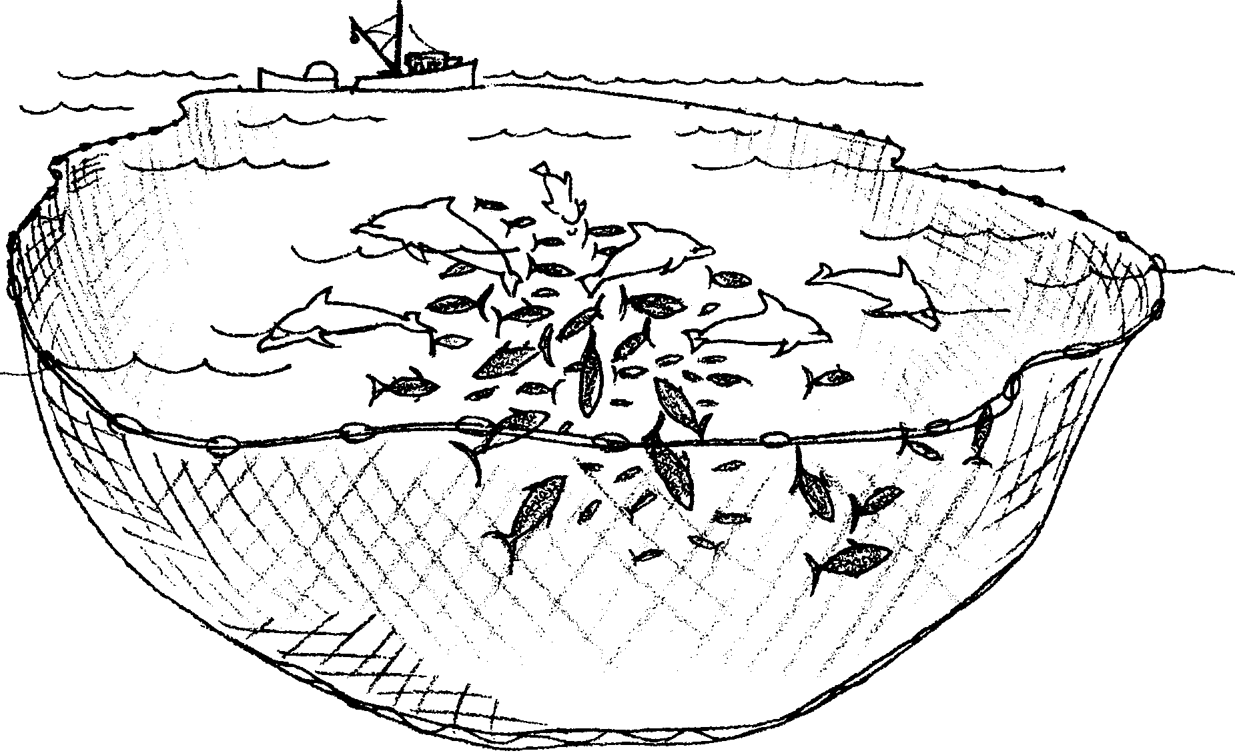
Hear Sighted

But can’t the dolphins see the nets? Couldn’t dolphins avoid the tuna nets if they saw them? Let’s take a look at dolphins.

Amazing, but a dolphin “sees” by hearing. What’s the benefit of this? Vision is difficult in the dark, murky seas. Dolphins may hunt at night. They may hunt below the lighted zone of the ocean. Vision depends on light. But sounds can be made at night or in deep water. A dolphin brain stores sound pictures. The sounds come from echoes of clicks the dolphins make. A dolphin can “see” things by listening to the echoes of its own clicks.

1. What are two reasons sound might be better than sight for dolphins?

a.

b.

Most dolphins have two kinds of voices. One voice is used to “talk” to each other. The other voice is used for navigation. Their second voice is also used for echolocation.

2. Navigation means finding out where you are. It also means finding out where you are going and how to get there. What do you think echolocation means?

Echolocation means sensing the location of objects by using sound. Dolphins send out sounds. They also interpret the echoes. Whalers and fishers had long suspected that dolphins had a special way of “seeing”. Scientists began to study the idea after several interesting observations.

In 1947, Arthur F. McBride made the first scientific observation. Mr. McBride collected animals for Marine Studios, now known as Marineland of Florida. He was using a net to catch bottlenose dolphins. He noticed that dolphins never swam into the net. The net had a small mesh. The dolphins jumped over the cork line. They jumped over in the dark. They jumped over in murky water.
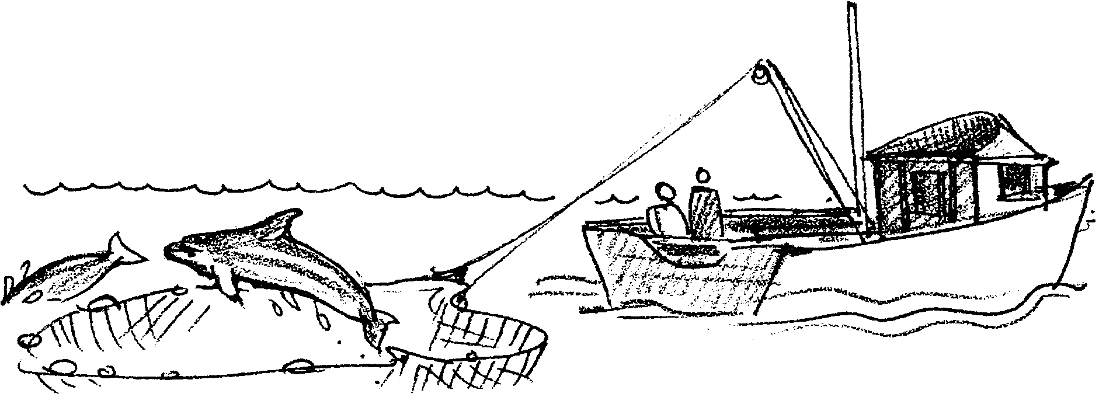
Mr. McBride noticed one more thing. If a large mesh net was used, the dolphins ran into the net. After dolphins became entangled in the net, the cork line would sink. At this point the other dolphins would leap over.

3. Three observations lead to scientific study of dolphin echolocation. Please circle the answers to tell what they were.

a. The dolphins never/sometimes swam into small mesh nets.

b. The dolphins would/would not jump over the nets in the dark.

c. The dolphins never/sometimes swam into large mesh nets.

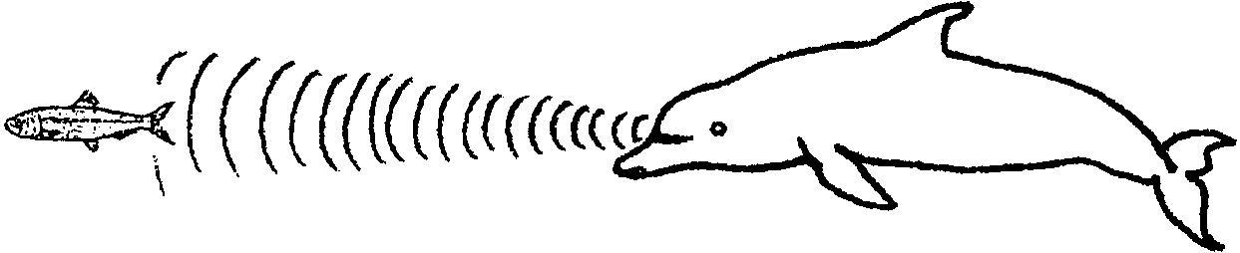
Dolphins make a series of clicks to echolocate. The clicks move through the water as sound waves. When the clicks strike an object, they bounce back. The dolphin senses the echoes. From the echo, the dolphin can judge location, speed, and direction of the object.

4. Name 3 things that dolphins can tell about an object by listening to the echoes.

a.

b.

c.

A dolphin can tell one kind of fish from another. It can also tell the size of the fish or object. It can tell other things, too. People sometimes swim with dolphins. What does a dolphin “see”? The dolphin can “see” inside the diver. It can “see” the diver’s skeleton, lungs, and other organs. How can this be? Human flesh has about the same density (“thickness”) as water. The echoes pass through objects with the same density as water. The dolphin can easily distinguish one object from another if they have different densities. So, to the dolphin, the diver might look like an x-ray photograph of the human body.

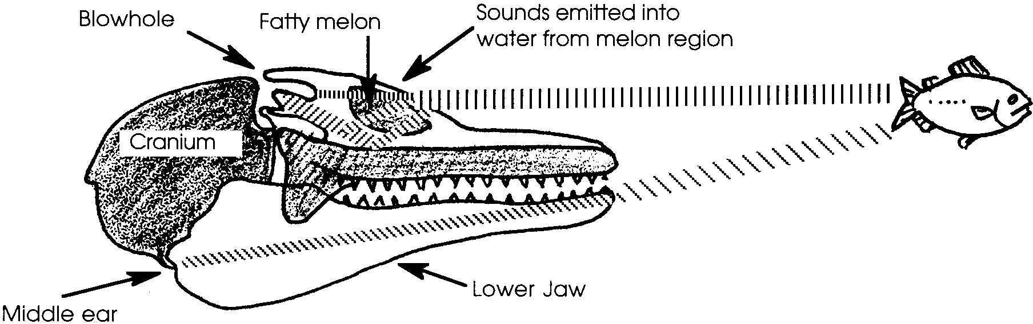
5. The dolphin can “see” the diver’s lungs. The lungs must have a density about the same as/different than water. (Please circle the correct underlined two words to choose your answer)

Scientists think the dolphin makes its clicks in special parts of its head. One part is the melon. The melon is found at the front of the head. It is called a melon because of its shape. The melon in filled with something that looks and feels like clear jelly.

Some sound may also be made inside the blow hole. The blow hole is a long tube. It reaches from the top of the dolphin’s head to its lungs. The dolphin breathes through this tube.

6. How is a “blow hole” at the back of the head helpful for a dolphin?

(Hint: To find out, try this. Make a loose fist. Make it slightly open so that you can open and close the tube it makes. This will represent a dolphin’s blow hole. Tilt yourself so that you are looking down at the floor. Now, place your “blow hole” (fist) on the back of your head. Notice that breathing through an opening at the back of your head allows you to keep your face down. This is very handy if your face is in water. Practice breathing like a dolphin. Open and close your fist blow hole each time you breathe in or out. Keep your face down as if you are a dolphin swimming in the water. Now, please answer the question. How is a “blow hole” at the back of the head helpful for a dolphin?)

Do the following activities to test your ability to echolocate.
Echolocation
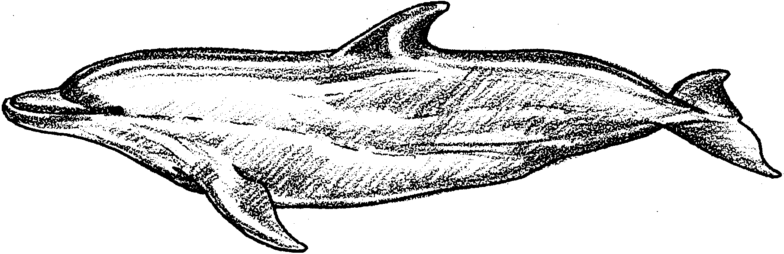

Can you echolocate as well as a dolphin? Do these activities to test your ability to echolocate.

Part I: Finding Direction

1. For this activity you will need to work with a partner. One person is the dolphin. The partner is the fish ’target’.

2. Have the dolphin close her eyes. (You may need a blindfold!) The fish ’target’ will choose three (3) locations in the room to hide.

3. At the first location, the fish snaps his fingers or claps his hands. The dolphin KEEPS HER EYES CLOSED AND HEAD STILL! She listens to the sound. The dolphin then points to the direction from which she thinks the sound is coming. RECORD whether the dolphin was correct on your data sheet.

4. Repeat step 3 for two other locations.

5. Now have the dolphin cover one ear. Repeat steps 2, 3 and 4 above. (The fish will want to choose new locations!)

6. Very few animals keep their heads still all the time. Many dolphin species have fused neck bones (vertebrae). A dolphin in this group cannot move its head to turn it. To turn its head, it must turn its body. To scan the water when it echolocates, it moves its entire body.

Try your skill at finding the fish by moving your head. Do this for three locations with both ears uncovered. Be sure to keep your eyes closed. RECORD your data.

7. Repeat step 6 with one ear covered.

8. If you have time, change roles and repeat the activity.

Analysis and Interpretation: Part I - Finding Direction

1. a. Was the dolphin always successful in locating the fish?

b. If not, was the dolphin more successful using one ear or two?

2. a. Was the dolphin more successful when she could move her head?

b. If so, was the dolphin more successful with one ear or two?

3. Sound sources usually are closer to one ear. Because of this, the sounds arrive at the ears at different times. Our brain computes the difference in messages from the ears. This information tells us something about direction.

Dolphins are different than humans. A dolphin actually receives the sounds through its jaw rather than its ears. To determine direction, dolphins turn toward the source of the echoes. As the dolphin turns its head and jaw, the intensity of the returning clicks changes. These changes give the dolphin information about direction.

Use the drawing below to answer these questions:

a. Circle the sound wave with the shortest distance to travel.

b. Put an X on the sound wave with the longest distance to travel.

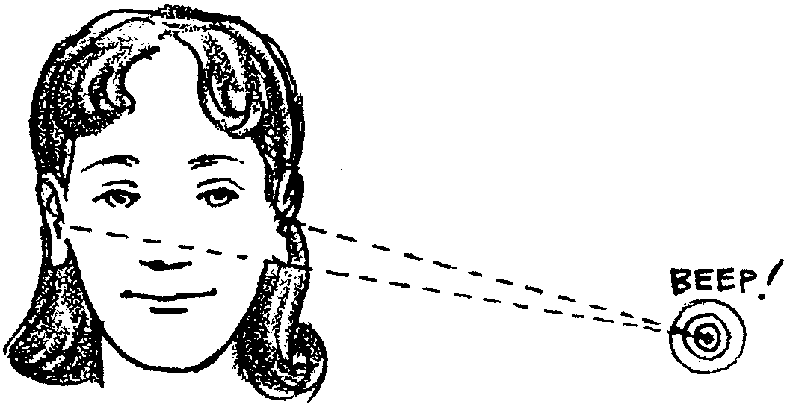

Part I - Finding Direction - Data Sheet

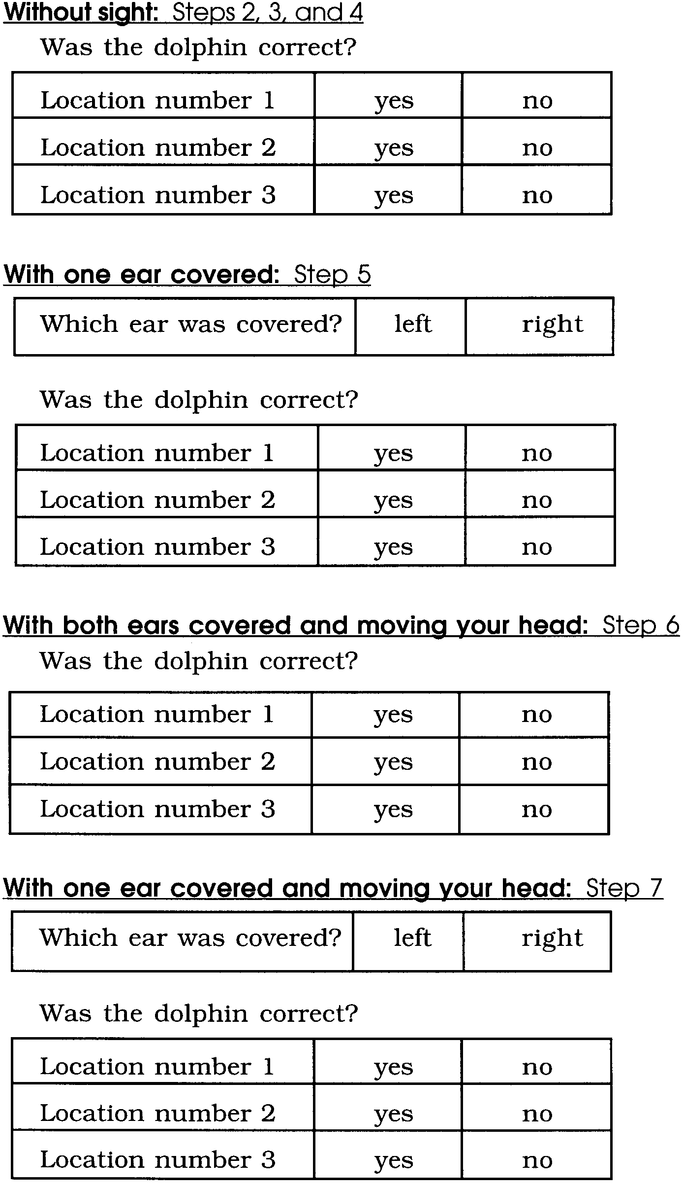
(Please circle your answer.)

Part II - Judging Size

A dolphin’s sense of echolocation is very accurate. From one hundred feet away, they can tell the difference between balls that are close in size. Let’s see how you can do on the same task.

Here’s what you will need:
• 1 circle sheet
• scissors

Here’s what to do:

1. A dolphin can tell the difference between a ball 2 1/2 inches across and one 2 1/4 inches across. You will need a circle sheet to do this activity.

2. Cut out two circles from the circle sheet. The larger circle is 2 1/2 inches across. The smaller is 2 1/4 inches across.

3. Work with a partner. Have one of the partners hold the circles. The other partner should walk 35 paces and turn around.

4. The partner holding the circles asks, “which circle is larger?” Without telling if the answer is correct, RECORD the answer. Use your data sheet.

5. Shuffle the two circles and repeat step 4, three more times.

6. If you have time, change places and repeat the activity.

Analysis and Interpretation: Part II - Judging Size

1. a. How many times was Partner One able to correctly identify the larger circle?

b. How many times was Partner Two able to correctly identify the larger circle?

c. Dolphins easily distinguish the two sizes at a greater distance. How does your eye sight compare with dolphin “ear sight”?
Summary

1. Some people have hearing in only one ear. What kind of problems might they face and how might they overcome them?

2. A spinner dolphin is swimming straight ahead. She is hungry. She sends out a series of clicks. She senses echoes from a tasty fish. She turns her head to the right. She continues swimming. The echo grows more and more faint. Which way should she turn to catch the fish?

Part II - Judging Size - Data Sheet
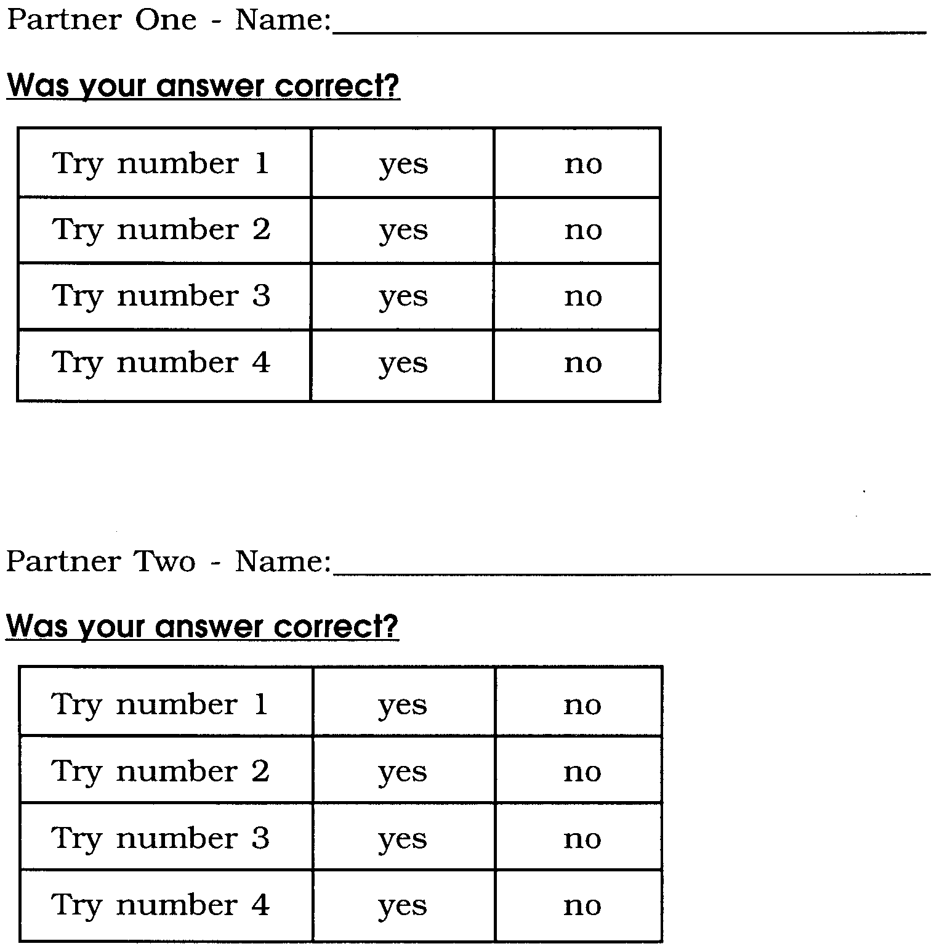

Circle Sheet

Can you tell these apart with your eyes as well as a dolphin can with its ears? Try and see. You need just one sheet for partners to share.



