Canned Tuna

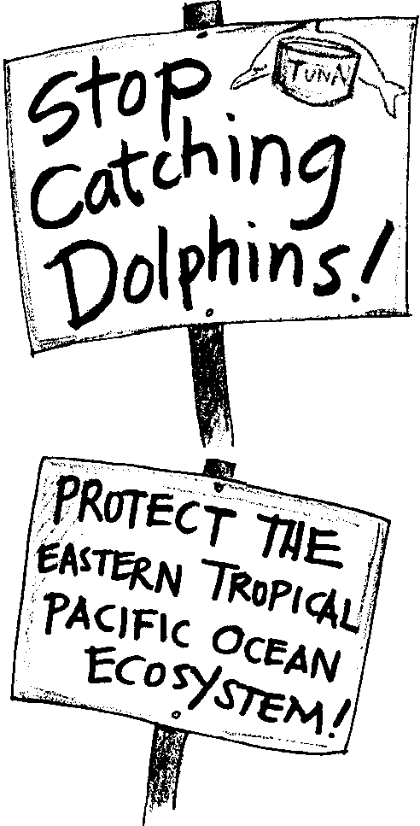
Key Concepts
1. People disagree about whether any dolphins may be killed to help catch tuna. The tuna/dolphin international controversy is based on this disagreement.
2. Consumer pressure through letter writing caused giant corporations to stop buying tuna that is caught in association with dolphins.
3. Canned tuna is labeled “dolphin safe” if the tuna was caught without association with dolphins.
4. Issues surrounding protection of marine mammals are complex but important.

Background

As noted in the “Background” section, for the preceding activity, “The Tuna/Dolphin Controversy”, issues surrounding the protection of dolphins found in association with tuna are complex but important. Complex problems such as the tuna/dolphin controversy require complex solutions. This problem has both scientific and social facets which must be considered in any solution.

Public pressure has been very successful in convincing tuna canners and fishers to adopt “dolphin safe” fishing practices. The decline in the number of dolphins killed has been dramatic. The issue facing us now is whether the number of dolphins killed should be reduced to zero and, if so, what costs are associated with that reduction. At this point, the dolphin safe policy has primarily affected the U.S. fleet. Most U.S. boats now fish elsewhere. The Earth Island Institute, a environmental group, has been successful in forcing changes in the way people fish for tuna. They are working to eliminate the practice of “dolphin fishing” for tuna in the eastern tropical Pacific.

Most of the public and scientists have applauded their efforts to date. However, some scientists, such as Marine Mammal Biologist, Doug DeMaster at National Marine Mammal Laboratory are very concerned about the effort to totally eliminate dolphin deaths. Dr. DeMaster has spent over ten years working on this problem. He fears that if The Earth Island Institute efforts are successful, tuna fishers will adopt a strategy of “log fishing” which does not entrap dolphins but does entrap large numbers of turtles, sharks, and other marine animals. His studies indicate the result could be the loss of 50,000,000 to 200,000,000 pounds of marine animals from the marine ecosystem each year. The reduction in the sustainable yield of tuna in the area will be 30%. These would be exchanged for not killing approximately 3,000 dolphins per year.

Our actions have very real consequences. Sometimes the choices are hard. The issue for us, and for your students, is “Do you think the trade of 50,000,000 to 200,000,000 pounds of other marine animals and 30% of the tuna for 3,000 dolphins is a good one?” The actions taken in response to the tuna/dolphin controversy depend upon the answer to that question.

If nothing else, the response of the tuna canners and tuna fishers indicates the very real power of public pressure. In particular, the nation’s three largest sellers of canned tuna announced April 12, 1990 that they would stop buying tuna that was caught in association with dolphins. Together these companies account for nearly 70 percent of the canned tuna sold in the U.S. Dr. Anthony J.F. O’Reilly, chairman of H.J. Heinz Co., said that his company was responding to consumer concerns about dolphin safe tuna. Officials at all three firms cited letter-writing campaigns, petitions, and telegrams from the tuna-eating public as reasons for their change in policy. Despite the fact that tuna consumption had been on the rise, canners said that protests and tuna boycotts (spearheaded by Earth Island Institute) would have eventually taken their toll at the market. Many believe the action taken by these corporations represented the most important step for protecting dolphins since the passage of the Marine Mammal Protection Act of 1972. The three companies are: 1) H.J. Heinz Co., owner of Starkist brand, 2) Van Camp Seafood Co., which markets Chicken of the Sea, and 3) Bumblebee Seafood, Inc.

To assure canners and consumers that the tuna they purchase is truly dolphin safe, the Marine Mammal Protection Act put observers on all U.S. vessels. The observers certify that the tuna caught on their boats are dolphin safe. Tuna purchased from vessels without observers is not certified dolphin safe. Many foreign vessels carry observers for this certification. The Dolphin Consumer Information Act of 1990 established the criteria which must be met before tuna sold in the U.S. can be labeled “dolphin safe”. Tuna products so labeled give consumers a good indication that the tuna was caught without killing dolphins.

It is important to note that even small changes in consumer preference and brand loyalty in purchases of canned tuna can have large economic consequences. For example, in April 1990, yellowfin tuna caught in the eastern tropical Pacific and unloaded in Panama for shipment to Italian canneries earned $1,375/ton. The next day, following the announcement that only dolphin safe tuna would be purchased by giant American companies, the canneries changed their tuna buying policy. The price of the same tuna dropped to $800/ton. The changes in the value of the fish, in turn effected changes in the behavior of fishers and increased the profits of the canneries that refused to buy “dolphin safe” tuna.

The Earth Island Institute advocates keeping the pressure on tuna fishers to assure that no dolphins are killed during harvest. Dr. DeMaster at the National Marine Mammal Laboratory, on the other hand, believes that the alternative fishing methods, while reducing dolphin kill, will kill millions of other marine animals. He notes that, if nothing else, our study of ecosystems shows us that each animal and plant has a special role to play in keeping a system functioning and that the wholesale destruction of animals and plants will jeopardize the entire eastern tropical Pacific Ocean ecosystem.

We must also remember that local ecosystems such as that of the eastern tropical Pacific Ocean are connected to the other ecosystems. This realization raises the question of dolphin mortality from tuna fishing in other areas of the world ocean. Many tuna fisheries outside the eastern tropical Pacific kill dolphins during fishing operations. In these areas all that is required to certify the catch as “dolphin-safe” is a statement by the vessel captain. There are no observers at sea to verify the statement.

Clearly, the tuna/dolphin controversy is an example of a complex problem. Before deciding upon which actions to take, you, and your students, will need to weigh both the scientific and social aspects of the opposing points of view in this controversy. The solution lies in cooperation between canners, fishers, consumers and governments.

Additional background information is found in the preceding activity, “The Tuna/Dolphin Controversy”.

Materials

For the class:

• cans of tuna brought by students or yourself

For each student:

• lined paper for rough drafts

• lined paper for stationery

• 2 envelopes

• 2 stamps

Teaching Hints

In “The Tuna/Dolphin Controversy” your students examined a complex issue as they investigated the relationship between yellowfin tuna, certain dolphins, and the “fishing on dolphins” method. They were challenged to solve the problem by creating a new fishing method. “Canned Tuna” provides a letter writing approach which may be used as a follow up for “The Tuna/Dolphin Controversy” activities.

In “Canned Tuna”, students examine cans of tuna to recognize the tuna safe mark on the can and to determine which brands are “dolphin safe”. Students discuss the issues involved in reducing the death of dolphins to zero and decide whether to write letters supporting a total ban on catching dolphins or letters which let the tuna companies know that the students appreciate their efforts to reduce dolphin kills but that now the problem needs further attention, expanded monitoring, and additional research into safer fishing alternatives to assure the health of the eastern tropical Pacific Ocean ecosystem.

Preparation

Collect cans of tuna from different companies. You may choose to have students bring cans of tuna from home or to visit local stores and examine tuna products there. If cans are brought from home, mark students’ names on the bottom of their cans for return to owners.

Have the class examine the labels to find out if the product is marked “dolphin safe”. The company’s address is usually on the can. Students could write to the companies to find out what species of tuna is in the can, where the tuna was purchased, whether it was imported or from the U.S, and what fishing technique was used.

Letter Writing Procedure

1. Tell your class that letter writing caused tuna canning companies to change their policy about buying tuna. Because of people’s letters, these companies stopped buying and selling tuna that was caught with dolphins. Many other kinds of food companies also stopped buying and selling tuna unless it was certified “dolphin safe”.

Review the issues discussed in the preceding activity, “The Tuna/Dolphin Controversy”, and discuss with your class their position on the controversy. Discuss how people make decisions. Help them to see that our decisions are based on lots of things including scientific knowledge, social beliefs and customs (for example, people that eat dolphins may have a rather different view of catching dolphins in nets), and feelings. As you discuss the two sides of the controversy, try and get students to examine the basis for their statements and choices. Once you feel students have a good grasp of the issues and the consequences of different actions, honor their individual choices and provide them with the appropriate set of instructions and addresses from the student pages.

2. Discuss how to write a “thank you” letter and a letter asking for help. Model simple letters.

3. Give students the letter writing instructions with addresses. Have them compose a rough draft of each letter in their own words as instructed in the text. Have them proofread their draft letters before they give them to you for proofing.

4. After you have proofed their drafts, have students neatly copy their letters onto lined stationery. Check their final letters before mailing.

5. Show students how to address an envelope. Then give them two envelopes to address as shown in the student text. Check their envelopes before giving them stamps to place in the proper place.

6. Take your class to your school’s out-going mail deposit and have each one deposit his/her letter to mail.

7. As students get replies, have them bring them from home to share with the class. Consider a bulletin board on which to display the responses. You may wish to include a map if students inquire about where the tuna was purchased and whether it was imported or canned in the U.S..

Key Words

adopt - take ownership for something

dolphin-safe tuna - tuna that was not caught without the incidental death of dolphins

importing - bringing products into the country

marine mammals - mammals (vertebrate animals that nourish their young with milk) that live in marine waters

policy - a course of action adopted by a government, etc.

proofread - check/edit for grammar, content and readability

rough draft - early document before final editing

tuna - a large deep-water fish that is a popular food source

Extensions

1. Design your own stationery for this project.

2. Write and illustrate ads supporting your position in the tuna/dolphin controversy or make video commercials.

3. Make a graph showing the brands of tuna and the numbers of cans brought in by students for each brand.

4. Conduct a product comparison by opening the cans and examining the contents. Have the students make up the criteria for comparison.

5. Try a taste test with blindfolded students.

6. Research restaurants and food supply companies in your town to find out if the carry only dolphin safe tuna. Write letters to them outlining the complexities of the tuna/dolphin controversy

7. Visit a post office to mail your letters.

Canned Tuna
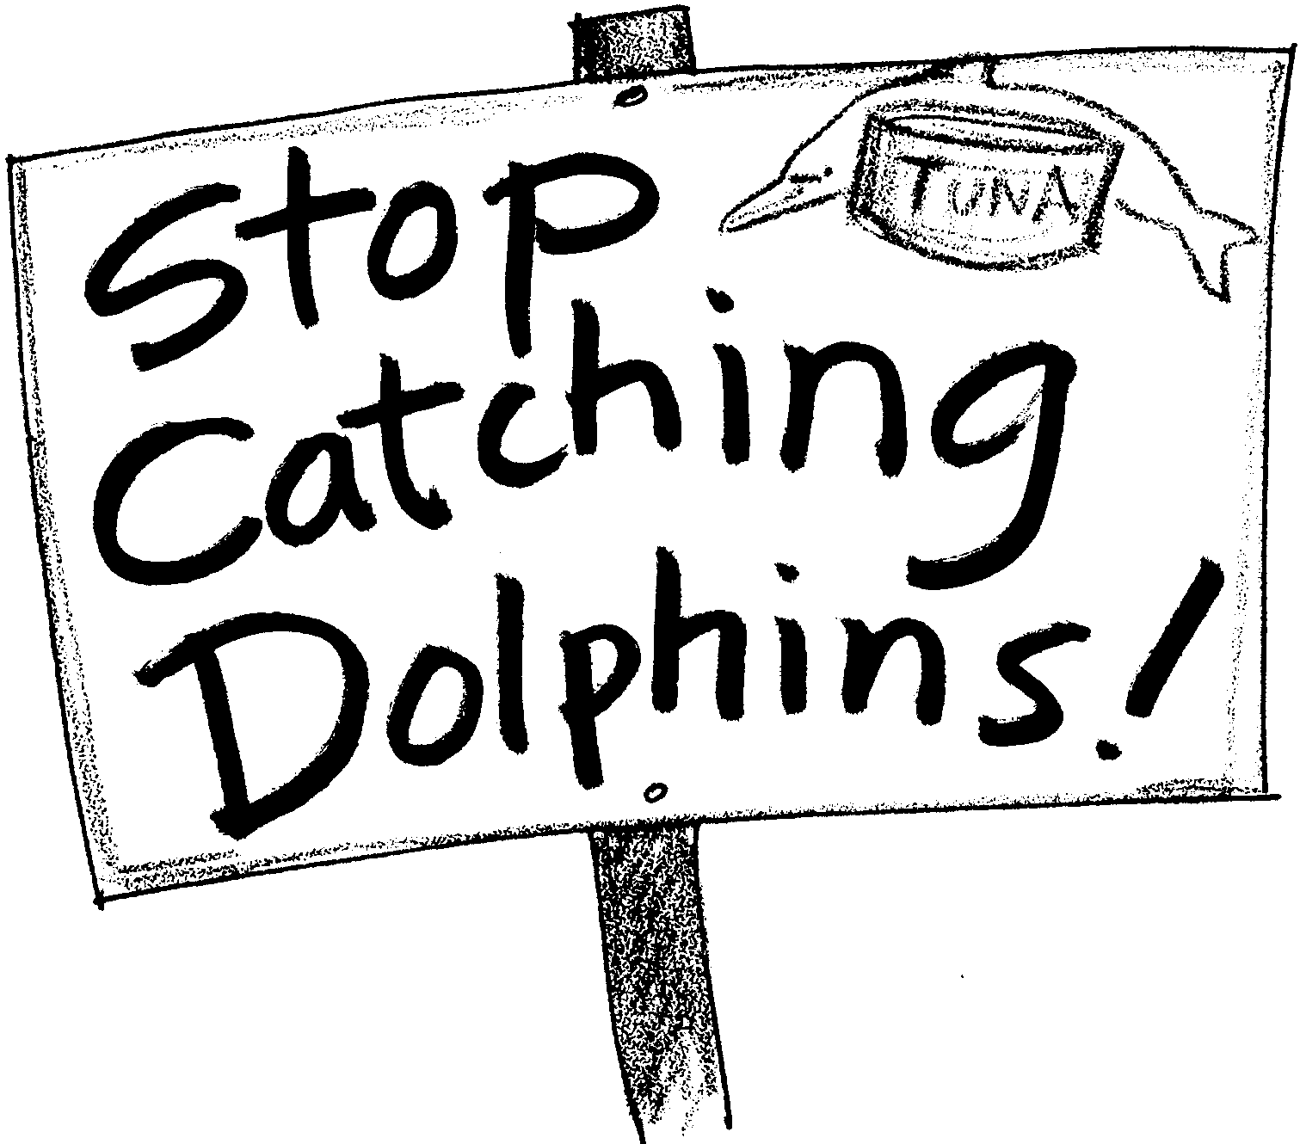

Look at some cans of tuna to see if they have the dolphin-safe label on them. If they do, then you know that the tuna in the can was caught without dolphins being caught also.

You’ve learned about tuna and dolphins. You used what you learned to make a choice. Here’s what to do if you think no dolphins should be caught.

You can write letters to save dolphins. Your letters count! Some restaurants sell dolphin safe tuna. Others do not. You can write letters to thank one restaurant chain for selling dolphin safe tuna. You can also write letters to ask the other to do so. You will also find some addresses for lawmakers. You can write to them, too. It is important that they know what you think. Don't forget to write your newspaper to inform your neighbors.

Here’s what you will need:
• lined paper for rough drafts
• lined paper for stationery
• 2 envelopes
• 2 stamps
Here’s what to do:

1. Tuna fishers have done a lot to reduce the number of dolphins killed. You can write a tuna fisher and say thanks. You can also encourage the tuna fisher to continue making progress. Send your letter to:

Starkist Foods, Inc.
180 E. Ocean Blvd.
Long Beach, CA 90802

H.J. Heinz Co.
P.O. Box 57
Pittsburgh, PA 15230

Van Camp Seafood Co.
901 Chouteau Avenue
St. Louis, MO 63164

Ralston Purina Co.
Checkerboard Square
St. Louis, MO 63164

2. Restaurants in the U.S. make a lot of tuna sandwiches. They have gone dolphin safe. They only use tuna that was caught without killing dolphins. Denny’s was one of the first restaurant chains to use only dolphin safe tuna. Many people wrote to Denny’s to ask them to do this. Their letters helped save dolphins. You can write to Denny’s and say thanks! Write your letter to:

President
Denny’s Restaurants, Inc.
203 E. Main St.
Spartanburg, SC 29318

3. Marriott Corporation owns many restaurants and hotels. They also sell tuna to airlines, business, schools, and hospitals. Find out if your school gets its food from Marriott. You can write a letter to Marriott Corporation. Thank them for their dolphin safe policy. Urge them to continue buying and selling only tuna that was caught without harming dolphins. Write your letter to:

Mr. Richard E. Marriott, Vice Chairman
Marriott Corporation
Marriott Drive
Washington, DC 20058

4. One of the strongest supporters of dolphin safe tuna is the Earth Island Institute. Write a letter thanking them and asking for more information:

Earth Island Institute, Dolphin Project
300 Broadway, Suite #28
San Francisco, CA 94133.
What else can you do?

Help protect marine mammals! Letter writing is one of the best ways to get people to save the animals. Here are some more ideas for letters you can write.

Write to lawmakers. If you do not know their names, ask your local chapter of the League of Women Voters. They will probably know or know how to find out.

When you write or call, ask them to vote for laws that will have industries buy and sell only dolphin safe tuna

Who to write to:
U.S. Department of Commerce
National Marine Fisheries Service
1335 East/West Highway
Silver Springs, MD 20910

1. Your Senator:
Senator (name)
Senate Office Building
Washington, DC 20510

2. Your Congress person:
Congressman or Congresswoman (name)
House Office Building
Washington, DC 20515

3. U.S. Secretary of Commerce:
Secretary of Commerce
U.S. Department of Commerce
National Marine Fisheries Service
Universal Bldg.
1825 Connecticut Avenue N.W.
Washington, D.C. 20235

4. The European Economic Community:
Ask them to prohibit the importing of dolphin-caught tuna in Europe.

Head of Delegation
Commission on European Communities
2100 M Street, N.W., 7th Floor
Washington, DC 20510

But, Does It Work?

Public opinion caused the tuna purse-seine fleet to change their fishing methods. Public opinion can work for a solution which protects all of the dolphins. We can make our voices heard and have an effect. Let’s do it now!
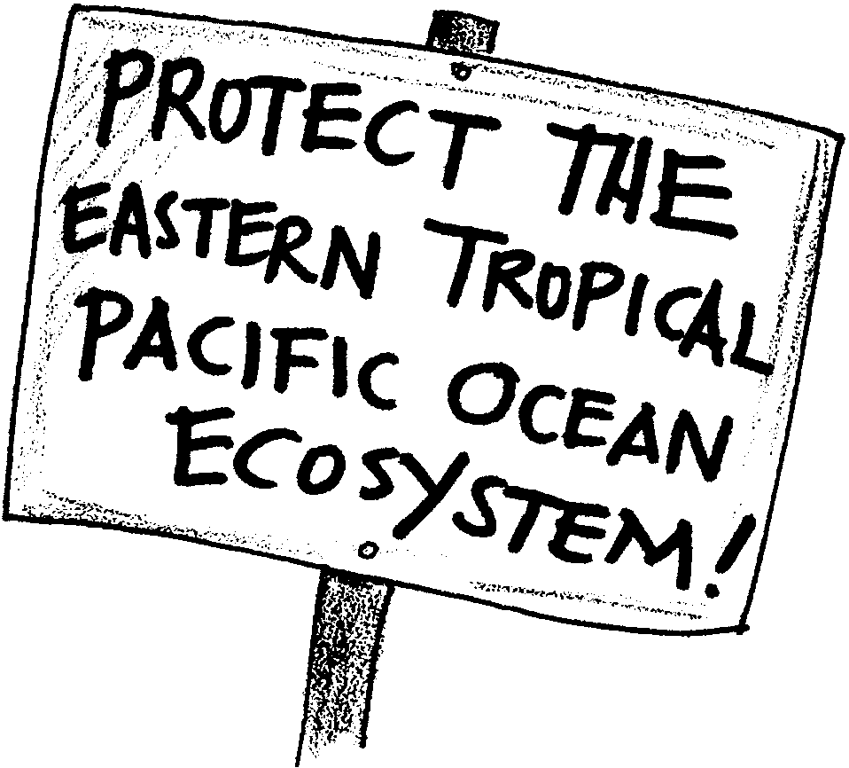
Canned Tuna

Look at some cans of tuna to see if they have the dolphin-safe label on them. If they do, then you know that the tuna in the can was caught without dolphins being caught also.

You’ve learned about tuna and dolphins. You used what you learned to make a choice. Here’s what to do if you think some dolphins can be caught to protect the life of the ocean.

You can write letters to thank and inform. Your letters count! You will also find some addresses for lawmakers. You can write to them, too. It is important that they know what you think.

Here’s what you will need:
• lined paper for rough drafts
• lined paper for stationery
• 2 envelopes
• 2 stamps

Here’s what to do:

1. Thank the tuna companies for their efforts to reduce dolphin kills. In your letter tell them how the problem needs further study. You may want to say why you won’t buy their “Dolphin Safe” products.

Van Camp Seafood Co.
901 Chouteau Avenue
St. Louis, MO 63164

Ralston Purina Co.
Checkerboard Square
St. Louis, MO 63164

Starkist Foods, Inc.
180 E. Ocean Blvd.
Long Beach, CA 90802

H.J. Heinz Co.
P.O. Box 57
Pittsburgh, PA 15230

2. Write Congress and the U.S. Commerce Department. Let them know that you support the Marine Mammal Protection Act. Tell them the Act was to reduce porpoise kills not to destroy the ecosystem of the eastern tropical Pacific. Say the U.S. should help stop ecosystem destruction in the name of dolphin protection

Chairman
House Subcommittee on Fisheries, Wildlife Conservation and the Environment
544 House Annex 11
Washington, D.C. 20515

National Ocean Policy Study
Senate Commerce Committee
527 Hart Senate Office Bldg.
Washington, D.C. 20510

U.S. Department of Commerce
National Marine Fisheries Service
1335 East/West Highway
Silver Springs, MD 20910

Your Representative
U.S. House of Representatives
Washington, D.C. 20515

Your Senator
U.S. Senate
Washington, D.C. 20510

3. Write letters to the editor in your local newspapers.

4. Let others know about the issue:

Write to:

Earth Island Institute, Dolphin Project
300 Broadway, Suite #28
San Francisco, CA 94133.

Thank them for their past efforts. Ask them to redirect their efforts toward protection of the eastern tropical Pacific ecosystem.

Prepare a public service announcement for your local radio station and television.

But, Does It Work?

Public opinion caused the tuna purse-seine fleet to change their fishing methods. Public opinion can work for a solution which protects the ecosystem as well as the dolphins. We can make our voices heard and have an effect. Let’s do it now!

