The Tuna/Dolphin Controversy

Key Concepts
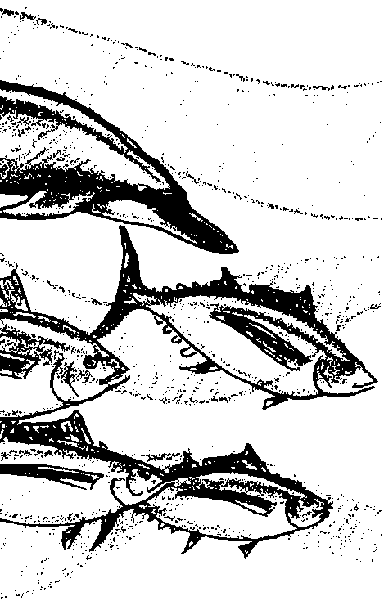
1. Humans use a variety of techniques for harvesting food from the ocean and coastal waters. New techniques need to be developed.
2. The harvesting of a food species can impact other marine animals. The “fishing on dolphins” method of fishing for tuna is a prime example.
3. People disagree about how whether any dolphins may be killed to help catch tuna. The tuna/dolphin international controversy is based on this disagreement.
4. Issues surrounding protection of marine mammals are complex but important.

Background

Human interaction with marine mammals is surrounded by controversy. The nature of an ongoing controversy, such as that surrounding dolphin kills from tuna fishing, is that there are no hard and fast answers. This is likely to be frustrating for students and the general public alike.

For centuries. the nations of the world have refused to accept any restrictions or limitations on the quantity of fish that any one nation could catch. The international law of the seas provided for “complete freedom of the seas” outside accepted territorial waters. For most of previous history, this lack of catch restrictions is understandable. For example, both the size of the ships and the methods used to catch fish ensured the continuation of almost all of the species. A ship would put to sea, catch as many as it could hold, and return to port to process and sell its catch. Enough of the fish stock would remain behind to ensure species survival. Even so, humans did manage to overfish some coastal populations as witnessed by the decline or disappearance of whales in many coastal areas.

Modern technology, however, has enabled fishers to increase the total fish catch often to the point of destruction of the fish resource. In the case of tuna fishing, modern technology has inadvertently had a major impact on dolphins, as well. In recognition of the potential adverse impact humans can have on populations such as those of tuna and dolphins, the U.S. "Law of the Sea" agreement and a similar United Nations agreement call on nations to conserve and protect resources. Some successes in conserving and protecting fish stocks have occured along with many failures. Although disappointing, the failures are more often due to a lack of enforcement than to a continued philosophy of unlimited exploitation.

The story of the interactions between dolphins and tuna is an incredible one, bathed in ambiguity, political power plays, and a haze of legalities. The issues have been emotional and hotly debated. It is an international issue requiring international solutions.

For many years, people in the eastern tropical Pacific Ocean have observed that schools of yellowfin tuna commonly swim beneath schools of dolphins. Tuna fishermen were among the people who observed this phenomenon. In order to catch the tuna underneath, they set mile-long purse-seine nets around the dolphins. In so doing, tens of thousands of dolphins were caught and drowned in tuna nets each year. In the early 1970s, conservationists brought these drownings to the public’s attention. Thus began the tuna/dolphin controversy.

It is important to note that the problem is virtually unknown to those under the age of 25. The vast majority of the public are either unaware that dolphin drownings occurred and continue to occur, or believe that the problem was solved long ago.

The controversy really has its roots in a method of fishing developed by the American tuna industry about 1960. The technique, called “fishing on dolphin”, depends on the mysterious relationship between dolphins and tuna. This method, which came to dominate the yellowfin tuna industry, is called “fishing on dolphin”. For unknown reasons, yellowfin tuna and certain dolphins (especially the spotted dolphin) swim together. One research theory states that the tuna rely on the dolphin’s acute sense of hearing, or echolocation, to find food or to avoid predators.

Since dolphins are air breathing mammals, spotting dolphins when they come to the surface is relatively easy. The tuna boats search for the dolphins. When they locate the dolphins, the boats deploy very long purse seine nets to entrap the tuna that swim below the dolphins. As the net is pursed (drawn together), the tuna and dolphins are caught. This is a critical moment for the dolphins. Since they are air breathers, they are highly susceptible to drowning as the net encircles them. Since the late 1970s, American boats have used a technique called “backing down” in which the boat pulls the net out from under the dolphins. This strategy has greatly reduced dolphin drownings.

(Note: While the term “drowning” is used in these lessons and commonly in articles and news stories about this topic, technically dolphins are incapable of drowning; that is, inhaling below the water surface and filling their lungs with water. A dolphin’s blowhole will not open unless it is above water. If prevented from reaching the surface (by getting entangled in a net, for example), a dolphin will asphyxiate from lack of oxygen.)

At any point in this fishing method, dolphins may be killed or injured. People disagree about whether or not it is acceptable to kill any dolphins in these fishing operations. Such a disagreement is called a “controversy”. The tuna/dolphin controversy centers over whether dolphins may be killed in order to catch the yellowfin tuna (and if so, how many?).

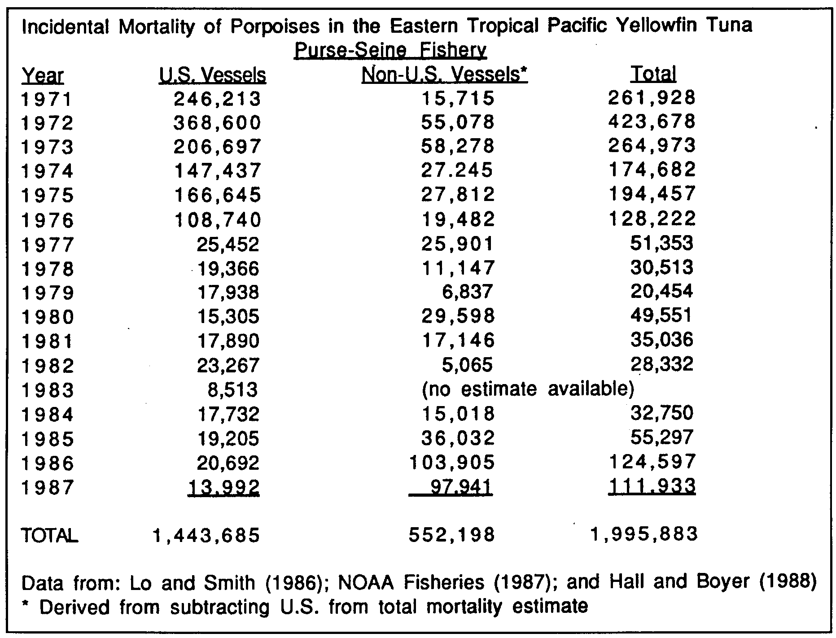
Since 1960, when the U.S. developed the technology of “fishing on dolphins”, an estimated 6,000,000 dolphins have died in purse seining nets. From 1959 to 1972 a total of about 4.8 million dolphins is estimated to have been killed. When the Marine Mammal Protection Act was passed in 1972, the U.S. fleet was responsible for 87 percent of the dolphin kill. Since then, there has been a decrease in dolphin kill as shown in the table below.

Above data is from Table 10 (Estimated incidental kill of dolphins in the tuna purse seine fishery in the eastern tropical Pacific Ocean, 1972-1996) of the Marine Mammal Commission's 1996 Annual Report.

Some people say that the decrease has not been enough. They fear that yellowfin tuna fishing has already drastically reduced the dolphin populations. Some scientists state that dolphin population danger signs already exist. They note that because estimates on the number of animals killed are based on actual body counts, the numbers can be seriously misleading. Individuals that have been injured and escaped only to die a short distance away are not counted.

Because of these fears, various environmental groups initiated a successful campaign to change the regulations governing yellowfin tuna fishing. They recognized that the United States Marine Mammal Protection Act (MMPA) of 1972 calls for the reduction of marine mammal kills “to insignificant levels approaching zero mortality”. As noted in the table above, in spite of the law a large number of dolphins continued to be killed each year.

In 1984, the U.S. Congress reviewed the Marine Mammal Protection Act. Congressional representatives recognized that the dolphins were still in danger. They also recognized that U.S. tuna fishing crews were at a competitive disadvantage. U.S. boats spent more money to fish in ways that did not capture dolphins. To provide help for the dolphins and the fishers, Congress amended the Marine Mammal Protection Act. The new Act required that each nation exporting tuna to the United States provide documentary evidence that it had adopted a program comparable to the U.S. dolphin protection program. Exporting nations also had to provide evidence that the average rate of accidental dolphin deaths caused by its fleet is comparable to that of the U.S. fleet.

Since much of the tuna caught worldwide was destined for U.S. markets, the 1984 plan seemed like a good one. However, during an MMPA reauthorization hearing in April, 1989, it was noted that NOAA Fisheries hadn’t yet completed regulations implementing the 1984 amendment. Foreign fleets were fishing and exporting tuna to the U.S. as they always had. It was also revealed that the U.S. tuna purse-seine fleet had declined by more than 60% in the last ten years but that the level of incidental dolphin take by the fleet had not gone down proportionately. The remaining boats were catching more, not fewer, dolphins. Finally, it was noted that the estimated numbers of dolphins killed by foreign fleets had increased dramatically in 1986 and 1987. Clearly, the 1984 changes in the Marine Mammal Protection Act were not being effectively implemented.

You might correctly guess that Congress was not pleased by these findings. In light of these developments, Congress enacted additional amendments that require the Secretary of Commerce (the person ultimately in charge of enforcing the MMPA) to find the regulatory programs of other nations unacceptable unless:

• They included prohibitions against encircling pure (i.e., single species) schools of certain marine mammals, and conducting “sundown sets”. Sundown sets were prohibited because dolphins are harder to see and remove from nets during sunset hours. The nation’s program would also need to implement other dolphin-saving measures applicable to U.S. vessels.

• The nation’s program reduced the average rate of incidental dolphin kills by its vessels to no more than 1 1/4 times that of American vessels.

• The total number of eastern spinner dolphins, Stenella longirostris, taken incidentally during the fishing season does not exceed 15% of the total number of all marine mammals taken incidentally by vessels of the harvesting nation.

• The total number of coastal spotted dolphins, Stenella attenuata, taken incidentally during the fishing season does not exceed 2% of the total number of all marine mammals taken incidentally by vessels of the harvesting nation.

• The rate of incidental takes during the fishing season is monitored by the Porpoise Mortality Observer Program of the Inter-American Tropical Tuna Commission or an equivalent international program in which the United States participates. The observer program must be based upon observer coverage equal to that of U.S. vessels during the same period.

• The harvesting nation complies with all reasonable requests by the Secretary for cooperation in carrying out the scientific research program required by the MMPA.

• The amendments also require that the government of any intermediary nation that exports yellowfin tuna or tuna products to the United States provide reasonable proof that these products didn’t originate from a country without an appropriate dolphin-protection program.

The message from the U.S. Congress to other nations was meant to be clear: “Play by these rules, or don’t sell tuna in this country”.

Congress also had a message for the U.S. tuna purse-seine fleet. The amendments to the Marine Mammal Protection Act which affect the U.S. fleet specified that:

• The Secretary of Commerce issue regulations to ensure that purse-seine sets on marine mammals are completed no later than 30 minutes after sundown.

• The Secretary establish performance standards encouraging U.S. fishermen to use the best marine mammal safety techniques and equipment that are economically and technologically practicable.

• The Secretary prescribe regulations prohibiting the use of Class C explosive devices (i.e., large firecrackers) to herd dolphins during fishing operations unless a study shows that the use of the devices doesn’t harm or kill dolphins;

• Each U.S. tuna purse-seiner carry an official observer to conduct research and observe fishing operations during each trip to the eastern tropical Pacific;

• The Secretary contract with the National Academy of Sciences to help identify possible alternatives to the practice of setting-on-dolphin to catch tuna and submit to Congress a plan for developing and implementing any promising techniques; and

• The secretary submit to Congress a report describing efforts to reduce the incidental take of dolphin in the yellowfin tuna purse-seine fishery, and propose legislation or other measures to reduce or eliminate it.

Clearly, the U. S. Congress, responding to public outcry, wants to drastically reduce or eliminate dolphin kills. You should want that, too. But as with many complex issues, things are not always what they seem. Marine Mammal Biologist, Doug DeMaster at National Marine Mammal Laboratory has spent over ten years working on this problem. He notes that there are some important things to keep in mind:

• First, he notes that past levels of kill of spinner and spotted dolphins killed by tuna fisherman were not sustainable. The populations of these dolphins declined by 60 to 80%.

• Second, he and other scientists believe that the current kill level of less than 3,000 animals per year is sustainable. A sustainable level of kill means that, even though individual members of the population are killed, the size of the population does not drop dramatically. A population being harvested at a sustainable kill level is not in jeopardy of extinction.

Dr. DeMaster notes that the current kill rate is less than 0.5% per year. This means that for the population as a whole less than one out of every 200 animals dies in tuna nets each year. How can the tuna population keep from declining when there is a continuing tuna net kill rate of 0.5%? There are two ways for the dolphin population to maintain a constant size when a “new” mortality factor such as net kills is added: increase the birth rate, or decrease the mortality from some other factor. The dolphins have apparently been successful at one or the other or a combination of both since the population is now stable.

• Third, the U.S. tuna fleet in the eastern tropical Pacific, which included as many as 110 boats in the 1970s, now includes fewer than 10 vessels.

• Fourth, tuna boats now have individual quotas for the number of dolphins they can kill as part of their tuna fishing. Since these quotas have been established, the number of dolphins killed in tuna nets has decreased dramatically.

This all sounds as if the move toward “dolphin safe” tuna has been successful. True enough, but this success comes with a real threat to the ecosystem of which the dolphin is a part. Let’s see how by looking at Dr. DeMaster’s final point.

• Fifth, there are three ways to catch tuna in the eastern tropical Pacific. “Dolphin fishing” in which the nets encircle associations of dolphins and tuna is the way we’ve been focusing on. “School fishing” in which schools of tuna are encircled is a way which poses little danger to dolphins. The third way to catch tuna is called “log fishing” in which the net encircles associations of tuna, turtles, sharks, and other animals that gather around floating objects.

The “by-catch” (i.e., animals other than tuna) is vastly different depending on whether one dolphin fishes or not. The by-catch for dolphin fishing, for example, is 100 pounds of animals per net set. Virtually 100 pounds are dolphin. The by-catch for school fishing, on the other hand, is 5,000 pounds per set and for log fishing is 20,000 pounds per set. The by-catch consists of shark, turtles, small tunas, etc.

Clearly, “log fishing” is most harmful to the marine ecosystem. Contrary to what anyone hoped, “dolphin safe” policies might be a disaster for the eastern tropical Pacific ecosystem because of the annual removal of huge numbers of a variety of organisms as by-catch from school fishing and log fishing activities. The magnitude of the removal of organisms can be quickly calculated by knowing that about 10,000 dolphin sets are made each year. If all 10,000 were shifted to school fishing, 50,000,000 pounds of by-catch would occur; if all were shifted to log fishing, 200,000,000 pounds of other marine organisms would be lost.

At this point, the dolphin safe policy has primarily affected the U.S. fleet. Most U.S. boats now fish elsewhere. The Earth Island Institute, a environmental group, has been successful in forcing changes in the way people fish for tuna. They are working to eliminate the practice of “dolphin fishing” for tuna in the eastern tropical Pacific. If they are successful, however, the result could be the loss of 50,000,000 to 200,000,000 pounds of marine animals from the marine ecosystem each year. The reduction in the sustainable yield of tuna in the area will be 30%. These would be exchanged for not killing approximately 3,000 dolphins per year out of an estimated population of 10,000,000.

Our actions have very real consequences. Sometimes the choices are hard. Do you think the trade of 50,000,000 to 200,000,000 pounds of other marine animals and 30% of the tuna for 3,000 dolphins is a good one? In the view of many scientists, the trade is not a good one. The long term effects on the eastern tropical Pacific ecosystem (including the dolphins which live there) could be extremely deleterious.

Surely, no one wants to destroy the eastern tropical Pacific ecosystem. So, how do we find ourselves in this predicament. After more than 10 years of study, Dr. DeMaster sums it up by saying: “This is a classic case of ...creating a bigger problem than necessary because of the way we value charismatic vertebrates relative to non-charismatic vertebrates.”

By “charismatic vertebrates” Dr. DeMaster means that dolphins have a special charm or spiritual attraction. This attraction tends to make people value certain animals as “more important” or “more worthwhile”. If nothing else, our study of ecosystems shows us that each animal and plant has a special role to play in keeping a system functioning. We’ve come to learn that when we simplify an ecosystem (say, turn a forest into a corn field), that ecosystem becomes more vulnerable to damaging change. We would do well to apply that knowledge to complex problems. From the tuna/dolphin controversy we can see simple solutions to complex problems sometimes become problems of their own.

The tuna/dolphin controversy also provides an opportunity for your students to examine different interpretations of the same data. For example, few will argue with the fact that the number of dolphins killed in the eastern tropical Pacific yellowfin tuna seine fishing has declined dramactically since the 1970s. People will argue, however, about the causes of the decline. Some will claim that it is the “dolphin-safe” policy which has led to the dramatic increase. Others look at fishing effort and changes in fishing techniques and management and state that the cause of the decline is due to these actions. The article “The Tuna Dolphin Controversy” by Michael C. Scott cited in the bibliography provides an interesting insight into these questions and provides a technique for distinguishing between the effects of the “dolphin-safe” policy and other effects such as improved performance by fishers brought about by individual vessel limits on dolphin mortality and 100% observer coverage.

And what about dolphin mortality in other areas of the world ocean? Many tuna fisheries outside the eastern tropical Pacific kill dolphins during fishing operations. In these areas all that is required to certify the catch as “dolphin-safe” is a statement by the vessel captain. There are no observers at sea to verify the statement.

Complex problems such as the tuna/dolphin controversy require complex solutions. This problem has both scientific and social facets which must be
considered in any solution. In the next activity, “Canned Tuna”, some concrete ways you can help solve this problem are provided.

Sources for additional resources for information about marine mammals are found at the end of this Teacher Background section.

Materials

For the class (optional):

• pictures of: tuna, dolphins, purse seine boats fishing for tuna, sportspeople fishing for tuna

• tuna advertisements

• tuna recipes and dishes

• maps of the Eastern Tropical Pacific from California to Chile and extending to Hawaii

For each student:

• “The Tuna/Dolphin Controversy” text and activity pages

Teaching Hints

In “The Tuna/Dolphin Controversy” your students will find out about a complex issue as they investigate the relationship between yellowfin tuna, certain dolphins, and the “fishing on dolphins” method. They are challenged to solve the problem by creating a new fishing method and writing letters to businesses and lawmakers. The activity, “Canned Tuna”, provides a follow up for “The Tuna/Dolphin Controversy” activities. Another activity in this unit, “Hear Sighted”, relates the dolphin’s sense of hearing, or echolocation, to the tuna industry.

“The Tuna/Dolphin Controversy” highlights the fact that the fishing operations spoken of in earlier activities do not exist in a vacuum. Supplement the activity with pictures as in the materials list. The pictures can be collected by yourself, students, and parent volunteers. Make a collection to keep in your files. A focus on the life histories rather that the death of dolphins, might be a more positive reason for students to care about these animals.

Duplicate the text pages as needed for your students. This activity may be completed by individual students or small groups as an in-class or homework assignment. Plan to devote some time to discussion of the reading and to provide the correct answers for the text questions.

Question number 8 calls for students to solve the problem of fishing methods. Help your students to brainstorm creative solutions. List what they know and discuss what needs to happen to save dolphins and still catch yellowfin tuna. Assigning this question is a good place for you to introduce the Marine Mammal Protection Act (MMPA) efforts to reduce the dolphin kill. Their strategy was threefold:

1) lower the allowable dolphin kill (quota) each year,

2) fund a vigorous research program to develop dolphin-saving gear and techniques, and

3) create an observer program to collect data on mortality and enforce provisions of the MMPA.

As they work, encourage creativity and thinking skills in your students by employing some of the suggestions found in the answer to question 8 in the Answer Key below.

Make room on a bulletin board to display students’ creative responses, written and drawn. You might make a transparency of the illustrations of the spotted dolphin and the yellowfin tuna and use them to make an enlarged life-size animal on butcher paper (spotted dolphins average about 7 feet long and 220 pounds, while yellowfin tuna can be 6 feet long and weigh 450 pounds). These enlargements could be used for a background or side borders on the bulletin board. Perhaps some of your students or parent volunteers could trace and cut out the enlargements.

Key Words

back down - a way to pull the seine net out from under entrapped dolphins

boycott - refuse to purchase a product or service

conservationist - a person who promotes or advocates conservation of natural resources

controversy - a debate or argument

dolphin-safe tuna - tuna that was caught without the incidental death of dolphins

“fishing on dolphin” - a method for fishing for the tuna that swim under dolphins

cork line - the buoyant top of a seine net

lead line - weighted line at the bottom of a seine net

marine mammals - mammals (vertebrate animals that nourish their young with milk) that live in marine waters

purse line - the line at the bottom of a seine net that pulls the net closed

purse seine - a fishing method using a purse seine net

purse seine net - a large seine net, generally deployed by two boats, that is drawn around a school of fish and then closed at the bottom by means of a line passing through rings attached along the lower edge of the net, like the draw string on a purse

sacrificed - lost or forfeited for a cause

tuna ( yellowfin, Albacore, skipjack, bonito ) - large deep-water fish that is a popular food source

Extensions

1. Consider contacting the following groups for additional current information:

Earth Island Institute
Dolphin Project
300 Broadway, Suite 28
San Francisco, CA 94133

Greenpeace USA
1611 Connecticut Avenue NW
Washington, D.C . 20009

Inter-American Tropical Tuna Commission
c/o Scripps Institution of Oceanography
La Jolla, CA 92093

Marine Mammal Commission
1625 I Street NW, Suite 300
Washington, D.C . 20005

National Marine Fisheries Service
1335 East/West Highway
Silver Springs, MD 20910

Whale Center
3929 Piedmont Ave.
Oakland, CA 94611
(415) 654-6621

Answer Key

1. Yellowfin tuna are often found swimming beneath groups of dolphins.

2. Dolphins come to the surface so often because they are air-breathing mammals.

3. Pictures and thoughts as to where the tuna goes will vary. The question calls for a speculation on the part of your students so any answer must be considered a possibility. The most common answers will be: the tuna swam away; and, the tuna are under the dolphins.

4. The tuna / dolphins need to come to the surface often in order to breathe. (The correct answer is underlined.) Dolphins need to surface often because they are air-breathing mammals, as we are.

5. Accept all reasonable answers. Then guide your students to understand that it is in the tuna fishers’ best interest to release the dolphins so that they may be used in the future to locate groups of yellowfin tuna.

6. This question again calls for an opinion.

7. A boycott could reduce fishers’ income. The reduced income would, in theory, cause the fishers’ to reconsider their tactics.

8. Answers will vary. The question is intended to start students wondering how someone who cares about the sea could believe that the 3,000 dolphins killed each year is acceptable.

9. a. Answers will vary, but most students will think that “dolphin fishing” is most harmful to dolphins.

b. Again, answers will vary. Many students will think that “log fishing” is most harmful to the ecosystem.

10. This question is a re-asking of question 9. b. which asked for an opinion. Students now have the factual information to recognize that “log fishing” is most harmful to the life of the sea.

“Dolphin safe” policies might be a disaster for the eastern tropical Pacific ecosystem because of the annual removal of huge numbers of a variety of organisms as by-catch from school fishing and log fishing activities. The magnitude of the removal of organisms can be quickly calculated by knowing that 10,000 sets are made each year. If all 10,000 were made during school fishing, 50,000,000 pounds of by-catch would occur; if all were made during log fishing, 200,000,000 pounds of other marine organisms would be lost.

11. Since this question calls for an opinion, accept any reasoned answer. In the view of many scientists, the trade is not a good one. The long term effects on the eastern tropical Pacific ecosystem (including the dolphins which live there) could be extremely deleterious.

12. Answers will vary. Use this question as an opportunity to discuss the role of public involvement and the need for that involvement to be informed.

13.This calls for students to solve a problem in a creative way. This will challenge thinking skills. Evaluate students responses on the basis of three criteria:

1. it catches many tuna

2. it protects many or all dolphins

3. it is different from the purse seine method described in the student text. Plans may modify this method and must be different in some way.

Students might use ideas presented in the text such as hook and line fishing or taking advantage of the dolphins’ natural tendency to scatter with the fish after being rounded up as described near the conclusion. Other techniques may include on-board observers, alternative gear, or methods of using existing gear. Someone may design an “alternative fish finder” that does not rely on the presence of dolphins to find the tuna.

The tuna industry has developed some techniques and gear. In the “backdown” method the boat reverses after the line is set to bury one end of the cork line (float line) so dolphins can escape. This method greatly improved dolphin survival rate. They have installed fine mesh panels near the cork line to prevent dolphins from becoming entangled in the seine net.

They have sent crewmen into the net to shepherd dolphins to freedom.

Other methods are being studied. They include locating tuna with sonar or LIDAR (a laser beam that penetrates the water to detect deep-swiming tuna moving without dolphins). The Japanese put out fish attracting devices that act like lures. Workshops for training sea captains have been held in the U.S. and Latin American and South American countries. Alternative methods save the fishers money because they do away with items like speed boats for herding the animals.

Allow time for display of student responses and a class discussion. After viewing and evaluating the effectiveness of students fishing methods, a compiled version may evolve.

Answer key is continued on the folowing page.

A correctly completed Tuna/Dolphin Puzzle is found below:
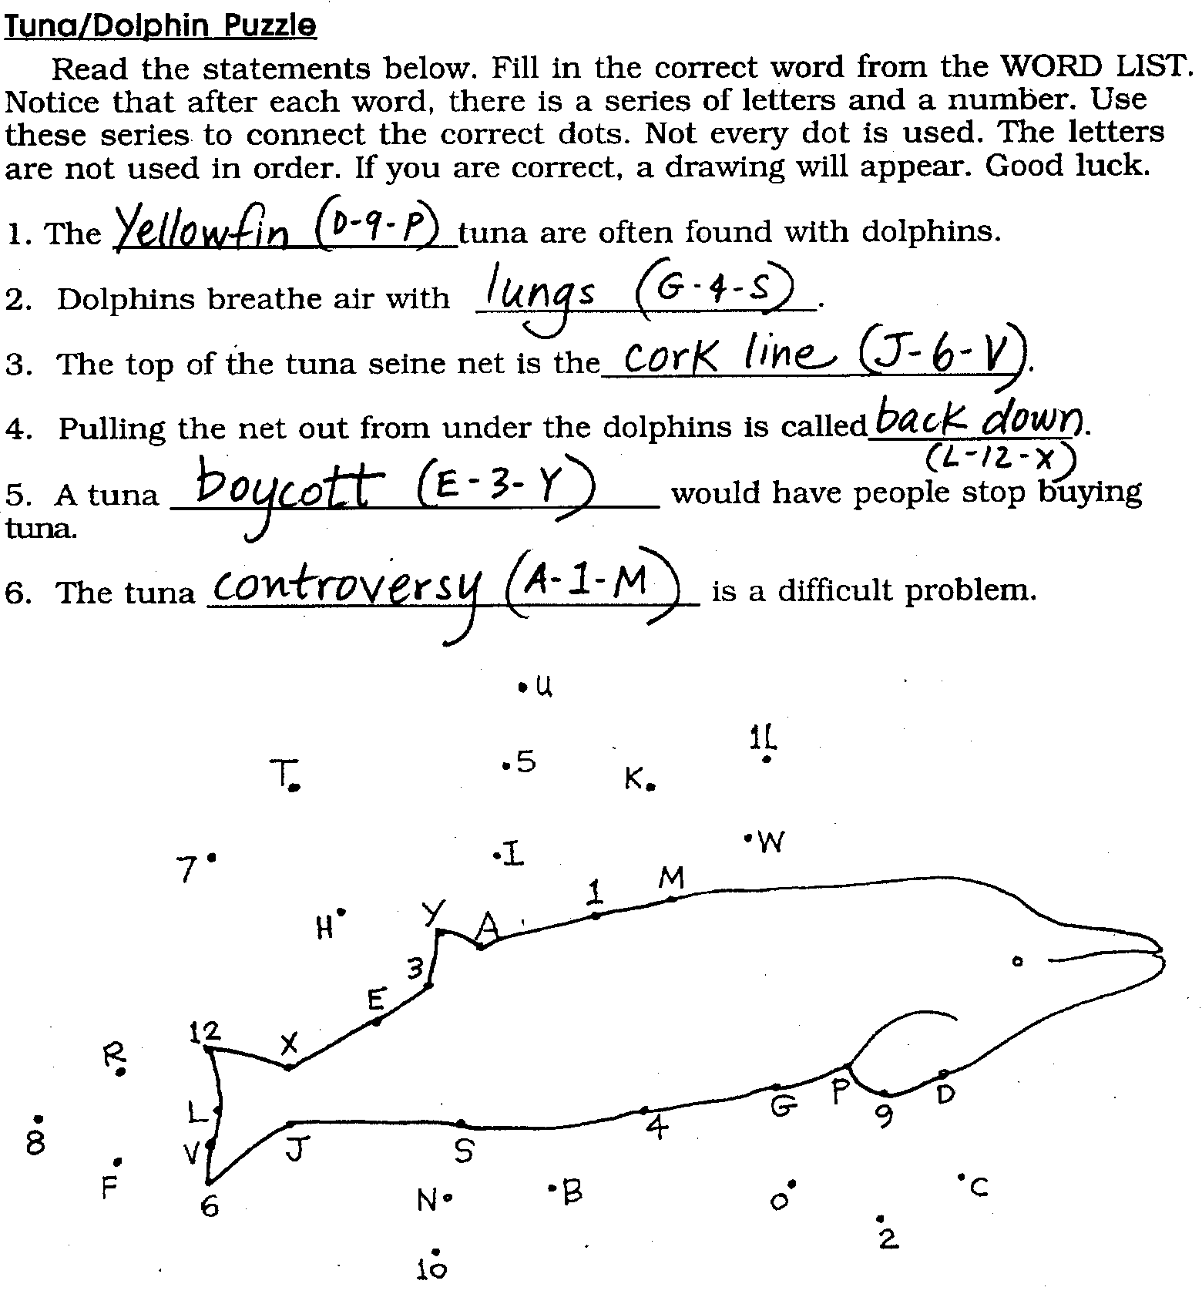

Marine Mammals: Resources For Teaching Materials and Research Questions

Write to these resources for free or inexpensive kits, posters, and other information about marine mammals. Save resources (trees for paper, money for copying and mailing) by ordering one of each and sharing them with other people.

--------------------------
American Cetacean Society
P.O. Box 2639
San Pedro, CA 90731

For recorded information: 310-548-6279
For membership, donations and sales: 310-548-7821
For a long range whale watching trip: 310-531-1430

Write for free materials. Ask for information about dolphins and sea lions. Send self addressed stamped envelope.

Ask them how you or your class can join the American Cetacean Society.

Also available for purchase, the American Cetacean Society (ACS) “Whale Fact Pack” that contains whale species sheets, subject sheets, how to draw a whale sheets, bibliography, and glossary.

---------------------------------
National Marine Mammal Laboratory
7600 Sand Point Way N.E., Bldg. 4
Seattle, Washington 98115-0070

Library 206-526-4013
Main # 206-526-4045

Ask for articles on specific animals and issues. If you can’t find articles noted in Teacher Background sections in your school or local libraries, request a photocopy of the articles from this library.

----------------------
Earth Island Institute
300 Broadway
San Francisco, CA 94133

To order free materials: 1-800 4-WHALES
For other information: 415-788-3666

This is who answers the phone when you call the number on the screen at the end of the movie “Free Willy”. They are very active in protecting marine mammals and will send a kit for letter writing, boycotting, information and a whale chart.

Ask for your free Personal Save the Whales Action Kit with letters, postcards, and petitions that you can send to help save whales. You will “Free Willy” (reprinted by permission of the American Cetacean Society). Also ask for a copy of their most recent newsletter.
---------------------------------------
---------------------------------------
The Humane Society of the United States
2100 L Street, NW
Washington, DC 20037

Ask for their Fact Sheet "Help Keep Whales and Dolphins Free" containing information about marine mammals and how to write to your representatives to protect the animals.

Also available is a Commercial Whaling Information Kit.

-----------------------
Oregon State University
M.O. Hatfield Marine Science Center
OSU Extension Service
2030 S. Marine Science Dr.
Newport, OR 97365-5296

503-867-0257

Ask for their standard marine mammal information sheets, especially those on dolphins and sea lions.

----------------
The Whale Museum
P.O. Box 945
Friday Harbor, WA 98250

206-378-4710
Whale Hotline: 1-800-562-8832 WA or 1-800-334-8832 BC to report whale sightings and strandings.

Ask about curriculum materials and educational tours. They produce the Gentle Giants of the Sea curriculum guide, and sell books, posters, and tapes. They give docent-led museum exhibit tours, provide classes for educators and offer whale watching tours led by docents from the museum.

----------
Greenpeace

206-632-4326

Ask for the education coordinator. Request materials for teaching about dolphins and sea lions.

------------
Center for Marine Conservation
Washington Habitat Conservation Program
2912 West Lynn St.
Seattle, WA 98199

206-283-2262

Publishes the Newsletter of the Habitat Program at the Center for Marine Conservation. Very involved with Washington Marine Sanctuaries and issues.
---------------------------------------

The Tuna/Dolphin Controversy
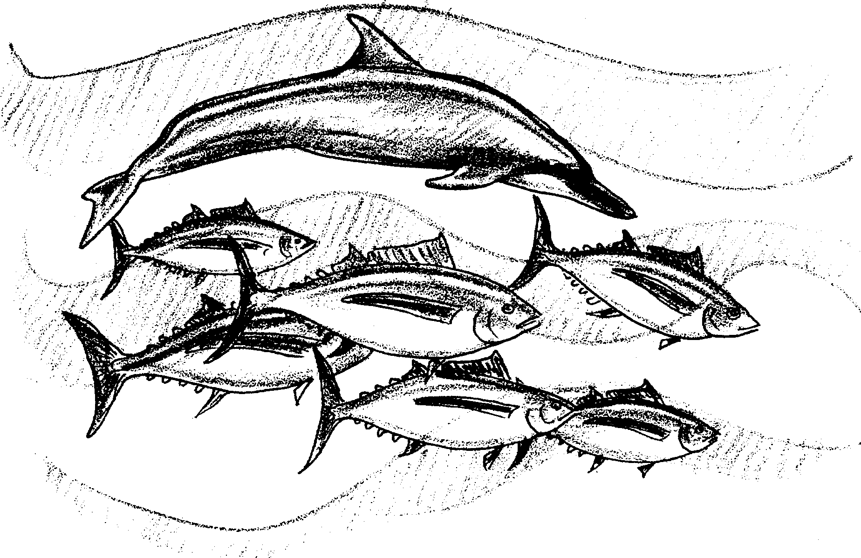

Why would anyone get upset about a tuna sandwich? Yellowfin tuna live in warm ocean waters. These tuna often swim beneath groups of dolphins. Fishers have known this for years. No one knows why this is so. About 1960, the tuna/dolphin controversy began.

1. Where are yellowfin tuna often found?

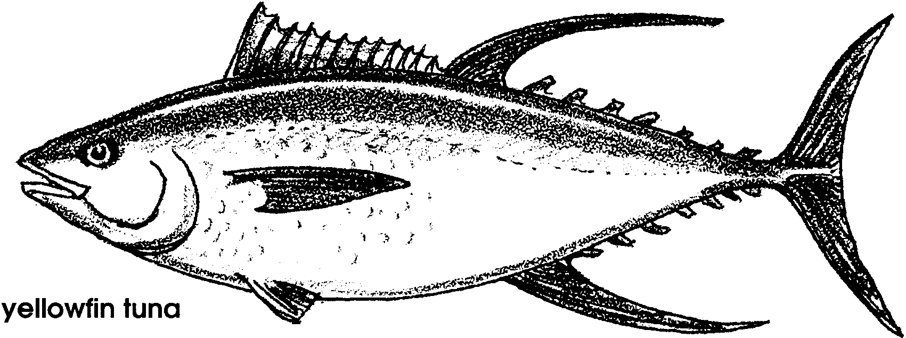
What happened in 1960? The American tuna industry developed a new way of fishing. The new method depends on the mysterious relationship between dolphins and tuna. This method is called “fishing on dolphin”. This is a story about the way it works.

Dolphins are mammals. Like you, they breathe air with lungs. They must come to the surface often to breathe. Their surfacing and jumping makes them easy to spot.
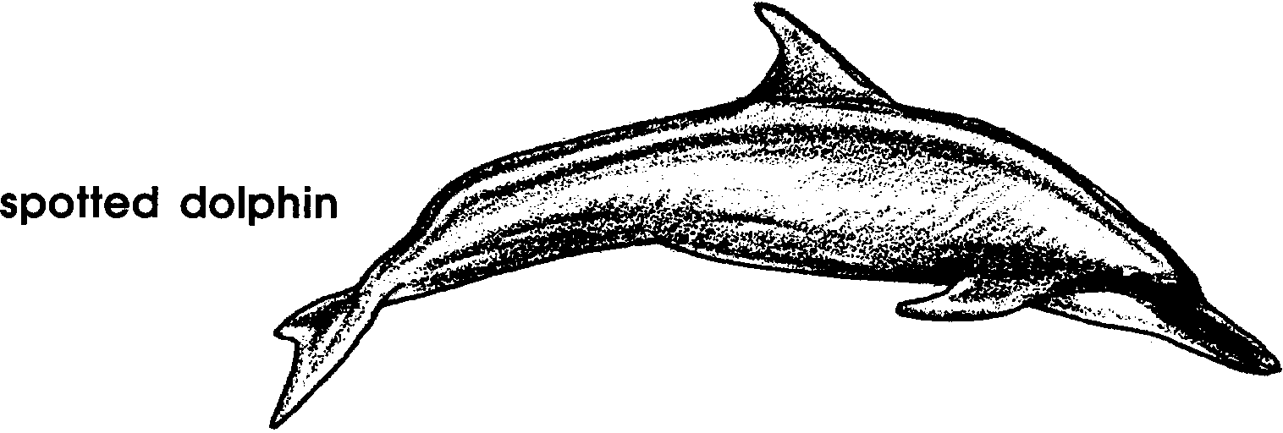
2. Why do dolphins surface so often?

Tuna fishers aboard the Joan P. spot a group of dolphins. The helicopter observer sees that tuna are with the dolphins. Speed boats are quickly lowered into the water. The motor noise panics the dolphins. They try to swim away. The speed boats encircle and “round up” the dolphins.

3. Draw a picture to show where you think the tuna go when the speed boats “round up” the dolphins.

For unknown reasons, the tuna stay close to the dolphins.
A small powerful boat called a “seine skiff” moves away from the Joan P. It is towing one end of a long net. The other end is fastened to the fishing boat. The net is towed around the dolphins and tuna.

The net is a mile long. It is 600 feet deep. How long is a mile? A mile is about as long as 12 city blocks. If you were to stand on top of a 60-story tall building and hold the top of the net, the bottom of it would reach the ground.
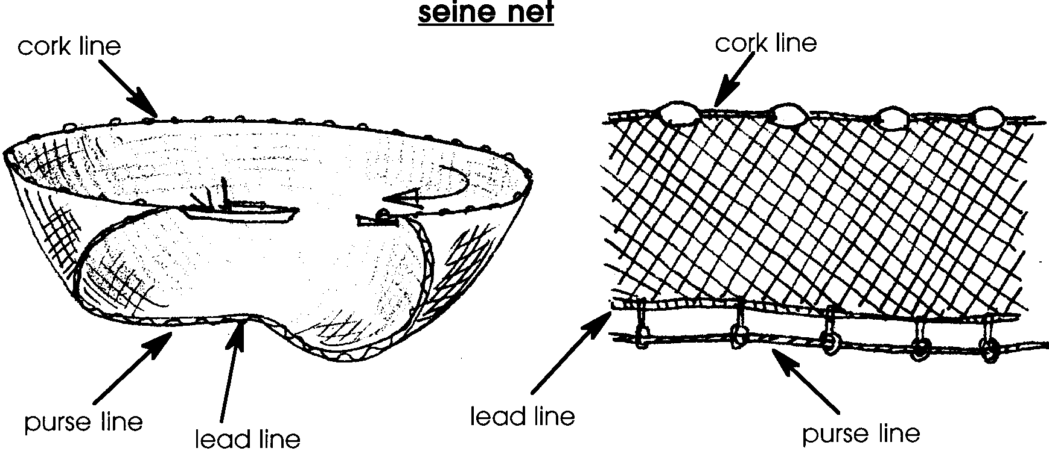
The two boats work together to complete the circle. The top of the net is kept in place by the cork line. The bottom is held down by the heavy lead line. The purse line is pulled in. It closes the bottom of the net the way a draw string closes a purse or bag. The tuna and the dolphins are caught.

4. The tuna / dolphins need to come to the surface often in order to breathe. (Please circle the correct answer)

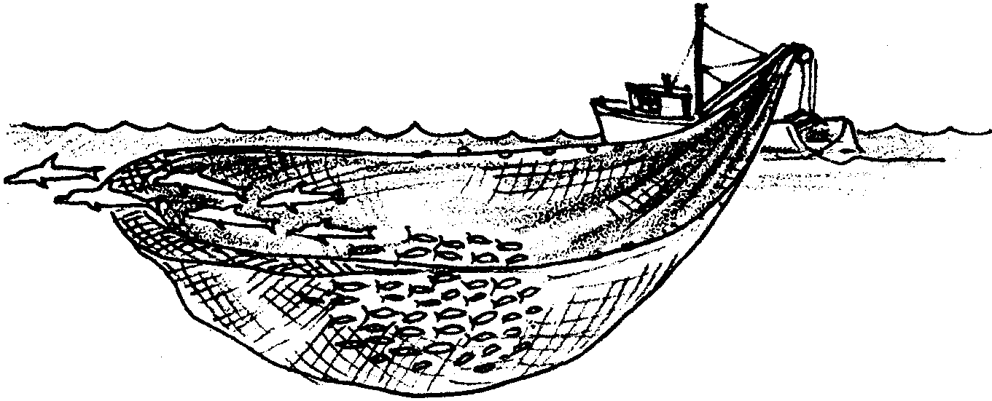
Most of the net is quickly pulled aboard. A small section is left in the water. The section contains the tuna and the dolphins. The tuna move to a deep pocket of water. The pocket is near the side of the ship. The dolphins stay near the edge of the net. This is the most important time for the survival of the dolphins.

The skipper of Joan P. begins to “back down”. The ship pulls the net out from under the dolphins. Most of the dolphins swim away.
5. Do you think it is in the tuna fishers’ best interest to safely release the dolphins? Why?

The rest of the net is hauled aboard the boat. The tuna and any remaining dolphins are caught. At any point in this fishing method, dolphins may be killed or injured. People disagree about whether it is all right to kill any dolphins while fishing. Such a disagreement is called a “controversy”. The tuna/dolphin controversy centers over whether dolphins may be killed in order to catch the yellowfin tuna.

6. How many dolphins do you think it is reasonable to kill in order to catch the tuna? Tell why you think this.

In the past 30 years, 6,000,000 dolphins have been killed by “fishing on dolphins”. Some people want to protect the dolphins. These people are called conservationists. Conservationists say sacrifice zero dolphins. They think it is not reasonable to kill any dolphins.

Not everyone feels the same way about dolphins. For one, the government of Japan classifies dolphins as “harmful marine mammals”. Some fishers treat the dolphins as such. And when the U.S. government passed laws to limit the dolphin kill, some tuna fishers left the country. In some other countries, they could fish as they pleased. Fishers from Mexico, Venezuela, and the European Community continued to kill dolphins as they fished.

Many people felt something needed to be done. One group of conservationists urged people to boycott yellowfin tuna. Boycott means “refuse to buy”. Yellowfin tuna is sold as “light meat” tuna. The boycott tried to get tuna fishers to change the way they fish. Many people stopped buying the tuna. Some tuna fishers had trouble selling the tuna they caught.

7. How might a boycott make fishers change?

The boycott worked. The three largest sellers of canned tuna stopped buying tuna that was caught with dolphins. All three sellers said the letters from the tuna-eating public caused them to change.

New tuna fishing methods are being developed to protect dolphins. Now 95% of all tuna are caught without harming dolphins. Other kinds of tuna, the Albacore, skipjack, and bonito, are caught on hooks. Sports fishermen catch the yellowfin tuna without a purse seine net.

Even so, about 3,000 dolphins are still killed each year. The Earth Island Institute is working to stop the practice of “dolphin fishing” for tuna. This seems like a good idea. After all, no one wants to kill dolphins.

But as with many complex issues, things may not always be what they seem. Marine Mammal Biologist, Doug DeMaster works at the National Marine Mammal Laboratory. He has spent over ten years working on this problem. He agrees that the number of dolphins killed in the past was unacceptable. But, he and other scientists believe that the 3,000 dolphins killed each year is acceptable.

8. What do you think might make Dr. DeMaster believe as he does?

How could someone who loves dolphins think such a thing? First, he sees the dolphin population is no longer decreasing. He also sees that the U.S. tuna fleet has decreased. Plus each boat is only allowed to kill a certain number of dolphins.

This all sounds good for dolphins. The move toward “dolphin safe” tuna has been successful. True enough, but this success comes with a real threat. The threat is to the ecosystem of which the dolphin is a part. Let’s see how.

Dr. DeMaster says there are three ways people catch tuna in warm Pacific Ocean waters. “Dolphin fishing” is the way we’ve been looking at. “School fishing” is a second way. In this, tuna are surrounded in a way which harms few dolphins. The third way to catch tuna is called “log fishing”. In this, the net surrounds all of the animals that gather near floating objects. Turtles, sharks, and other animals are caught along with the tuna.
9. a. Think about these three ways to fish for tuna? Which do you think is most harmful to dolphins? Please explain your choice.

b. Which do you think is most harmful to the overall life of the sea? Please explain your choice.

Each of these three ways of fishing kills animals other than tuna. The other animals killed are called “by-catch”. The by-catch for dolphin fishing is 100 pounds of animals each time the net is set. All 100 pounds are dolphin. The by-catch for school fishing is 5,000 pounds each set. For log fishing the by-catch is 20,000 pounds each set. These by-catches consist of shark, turtles, small tunas, etc.

10. Which fishing method is most harmful to the overall life of the sea?

This is why Dr. DeMaster is worried. He thinks a successful tuna boycott will increase “school” or “log” fishing. This could be a disaster for the life of the warm Pacific Ocean. The loss would be 50,000,000 to 200,000,000 pounds of marine animals each year. 3,000 dolphins per year would be saved.

11. Our actions have very real consequences. Sometimes the choices are hard. Do you think the trade of 50,000,000 to 200,000,000 pounds of other marine animals for 3,000 dolphins is a good one? Please explain your choice.

Our study of the oceans shows us that each animal and plant has a special role to play. We would do well to apply that knowledge to complex problems. From the tuna/dolphin controversy we can see simple solutions to complex problems sometimes become problems of their own.

12. What types of action could you take to let others know about this complex problem?

You can help solve this problem. In the next section, you will find some ways.

At least some of the dolphins are not waiting for people to solve the problem. These dolphins allow themselves to be “rounded up”. They are herded into an ideal position for capture. But as soon as the net is set out in the water things change. The dolphins scatter in all directions. They take the tuna with them.

The tuna/dolphin controversy is a difficult problem. Hopefully, fishers and conservationists will reach a good solution quickly. Whatever the final solution, both fishers and non-fishers need dolphins and tuna.

13. Create a new fishing method. It should protect the dolphins but still allow fishers to catch many yellowfin tuna. Write about and draw a picture of your new tuna fishing method. (Note: The fisher’s goal is to catch as many fish as possible and as quickly as possible. The fisher’s other goal is to protect the dolphin.)

Tuna/Dolphin Puzzle

Read the statements below. Fill in the correct word from the WORD LIST. Notice that after each word, there is a series of letters and a number. Use these series to connect the correct dots. Not every dot is used. The letters are not used in order. If you are correct, a drawing will appear. Good luck.

1. The tuna are often found with dolphins.

2. Dolphins breathe air with .

3. The top of the tuna seine net is the .

4. Pulling the net out from under the dolphins is called .

5. A tuna would have people stop buying tuna.

6. The tuna is a difficult problem.

