The Fish Are Running

Key Concepts
1. Finfish are important natural resources for food, income, and cultural traditions.

2. Some important finfish such as salmon, halibut, albacore, and “bottomfish” have interesting life histories and special habitat needs.
3. Pacific Rim nations contribute to supply and demand for fish resources and habitat.
4. International competition for Pacific Ocean fish resources leads to depletion of stock and a need for cooperation among fishing nations.

Background

The Exclusive Economic Zone, which extends 200 miles offshore from nations of the Pacific Rim, was enacted to solve political problems over territorial rights to saltwater and coastal resources. Who owns ocean fish and what they are entitled to do with those fish are important questions being debated globally.

There are billions and billions of commercially important bottomfish in the Bering Sea, the Gulf of Alaska and in other U.S. coastal waters. Historically, these stocks of fish were largely harvested by foreign fishers. Since 1976, when the U.S. Fisheries Management Act extended the U.S. fisheries management zone 200 miles off our shore, U.S. fishers have taken more interest in what could be a multi-billion dollar, year-round industry. But there is a catch to the Fisheries Management Act: we use the fish or we lose them.

The law taking over control of all fisheries within 200 miles off our coasts was designed to fill a gap until the nations of the world could agree on a Law of the Sea treaty that would cover the resources of all the oceans. But in the meantime, it gave American fishermen first chance at all the fisheries within the 200 mile zone. Until that time, except for a few international treaties, high seas fishing was a wide open affair. Fishermen could fish for anything they wanted and take as much as they pleased. The white fish stocks off some U.S. coasts were being harvested so heavily by foreign fleets that the total numbers of some species had dropped to dangerously low levels. The result was the development of the main goals of the Fisheries Management and Conservation Act of 1976 which were: (1) to bring foreign fishing under control and set management plans so the stocks could build back up, and (2) to give Americans a reasonable chance to develop the fisheries off their own coasts.

The law did not say that foreign fishers would have to stay out of the 200 mile zone. But it did say that foreign harvests would be limited to those fish that Americans are unable to catch. In other words, if we don’t take them, they may.

Setting up management plans, including quotas for foreign and domestic (U.S.) fishers, is the tricky task of regional councils, whose actions must be approved by the U.S. Secretary of Commerce. For example, in Alaska, this council is the North Pacific Fisheries Management Council.

Very simply, here is the formula used for setting those quotas:

OY - DAH = FAC

Translation: OY stands for Optimum (best) Yield (production). This figure is based on what scientists believe is the largest catch that can be taken while still keeping stocks at the same level or building back stocks that have fallen. Also considered are social, economic and ecological factors, including food needs.

minus(-)

DAH stands for Domestic (U.S.) Annual Harvest. An estimate of American fishing effort for each species, based on size of boats, amount of gear, price of fish, processing capacity, etc.

equals(=)

FAC stands for Foreign Allowable Catch. This is the total amount left over, which is granted to foreign fishermen (who must get a permit and pay a fee).

In addition to regulations governing who may fish and how much they may catch, fishers face other challenges. Fishing gear is often not very selective. This means that fishers intent on catching salmon or halibut, often catch other species of fish. The other species of fish are referred to as “incidental catch” and were historically returned to the sea. Unfortunately, trawl nets and similar fishing gear tend to kill or severely injure the fish caught. As a result, most of the incidental catch returned to the sea was dead. There is a great deal of concern that the death of millions of tons of fish labeled “incidental catch” is having a serious impact on the ecology of the oceans. Some say the answer is to utilize the “incidental catch” as food and reduce the overall catch to lessen the impact on ocean fish species. Others say that we must develop gear and fishing techniques that are specific to a certain “target” fish. Some say we must stop all ocean fishing to let the oceans recover. The solutions adopted will probably combine elements of these and other proposals and will likely have far-reaching consequences.

Materials

For the class:

• 1 Map of the Pacific Ocean and the north Pacific Rim nations

• chart paper or butcher paper

For each student or small group of students:

• “The Pacific Rim” student activity pages

• colored ribbons or flags

• “flags” of Pacific Rim nations made on index cards

• masking tape to attach the flags to “fishing vessels” i.e., players

• signs indicating important coastal regions, rivers, and nations of the north Pacific Rim

• data table for recording catch data

Teaching Hints

“Fish Are Running” is a kinesthetic simulation game in which students practice fishing the open seas for “target fish” and “incidental catches”. They are faced with international problems to solve based on their experiences in the simulation. The game also helps students to locate and identify nations and geographic locations of the Pacific Rim.

“Fish Are Running” provides the culminating activities for the preceding two activities, “Ocean Address” and “The Fishing Business”. Background information about the fish, their value, and how they are harvested is found in these preceding activities.

By way of preparation, have students help make a display with maps, pictures, and artifacts of the geography and cultures of the north Pacific Rim, especially: the U.S. (including Hawaii), Canada, Russia, Japan, China, and Korea. You might place the map in the center of a bulletin board with the pictures around the map in respective locations. Colored yarn can be used to match locations with illustrations.

Part I - “The Pacific Rim” Map Reading

“The Pacific Rim” is an introductory map exercise designed to highlight the Pacific Ocean countries which students will role play in the simulation game in Part II. The activity benefits from the aforementioned bulletin board display. If your students are familiar with the geography of the region, you may wish to omit this part of the activity.

Part II - Simulation Game

Procedure
1. Set up the playing area. You will need a large area such as a gym or outdoor play field. The center is the “ocean”. Determine compass directions (N,S,E,W) and indicate them to students. Around the edges of the “ocean”, put signs in the appropriate geographic locations for Pacific Rim nations (in this case, Mexico, United States, Canada, Russia, Japan, Korea, and China). Then place signs on gym walls or walk with students to point out the locations of some very important fish habitat areas such as estuaries and rivers: the Amur of Russia, Yukon, Fraser, Columbia, Sacramento, Yangtze. Also locate Puget Sound (WA), Gulf of Alaska, Bering Sea, Okhotsk Sea, Sea of Japan, and the China Sea.

2. Remind students about the importance of fish in the Pacific Ocean to people of the Pacific Rim. Stress the fish resource value for food, income, and cultural traditions. Tell them that all the nations view the fish as valuable resources and want to be able to catch fish.

3. Assign roles to your students:

Fishers - at least one from each nation, wearing his/her national “flag” attached to each “fishing vessel” (student)

“Target” Fish - select one or two species to target, attach the same color ribbon to all species of target fish

“Incidental Catch” Fish - other species that might be caught unintentionally with the target fish, attach the same color ribbon to all incidental fish, but a ribbon of a different color than that for the target fish

Observers - scientists and national representatives who will observe and record catch data for each round.

4. Play begins with all fish swimming in “the ocean”. They can be anywhere. They might be near shore, especially near important habitat you have pointed out, or far out in the ocean.

Ask students why fish might be found at different locations and at what stage of their life cycle they might be in.

Fishers enter the ocean from their respective national locations on the Pacific Rim. They are to tag as many target fish as they can before the round is up. When they tag a fish, they must escort their “catch” (tagged fish) to their “nation’s” sign where the “catch” waits for the end of the round.

Fishers may also tag “Incidental Catch” fish. Those fish are also escorted to the nation’s sign.

Start round one with unlimited time. When all the target fish have been caught the round ends. Some incidental catch fish may be left swimming.

5. At the end of each round, observers collect and record catch data. Post the data on a chart where everyone can see it. Collect this data, record it, and add totals for each column:

• name of observer

• number of this round

• name of each country

• number of fishing vessels (assume they are all the same size)

• number and market value of target fish caught (Award market value points for fish catches. For example, each target fish might be worth 10 points while each incidental fish is worth 2 points.)

• number and market value of incidental fish caught

• number of target and incidental fish not caught by any nation (those fish still swimming in the ocean at the end of a round)

The nation with the most points wins that round.

6. Continue repeating rounds and recording data. After three rounds analyze your data. Ask questions such as:

Which nation has the most points overall?

What strategy did that nation use to catch fish?

Where were fish hardest to catch?

Could a nation who succeeded in catching few target fish but lots of incidental fish might earn enough points to win the round? How?

How could the price of fish influence fishers to target different species?

How could incidental fish having a market value make them secondary targets?

7. Play the game again, but with this variation. Have the “fish” remove their colored ribbons and put them in their pockets. This arrangement more closely models the real ocean where fishers cannot “see” the fish before they catch them. After three rounds ask questions such as:

Which nation has the most points overall?

Did that nation use a different strategy this time to catch fish?

How did not being able to see the type of fish you were catching change the way you fished?

Do you think that not knowing the type of fish would increase or decrease the incidental catch? Why?

Compare your results from the first three rounds with those from these three. On which set did you have a greater incidental catch?

8. Add some other variations (see suggestions below), play some more rounds and analyze your data again. Continue to make more adjustments and variations to keep the game stimulating and to point out difficulties in trying to regulate ocean fisheries and share scarce resources. You can make the regulations yourself or choose a “committee” of students to do so. How to choose the committee? Perhaps have representatives from each nation or only the richest or most politically powerful nations (the debate over how to choose the committee will parallel similar debates on-going in the United Nations).

Suggestions for variations in rounds:

• Adjust time limit (“fishing season opening”) to catch fish.

• Make and adjust quotas.

• Change the target fish species.

• Change the market values for different fish species.

• Play with only the fish that were not caught in the last round.

• Make it illegal to have incidental catch of certain species and “fine” fishing vessels a point value for each illegal catch

• Create and play rounds using the concept of the Exclusive Economic Zone. Decide if you will have national fishers fishing within their EEZ while others fish outside it.

• Limit the location for fish.

• Allow changes in the number of fishing vessels in each nation’s fishing fleet. A nation might exchange market points for a fishing vessel.

• Limit the number of fishing vessels a nation may have. (Can the nation register its vessel under a foreign flag?)

• Assign certain fish to certain habitats and coastal areas. Limit the range for those fish.

• Create a safety zone for the fish, a marine sanctuary.

9. Continue to analyze data and make adjustments. Talk with students about how the adjustments in fish populations, limits, regulations, and market value, may effect the resource. Ask students to set goals for the rounds and for maintaining the resource. Do all nations have to have the same goals? Does it have to be “fair” and “equal”? Explore some possibilities. Talk about how nations feel and about reasons for cooperation among nations.

Key Words

“catch” data - information about number, size, species, gender, etc. of the fish caught

cultural traditions - customs and habits of a people or nation

estuary - a place where fresh water meets salt water

Exclusive Economic Zone - a fisheries management area that reaches up to 200 miles off the U.S. coast

fisher - a person who fishes for sport or commerce

geographic locations - designated places on the Earth’s surface

“incidental catch” - fish caught with the targeted species

market value - the worth of an item for sale

observers - in this case, those watching and recording the results of the fishing activities

Pacific Rim nations - countries located around the Pacific Ocean

quota - allowed amount, allowance

resources - in this case, property that can be converted into money

“target” fish - the species of fish the fisher intends to catch

Extensions

1. Tell, read, and dramatize folktales about people and fish resources of the Pacific Rim.

2. Research and make projects about how each Pacific Rim culture uses and values fish resources.
3. Find seafood recipes from Pacific Rim cultures. Prepare and taste the dishes. Publish them in a class cookbook.

4. Make mobiles showing cultures and nations of the Pacific Rim. You might use cut out shapes of people, national boundaries, fishing vessels, national flags.

5. Locate and share the map of Pacific salmon ranges in the north Pacific Ocean (Pacific Rim) found in an article about the phenomenally large return of the fish to Pacific Rim rivers in 1989. See National Geographic, Vol. 178, No. 1, July, 1990.

6. Further explore the exclusive economic zone in “Oceanus”, Vol. 27, No. 4, Winter 1984/85.

Answer Key

Part I - The Pacific Rim
1. Three countries on the eastern shore of the Pacific Ocean shown on the map are: Mexico, United States, and Canada. The trick here is for students to recognize that we are on the eastern shore of the Pacific Ocean, even though the Pacific is our western ocean.

2. Russia, China, and Japan should be circled on student maps.

Challenge: Russia, China and Japan catch about 33 million tons of fish each year. This problem is included to help stretch math skills.

3. a. People in Japan eat the greatest amount of fish.

b. A person in Hong Kong eats about two or three times (actually, two and a half times) as much fish as a person in the United States. The question is designed to help students estimate from data presented on a bar graph.

4. Countries, rivers, and seas should be colored on student maps.

5. Answers will vary depending upon student preferences. The question is included as a bridge to the Part II, the simulation activity.

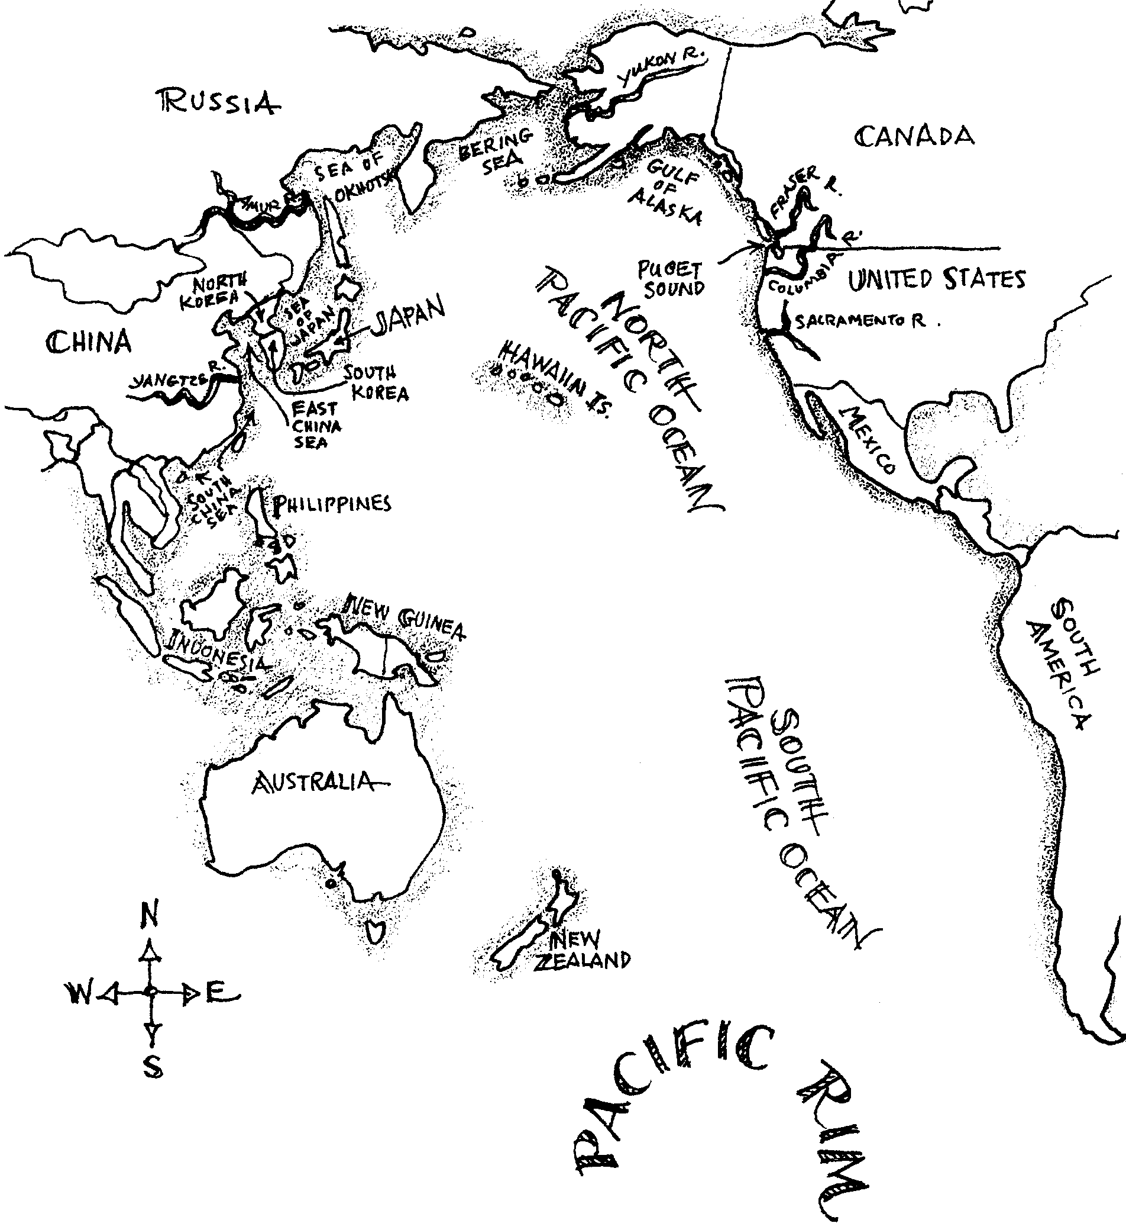
The Fish Are Running

Part I — The Pacific Rim
People of many different nations live along the shores of the Pacific Ocean. For thousands of years, these peoples have caught and eaten fish. As the number of people grows, competition for these fish also grows. Let’s look at some of the nations that ring the Pacific. These nations are called Pacific Rim nations.

Look at the map of the Pacific Rim nations.
1. What are three countries on the eastern shore of the Pacific Ocean?
(Hint: Having trouble finding east? Look at the compass points in the corner of the map.)

The top three fishing nations are on the Pacific Rim. They are Russia, China, and Japan.

2. Circle Russia, China, and Japan on your map.

Together, these three countries catch about one third of all the fish. This means that they catch one out of every three pounds of fish caught.

Challenge: The total annual catch is about 100 million tons of fish. How many tons of fish do these three countries catch in year?
(Hint: If the annual catch was three million tons, how many would be caught by the three countries? How many three million tons are there in 100 million tons?)

3. People in different Pacific Rim countries eat different amounts of fish. The following graph shows some of the countries.
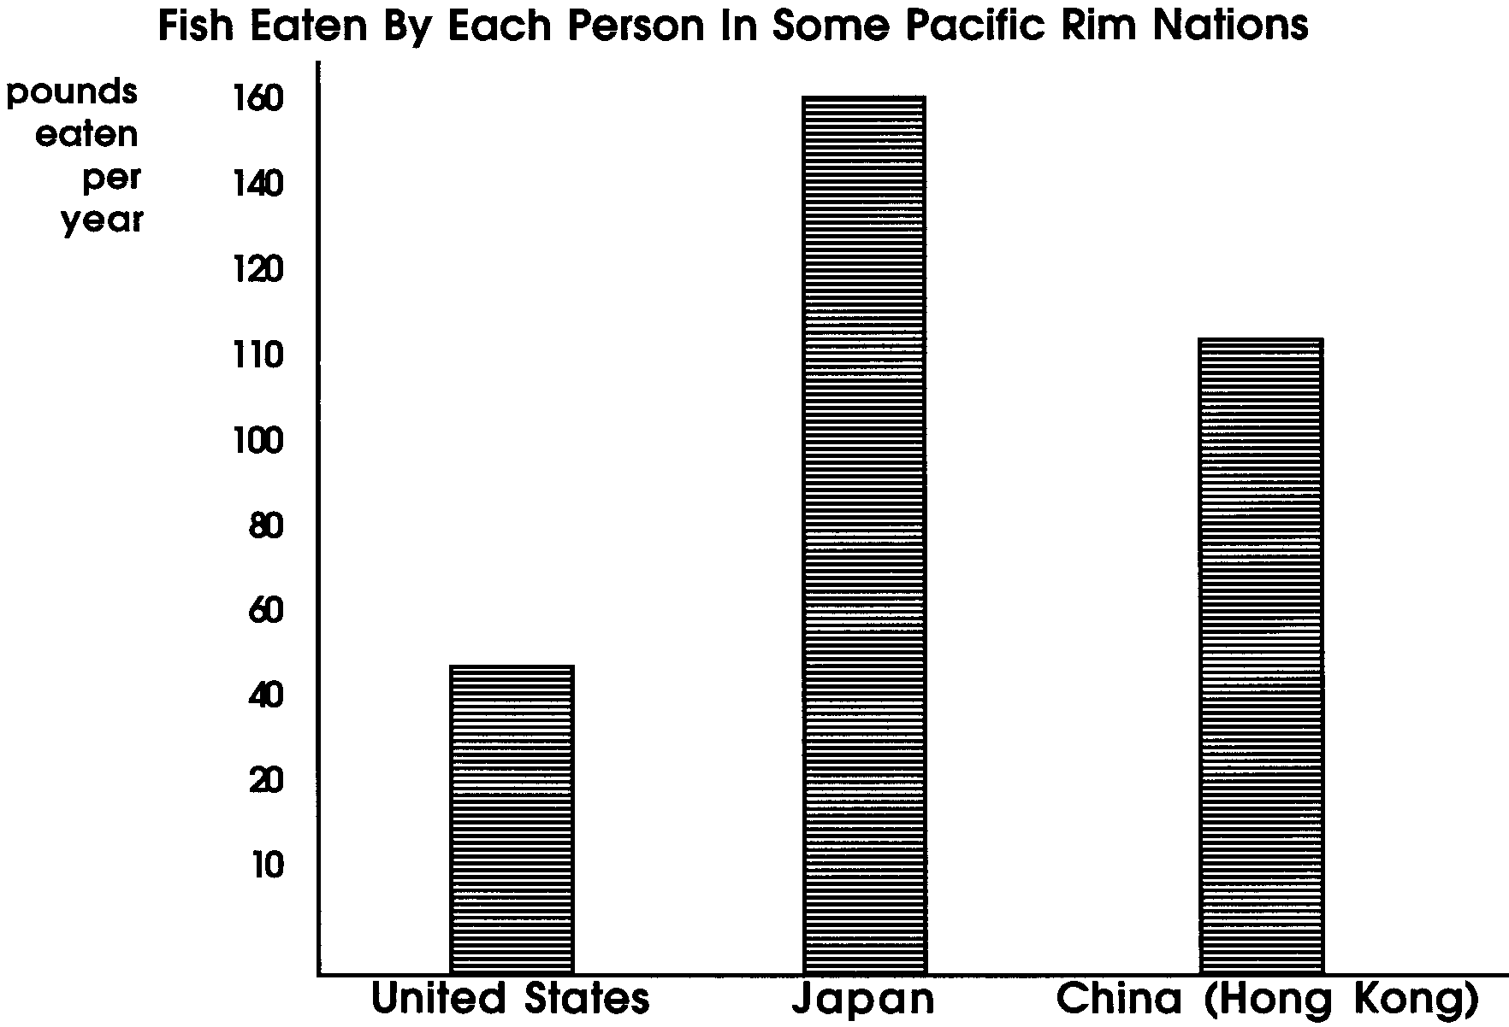

a. People in which country eat the greatest amount of fish?

b. Look at the length of the bars on the graph. About how many times more fish does a person in Hong Kong eat than a person in the United States? (Hint: About how much longer is the bar for China than for the United States?)

4. Color these countries:
Mexico
United States
Canada
Japan
Russia
Korea
China

Color these rivers and seas blue:
Amur, Russia
Yukon, Alaska
Frazier, British Columbia
Columbia, Washington State/Oregon
Sacramento, California
Yangtze, China
Puget Sound, Washington State
Gulf of Alaska
Bering Sea
Okhotsk Sea, Japan/Russia
Sea of Japan
China Sea

5. Think about the countries of the Pacific Rim. In the next activity, you may get to role play one of the countries. Which would you choose to be?

