The Fishing Business

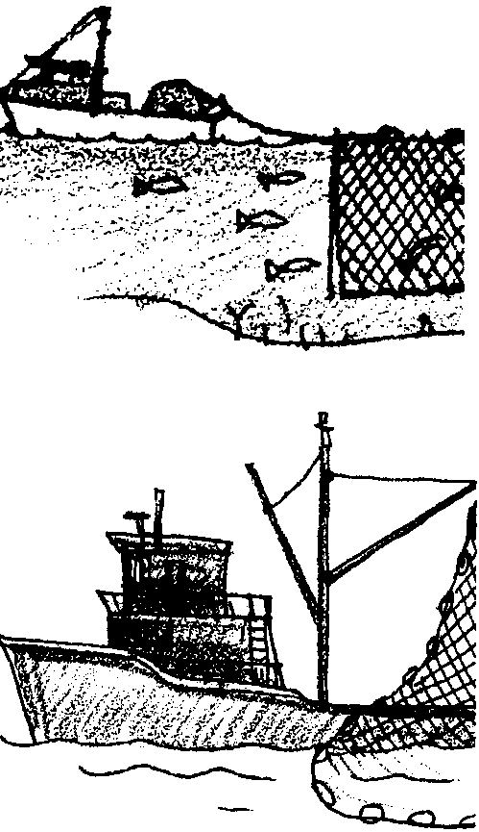
Key Concepts
1. Finfish are important natural resources for food, income, and cultural traditions.
2. Humans use a variety of techniques for harvesting food from the ocean and coastal waters.
3. The harvesting of food from coastal waters can impact marine habitats.
4. International competition for Pacific Ocean fish resources leads to depletion of stock and a need for cooperation among fishing nations.

Background

Throughout the countries of the Pacific Rim, commercial fishing for many different kinds of fish employs many workers. From single hooks and lines to giant trawl nets hundreds of feet in length, a wide variety of methods are used by these commercial fishers to catch fish. In the Pacific Ocean, people of these different nations fish, seeking the same finite supply of fish. The population of people on the Pacific Rim has increased. The populations of important food fish have decreased. Many people wonder if we are catching too many fish.

Fishing gear is often not very selective. This means that fishers intent on catching salmon or halibut, often catch other species of fish. The other species of fish are referred to as “incidental catch” and were historically returned to the sea. Unfortunately, trawl nets and similar fishing gear tend to kill or severely injure the fish caught. As a result, most of the incidental catch returned to the sea was dead. There is a great deal of concern that the death of millions of tons of fish labeled “incidental catch” is having a serious impact on the ecology of the oceans. Some say the answer is to utilize the “incidental catch” as food and reduce the overall catch to lessen the impact on ocean fish species. Others say that we must develop gear and fishing techniques that are specific to a certain “target” fish. Some say we must stop all ocean fishing to let the oceans recover. The solutions adopted will probably combine elements of these and other proposals and will likely have far-reaching consequences.

Materials

For the class:

• 1 Map of the Pacific Ocean and the north Pacific Rim nations

For each student or small group of students:

• “The Fishing Business” activity pages

Teaching Hints

“The Fishing Business” introduces students to how fish are commercially caught through an examination of several different fishing methods. This activity builds on the information provided in the preceding activity, “Ocean Address”, and sets the stage for the simulation game found in the following activity, “Fish Are Running”. The text in this section provides descriptions of how people make a living fishing. The questions provide material for discussions of how fishing can impact the fish populations. Use the text and questions as point and counterpoint for your discussions.

The previous activities entitled, “Long Wet Journey”,“Hooks and Ladders”, and “Investigating a Declining Resource” provide additional background regarding salmon.

“The Fishing Business” is somewhat lengthy and may best be utilized by dividing the material over several sessions. Consider dividing the material by method of capture: net (Introduction, Purse Seine Fishing, Gill Net Fishing), hook and line (Troll Fishing, Skate Line Fishing), bottomfishing (Bottomfishing), and marketing (Marketing and Distribution). There are, of course, other ways in which the text may be divided. The exact divisions will depend upon your time and class. Review the section in order to select the teaching strategy best suited to your particular group.

Duplicate the pages of the text and the activity as needed for your students.

Key Words

bottom dragger - another name for a trawler fishing vessel

bottom fish - any of a group of fishes found at or near the bottom of the sea consisting of certain cod and their relatives and the flatfishes; also called ground fish

buoy - a distinctively marked and shaped float

fathom - a unit of measurement equivalent to six feet

Fish Protein Concentrate (FPC) - a tasteless and odorless high protein food additive made from ground fish, usually used as animal food although it is suitable for human consumption

gill net - a curtain-like net, suspended vertically in the water. with meshes of such a size as to catch by the gills a fish that has thrust its head through

migrate - periodic movement from one region or climate to another

otter trawl - a bag-like fishing net whose lateral spread during trawling is maintained by otter doors which work like a kite, sailing through the water

population - in this case, all of the individuals of one species in a given area

processor - in this case, the boat or factory which receives fish from fishers and prepares it for market

purse seine - a large net, drawn by two boats around a school of fish, and then closed at the bottom by means of a line passing through rings attached along the lower edge of the net

skate line - a long fishing line, secured by buoys, deployed on the sea bottom and containing multiple hooks

species - a classification or group of plants or animals composed of related individuals that resemble each other, are able to breed among themselves, but are not able to breed with members of another species

stern - the rear or after part of a vessel

trawler - any of various types of vessels used in fishing with a trawl net

troller - any of various types of vessels which fish by slowly towing trailing lines and hooks

Answer Key

l. Your students may suggest a variety of explanations including: overfishing, increases in human activities on streams (dams, houses, roads), and pollution. All of their ideas are worthy of discussion and probably contribute to the answer to a really complex problem.

2. a. The Chinook salmon is the largest. For this reason, it is also called the King and the Tyee which means: head, chief, leader.

b. The Pink salmon is the smallest.

c. The Chinook salmon may stay in the ocean the longest. In fact some have been known to stay in the ocean for 8 years.

d.The Coho, Chum, Cherry, and Steelhead salmon are about the same in weight and length. The Sockeye is about the same length, but weighs less.
3. Seine operators are not always able to restrict their catch to a single species. Most of the time other (“incidental”) fish are taken. Fishers try to make their sets in areas rich in the fish they are seeking. They assess the areas with electronic equipment, listen to other fishers, and use their past experience as a guide in making their sets. This question is included to get your students thinking about the fate of these unintended captures.

4. Different fishers handle the problem of fewer fishing days in different ways. Some sell their fish to a buyer to maximize their days on the fishing grounds. Others sell their fish to a cannery to maximize their return per pound of fish caught. Like your students, each fisher makes a reasoned judgement and acts accordingly.

5. The department should require nets to have holes greater than 5" across.

6. Gillnetters fish at night because the net is harder for fish to see increasing the likelihood that fish will run into the net.

7. a. George’s net will go on “ghost fishing” if the anchor is lost. Fish will continue to get caught, die and become bait, eat the bait, and get caught, until the cycle is broken when the net disintegrates. The nets also present an entanglement hazard, capturing birds, mammals, and other organisms. New nets have panels that rot after prolonged time in the water to reduce ghost fishing.

b. George might expect to see a decrease in the number of fish he catches since his net is in competition with the ghost fishing net.

8. Answers will vary depending upon student experience and knowledge. Some may say the answer is to utilize the “incidental catch” as food and reduce the overall catch to lessen the impact on ocean fish species. Others may say that we must develop gear and fishing techniques that are specific to a certain “target” fish. Some may say we must stop all ocean fishing to let the oceans recover. The solutions adopted by Pacific Rim nations will probably combine elements of these and other proposals.

9. Troll caught salmon command higher prices because they are physically more attractive (fewer bruises and lost scales) and because they are generally handled less and placed on ice more quickly than fish caught in other fashions. Troll caught fish are usually sold whole and fresh or frozen in markets where appearance matters and is paid for.

10. This question calls for an opinion. Entertain reasonable positions regarding which fishing method is least harmful to other species. While all have their problems, troll fishing could claim to have less impact on other species since troll fishers can use lures that are targeted toward salmon.

11. Answers will vary depending upon student experience and knowledge. Things to take will include items for: work (nets, hooks, lines, etc.), survival (food, water, etc.), safety (life preservers, flares, etc.), and pleasure (books, VCR, etc.)

12. More and more salmon boats also fish for tuna in large part because of the shortening salmon season. The boats are expensive and do not make any return when not fishing. Some fishers need to fish more than one fishery in order to make a living wage. The fact that this is so is used as evidence that the fish stocks are declining and/or there are too many fishing boats chasing the resource. This question is included to further discussion on striking a balance between fishing and fish survival.

13. Dolphin-loving tuna eaters could satisfy their craving by eating albacore tuna caught on hooks, not in nets.

14. Halibut eggs develop as plankton, floating in the water.

15. a. The Mary Catherine carries 90,000 feet (i.e., 1,800'/skate line x 50 skate lines) of skate line.

b. The Mary Catherine carries 17 miles (i.e., 90,000 ' x 1 mile/5,280') of skate line.

c. There are 90 hooks (i.e., 1,800'/skate line x 1 hook/20') per skate line.

d. All together, there are 4,500 hooks (i.e., 90 hooks/skate line x 50 skate lines).

e. The Mary Catherine will catch 900 fish (i.e., 4,500 hooks x 1 fish/5 hooks).

16. The observation that the size of halibut being caught is decreasing may mean that younger fish are being taken. If these fish are taken before they can reproduce serious damage can occur. The stock is being depleted and over-fishing could be indicated.

17. Fisher Barbara is going fishing for sole. She should set her net in the bottom third of the ocean. (The correct answer is underlined).

18. Three parts which help keep the net open include: otter doors, cork line, cork floats, lead line, and wings.

19. a.-b. The picture below shows a correctly labeled trawler.
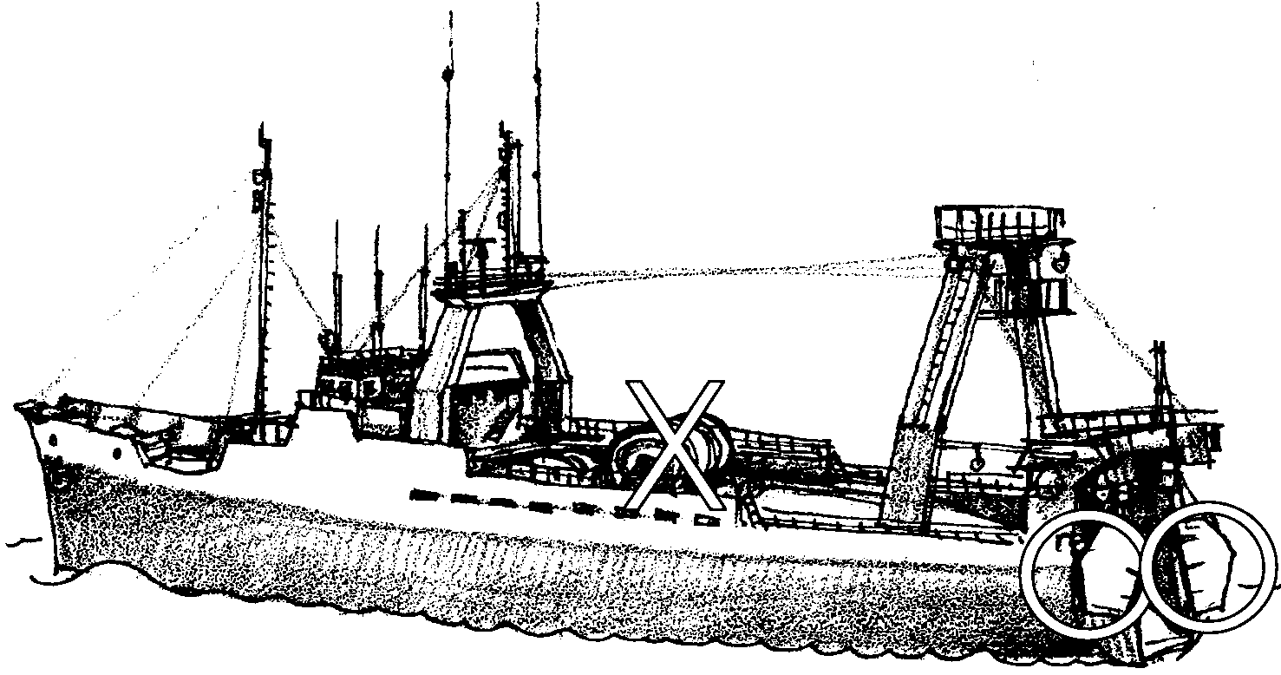
20. Draggers work in water from 10 to 500 fathoms deep. A fathom equals six feet. How deep is the water in feet? Sixty to 3,00O feet deep. (The correct answers are underlined.) The work should look something like the following:

10 fathoms x 6 feet/fathom = 60 feet and,
500 fathoms x 6 feet/fathom = 3,000 feet.

21. Fish smaller than 5" around may escape 5" net mesh. The object of this question is to start a discussion on the effects of different net mesh sizes on the catch. Smaller mesh nets catch more small fish with possible adverse effects on the fish populations. The regulation of net mesh sizes is an important fisheries management tool.

22. The lead line drags along the bottom and stirs up the fish. The fish rise to escape and are captured.

23. A good trawl can bring up 30 tons of bottom fish as noted in the text above this question. Thirty tons is 60,000 pounds of fish, that’s a lot of fish in a single set! This question requires your students to locate the information in the text and then multiply 30 tons of fish/good trawl x 2,000 pounds per ton to give 60,000 pounds of fish/good trawl.

24. Many students will have eaten salmon.

25. Most salmon flesh is pink. However, some salmon flesh is white and some almost red.

26. From the text, your students should be able to determine at this point that trawl fish are marketed as fresh “white fish” and as frozen fish patties.

27. This question can start your students on a detective hunt that can involve the school cafeteria staff and others. You may be surprised how helpful people want to be.

28. FPC is fish protein concentrate, fish meal made from processed bottom fish and used primarily for farm feed in this country.

29. Plastics, paints, and cosmetics are made from fish oils.

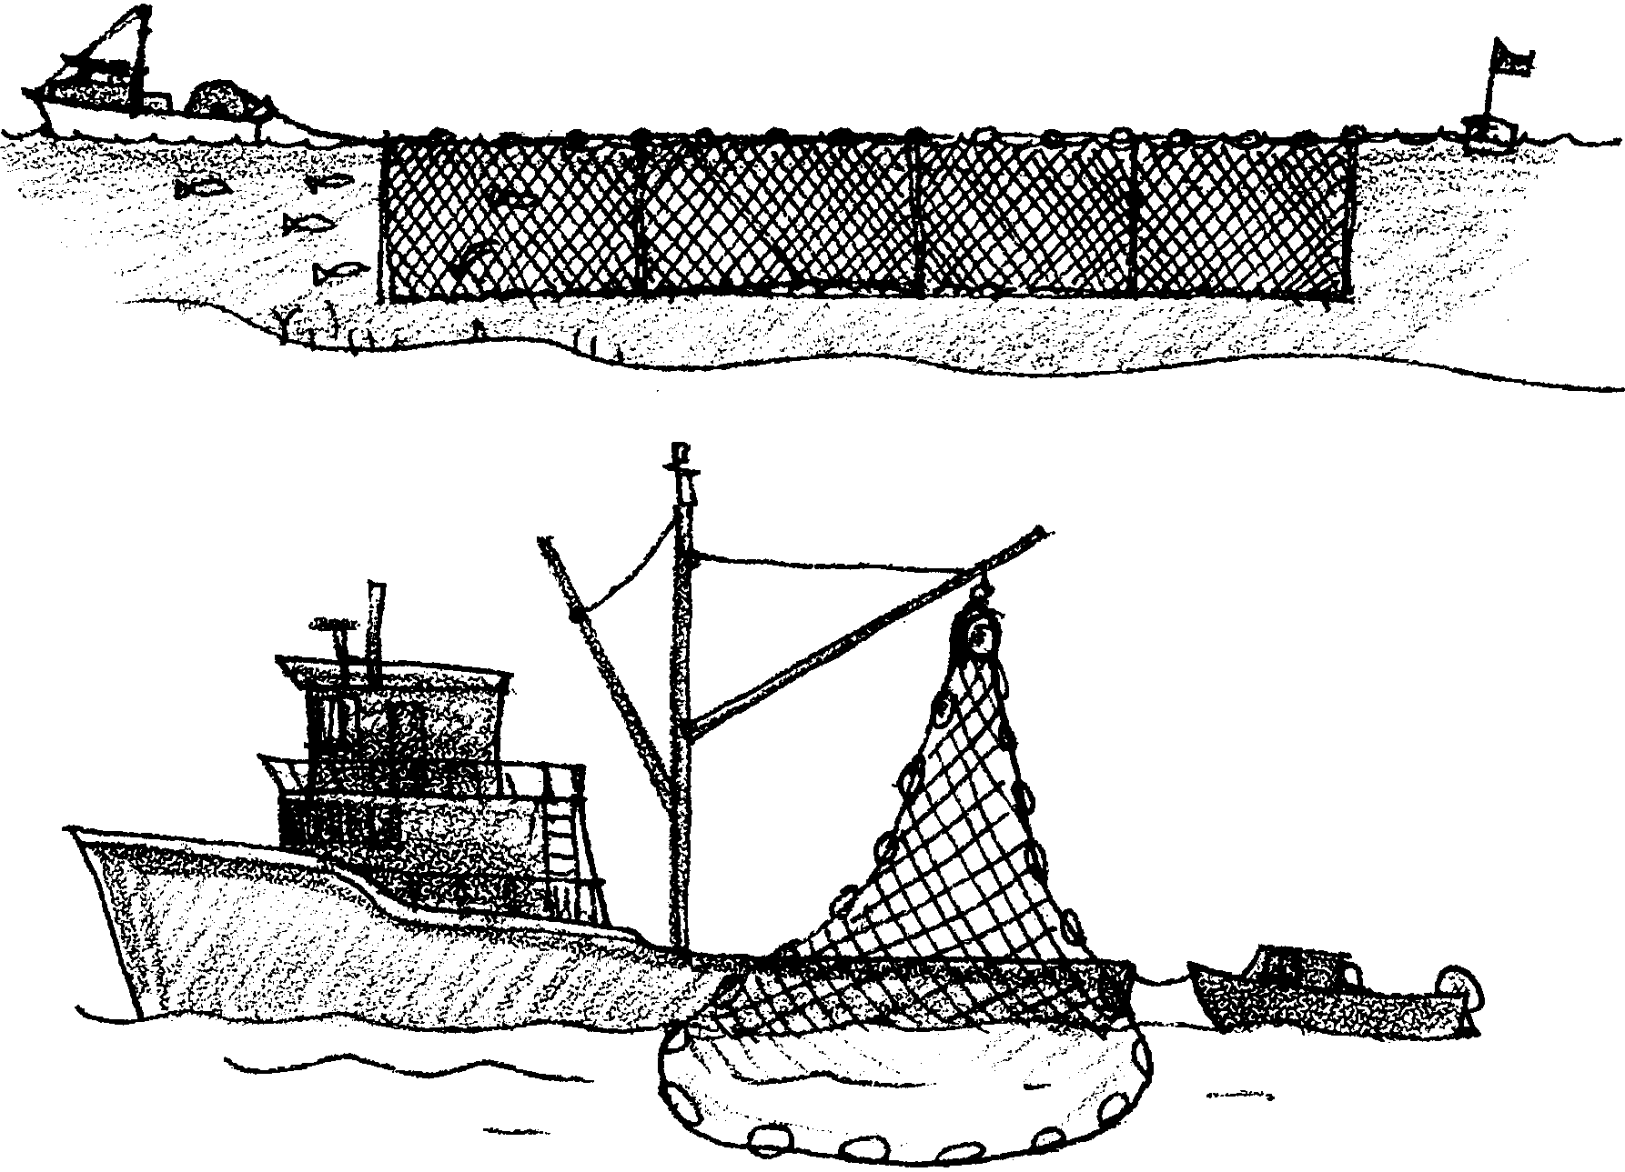
The Fishing Business

Many different kinds of fish live in the Pacific Ocean. These fish provide food for many people of the Pacific Rim. The Pacific Rim is all the land at the edge of the Pacific Ocean. Many countries are on the Pacific Rim. In all of these countries, commercial fishing is big business. Many different kinds of fish are caught. Many different methods are used to catch these fish. In the north Pacific, salmon, albacore, tuna, halibut, and “bottomfish” are important fish. These four kinds of fish provide a living for many fishers and packers. Let’s find out about fish and people of the Pacific.

For thousands of years, people of the Pacific Rim have used salmon for food. The native people of the U.S., Canada, Russia, and Japan fished for salmon in several ways. Some groups used bone and wood hooks. Others used fish traps. A fence was placed in salmon streams. The fence directed the fish into traps. Still other groups used woven nets to scoop the salmon from the streams. The old methods are no longer used by commercial fishers.

l. What might have caused the salmon population to decrease?

Today, salmon are one of the most sought after fish. In the Pacific Ocean, people of different nations fish for the salmon. The population of people on the Pacific Rim has increased. The populations of salmon and other important fish have decreased. Many people wonder if we are catching too many salmon.

Seven species (kinds) of salmon live in the Pacific Ocean. They grow to different sizes and spend different amounts of time in the ocean. They are the Chinook (King), Coho (Silver), Sockeye (Red), Chum (Dog), Pink (Humpback), Cherry, and Steelhead. The Cherry salmon lives in the western Pacific near Japan and Russia.

Salmon Statistics
Species average weight (lbs.) average length (inches) years in ocean
Chinook 22 36 1 to 8
Coho 10 24 3
Sockeye 6 5 1 to 2
Chum 9 5 3 to 5
Pink 4 20 1.5
Cherry 9 23 not known
Steelhead 9 24 1 to 5

2. Read the chart to answer these questions.

a. Which salmon is the largest?

b. Which salmon is the smallest?

c. Which salmon may stay in the ocean the longest?

d. Which salmon are about the same in weight and length?

Commercial salmon fishers use three main fishing methods. They are purse seining, gill netting, and trolling. These methods are used to catch other kinds of fish, too.
Purse Seine Fishing

Purse seine fishing involves two boats. One is a large fishing boat called the seiner. The other is a small boat called a seine skiff. The nets are carried on the stern (back) of the seiner. The skiff is towed behind the large boat.
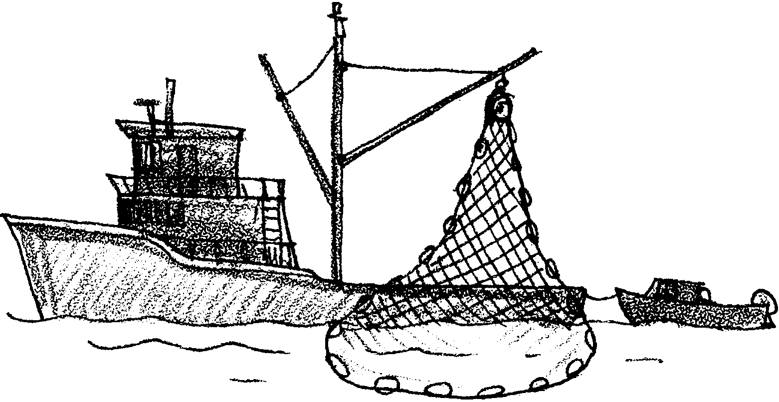
Purse seiners use special nets. Here’s what the net looks like.
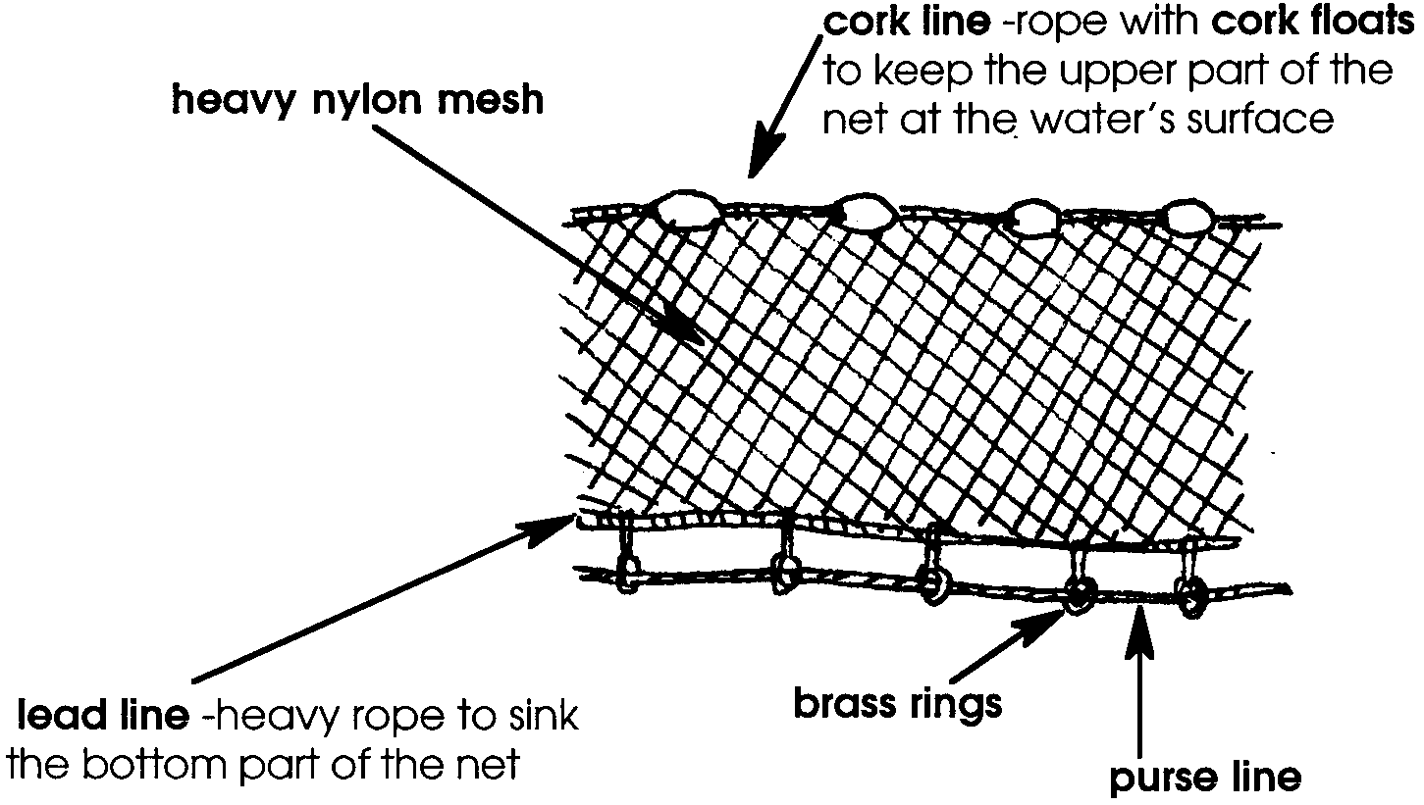

The lead line and cork line help the net to hang straight up and down in the water. The purse line runs along side the lead line. It slides through several brass rings. The brass rings are tied to the lead line. The purse line is used to draw the net together like a purse string.

3. Purse seine nets do not know the difference between a salmon and a seal. How might seine operators avoid catching other kinds of animals in their salmon nets?
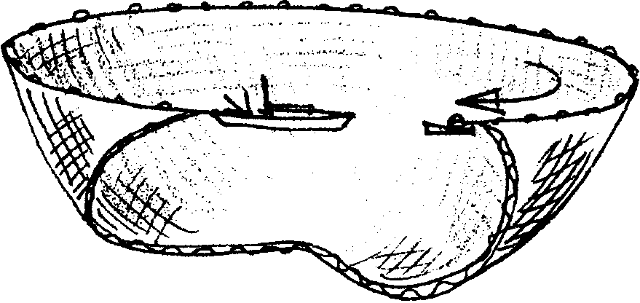
Here’s how a purse seiner works. The captain finds a school of fish. The net is placed around the fish. The small skiff takes one end of the seine net out around the school of fish. The seiner goes in the opposite direction to finish the circle. The seiner begins to tighten the purse line. The net forms a pocket or purse. The fish are trapped inside.

The net is pulled and lifted along side the seiner. It is too heavy to pull by hand. A special motor called a “power winch” does the work. The fish are then taken out of the seine net. The crew uses a circular net on a pole to dip the salmon out of the net. The fish are placed in the boat’s hold. They are either taken to a cannery or a fish buyer boat. Fish buyers pay less money than the cannery. But selling to a fish buyer saves the fisher time.

4. Laws regulate how many days purse seiners can fish. Each year there are fewer and fewer days to fish. Do you think more or fewer seine fishers sell their fish to fish buyer boats? Why?

Purse seine nets are also used to catch some kinds of tuna. Tuna nets are longer than salmon nets. Tuna fishers have to be careful not to catch dolphins along with the tuna. You will have a chance to look at this problem in another lesson.

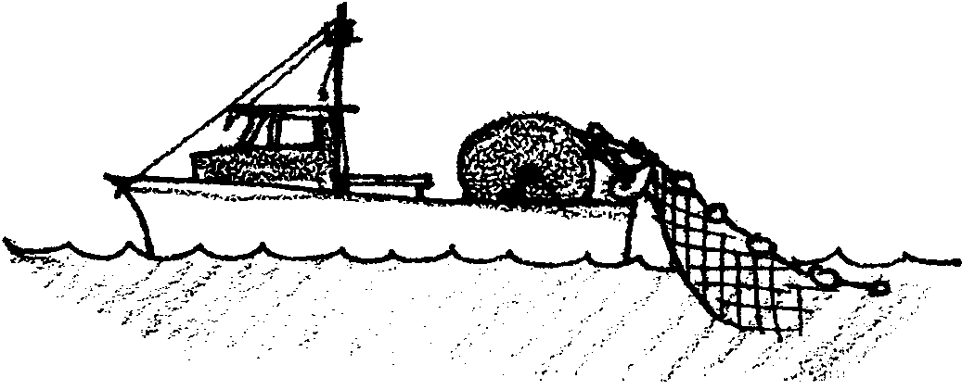
Gill Net Fishing

Gill net fishing is quite different from purse seining. On the deck of the gill netter is a large reel. The gill net is wound on this reel. The gill net is very long. It has a lead line and a cork line like the purse seine.
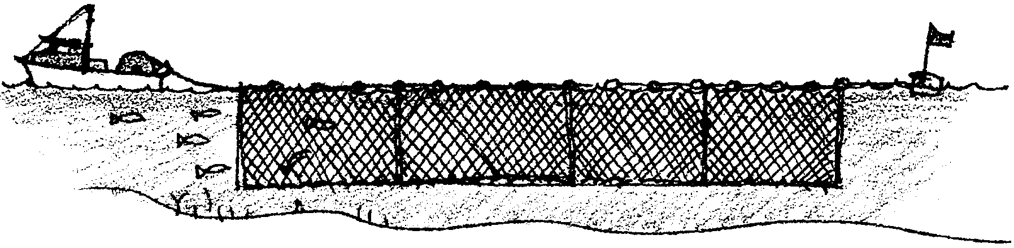

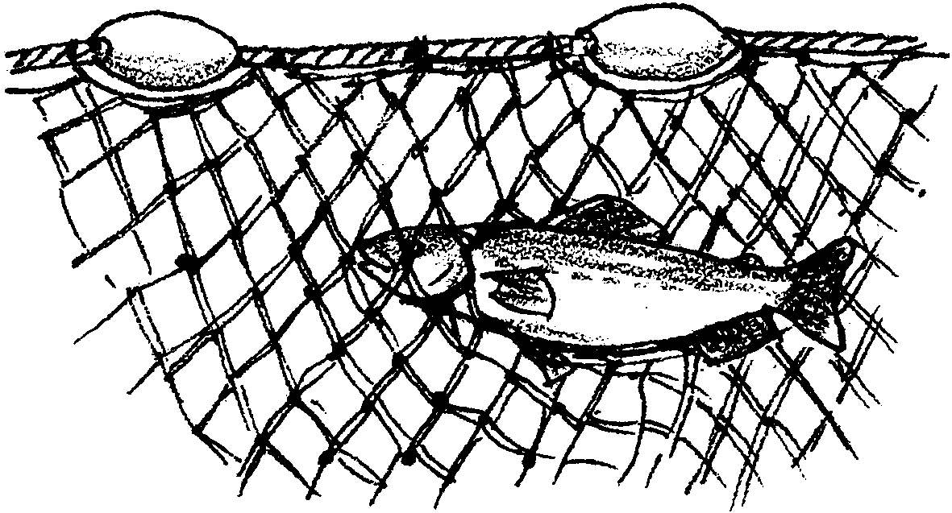
The gill net is also made of a heavy nylon mesh. However, the holes in the mesh are larger. Smaller fish can swim right through. The larger fish, are the fish the fishers want to catch. These are caught by their gills as they try to swim through the openings.

5. The state fisheries department wants to be sure that salmon under 20 inches long escape. Twenty inch long salmon are five inches across. What size holes should the department require gill nets to have?

The gill net is strung out in a straight line behind the boat. It is left floating in the water until the fisher “feels” that fish have been caught. The reel pulls the net and the fish back into the boat.

6. Why do you think that gill netters fish from sunset to sunrise?

7. George Gillnetter cannot find the net he set. Oh well, he’s not worried. It was an old net anyway. George should be worried.

a. What will happen to the net?

b. What will happen to the number of salmon available for him to catch?

Gill netting for salmon is a one person operation. Gill netting for bottom fish is quite different. Some of these gill nets are over 1000 feet long. They catch tons of fish each time they are put out. Gill nets capture all of the fish larger than a certain size. This means that a boat fishing for salmon will also catch many other kinds of fish. These other fish die. Often, they are thrown back in the sea. Millions of tons of fish die this way each year.

8. Think about the problem of catching all kinds of fish in a gill net. How would you solve the problem?

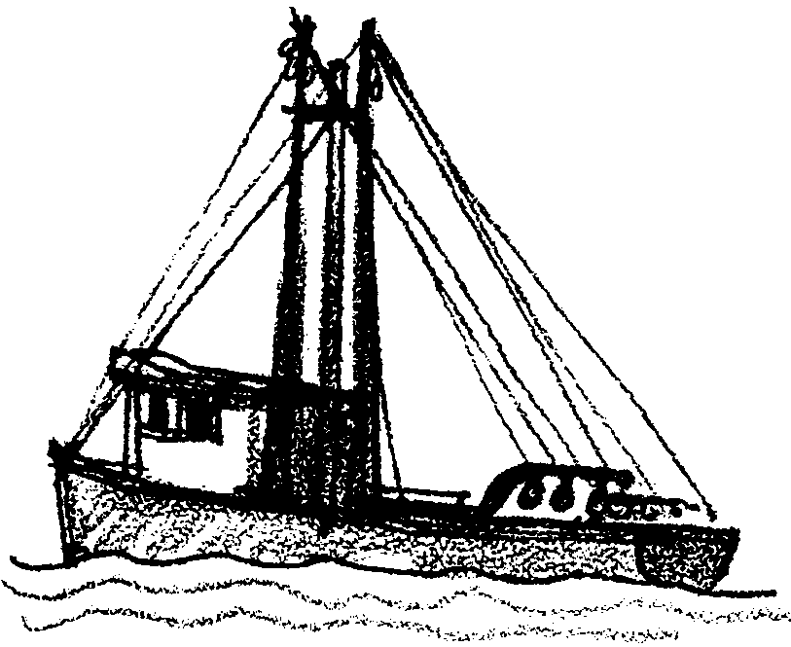
Troll Fishing

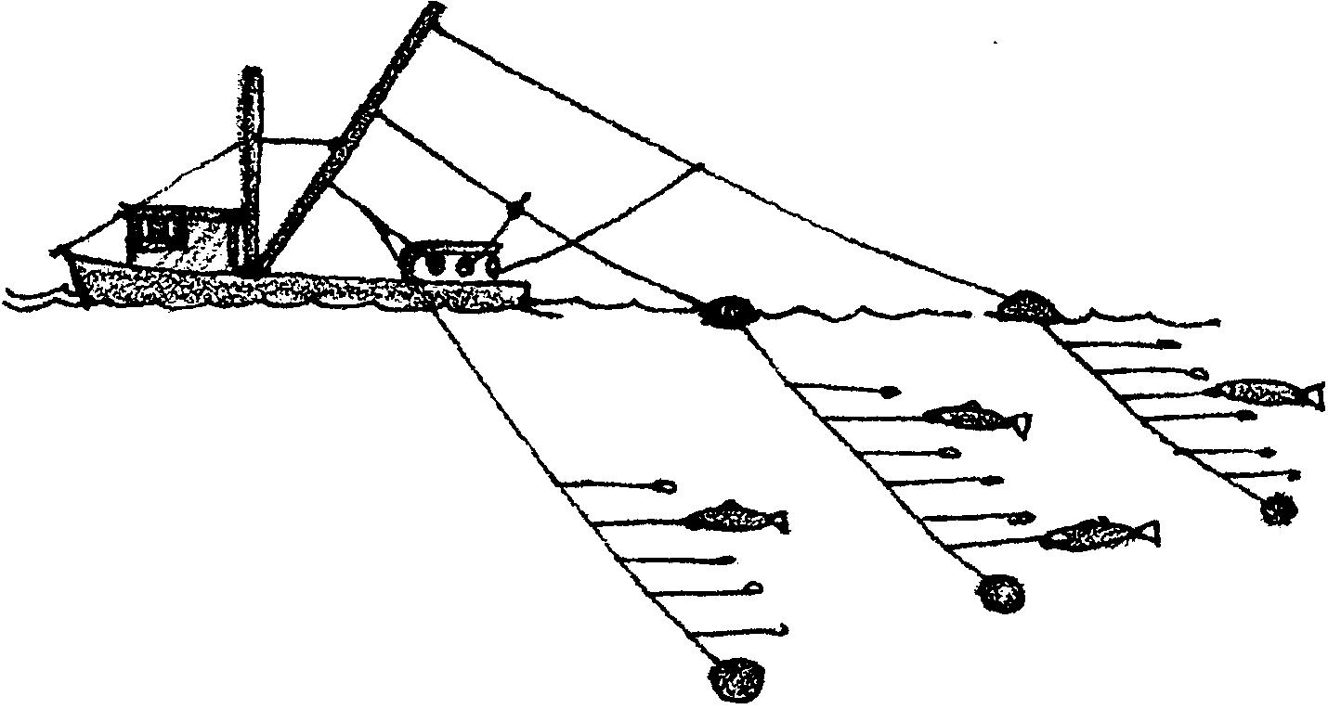
Trolling is another important type of commercial fishing. Trollers do not use nets. They fish with long fishing poles. The poles are attached to the boat. They fish many main lines at a time. The main lines are all around the boat. Main lines may be weighted with heavy sinkers at the end. Sometimes several short lines are tied to each main line. Each short line has one hook. The fisher is able to pull in any line at any time.

When the fish are caught, they are cleaned. They are packed in ice right away. Fewer fish are caught by trolling per day than by netting. However, fish harvested by trolling bring a higher price. This is because they are not damaged. They are often sold fresh.

9. Why do troll caught fish cost more?

10. Salmon are caught with purse seines, gill nets and by trolling. Which kind of salmon fishing do you think is least harmful to other kinds of fish? Why?

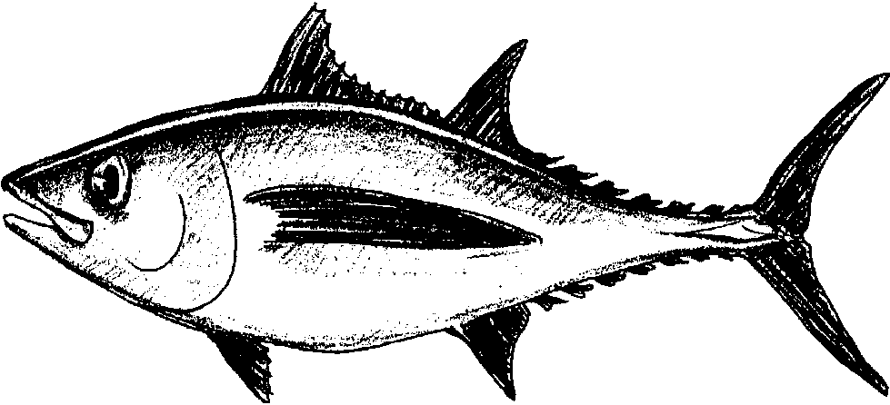

Albacore, a species of tuna, is caught by trolling. It can weigh up to 96 pounds and grow up to 5 feet in length. It is smaller than other tuna. It lives on the surface and at middle depths in the ocean.

Tuna usually travel in large areas of open sea. They follow warm ocean currents of the north Pacific waters. They travel from Mexican, U.S., and Canadian waters to the middle of the Pacific Ocean. Sometimes they go as far as Japan in the winter. They return to the California coast for the summer. Tuna fishers must be prepared to travel.

11. Tuna boats often travel great distances to fish. They may be gone from home for a long time. There are no stores in the middle of the ocean. What kinds of things do you think tuna boats must take with them?

Albacore is the highest grade of tuna. It is always in demand. Albacore is caught by trolling. Live bait or feathered lures are used to catch this small tuna.
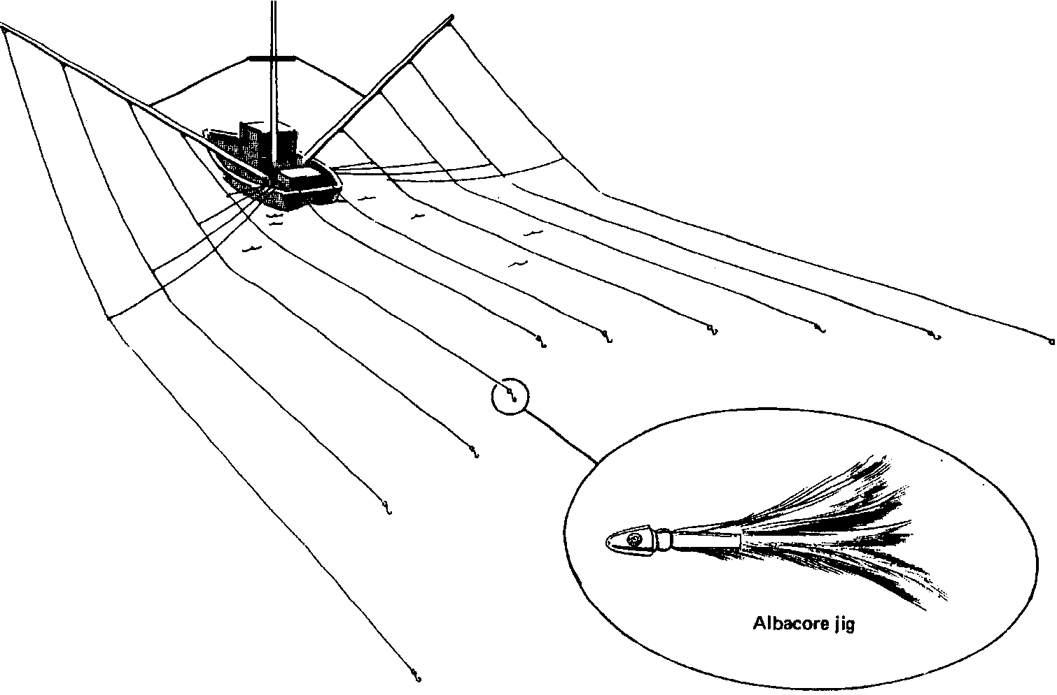

12. Lately, more salmon boats are joining the tuna fleet. What do you think causes this to be so?

Every year the fleet searches for migrating schools of albacore. The fishing often takes place hundreds of miles offshore. Albacore are caught between Baja California, Mexico and Vancouver Island, Canada. Some albacore is sold as fresh fish. However, most of this tuna is processed in canneries.

13. Other kinds of tuna are caught in nets. A few years ago, many people decided not to buy tuna because the nets used then also caught dolphins. How could dolphin loving people safely satisfy their craving for tuna?

Skate line Fishing

Halibut is another fish caught on hooks. However, the catching is different from trolling.

Halibut are a bottom dwelling fish. Large numbers of Pacific halibut are found in the North Pacific Ocean. They live in waters up to depths of 3,600 feet.
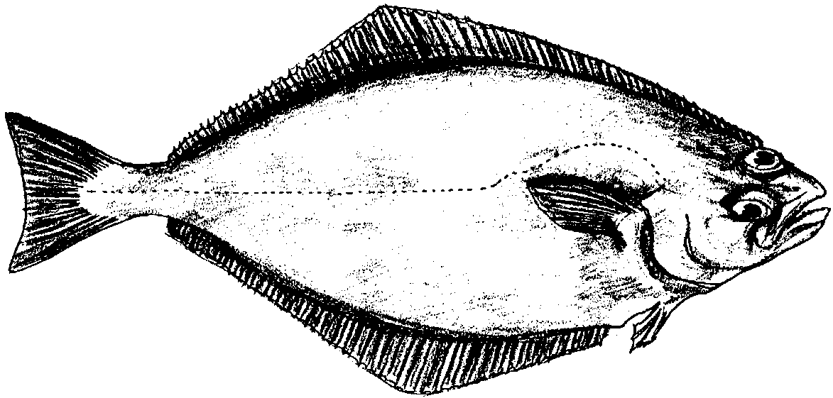
Female halibut grow up to 8 feet 9 inches in length. They can weigh over 500 pounds. Males are smaller. They grow to 4 feet 7 inches and 150 pounds.

Halibut eggs drift as they develop. Many are eaten. Eventually, the developed eggs drop to the bottom in shallow waters. They have become young fish. The young fish increase in size. They move to deeper waters. After about 12 years, the halibut are able to lay eggs.

14. Where do halibut eggs develop?

Halibut are caught from Vancouver Island, Canada to as far north as the Bering Sea. The main fishing grounds, however, are off Kodiak Island, Alaska. The average trip lasts from seven to fifteen days. During this time the crew works long hours. They sometimes work 20 to 22 hours straight. They take time off only to eat.

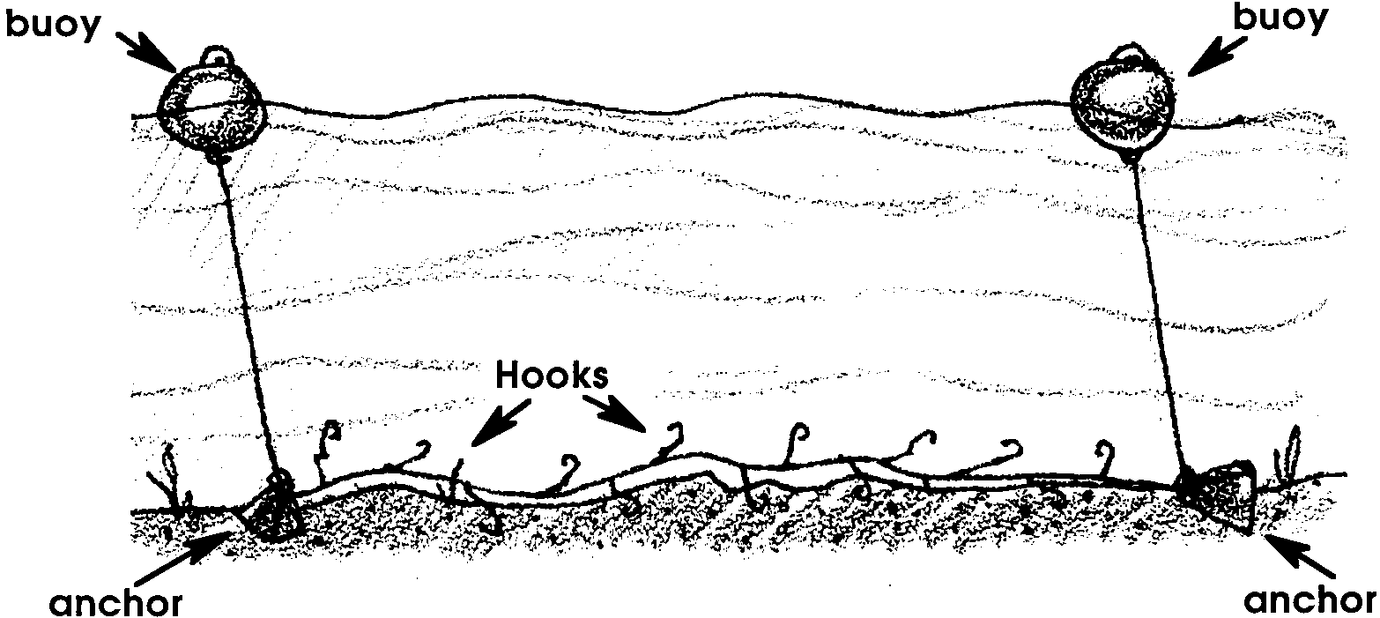
Halibut fishing is done with long sections of line called “skates.” Most boats carry from 50 to 60 skates. Each skate is about 1,800 feet long. A skate line fishes near the sea floor. An anchor holds the line at each end. The anchors are tied to buoys. The buoys float on the surface. They mark the skate line. The skate line has hooks every 18 to 21 feet. The hooks are baited with herring, salmon, octopus or squid.

15. The Mary Catherine is fishing for halibut. The boat has 50 skate lines. Each skate line is 1,800 feet long.

a. How many feet of skate line does the Mary Catherine carry?

b. How many miles of skate line does she carry? (Hint: There are 5,280 feet in a mile.)

c. Each skate line has a hook every 20 feet. How many hooks are there on each skate line?

d. How many hooks are there all together on the Mary Catherine?

e. The Mary Catherine catches one fish for every 5 hooks on the skate line. How many fish will the boat catch on this set of the net?

Skate lines may be placed end to end in one row. They may also be placed in rows like a garden. The lines are left in place for up to two days. The length of time depends on how successful the fishing is. The fishers return. They pick up the skate lines. The halibut are removed from the hooks, cleaned and packed in ice. Later they will be taken to a processing plant. From there they are sent to markets.

16. Fishers have noticed that the size of the halibut they catch is decreasing. What might this observation mean?

Bottomfishing

You have seen hooks and nets, skatelines and buoys. There are lots of ways to catch fish. Many fish such as cod, flounder and sole live on the bottom. How do fishers harvest these fish?

17. Fisher Barbara is going fishing for sole. She should set her net in the top/middle/bottom of the ocean. (Circle the correct answer).

Fishers have developed special boats and nets to catch bottomfish. The boats are called bottom draggers or trawlers. The nets are called otter trawls. Let’s look at the nets first. Most nets are made to catch particular groups of bottomfish.
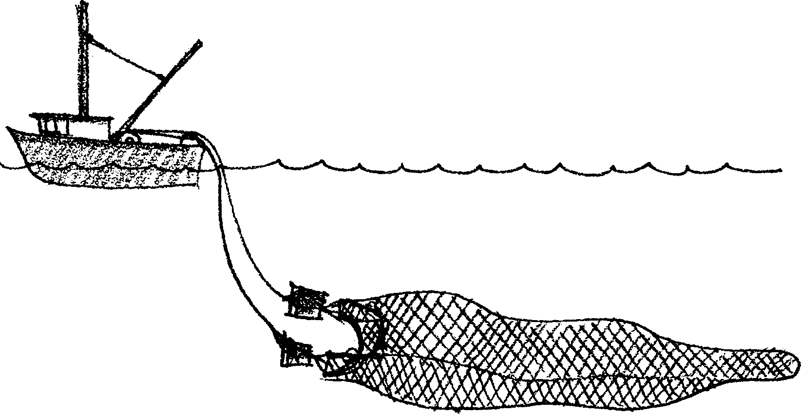
The otter trawl is a funnel-shaped net. The net is towed through the water along the ocean floor. The net is wide at the mouth. It tapers back to the narrow “cod” end. Trawls can be over 100 feet across. Some trawls are over 150 feet long. Here’s what the net looks like.
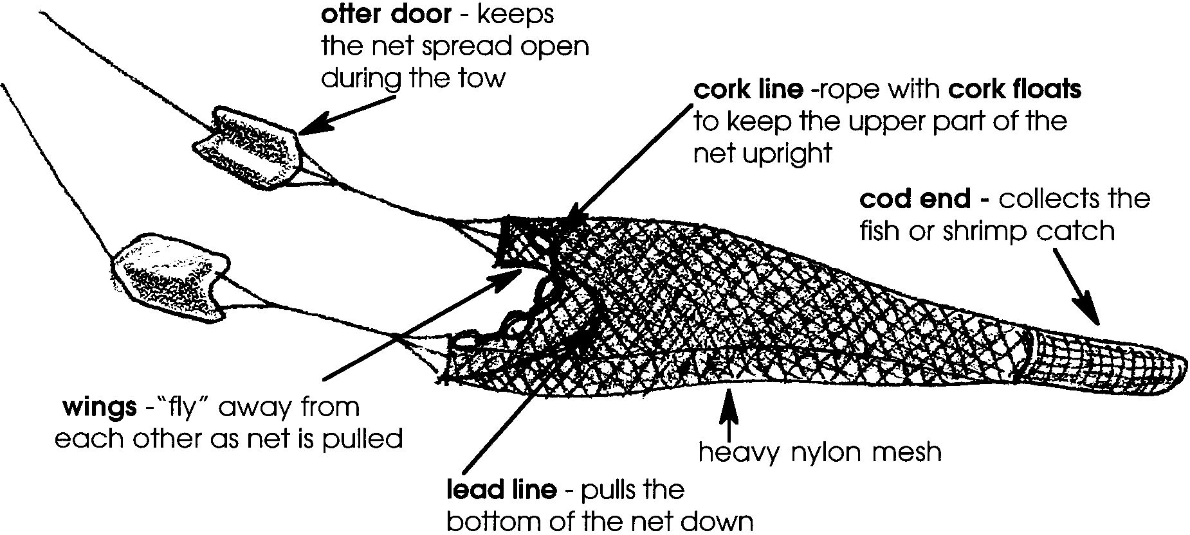

18. Which three parts of the net help hold the net open?
a.
b.
c.

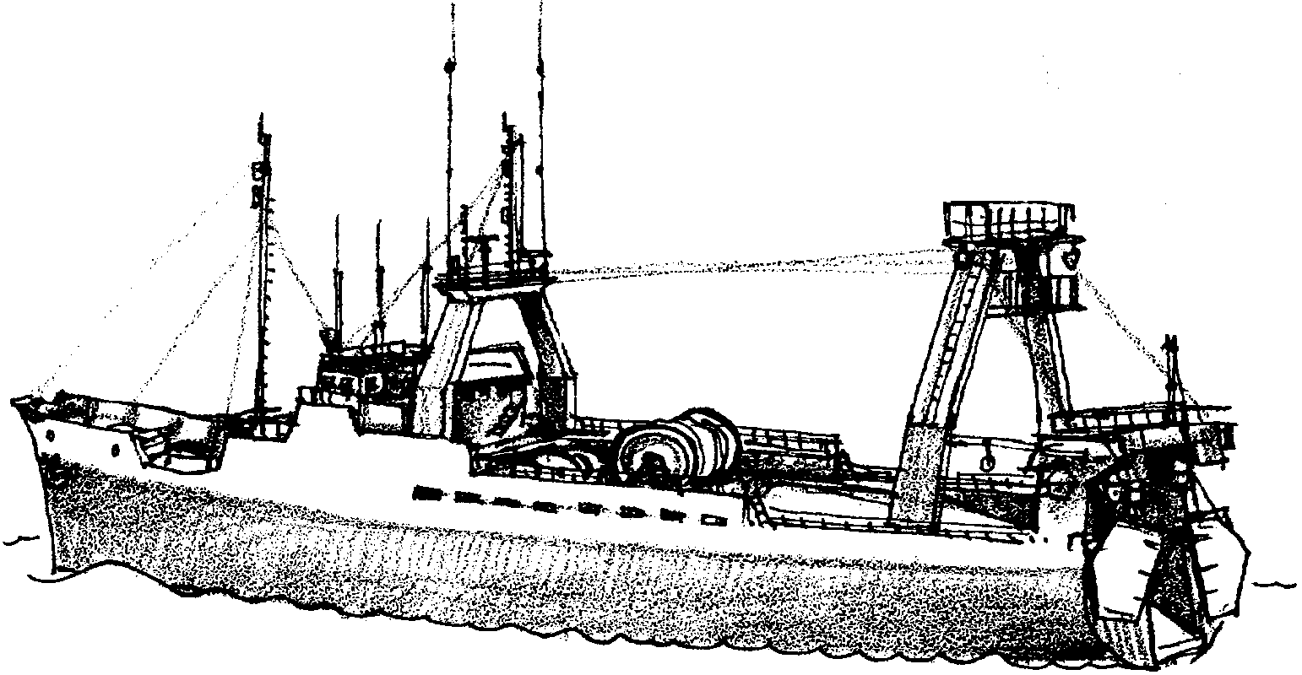
How do fishers use trawl nets to catch fish? The net is kept on a reel. The doors are stored near the stern. The crew unwinds the net from the reel into the water. The cod end goes into the water first. The boat keeps moving ahead. The movement pulls the net off the reel. The picture below shows an ocean trawler.
19. a. On the picture of the trawler, mark the reel with an X.

b. Circle the two doors on the same picture.

The doors are next lowered into the water. After the net is lowered, the boat tows it along. The nets are towed from 30 minutes to several hours.

20. Draggers work in water from 10 to 500 fathoms deep. A fathom equals six feet. How deep is the water in feet? From to feet deep. Please show your work.

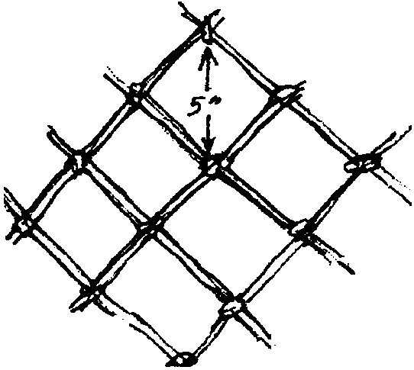

The nets have a 5 inch mesh. This means the “holes” in the net are 5 inches from corner to corner. The drawing to the right shows a portion of a net.

21. Fish bigger/smaller (circle the correct answer) than 5" around may escape 5" net mesh.

The lead line drags along the bottom. The fish rise to escape. Usually, they dart into the mouth of the net. Once inside the net, the fish’s escape routes are few.

The crew next hauls the net on board. They wind in the cables. Soon the doors and most of the net come aboard. Finally, the cod end is pulled up and aboard. The draw-rope which closes the cod end is loosened. The fish spill onto the deck.

Now the catch is aboard. The crew resets the net for another tow. Then they separate the fish by species (kinds). To keep them fresh, fish are iced or refrigerated. One good tow can bring up 30 tons of bottom fish.

22. The lead line helps hold the net open. What else does the lead line do as it moves along the bottom?

23. Five to ten thousand pounds of fish are often caught on one trawl. How many pounds of fish can a good tow bring up? (Hint: one ton = 2,000 pounds) Please show your work. Look in the text above and remember.

Marketing And Distribution

Catching the fish is just the beginning. How does the fish get to your dinner table? Let’s look at a salmon fisher. After a good day’s fishing, the boat is filled with fish. Sometimes the fisher may not want to return to the docks. The fishing may be too good. He can sell his fish to a fish buyer boat at sea. The buyer then takes the fish into shore. The fisher who takes his fish into the processing plant gets a slightly higher price. However, he loses valuable fishing time.

The salmon are “off loaded” at the dock. They are put in large metal trays on wheels. The fish are weighed and separated. The next stop is the cutting tables. There the fish are cleaned. They are then ready to be canned or frozen. Some of the cleaned salmon are sold as fresh fish. The “fresh” salmon are iced and shipped. They are sent out to markets immediately. The salmon to be canned is cut into can-sized pieces. The pieces are put into the cans. The fish is cooked in the cans. The cans are cooled and labeled. The canned salmon is shipped to stores by truck. The salmon is sold world wide. Salmon is a much sought after food.

24. Have you ever eaten salmon?

25. What color was it?

Albacore tuna is processed the same way as salmon. Most of the albacore is sold in cans. A small amount is sold as fresh fish. Halibut is sold as frozen fish rather than canned. Freezer trucks deliver the halibut to dealers. Next time you are in the grocery store, look for the canned fish department. What kinds of salmon are available? Where did the salmon come from? Look for albacore tuna. What is the price of the albacore tuna compared to the price of other kinds of tuna? Look in the frozen food section for halibut. What is the price per pound for halibut?

You probably have seen tuna and salmon in the market. You may not have seen “bottomfish”. Perhaps you have seen “white fish”. Some trawl caught fish is sold as fresh “white fish”. What, then, happens to the rest of the trawl caught fish?
Next time you’re eating a “Fillet of Fish” sandwich, stop. Where does your favorite fast food restaurant get the fish? Thank the trawl fishers who caught the fish. Thank the workers who removed the bones. Thank the processor who formed the fish into patties. Thank the trucker who carried the fish to the restaurant. Thank the chef. Thank the salesperson who sold you the sandwich. Thank the person who took you to the restaurant and bought the meal for you. Wow, what a lot of people involved to get that “Fillet of Fish” to you.

26. What are two forms in which trawl-caught fish are marketed?

a.

b.

Fish sticks and countless other frozen fish products are made from trawl caught fish. Read the labels on your favorite frozen fish. Pollock and hake are common trawl caught fish used for frozen food.
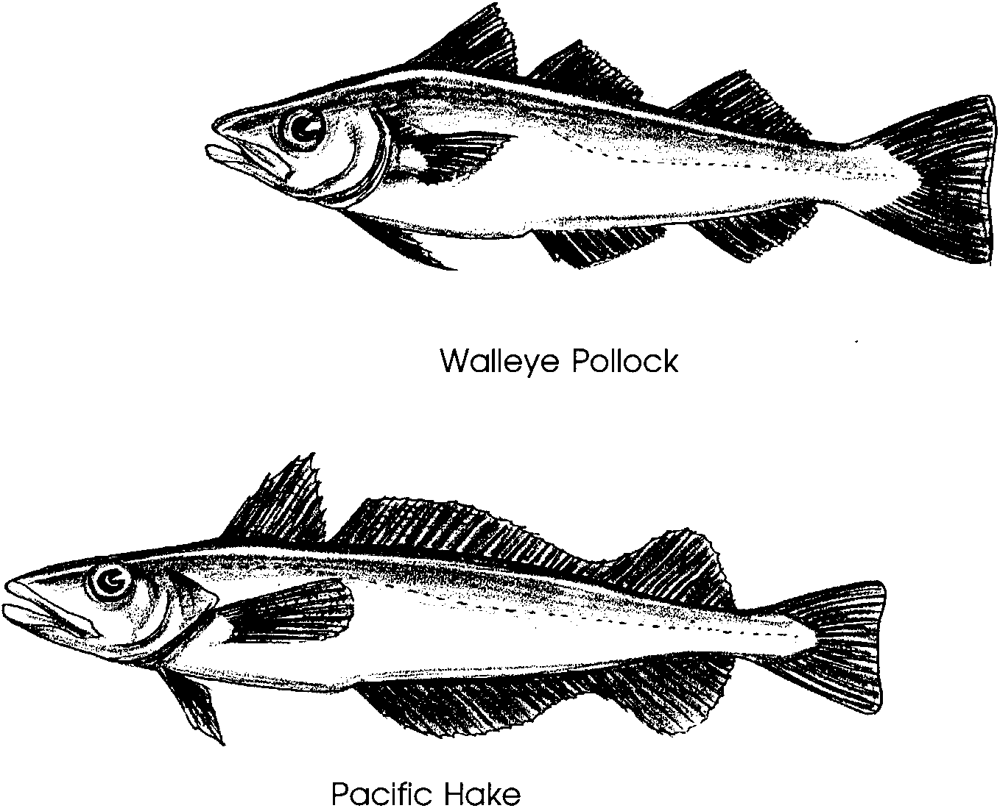
27. Does your school have a hot lunch program? If so, what kind of fish are you eating? Don’t know? How might you find out?

Other trawl-caught fish have a less glorious fate. Some trawl fish are sent through rollers. These rollers press the oils from the fish. The solid fish left is called Fish Protein Concentrate or FPC. FPC hasn’t caught on as human food. It is, however, a valuable food for poultry, cattle, and hogs. Interestingly enough, FPC is also used as food to raise other fish and shellfish. The oils pressed from these fish are very useful. They are made into plastics, paints, cosmetics and other products.

28. What is FPC?

29. What kinds of things are made from fish oils?

Fish are good to eat and good for you. Do you eat fish often? Think of all the people who had a hand in getting the fish from the ocean to your plate. Next time you go shopping take along a pencil and paper. Write down the different ways fish are sold in your store. Keep your eyes open. Be sure to look in all the different areas of the store! Pick out your favorite fish. Why don’t you have it over for dinner tonight?

